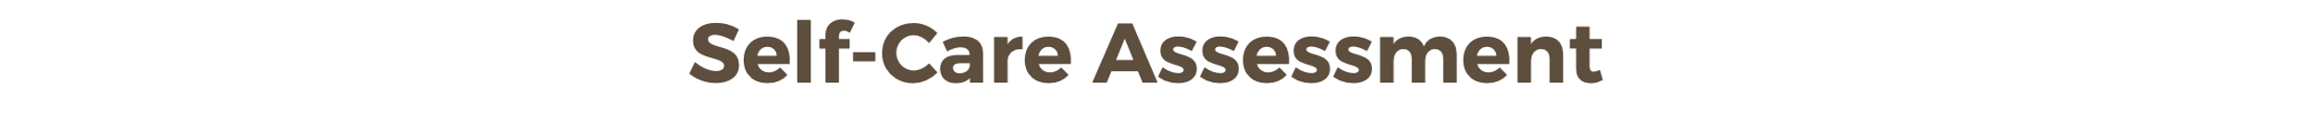
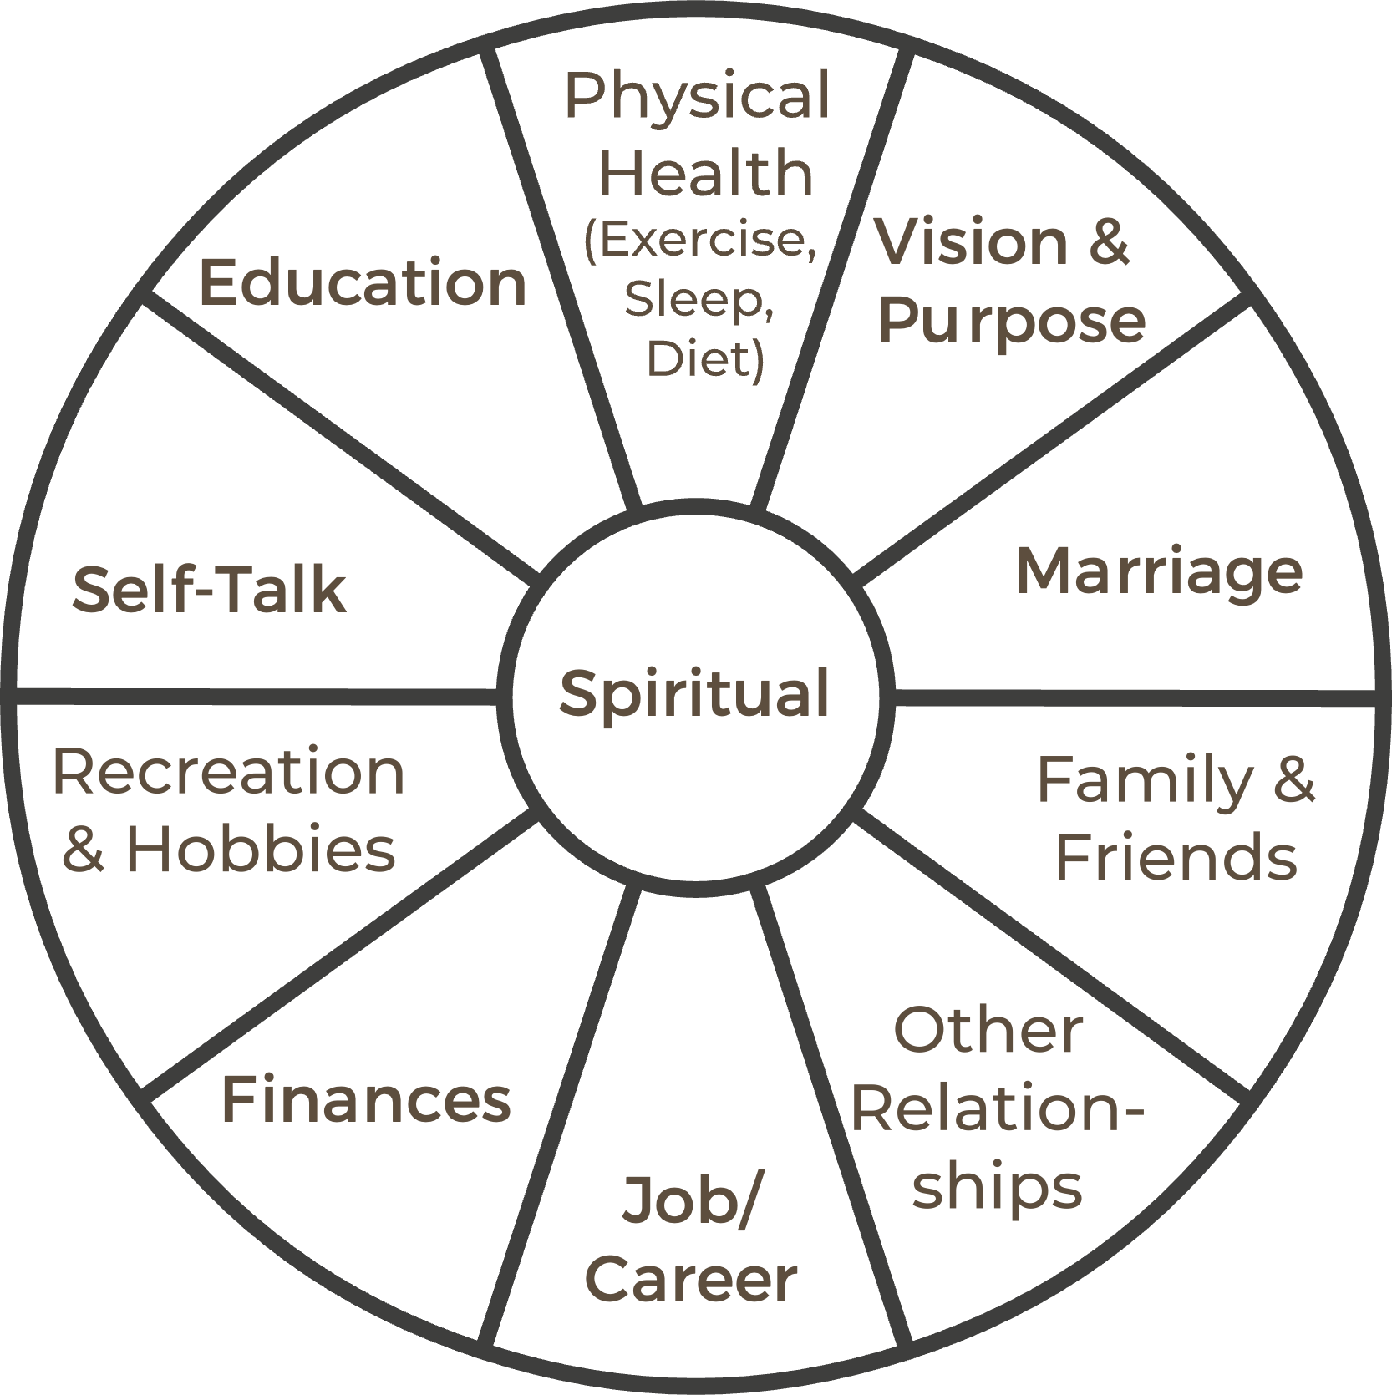

Instructions:
- Carefully evaluate each area of your life as described in this self-care pie chart.
- Assign a personal score (from 1–10, where 10 means “Very Good”) to each slice.
- Select the primary areas you want to focus on improving first.
- Set some measurable action steps for yourself on the lines below.

STEP 1: ______________________________________________________________________
STEP 2: ______________________________________________________________________
STEP 3: ______________________________________________________________________
STEP 4: ______________________________________________________________________
STEP 5: ______________________________________________________________________

©2024 Dr. Mike Garrett

