


P.O. BOX 20165
Lehigh Valley, PA 18002-0165

484-767-0501 (Hannah’s cell)
hajobo1998@gmail.com
www.yfclv.org

P.O. BOX 20165
Lehigh Valley, PA 18002-0165

484-767-0501 (Hannah’s cell)
Hajobo1998@gmail.com
www.yfclv.org
LEHIGH VALLEY

P.O. BOX 20165
Lehigh Valley, PA 18002-0165

484-221-5886 (John’s cell)
campuslifelv@aol.com
www.yfclv.org

January 2026

Dear,

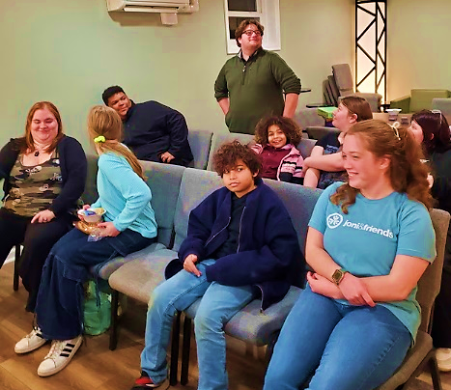
Happy New Year!! I hope you had a wonderful holiday and that you have been staying warm! These past few weeks we have gotten more snow in PA than we have seen in years, cancelling school these last few days (much to the joy of our students). Hopefully you had some strapping young men to help shovel you out this past week!

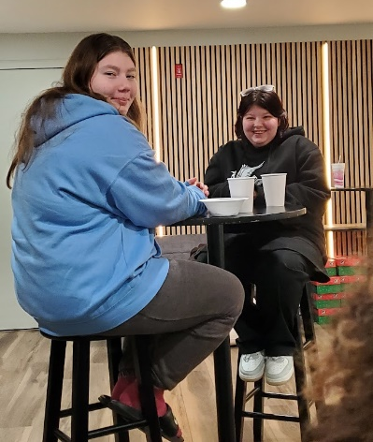
This past month, we have begun a new series, “Shade”. In the lingo of our students’ generation, giving “shade” means to show disrespect towards someone in various ways. Our first topic we covered was on “Bullying”. We showed a skit, based on a true story, about a boy named Dennis diagnosed with cerebral palsy whose life was changed because a girl who shared Christ’s love with him. Dennis had experienced the stares and laughs of kids at school for his appearance and clumsiness (due to his disability). But this girl, Stacy, reached out and befriended him, inviting him roller skating, swimming, and eventually to church. Through her friendship, Dennis was able to learn about the father who had created him and loved him inside and out.

In our small groups, we discussed which wounds were the fastest to heal, physical or emotional wounds. Almost all our kids agreed that emotional wounds tend to stick around much longer than the physical. And in this world, these kids don’t get a break from the emotional wounds. Through phones and social media now, they aren’t able to disconnect from hurtful words as easily. Pray for our kids who are constantly fighting battles of self-doubt and poor self-image. Pray that they might know that there is a Father that loves them, scars and all.

Please keep myself and my team in your prayers as we enter the second half of our year. Pray for wisdom and direction for me as I lead this group in the coming months. Please pray for growth for our club, both spiritually and numerically, that we might reach more searching and lost kids (all in the Lord’s time). As always, thank you so much for your prayerful and financial partnership with us, I am so grateful for you! May God bless you throughout this year and in the coming days.

Hannah Bovard
Campus Life Director
484-767-0501

