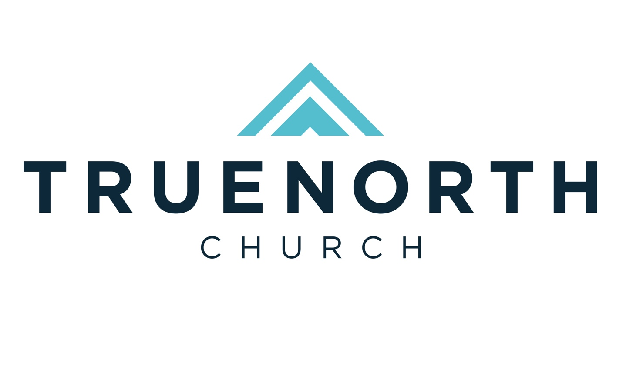
2026 Mission Trip Information

Index

Topic | Page
Trips and Dates | 3
Participant Age Guidelines | 3
Passport Information | 3
Vaccine Information | 3
Mission Trip Application | 3-4
Trip Cost | 4
Team Meetings | 4
Mission Trip Covenant | 5
Short Term Mission Trip Release Form | 6
How to successfully build a support team for your mission trip | 7-8
Miscellaneous financial questions and answers | 8
Who Do You Know? | 9
Support Team List | 10
Guatemala Sample Support Letter | 11
Ecuador Sample Support Letter | 12
Middle East Sample Support Letter | 13
Zambia Sample Support Letter | 14
Japan Sample Support Letter | 15
Supporter Response Card/  Contribution Guidelines | 16-17

**If you have any questions, don’t hesitate to contact your team leader or email outreach@truenorthchurch.com .

Trips

Location | Dates | Team Leader(s) | Focus
Middle East | Mar 19-27 | Don King | Refugee outreach
Guatemala | June 13-20 | Nicole Juhan | Light for the Future  VBS/School/Food Distribution
Zambia | June 25 – July 3 | TBD | Hands of Hope  Assistant Camp Counselor
Guatemala | Sept. 19-26 | Jennifer Cloy | El Puente  Construction
Japan | Fall | TBD | TBD
Middle East | October | Don King | Refugee outreach
North Africa | Fall | TBD | Aslan Child Rescue Ministries

- Participant Age Guidelines
- International trips are not designed for children or students 14 years old and under.
- Prior to completing the application, a meeting with a pastor will be required for the student (under 18) and parent to determine if the trip is a good fit for the student. Paperwork will need to be notarized prior to the trip for students.

- Passport
- Your passport must be valid for a minimum of six months after the trip return date to travel internationally.
- Make an appointment online with the Post Office to complete the passport process, including photo. Print and fill out the appropriate application and take all documents with you.
- Passport information/applications
- Once you receive your passport, please email a clear picture of it to your team leader.

- Vaccines
- CDC for travelers: Select your country to see current recommendations.
- Guatemala hosts strongly encourage an up-to-date Tetanus vaccine.
- The Yellow Fever Vaccine (among others) is necessary for Ecuador. It can be difficult and expensive to obtain. Contact Passport Health Services (888) 499-7277 to arrange your vaccines. It will likely require an appointment out of the area.
- The Columbia County Health Department is the least expensive place to obtain your vaccines whether you live in GA or not. The walk-in clinic is on Fridays from 8:30 AM - 3:30 PM. Take your shot records with you. Call (706) 868-3330 for more information.
- You can also obtain your vaccines from your family physician.

- Mission Trip Application
Your first step is to fill out the application.
- Fill out your mission trip application here.
- Once the application is submitted you will be approved for the trip or notified that more information is needed.
- Once approved, you will receive your team member text keyword and specific link to be used to raise support for your trip.

- Trip Cost
- Cost covers all transportation, food, lodging, medical insurance, trip supplies, and visas.
- Each trip is unique and the costs vary depending on the location. Your team leader will let you know a more exact number early in the development of the team. Generally speaking, trips are around $1000-$1500 plus airfare.

- Team Meetings
- Please attend as many meetings as possible before and after your trip.
- At the first meeting, you will complete the Trip Covenant, Mission Trip Release Form, and turn in your $100 non-refundable deposit.

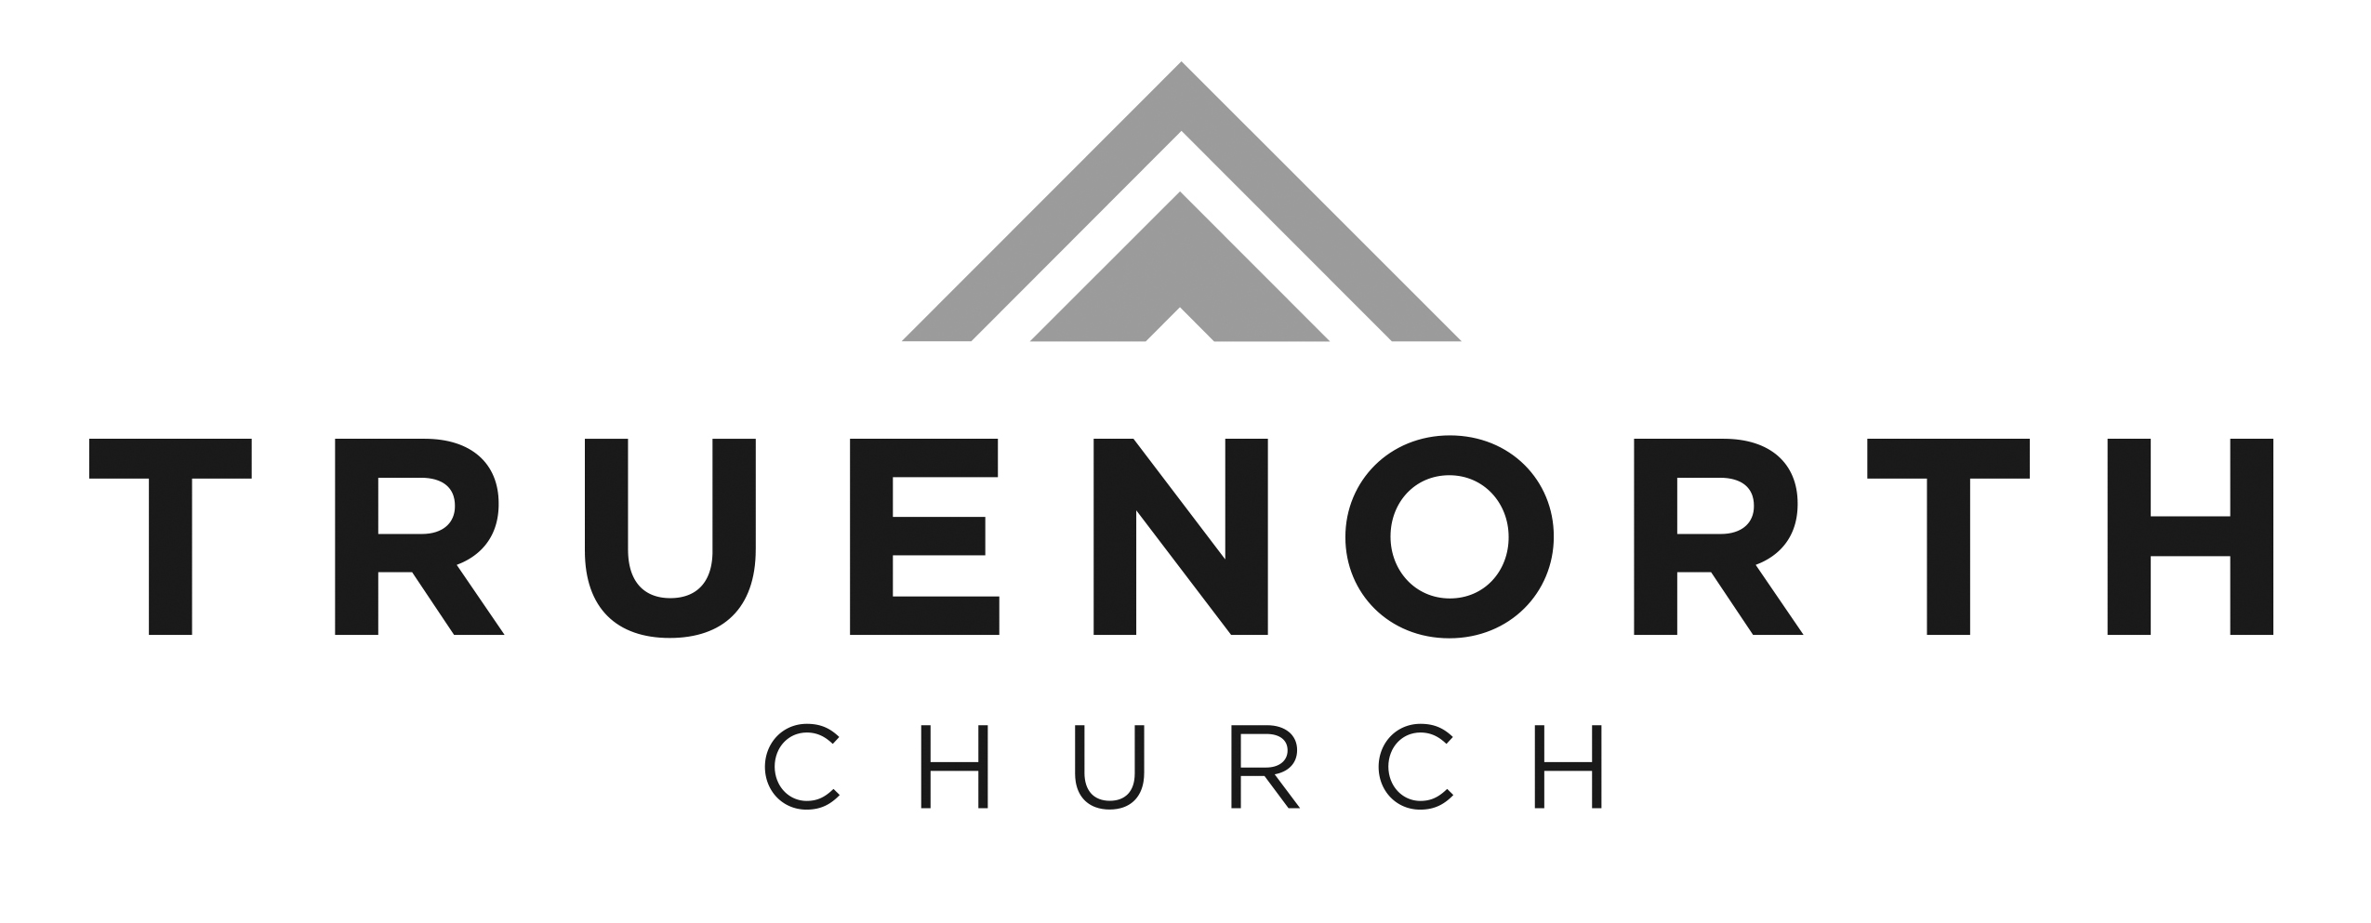
Mission Trip Covenant

As a member of this mission team, I commit to actively participate and support the whole team to accomplish the goals of our project. I recognize that by being part of this team I agree to the following:

1. Developing my personal relationship with Jesus Christ - I commit to discipline myself and put a priority on growing deeper in my walk with Christ during the entire preparation process and during our project assignment. This includes:

- Having a regular time of Bible study and prayer.
- Diligently praying for and encouraging the members of my team and the partnership and praying for opportunities to share my faith.
- Developing an attitude of service and flexibility - I commit to serve the team, the team leader, the nationals and the overseas workers on the field. I will bring a spirit of flexibility to the project knowing that plans often change.
Initial here if you agree to follow the above: ________.

2. While I am a part of this team I will:

- Make it a priority to attend 100% of the team meetings and be an active participant in all team and project activities.
- Follow the rules and standard of behavior set by my team, team leader(s), and host country.
- Seek to be sensitive to the culture in my words, actions, and dress.
- Refrain from any activity or behavior that might be a stumbling block to my team or any team member, our partnership ministry, or the people I am seeking to influence. I will be especially careful to treat those of the opposite gender as a brother or sister in Christ and refrain from romantic relationships.
- Submit to the authority of the team leader(s). I realize I can be sent home by the team leader(s) at my own additional expense if I do not strive to follow this covenant.

Initial here if you agree to follow the above: ________.

3. Financially supporting the short-term trip:

- To secure a spot on the team, I will give a non-refundable $100 deposit.
- Once airline tickets have been purchased, I commit to paying for 100% of the ticket price, even if I do not go on the trip.
- I commit to joining my team in raising prayer and financial supporters for our trip. I will have 100% of my financial support 15 days prior to our departure. If my financial support is not attained 15 days prior to the trip, I will meet with church leadership to determine actions I can take to fulfill my commitment.

Signed: __________________________ Leader signed (as witness): ______________________
Name: __________________________ Leader Name: ________________________________
Date: _______/_______/____________

Short Term Mission Trip Release Form

I, ______________________________, acknowledge that I have voluntarily applied to participate in a short-term mission trip to ________________________ with TrueNorth Church. I am fully aware that this mission trip may expose me to unique hazards such as sickness, disease, dangerous environments, crime, political instability, government opposition, personal injury, death, as well as similar and dissimilar risks. I am voluntarily participating in the mission trip with the knowledge of the risks involved. I release and forever discharge TrueNorth Church, and any other organization involved and each of the respective members, employees, officers, directors, and representatives from any and all claims for any and all injuries, illnesses, losses, or damages I might have on or in any way relating to such mission trips, including without limitation, those relating to me leaving the United States of America and visiting the above stated country (including my stay in, and travel to and from stated country). As consideration for being permitted by TrueNorth Church to participate in the mission trip, as consideration for TrueNorth Church assisting in arranging the mission trip, and for other good and valuable consideration the receipt and sufficiency of which is hereby acknowledged, I hereby irrevocably and unconditionally release, waive, discharge, and covenant not to sue or attack the property of TrueNorth Church, or any of their affiliates, subsidiaries, divisions, members, directors, officers, employees, and agents (collectively referred to as the “Releasees”), for and from all claims of any nature now or hereafter existing whether known or unknown, including but not limited to all liability, on account of death, injury, or damage resulting from the negligence or other acts, however caused, of the Releases as a result of my participation in the mission trip. I UNDERSTAND THAT I AM GIVING UP MY LEGAL RIGHTS AND THE RIGHTS OF MY REPRESENTATIVES TO RECOVER FOR INJURY, DEATH, OR PROPERTY DAMAGE.

I give TrueNorth Church, and its representatives with me on such mission trip, authority to request and authorize medical and/or hospital treatment for my benefit in the event of an injury or sickness sustained by me while on such missions trip, including but not limited to circumstances arising while traveling to and from above stated country. I agree to pay for all such treatment and to reimburse TrueNorth Church for all costs and expenses incurred by it with respect to such treatment.

I have carefully read this agreement and fully understand its contents. I am aware that this is a release of liability and a contract between me on one hand, and TrueNorth Church, and or their affiliates on the other hand. No oral representations, statements, or inducements apart from this agreement have been made to me. I SIGN THIS AGREEMENT OF MY OWN FREE WILL.

_____________________________________
Signature of Participant
_____________________________________
Printed Name of Participant

_____________________________________
Date

How To Successfully Build a Support Team for Your Mission Trip

Five Steps
- Develop a Biblical Perspective
- Shift Your Mindset
- See the Benefits
- Build Your Team
- Follow Up

Develop a Biblical Perspective
- In the Old Testament, priests, Levites, and prophets lived off tithes and offerings of the people. Numbers 18
- Jesus tells His disciples, … “The harvest is great, but the workers are few.” Matthew 9:37
- Paul discussed missionaries receiving support.
  - Let the one who is taught the word share all good things with the one who teaches. Galatians 6: 6
Shift Your Mindset
- You are fulfilling the Great Commission. Matthew 28: 18-20
- Change your thinking from "I'm asking for money" to, "I'm telling people about what God is doing while giving others an opportunity to be a part of it.”
- People are giving money to the team for His work, not to you.
- You are a servant of the Most High God!

See the Benefits
- Educate others about missions.
- Strengthen your faith in God to provide.
- Make new friendships.

Build a Prayer Support Team
- Develop a list of people who would commit to pray now and during the trip.
- Share your passion and mission with them.
- Communicate specific prayer requests about the trip such as needs and concerns.

Building a Financial Support Team
- Pray for God's guidance as you make a list of potential financial supporters.
- Write a letter/email to each potential supporter explaining what the team will be doing.
  - Include a Response Card that you’ve printed front and back and a self-addressed stamped envelope for those who will write a check instead of giving online.

Writing the Letter
- Personalize your letter
  - Focus on the specifics of the teams’ trip.
  - Thank donors and tell them they are necessary.
- The Ask
  - Explain the cause.
    - Show there is a need, and the trip is critical in addressing that need.
    - Explain exactly what the team needs.
- The Closing
  - Thank donors in advance for their support.

Financial Details
You will receive a specific link and text keyword (text to 803.279.1555) for donors to give to your trip. If you send an email, please include both options for your donors. If you mail a letter, let the donor know they may give online or text to give. (You could email or text them the online/text options.)
- Online Giving: Provide your specific link.
- Text to Give: Provide your specific text keyword.
- Checks are written to TrueNorth Church with your text keyword in the memo line.
- Cash should be in an envelope with your text keyword and the name of the donor.
- Deliver checks/cash to the TNC Office in person or by mail (Attn: Gene Jennings).

Follow Up
- Follow up if you don't hear from potential supporters.
- Send each person who supports you a thank you note or thank them verbally.

After the Trip Suggestions
- Send a photo and thank you note.
- Tell them what their support achieved.

Any deep sense of God’s leading should be accompanied by the confidence that when he guides, He also provides. Raising one’s own support is a challenge to faith.

What happens if I raise more money than required?
Due to IRS regulations, all donations belong to the church, not to an individual team member or a team, and are non-refundable. Extra funds that are raised can be re-allocated after the trip has returned. We generally allocate any extra team member funds to supplement other teammates that might be in need. Any extra funds would then be used for other ministry efforts in the area.

What happens to the money if I can’t go?
If any team member must cancel prior to the date of the trip, he or she will be financially responsible for any amount of funds that have been spent on his or her behalf in the arrangement of the trip. In certain circumstances, those unused funds can be reserved for other future short-term trip opportunities. We assess these situations on a case-by-case basis.

Who Do You Know?

You can include anyone on your list who you think may be interested in the team’s project. List people you think may support the team in prayer or financially. Both are important and you may be surprised who will give to help the ministry financially. To remind you of people who might be interested in knowing about the ministry, look through your personal phone numbers and social media.

Here’s a list to help you think of others to send your letter to:

- Bible study group
- Business acquaintances
- Campus leaders of Christian groups
- Christian business groups
- Christmas card lists
- Church members
- Civic clubs
- Coaches
- Coworkers
- Employers
- Fellow students
- Former or present teachers
- Friends
- Friends of your family
- High school and college friends
- Neighbors (present and former locations)
- Parents' employers
- People you have led to Christ
- Relatives
- Retired friends
- Rotary Club
- Sunday school classes
- Teammates
- Those who have influenced you spiritually
- Wedding lists

Support Team List

Name | Address | Phone/Email | Date Contacted | Response

Sample Support Letter

Dear ,

I am writing to let you know I am going on a short-term mission trip to location from dates. During the trip, I will help provide services to the community by (make specific to your trip). Through these activities, my team hopes to build relationships and share the hope we have found through Jesus Christ.

TrueNorth Church is partnering with name of local partner while working in location. You can see that the needs of this community are critical, and we can have a huge impact here for Christ (something to show the importance of you going on this trip.)

Would you consider partnering with our team in prayer and financially? We need prayer for what. Financially, I need to raise $xyz to cover my expenses, including the cost of an airline ticket (approximately $xyz). I need all funds by date. I hope that you see this as an opportunity to partner with us and serve God. Thank you for your support and I am excited about the possibility of you as my encourager!

To contribute financially, click on the link insert your specific link or text your text keyword to 803.279.1555. Checks can be made out to TrueNorth Church with your text keyword on the memo line. If you write a check, please send the check and Response Card to me in the enclosed self-addressed stamped envelope. All donations for this ministry are tax deductible and non-refundable.

Thank you for considering being part of my support team. Please let me know if I can answer any of your questions.

Sincerely,

NOTES
- Speak to your team leader about the specifics of your trip
- For the Middle East and North Africa trips, you cannot share the specific country name or partner names; nor can any appeal for support be made on any social media platforms

Team Member ___________________

Team Keyword ___________________

Yes, I want to be a part of your Mission Trip!

- ____ Praying
- ____ Giving (See Contribution Guidelines on reverse)

Name ________________________________________

Address ________________________________________
________________________________________

E-mail ________________________________________

Phone ________________________________________

If giving by check, please enclose this card and return to the team member.

Contribution Guidelines

- The preferred method of giving is online giving or text to give. See letter for this information.

- If giving by check, please make checks payable to TrueNorth Church. Checks should not be made out to the team member, nor should the team member’s full name be written on the memo line. Response cards will be labeled with a team member keyword for identification, record keeping, and tax deduction purposes.

- All money is solely donated to TrueNorth Church, North Augusta, SC, USA and is not refundable or transferable. TrueNorth may use any excess funds to develop new aspects of the current trip, for other mission trips, or for any mission work deemed worthy by TrueNorth Church.

