
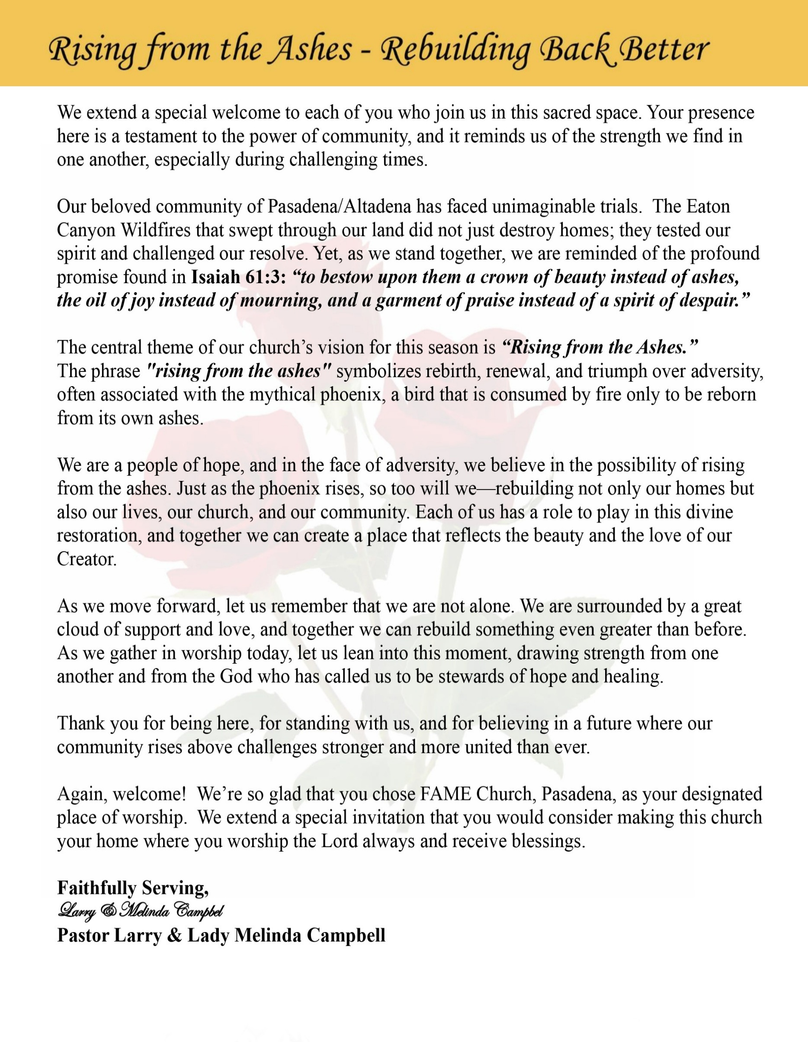

Sunday, February 15, 2026 | 9:30 a.m.

Rt. Rev. Francine A. Brookins, Esq., Presiding Bishop
Rev. Miriam Burnett, MD, MPH, Supervisor of Missions
Rev. Roosevelt Lindsey, Jr. Presiding Elder

The Rev. Dr. Larry E. Campbell ~ Senior Pastor ~ Minister

Mobile: (951) 587-1894 ~ Email: larrycampbell@famepasadena.org

Our First Lady: Mrs. Melinda G. Campbell

The Reverend Dr. Jennifer Oliver ~ Itinerant Elder -
The Reverend Dr. Nikia Smith-Robert ~ Itinerant Elder (Affiliated)
The Reverend Lois Woodard ~ Itinerant Elder Superannuated (Retired)
The Reverend Rochelle Wright Moore ~ Itinerant Deacon
The Reverend Deborah West-Jones ~ Local Elder
The Reverend Philis J. Griffin, MDiv ~ Local Elder
Dr. Phyllis Beech ~ Evangelist
Sister Tessie Bonner ~ Deaconess

Community Resource Center Director ~ Ms. Kischchen Hazelton Venerable
Church Administrative Assistant: Ms. Letha Rhymes

Church Office Hours:
Tue - Wed 9:00 am - 5:00 pm, & Fri 9:00 am -3:00 pm.
Closed for Lunch Daily: 12:00 pm - 1:00 pm.

Music Ministry
Dr. Timothy Davis, Minister of Music
Bro. Jimmy Watlington, Percussionist ~ Bro. Carlos Caldwell, Organist
Bro. Darien Dorsey, Keyboardist
Sis. Karen Law, Women’s Chorus Director ~ Sis. Tonia Graham, Children’s Choir Director
Bro. J. Renard Washington, New Generation’s Choir

FREE WI-FI service is available on the FAME Campus by accessing FAME 1700
Password: 6267980503

-3-

Worship Experience ~
Warning: This order of worship is subject to change without warning or prior notice --- everything is governed by the Sovereignty of the Holy Spirit.



+ + + The Altar Call +++
Praise & Worship

Doxology: “Praise God From Whom All Blessings Flow”

The Call to Worship Masters Vann & Koah Rahman
Leader: I was glad when they said unto me, let us go into the house of the Lord, our feet shall stand within Thy gates O Jerusalem! (Psalm 122:1)

People: For a day in Thy courts is better than a thousand. I had rather be a doorkeeper in the house of my God than to dwell in the tents of wickedness. (Psalm 84:10)

Leader: Because of the house of the Lord our God, I will seek Thy good.
(Psalm 122:9)

People: Those that be planted in the house of the Lord, shall flourish in the courts of our God. (Psalm 92:13)

Leader: Blessed are they that dwell in Thy house. Lord, I have loved Thy habitation, the place where Thy honor dwelleth. (Psalm 26:8)

People: For the Lord is in His holy temple; let all the earth keep silence before Him.
(Habakkuk 2:20)

Leader: Let the words of my mouth and the meditation of my heart, be acceptable in Thy sight, O Lord my strength and my redeemer. (Psalm 19:14)

Unison: O Sing unto the Lord a new song, for He has done marvelous things. Make a
joyful noise unto the Lord, all the earth, sing His praises. (Psalm 98:1, 4)

-4-

The Song of Praise In the Sanctuary
We lift our hands in the sanctuary
We lift our hands to give You the glory
We lift our hands to give You the praise
And we will praise You for the rest of our days
Yes we will praise You for the rest of our days
Chorus
Jesus we give You the praise
Emmanuel we lift up Your name
Heavenly Father coming Messiah
And we will praise You for the rest of our days
Yes we will praise You for the rest of our days
We clap our hands in the sanctuary
We clap our hands to give You the glory
We clap our hands to give You the praise
And we will praise You for the rest of our days
Yes we will praise You for the rest of our days
(Repeat Chorus)
We sing our song in the sanctuary
We sing our song to give You the glory
We sing our song to give You the praise
And we will praise You for the rest of our days
Yes we will praise You for the rest of our days
(Repeat Chorus)

Hallelujah in the sanctuary
Hallelujah, we give You the glory
Hallelujah, we give You the praise
And we will praise You for the rest of our days
Yes, we will praise You for the rest of our days
(Repeat Chorus)

Yes
Yes, Lord for the rest of our days
Hallelujah, hallelujah
Hallelujah for the rest of our days
And we will praise You for the rest of our days

The Invocation Princess Jasmine Ludd
Master “Cubby” Ludd

Ministry of Music The Praise Team

-5-

Scripture Lesson Princess Heaven Gaddis
(Please Stand for the Reading of God’s Words)
Exodus 13:17-22 (New International Version -- Crossing the Sea
¹⁷ When Pharaoh let the people go, God did not lead them on the road through the Philistine country, though that was shorter. For God said, “If they face war, they might change their minds and return to Egypt.” ¹⁸ So God led the people around by the desert road toward the Red Sea. The Israelites went up out of Egypt ready for battle.
¹⁹ Moses took the bones of Joseph with him because Joseph had made the Israelites swear an oath. He had said, “God will surely come to your aid, and then you must carry my bones up with you from this place.”
²⁰ After leaving Sukkoth they camped at Etham on the edge of the desert. ²¹ By day the Lord went ahead of them in a pillar of cloud to guide them on their way and by night in a pillar of fire to give them light, so that they could travel by day or night. ²² Neither the pillar of cloud by day nor the pillar of fire by night left its place in front of the people.

The Summary of the Decalogue Princess Love Gaddis
LEADER: From all that dwell below the skies…
SUNG: From all that dwell below the skies, Let the Creator’s praise arise; Let the
Redeemer’s Name be sung, through every land, by every tongue.
LEADER: Hear what Christ our Savior saith, Thou shalt love the Lord thy God with all thy
heart, with all thy soul, and with all thy mind. This is the first and great
commandment. And the second is like unto it: Thou shalt love thy neighbor
as thyself. On these two commandments hang all the law and the prophets.
SUNG: Glory be to the Father, and to the Son, and to the Holy Ghost; as it was in
the beginning is now, and ever shall be, world without end. A~Men

Abbreviated Announcements/Visitor’s Welcome

K-FAME Radio
&
BLACK HISTORY MOMENTS


-6-

Special Congregational Hymn (Sing along)
#378 Lead Me, Guide Me

Black History Litany for Gifts, Tithes, and Offerings Bro. Kenneth Caudle

Leader: From fields we did not own, from wages we were denied, from blessings God
multiplied in spite of oppression—

People: We give thanks to the Lord, for God has been faithful.

Leader: Our ancestors gave praise without possessions, faith without fortune, and hope
without guarantees.

People: What we have, we give to God with grateful hearts.

Leader: For God made a way out of no way, opened doors no one could shut, and sustained
us through struggle and sacrifice.

People: We bring our tithes and offerings as a testimony.

Leader: The Scripture declares, “Honor the Lord with your substance and with the first fruits of all your increase.” (Proverbs 3:9)

People: We honor God with what is in our hands.

Leader: Because God fed us in lean seasons, strengthened us in hard times, and blessed us beyond what systems allowed—

People: We will not withhold our praise or our giving.

Leader: Like those who built churches brick by brick, schools’ penny by penny, and
movements prayer by prayer—

People: We sow into God’s work with faith and courage.

Leader: For we remember the words of Scripture: “Give, and it will be given to you—
pressed down, shaken together and running over.” (Luke 6:38)

People: We give trusting God for increase and impact.

Leader: May these gifts uplift the community, strengthen the church, and advance justice,
mercy, and hope. Let our giving honor God and bless generations to come.

All Together: God of our ancestors, receive our gifts, our tithes, and our offerings. We give because You first gave to us. Amen.

-7-

The following Electronic GIVING Platforms are creditable methods to GIVE to FAME:

#1. GIVELIFY - Mobile Giving App available on the App Store. It’s easy to set up, just follow the guidelines.

#2. Cash App: $FirstAMEPASADENA

#3. Mail in your Tithes & Offering - If you would like to mail your tithes and offering by check or money order, please send it to: First AME Church, 1700 N. Raymond Avenue, Pasadena, CA 91103.

#4. Drop off your Tithes & Offering - During business hours in the basket outside of the office.

Choral Response: “All things come of Thee, O Lord; and of Thine own have we given Thee. Amen.”

Children’s Church Dismissal

Sermonic Selection The Praise Team

Proclamation of The Word Pastor Larry E. Campbell

The Invitation (Public/Private)

How to Join First A.M.E. Church of Pasadena
PROFESSION OF FAITH. If you have never been a member of any church, you may join by professing Jesus Christ as your personal Lord and Savior.

RENEWAL OF VOWS. If you have been a member of a church at one time, but have been in active, you may join by renewing your faith in Jesus Christ as Lord and Savior.

TRANSFER. If you are a member of another African Methodist Episcopal Church and you are in good standing, you may join by requesting that your membership be transferred to the First African Methodist Episcopal Church of Pasadena.

AFFILIATE MEMBER. Sometimes an individual has reasons for keeping /his/her membership in another church but would like to be an active member of First African Methodist Episcopal Church, too. This is possible as an affiliate member. ________________________________________________________________________________

The Doxology

The Benediction

-8-

Scripture of the Day
Divine direction. “And the Lord will guide you continually, and satisfy you with all good things, and keep you healthy too; and you will be like a well-watered garden, like an ever-flowing spring.” Isaiah 58:11

Quote of the Day
“God doesn’t always explain the route, but God always secures the destination.””
— Reverend C.L. Franklin

Thought of the Week
Proverbs 3:5–6 — “Trust in the Lord with all your heart, and do not lean on your own understanding. In all your ways acknowledge Him, and He will make straight your paths.”
Life is full of uncertainties, changes, and challenges. Sometimes we feel unsure which way to go or how to make the right decision. Yet God promises that when we trust Him, He will lead us.
God’s leading is not always obvious. Sometimes it asks us to step out in faith, wait patiently, or take a different direction than we planned. Like the Israelites in Exodus 14, there are moments when God calls us to trust Him even without knowing all the details.
Following God’s direction means relying on Him completely, rather than our own understanding. It means walking with confidence that He is faithful, His timing is perfect, and His plans for us are good. Reflection: God’s leading is perfect, even when the way is unclear. Trust Him, step out, and let Him direct your path.
Humor of the Week
There was this airplane that was about to crash, there were four passengers but only three parachutes.
The first passenger said,
“I’m a leading heart surgeon; my patients need me!” He took the first parachute and jumped.
Second passenger said,
I’m a rocket scientist, one of the smartest men alive, my country needs me!” He took the second parachute and jumped.
The third passenger was an old black preacher. He said to the fourth passenger, a ten-year old boy scout,
“Son, I’m old and frail, I don’t have much time left, you can take the last parachute.”
The boy scout said, “Don’t worry about that sir, we still have two parachutes left, you see the smartest man alive, he just jumped out with my back pack!”

HOME DAILY BIBLE READINGS
February 16, 2026 – February 22, 2026 (Week 22, Joel)
Monday Day 148 Job 38-39, Psalm 62:1-8
Tuesday Day 149 Job 40-42, Psalm 62:9-12
Wednesday Day 150 Songs of Solomon 1-8, Psalm 63:1-5
Thursday Day 151 Isaiah 1-4, Psalm 63:6-11
Friday Day 152 Isaiah 5-8, Psalm 64:1-6
Saturday Day 153 Isaiah 9-12, Psalm 64:7-10
Sunday Day 154 Isaiah 13-17, Psalm 65:1-8

-9-

ANNOUNCEMENTS

Save the Date!
We are excited to announce that our new Children’s Praise Dance Ministry, “Roses of Worship,” will make their debut during the Worship Service on February 22nd. Please come out and support our children as they share their gifts in praise and worship.
Souper Bowl of Caring Kick-Off
The YPD has kicked off its Community Service Project, Souper Bowl of Caring, this past Sunday, February 8, 2026. We are seeking a donation of cereal for our church's Food Pantry. Packaged breakfast cereal boxes may be dropped off at the Fellowship Hall in the box marked YPD Souper Bowl Sunday throughout February. Please support our YPD as we assist our community!
20/20 (14.0)
The 20/20 initiative is a Church-wide fundraising project managed by the Stewards. This project was established to assist with our Annual Connectional Budget. Financial gifts donated through the 20/20 initiative are added to our collected conference claims and assist greatly in meeting the first and second half of our Connectional Budgetary obligations. The Steward Board is requesting 150 participants for the conference year 2025-2026. The first half of our budget is due in February 2026. In addition to the 18 officers and we are asking 132 people to give 20 dollars per week for 20 weeks in addition to your regular tithes, gifts and offerings. Please mark your envelopes 20/20 and allocate $20.00. Our goal is to raise $60,000. Again, this will satisfy all budgetary needs on the conference level without utilizing any operational funds. Please see or contact any Steward to participate; we are looking forward to your commitment.

Ash Wednesday Service
Join us for Ash Wednesday Worship on Wednesday, February 18, 2026 at 11:00 a.m.
Ash Wednesday marks the beginning of the 40 days of Lent (excluding Sundays) as we journey toward Easter Sunday—the celebration of the resurrection of Jesus Christ. It is a sacred season of reflection, repentance, and renewal.
On this holy day, we gather to kneel, to pray, and to seek God’s forgiveness. We acknowledge that sin is universal—we have all fallen short. Yet we come trusting the promise that “God hates nothing God has made and forgives the sins of all who are penitent.” We stand humbly before God, remembering that we are all sinners—no better and no worse than one another.
During Lent, we are invited to sacrifice those things that separate us from God. This may mean laying aside habits that distract us from prayer, attitudes such as pride, bitterness, or unforgiveness, and behaviors that wound others or ourselves. It may mean fasting from excessive social media, unhealthy speech, selfishness, or anything that dulls our spiritual sensitivity. As we give up these things, we make room for deeper devotion, greater compassion, and renewed obedience. Come begin the Lenten journey with prayer, reflection, the imposition of ashes, and a commitment to draw closer to God.

-10-

ANNOUNCEMENTS (Continued)

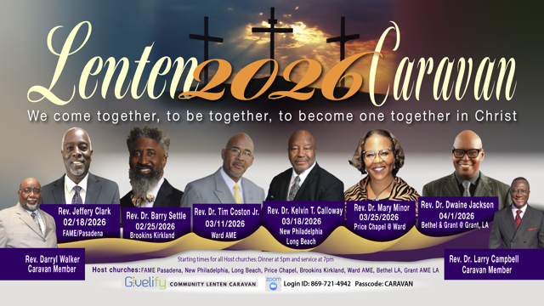

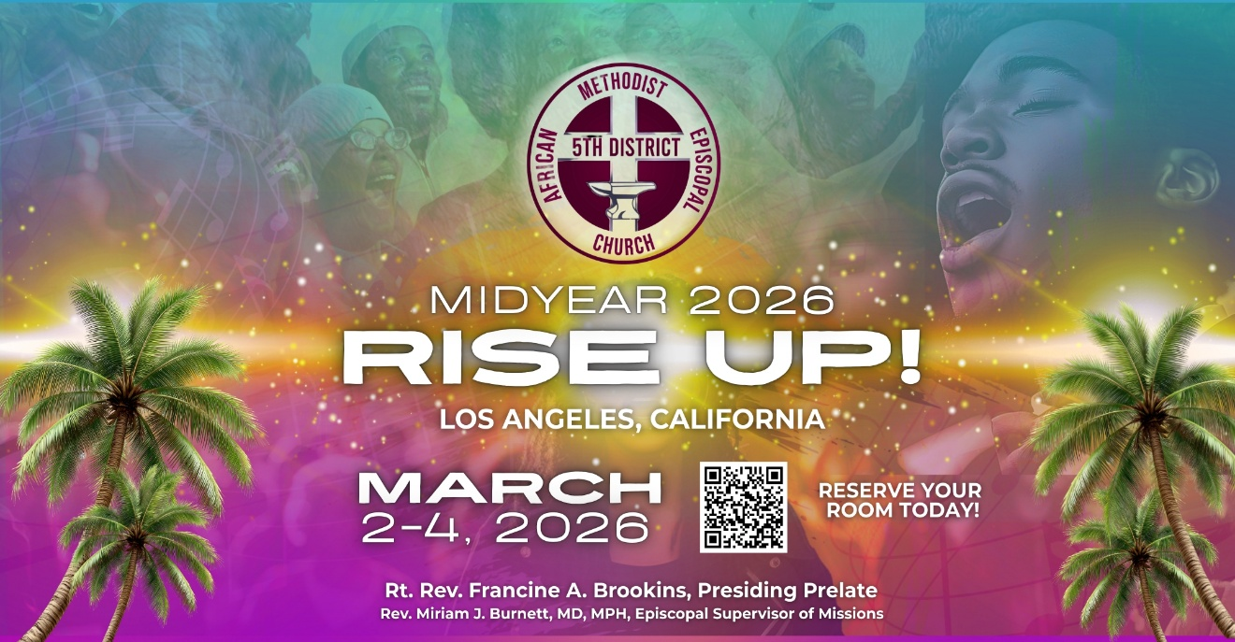

-11-

Stacey Abrams’ 10 Steps to Autocracy

Stacey Abrams has outlined a "10 Steps to Autocracy" framework, heavily influenced by the work of Princeton Professor Kim Scheppele, designed to illustrate how democracies can transition into authoritarian regimes. She launched the "10 Steps Campaign" as a, educational and mobilization effort to help Americans recognize these signs and fight back.

According to Abrams, the following 10 steps describe how this shift occurs:

- Win the last fair election: Using democratic systems to gain power.
- Expand executive power: Consolidating authority and breaking down checks and balances.
- Weaken oversight: Neutralizing the judiciary and making Congress complicit.
- Gut the government: Firing experienced civil servants to undermine government functions.
- Install loyalists: Placing loyalists in charge of agencies like the DOJ, FBI, and Defense.
- Attack the media: Flooding the zone with propaganda and creating an echo chamber, destroying shared truth.
- Scapegoat vulnerable communities: Targeting immigrants, LGBTQ+ people, and people of color.
- Destroy support systems: Undermining institutions like universities, legal aid, and philanthropy.
- Normalize state violence and fear: Using violence and fear to control the narrative.
- End democracy: Rigging rules to ensure the opposition cannot win, preventing peaceful transfers of power.

-12-

Prayer Request(s)
Please notify the Church Office of Sick & Shut-in additions, deletions, or status/address changes.

Bishop Francine A. Brookins, Esq. Supervisor Miriam Burnett, MD
Presiding Elder Roosevelt & Dr. Kaye Lindsey Rev. Dr. Larry & Melinda Campbell
Richard Craig Hazel Clark Erica Woodard Jason Shirley Joshua Shirley Julian Shirley Ayanna Terry Cheryl Jamerson Gwendolyn Flowers Andrea Anderson Ocilda Files Danielle Clark Donita Towler Rev. Charles Brooks Doris Bailey Kimberly Woods Cynithia Grace Zechariah Robinson Diane Jordan Christopher McCarthy Wilma Haynes Jewell Malloy Calle Burns Noel Johnson Brittney Petty Taylor Family Deborah Burton Nettie McChristen Jacquelyn Walker Carita Smith
Rev. Rochelle Moore Lorene Butler Stella Pulliam Collette Blizzard The Caple Family Donita Towler
The Eaton Canyon Fire Victims Selene Cox Mel Beech

College Students

Let’s continue to support and pray for our beloved College Students

Isaiah Crowell Alecia Davis Chase Johnson Grant Blizzard

Tyler Johnson Richard Jones Tyrikk Lawson Makia Rose Talbert Isaiah Ringo Journey Rogers Elyse Sharp Kylee Sharp Zion Otano Elise Tervalon Grace Jones Jordan Patterson Kimberly Robinson Donovan Williams Jasmine Collins Brandon Bates Gabriel Blizzard

Sick and Shut-Ins
Andrew Oliver 1405 N. Roosevelt Avenue. Pasadena, CA 91104
Bettina Ayers Pasadena Meadows Nursing Home, 150 Bellefontaine St., Pas., CA 91105
Bobby Thomas 1052 E. Morada Place, Altadena, CA 91001
Carrie Wynne Senior Living Heritage, 161 N. Hemet St., Hemet, CA 92545
Doris Curd 11619 Woodcock Avenue, San Fernando, CA 91340
Edmund Riddle Active Care Mission Bay, 2440 Grand Avenue, San Diego, CA 92109
Eleanor Towler 975 E. Union Street, Unit #417, Pasadena, CA 91106
Elois Blizzard P. O. Box 3646, So. Pasadena, CA 91031
Emily Cormier-Ross 2549 La Fiesta Avenue, Altadena, CA 91001
Ernestine English 26 W. Fair Oaks Drive, Pasadena, CA 91103
Fred Caple 51 North 15th Street Haledon, NJ 07508
Gloria Cubit Clay 11745 Pierce St., Lake View Terrace, CA 91342
Hugh Hamberry 19225 Chole Rd., Apple Valley, CA 92307
Jeff Thomas 603 Tocino Dr. Duarte, CA 91010 | Mountain View Terrace
Jessie Smith 3925 S Jones BL, Apt 2118 Las Vegas, NV 89103| Spring Valley Community
Josephine Brown 15607 Saddleback Rd, Riverside, CA 92506
Linnie G. Nollie 2250 E. New York Drive, Altadena, CA 91001
Malika G. Hendry P. O. Box 94082, Pasadena, CA 91109
Mildred Lewis C/O Hazel Rohr, 884 W. Jane Court, Upland, CA 91786
Norma Burnett 618 Fairview Avenue, Unit #228, Arcadia, CA 91007
Opal Hampton 1030 Chevron Court, Pasadena, CA 91103
Paul Ratliff P.O. Box 40407 Pasadena, CA 91114
Ruthie Hopkins 1155 Via Verde , San Dimas, CA 91773
Virlyn Grant 15122 Orange Ave., Paramount, CA 90723
Wanda Nelson 3618 N. Fair Oaks Avenue, Altadena, CA 91001
William Hilliard 7504 Wynstone Pl., Fontana, CA 92336
Zell L. Hill 375 Barthe Drive, Pasadena, CA 91103

-13-

Sermon Notations

Scripture: _____________________________________________________________

Subject: _______________________________________________________________

Points of the Message: ___________________________________________________
_______________________________________________________________________
_______________________________________________________________________
_______________________________________________________________________
_______________________________________________________________________
_______________________________________________________________________
_______________________________________________________________________

Main Ideas of the Sermon: ________________________________________________
_______________________________________________________________________
_______________________________________________________________________
_______________________________________________________________________
_______________________________________________________________________
_______________________________________________________________________

Illustrations I want to remember: _________________________________________
_______________________________________________________________________
_______________________________________________________________________
_______________________________________________________________________
_______________________________________________________________________
_______________________________________________________________________
_______________________________________________________________________

What should I do as a result of this Sermon? ________________________________

_____________________________________________________
_____________________________________________________
_____________________________________________________
_____________________________________________________

-14-

