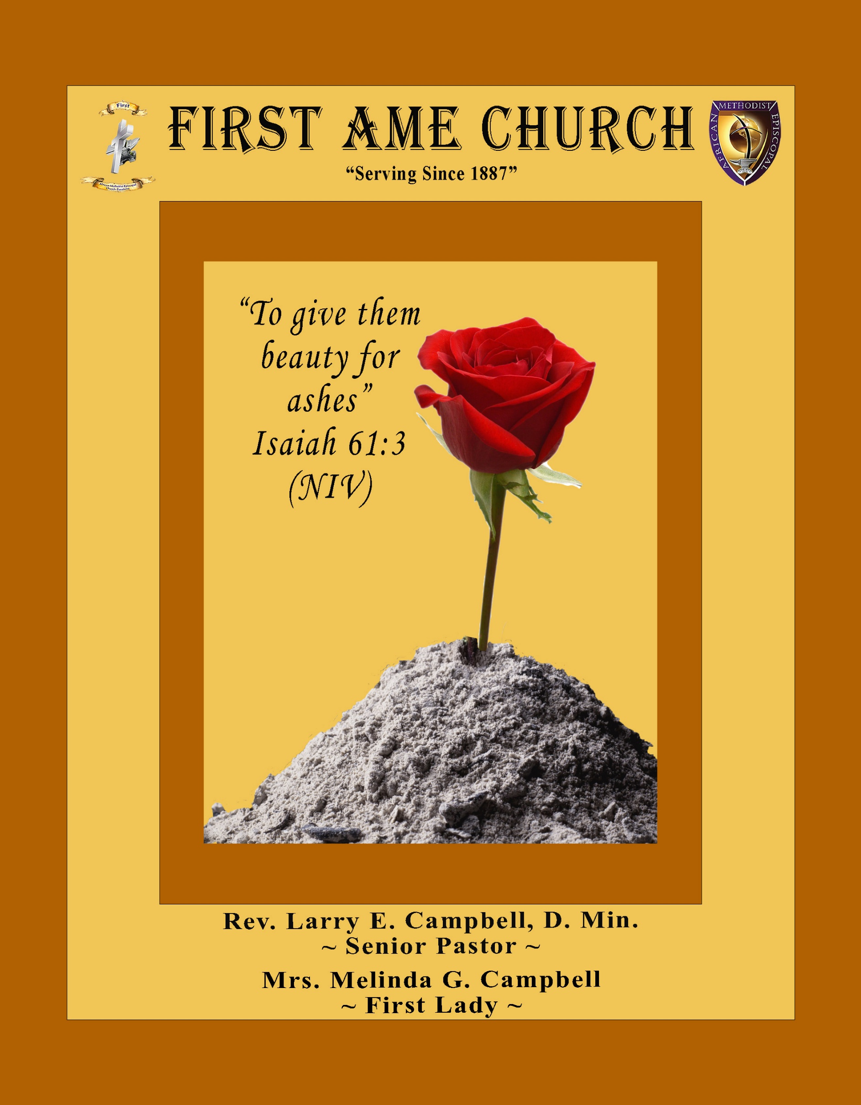
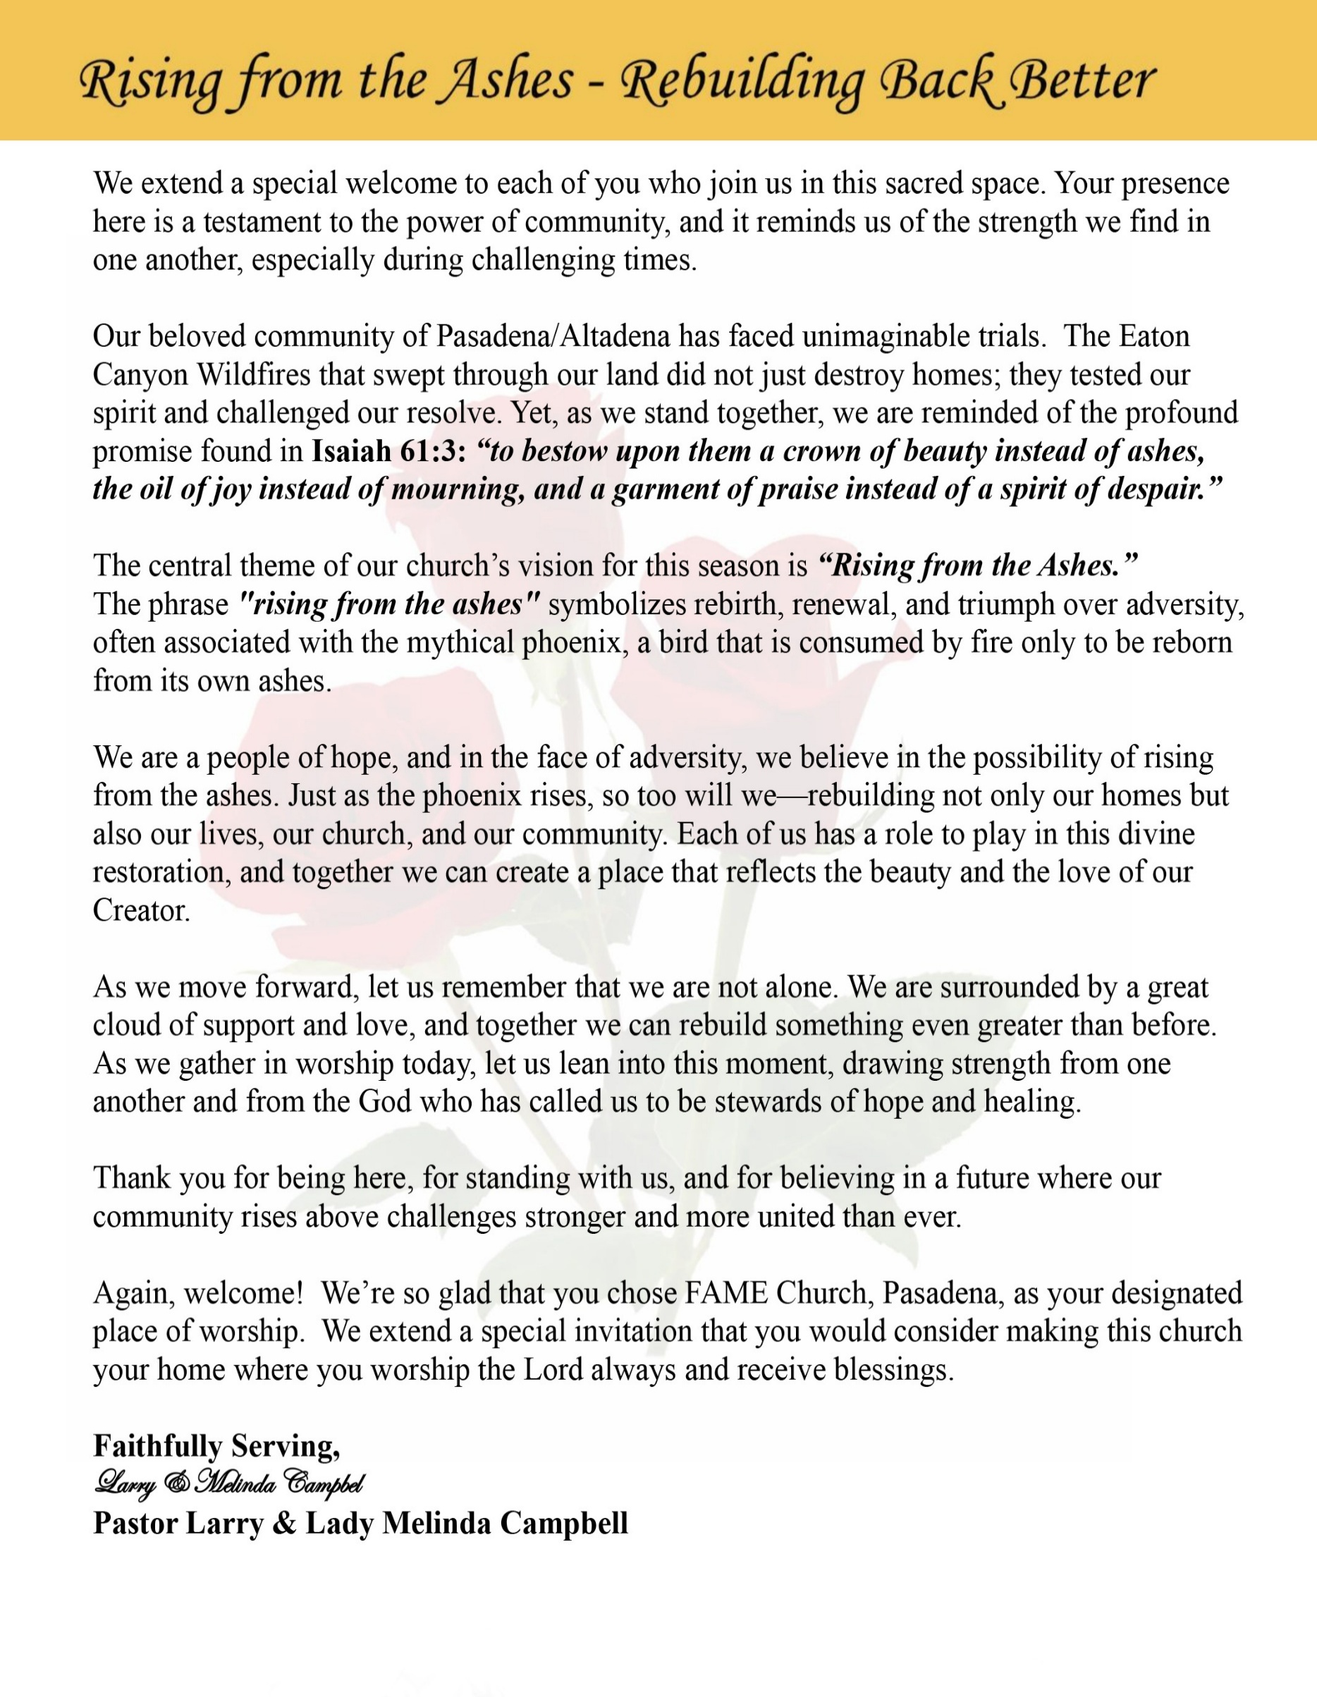

Sunday, February 1, 2026 | 9:30 a.m.

Rt. Rev. Francine A. Brookins, Esq., Presiding Bishop
Rev. Miriam Burnett, MD, MPH, Supervisor of Missions
Rev. Roosevelt Lindsey, Jr. Presiding Elder

The Rev. Dr. Larry E. Campbell ~ Pastor ~ Minister

Mobile: (951) 587-1894 ~ Email: larrycampbell@famepasadena.org

Our First Lady: Mrs. Melinda G. Campbell

The Reverend Dr. Jennifer Oliver ~ Itinerant Elder -
The Reverend Dr. Nikia Smith-Robert ~ Itinerant Elder (Affiliated)
The Reverend Lois Woodard ~ Itinerant Elder Superannuated (Retired)
The Reverend Rochelle Wright Moore ~ Itinerant Deacon
The Reverend Deborah West-Jones ~ Local Elder
The Reverend Philis J. Griffin, MDiv ~ Local Elder
Dr. Phyllis Beech ~ Evangelist

Community Resource Center Director ~ Ms. Kischchen Hazelton Venerable
Church Administrative Assistant: Ms. Letha Rhymes

Church Office Hours:
Tue - Wed 9:00 am - 5:00 pm, & Fri 9:00 am -3:00 pm.
Closed for Lunch Daily: 12:00 pm - 1:00 pm.

Music Ministry
Dr. Timothy Davis, Minister of Music
Bro. Jimmy Watlington, Percussionist ~ Bro. Carlos Caldwell, Organist
Bro. Darien Dorsey, Keyboardist
Sis. Karen Law, Women’s Chorus Director ~ Sis. Tonia Graham, Children’s Choir Director
Bro. J. Renard Washington, New Generation’s Choir

FREE WI-FI service is available on the FAME Campus by accessing FAME 1700
Password: 6267980503

-3-

~ Order of Worship Experience ~

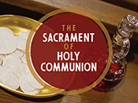

+++ The Altar Call +++
Praise & Worship

Doxology: “Praise God From Whom All Blessings Flow”

The Call to Worship Pastor Larry E. Campbell

Leader: I was glad when they said unto me, let us go into the house of the Lord, our feet shall stand within Thy gates O Jerusalem! (Psalm 122:1)

People: For a day in Thy courts is better than a thousand. I had rather be a doorkeeper in the house of my God than to dwell in the tents of wickedness. (Psalm 84:10)

Leader: Because of the house of the Lord our God, I will seek Thy good.
(Psalm 122:9)

People: Those that be planted in the house of the Lord, shall flourish in the courts of our God. (Psalm 92:13)

Leader: Blessed are they that dwell in Thy house. Lord, I have loved Thy habitation, the place where Thy honor dwelleth. (Psalm 26:8)

People: For the Lord is in His holy temple; let all the earth keep silence before Him.
(Habakkuk 2:20).

Leader: Let the words of my mouth and the meditation of my heart, be acceptable in Thy sight, O Lord my strength and my redeemer. (Psalm 19:14)

Unison: O Sing unto the Lord a new song, for He has done marvelous things. Make a
joyful noise unto the Lord, all the earth, sing His praises. (Psalm 98:1, 4)

-4-

The Hymn of Praise A.M.E. Hymnal #139
Alas! And Did My Savior Bleed
(At the Cross)

(Words: Isaac Watts, 1674-1748)

Alas! And did my Savior bleed, And did my Sovereign die?
Would He devote that sacred head
For sinners such as I?

Refrain

At the cross, at the cross where I first saw the light,
And the burden of my heart rolled away,
It was there by faith I received my sight,
And now I am happy all the day.

Was if for crimes that I had done He groaned upon the tree?
Amazing pity! Grace unknown!
And love beyond degree!

Refrain

Well might the sun in darkness hide, And shut his glories in,
When Christ the mighty Maker died
For man, the creature’s sin.

Refrain

But drops of grief an ne’er repay The debt of love I owe;
Here, Lord, I give my self away;
‘Tis all that I can do.

Refrain

The Invocation Rev. Rochelle Moore

Ministry of Music The Mass Choir

-5-

Holy Communion Responsive Reading 1 Corinthians 11:17–27)
Evangelist Phyllis Beech
Minister: Beloved, when we come together, let us come in unity and reverence before the Lord.
(1 Corinthians 11:17)

People: Lord, make us one body in Christ.

Minister: The Lord’s Table is not a place for division, but for love, justice, and mutual care.
(1 Corinthians 11:20–22)

People: Forgive us, O God, and teach us to discern the body.

Minister: “For I received from the Lord what I also delivered to you: that the Lord Jesus, on
the night He was betrayed, took bread…” (1 Corinthians 11:23)

People: We remember Jesus.

Minister: “This is My body, broken for you. This do in remembrance of Me.”
(1 Corinthians 11:24)

People: We remember His sacrifice.

Minister: “This cup is the new covenant in My blood.” (1 Corinthians 11:25)

People: We receive the promise of new life.

Minister: “For as often as you eat this bread and drink this cup, you proclaim the Lord’s
death till He comes.” (1 Corinthians 11:26)

People: We proclaim Christ—crucified, risen, and coming again.

Minister: Let us examine ourselves and come humbly to the Lord’s Table.
(1 Corinthians 11:27)

All: We come in repentance, faith, and thanksgiving. Amen.

The AFFIRMATION OF FAITH (The Apostle Creed)

Minister: What do you Believe?

People: I believe in God the Father Almighty, Maker of heaven and earth, and in Jesus
Christ His only son our Lord who was conceived by the Holy Spirit, born of the Virgin Mary, suffered under Pontius Pilate, was crucified, dead and buried. The third day he arose from the dead; he ascended into heaven and sitteth at the right hand of God the Father Almighty; from thence he shall come to judge the quick and the dead. I believe in the Holy Spirit, the Church Universal, the communion of saints, the forgiveness of sins, the resurrection of the body and the life
everlasting. Amen.

-6-

THE PRELUDE TO THE DECALOGUE Pastor

“From all that dwell below the skies, Let the Creator’s praise arise;
Let the Redeemer’s name be sung. Through every land, by every tongue.”

THE DECALOGUE (An Affirmation of God’s Law)

Minister: Let us express our commitment to keep God’s Law

People: God of our salvation, only You are God.
We will make no idols.
We will not invoke with malice your name, O God.
We will remember the Sabbath Day and keep it holy.
We will honor our father and our mother.
We will not commit murder.
We will not commit adultery.
We will not steal.
We will not be a false witness.
We will not covet anything that belongs to our neighbor.
Minister: Jesus said: “You shall love the Lord your God with all your heart, and with all your soul and with all your mind. This is the great and first commandment.”

ALL: Jesus also challenged us to love justly with a second commandment
which is like the first. We shall love our neighbor as ourselves! On these
commandments depend all the law and the prophets.

THE GLORIA PATRI
Glory be to the Father, and to the Son, and to the Holy Ghost.
As it was in the beginning, is now and ever shall be, world without end. Amen Amen!!

Abbreviated Announcements/Visitor’s Welcome

From the Desk of the Pastor

-7-

The Offertory (Tithes ~ Gifts ~ Benevolent Offerings) Barbra McPheeters, Steward
The following Electronic GIVING Platforms are creditable methods to GIVE to FAME:

#1. GIVELIFY - Mobile Giving App available on the App Store. It’s easy to set up, just follow the guidelines.

#2. Cash App: $FirstAMEPASADENA

#3. Mail in your Tithes & Offering - If you would like to mail your tithes and offering by check or money order, please send it to: First AME Church, 1700 N. Raymond Avenue, Pasadena, CA 91103.

#4. Drop off your Tithes & Offering - During business hours in the basket outside of the office.

Choral Response: “All things come of Thee, O Lord; and of Thine own have we given Thee. Amen.”

Children’s Church Dismissal

Introduction of Guest Preacher Pastor

Sermonic Selection The Mass Choir

Proclamation of The Word: Rev. Mark K. Tyler, Ph.D.
Executive Director, Department of Research and Scholarship/Historiographer

The Invitation (Public/Private)

How to Join First A.M.E. Church of Pasadena
PROFESSION OF FAITH. If you have never been a member of any church, you may join by professing Jesus Christ as your personal Lord and Savior.

RENEWAL OF VOWS. If you have been a member of a church at one time, but have been in active, you may join by renewing your faith in Jesus Christ as Lord and Savior.

TRANSFER. If you are a member of another African Methodist Episcopal Church and you are in good standing, you may join by requesting that your membership be transferred to the First African Methodist Episcopal Church of Pasadena.

AFFILIATE MEMBER. Sometimes an individual has reasons for keeping /his/her membership in another church but would like to be an active member of First African Methodist Episcopal Church, too. This is possible as an affiliate member. ________________________________________________________________________________________
The Doxology

The Benediction

-8-

The Sacrament of the Lord’s Supper or Holy Communion

THE SOLICITATION

You that do truly and earnestly repent of your sins, and are in love and charity with your neighbor, and intend to lead a new life, following the commandments of God, and walking from henceforth in His holy ways, draw near with faith and take this holy sacrament to your comfort; and make your humble confession to Almighty God.

THE GENERAL CONFESSION

Minister: Let us humbly confess our sins unto Almighty God.

Minister and People:

Almighty God, Father of our Lord Jesus Christ, Maker of all things, Judge of all men, we acknowledge and bewail our manifold sins and wickedness which we from time to time most grievously have committed by thought, word, and deed against Your divine Majesty, provoking most justly Your wrath and indignation against us. We do earnestly repent and are heartily sorry for these, our misdoings; the remembrance of them is grievous unto us. Have mercy upon us, have mercy upon us, most merciful Father for Your Son our Lord Jesus Christ’s sake; forgive us all that is past, and grant that we may ever hereafter serve and please You in newness of life, to the honor and glory of Your name through Jesus Christ our Lord.

Amen. (Choral). (You may be seated).

THE PRAYER OF PARDON

Almighty God, our Heavenly Father, who of Your great mercy has promised forgiveness of sins to all them that with hearty repentance and true faith turn unto You, have mercy upon us; pardon and deliver us from all our sins; confirm and strengthen us in all goodness; and bring us to everlasting life through Jesus Christ, our Lord.

Choral Response: Amen.

THE PRAYER OF CONSECRATION

Minister: Almighty God, our Heavenly Father, who for your tender mercy did give your only Son, Jesus Christ, to suffer death on the cross for our redemption, who made thereby his own oblation of himself, once offered; a full, perfect and sufficient sacrifice, oblation, and satisfaction for the sins of the whole world; and did institute and in his holy gospel command us to continue a perpetual memory of that, his precious death, until his coming again.

Hear us, O merciful Father, we most humbly beseech you, and grant that receiving these your creatures of bread and wine, according to your Son, our Savior Jesus Christ’s holy institution, in remembrance of his death and passion, may be partakers of his most blessed body and blood: who in the same night that He was betrayed took bread and when He had given thanks, He broke it, and gave it to His disciples, and saying, “Take, eat: This is My body which is given for you. This do in remembrance of Me.” Likewise, after the supper, He took the cup; and when He had given thanks, He gave it to them and said, “Drink this, all of you; for this is My blood of the New Testament, which is shed for you and many for the remission of sins. Do this, as often as you drink it, in remembrance of Me.”

THE LORD’S PRAYER (ALL)

THE ELEMENTS SHARED

-9-

ANNOUNCEMENTS

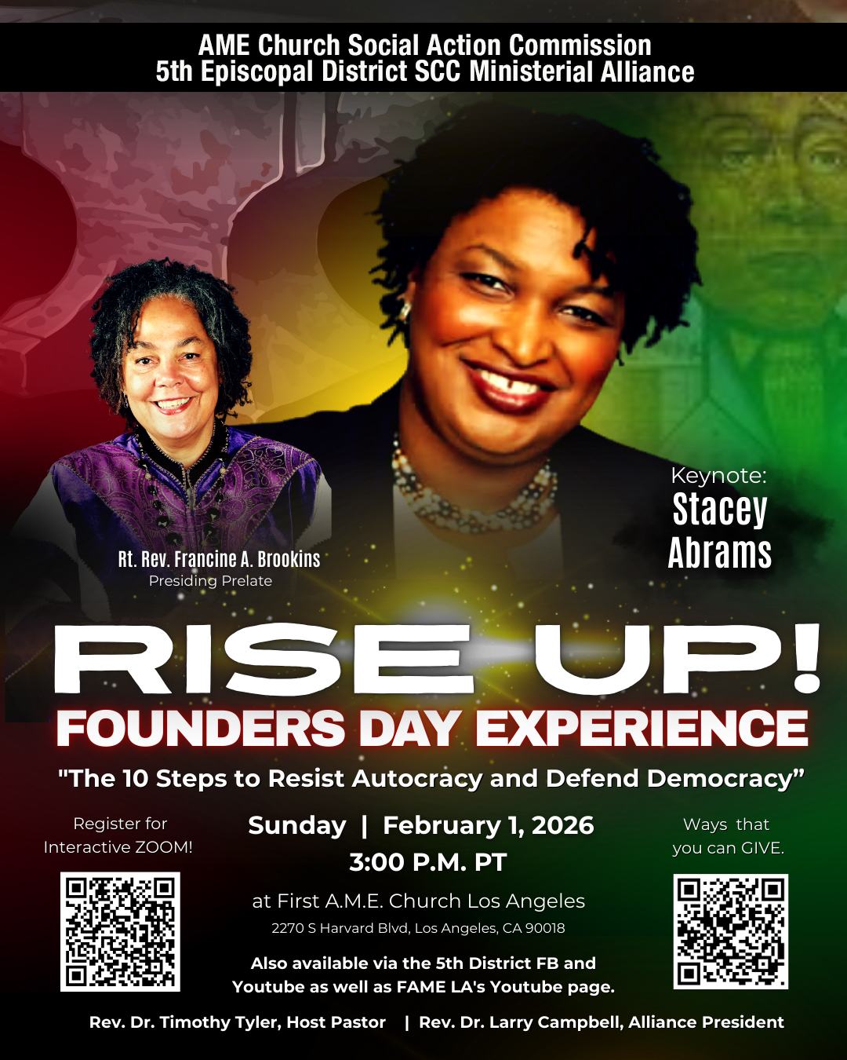

WELCOME! WELCOME! WELCOME! It is with great pleasure and joy that we officially welcome Deaconess Tessie Bonner, Sis. Dana Howard and Bro. Edwin Koltz to the FAME Family kinship. We are truly blessed and very grateful for their presence and valued membership in our church family.

Men's Ministry - BIBLE STUDY
Time: Tuesday, February 3, 2026 | 6:00 p.m.
Meeting ID: 894 7536 6487; Passcode: 465177
One tap mobile: +16699006833,,89475366487#,,,,*465177# US (San Jose)

Women's Ministry - BIBLE STUDY
Time: Tuesday, February 3, 2026 | 6:00 p.m.
Meeting ID: 857 0061 9461; Passcode: 933892
One tap mobile +16699006833,,85700619461#,,,,,,0#,,933892# US (San Jose)

-10-

ANNOUNCEMENTS (Continued)

Senior Ministry In-Person Gathering
Tuesday, February 10, 2026 | 11:30 a.m.
Church Fellowship Hall

20/20 (14.0)
The 20/20 initiative is a Church-wide fundraising project managed by the Stewards. This project was established to assist with our Annual Connectional Budget. Financial gifts donated through the 20/20 initiative are added to our collected conference claims and assist greatly in meeting the first and second half of our Connectional Budgetary obligations. The Steward Board is requesting 150 participants for the conference year 2025-2026. The first half of our budget is due in February 2026. In addition to the 18 officers and we are asking 132 people to give 20 dollars per week for 20 weeks in addition to your regular tithes, gifts and offerings. Please mark your envelopes 20/20 and allocate $20.00. Our goal is to raise $60,000. Again, this will satisfy all budgetary needs on the conference level without utilizing any operational funds. Please see or contact any Steward to participate; we are looking forward to your commitment.

Annual Lenten Caravan
The FAME Pasadena Church Family will be participating in the upcoming 2026 Annual Lenten Caravan. The Lenten Caravan is a voluntary collaboration of churches of like-minded pastors to bring their congregations together during the Lenten season for worship and fellowship. As the motto says, “We come together, to be together, to become one together in Christ”. PLEASE JOIN US FOR DINNER FROM 5:00 pm - 6:45 pm, followed by worship. The schedule of participating churches and worship services is listed below.:
February 18 | Host Church: FAME Pasadena Preacher: Rev. Jeffery Clark
February 25 | Host Church: Brookins/Kirkland Preacher: Rev. Dr. Barry Settle
March 11 | Host Church: Ward A.M.E.  Preacher: Rev. Dr. Timothy O Coston, Jr.
March 18 | Host Church: New Philadelphia Preacher: Rev. Dr. Kelvin T. Calloway
March 25 | Host Church: Price Chapel @ Ward A.M.E. Preacher: Rev. Dr. Mary S. Minor
April 1 | Host Church: Bethel at Grant A.M.E. Church, Los Angeles Preacher: Rev. Dr. Dwaine Jackson
April 3 | Good Friday Service

-11-

Scripture of the Day
Lord’s Supper. “Take, eat; this is my body... Drink of it, all of you, for this is my blood of the covenant, which is poured out for many for the forgiveness of sins”.
Matthew 26:26-28

Quote of the Day
“At the table of communion, there are no outsiders. All who hunger for life are welcome, and all who thirst for meaning are invited.” James H. Cone

Thought of the Week
The Lord’s Table
The Lord’s Table has always been a place of hope for our people.
We come remembering a Savior who was broken, yet never defeated.
The bread reminds us that Jesus knows our pain.
The cup tells us that suffering does not have the final word.
At this table, all are equal, all are welcome, and all are loved.
Here, God affirms our worth and renews our strength for the journey.
As we eat the bread and drink the cup,
we remember Christ, we proclaim hope,
and we rise committed to live as resurrection people.

Humor of the Week
A young boy enters a barbershop and the barber whispers to his customer, "This is the dumbest kid in the world. Watch while I prove it to you."
The barber puts a dollar bill in one hand and two quarters in the other, then calls the boy over and asks, "Which do you want, son?"
The boy takes the quarters and leaves.
"What did I tell you?" said the barber. "That kid never learns!"
Later, when the customer leaves, he sees the same young boy coming out of the ice cream store. "Hey, son! May I ask you a question? Why did you take the quarters instead of the dollar bill?"
The boy licked his cone and replied, "Because the day I take the dollar, the game's over!"
HOME DAILY BIBLE READINGS
February 2, 2026 – February 8, 2026 (Week 20, Daniel)
Monday Day 134 Nehemiah 12-13, Psalm 55:15-19
Tuesday Day 135 Ester 1-5, Psalm 55:20-23
Wednesday Day 136 Ester 6-10, Psalm 56:1-7
Thursday Day 137 Job 1-4, Psalm 56:8-13
Friday Day 138 Job 5-7, Psalm 57:1-6
Saturday Day 139 Job 8-10, Psalm 57:7-11
Sunday Day 140 Job 11-13, Psalm 58:1-5

-12-

Prayer Request(s)
Please notify the Church Office of Sick & Shut-in additions, deletions, or status/address changes.

Bishop Francine A. Brookins, Esq. Supervisor Miriam Burnett, MD
Presiding Elder Roosevelt & Dr. Kaye Lindsey Rev. Dr. Larry & Melinda Campbell
Richard Craig Hazel Clark Erica Woodard Jason Shirley Joshua Shirley Julian Shirley Ayanna Terry Cheryl Jamerson Gwendolyn Flowers Andrea Anderson Ocilda Files Danielle Clark Donita Towler Rev. Charles Brooks Doris Bailey Kimberly Woods Cynithia Grace Zechariah Robinson Diane Jordan Christopher McCarthy Wilma Haynes Jewell Malloy Calle Burns Noel Johnson Brittney Petty Taylor Family Deborah Burton Nettie McChristen Jacquelyn Walker Selene Cox
Rev. Rochelle Moore Lorene Butler Stella Pulliam Colette Blizzard Carita Smith Joyce Johnson The Eaton Canyon Fire Victims The Caple Family Barbra McPheeter

College Students

Let’s continue to support and pray for our beloved College Students

Isaiah Crowell Alecia Davis Jade Williams Chase Johnson Grant Blizzard

Tyler Johnson Richard Jones Tyrikk Lawson Makia Rose Talbert Isaiah Ringo Journey Rogers Elyse Sharp Kylee Sharp Zion Otano Elise Tervalon Grace Jones Jordan Patterson Kimberly Robinson Donovan Williams Jasmine Collins Brandon Bates Gabriel Blizzard

Sick and Shut-Ins
Andrew Oliver 1405 N. Roosevelt Avenue. Pasadena, CA 91104
Bettina Ayers Pasadena Meadows Nursing Home, 150 Bellefontaine St., Pas., CA 91105
Bobby Thomas 1052 E. Morada Place, Altadena, CA 91001
Carrie Wynne Senior Living Heritage, 161 N. Hemet St., Hemet, CA 92545
Doris Curd 11619 Woodcock Avenue, San Fernando, CA 91340
Edmund Riddle Active Care Mission Bay, 2440 Grand Avenue, San Diego, CA 92109
Eleanor Towler 975 E. Union Street, Unit #417, Pasadena, CA 91106
Elois Blizzard P. O. Box 3646, So. Pasadena, CA 91031
Emily Cormier-Ross 2549 La Fiesta Avenue, Altadena, CA 91001
Ernestine English 26 W. Fair Oaks Drive, Pasadena, CA 91103
Fred Caple 51 North 15th Street Haledon, NJ 07508
Gloria Cubit Clay 11745 Pierce St., Lake View Terrace, CA 91342
Hugh Hamberry 19225 Chole Rd., Apple Valley, CA 92307
Jackie Johnson 641 W. Mariposa, Altadena, CA 91101
Josephine Brown 15607 Saddleback Rd, Riverside, CA 92506
Jessie Smith 7980 Mayten Avenue, Apt 3050 Rancho Cucamonga, CA 91730-8113
Linnie G. Nollie 2250 E. New York Drive, Altadena, CA 91001
Malika G. Hendry P. O. Box 94082, Pasadena, CA 91109
Mildred Lewis C/O Hazel Rohr, 884 W. Jane Court, Upland, CA 91786
Norma Burnett 618 Fairview Avenue, Unit #228, Arcadia, CA 91007
Opal Hampton 1030 Chevron Court, Pasadena, CA 91103
Paul Ratliff P.O. Box 40407 Pasadena, CA 91114
Ruthie Hopkins 1155 Via Verde , San Dimas, CA 91773
Virlyn Grant 15122 Orange Ave., Paramount, CA 90723
Wanda Nelson 3618 N. Fair Oaks Avenue, Altadena, CA 91001
William Hilliard 7504 Wynstone Pl., Fontana, CA 92336
Zell L. Hill 375 Barthe Drive, Pasadena, CA 91103

-13-

Sermon Notations

Scripture: _____________________________________________________________

Subject: _______________________________________________________________

Points of the Message: ___________________________________________________
_______________________________________________________________________
_______________________________________________________________________
_______________________________________________________________________
_______________________________________________________________________
_______________________________________________________________________
_______________________________________________________________________

Main Ideas of the Sermon: ________________________________________________
_______________________________________________________________________
_______________________________________________________________________
_______________________________________________________________________
_______________________________________________________________________
_______________________________________________________________________

Illustrations I want to remember: _________________________________________
_______________________________________________________________________
_______________________________________________________________________
_______________________________________________________________________
_______________________________________________________________________
_______________________________________________________________________
_______________________________________________________________________

What should I do as a result of this Sermon? ________________________________

_____________________________________________________
_____________________________________________________
_____________________________________________________
_____________________________________________________

-14-

