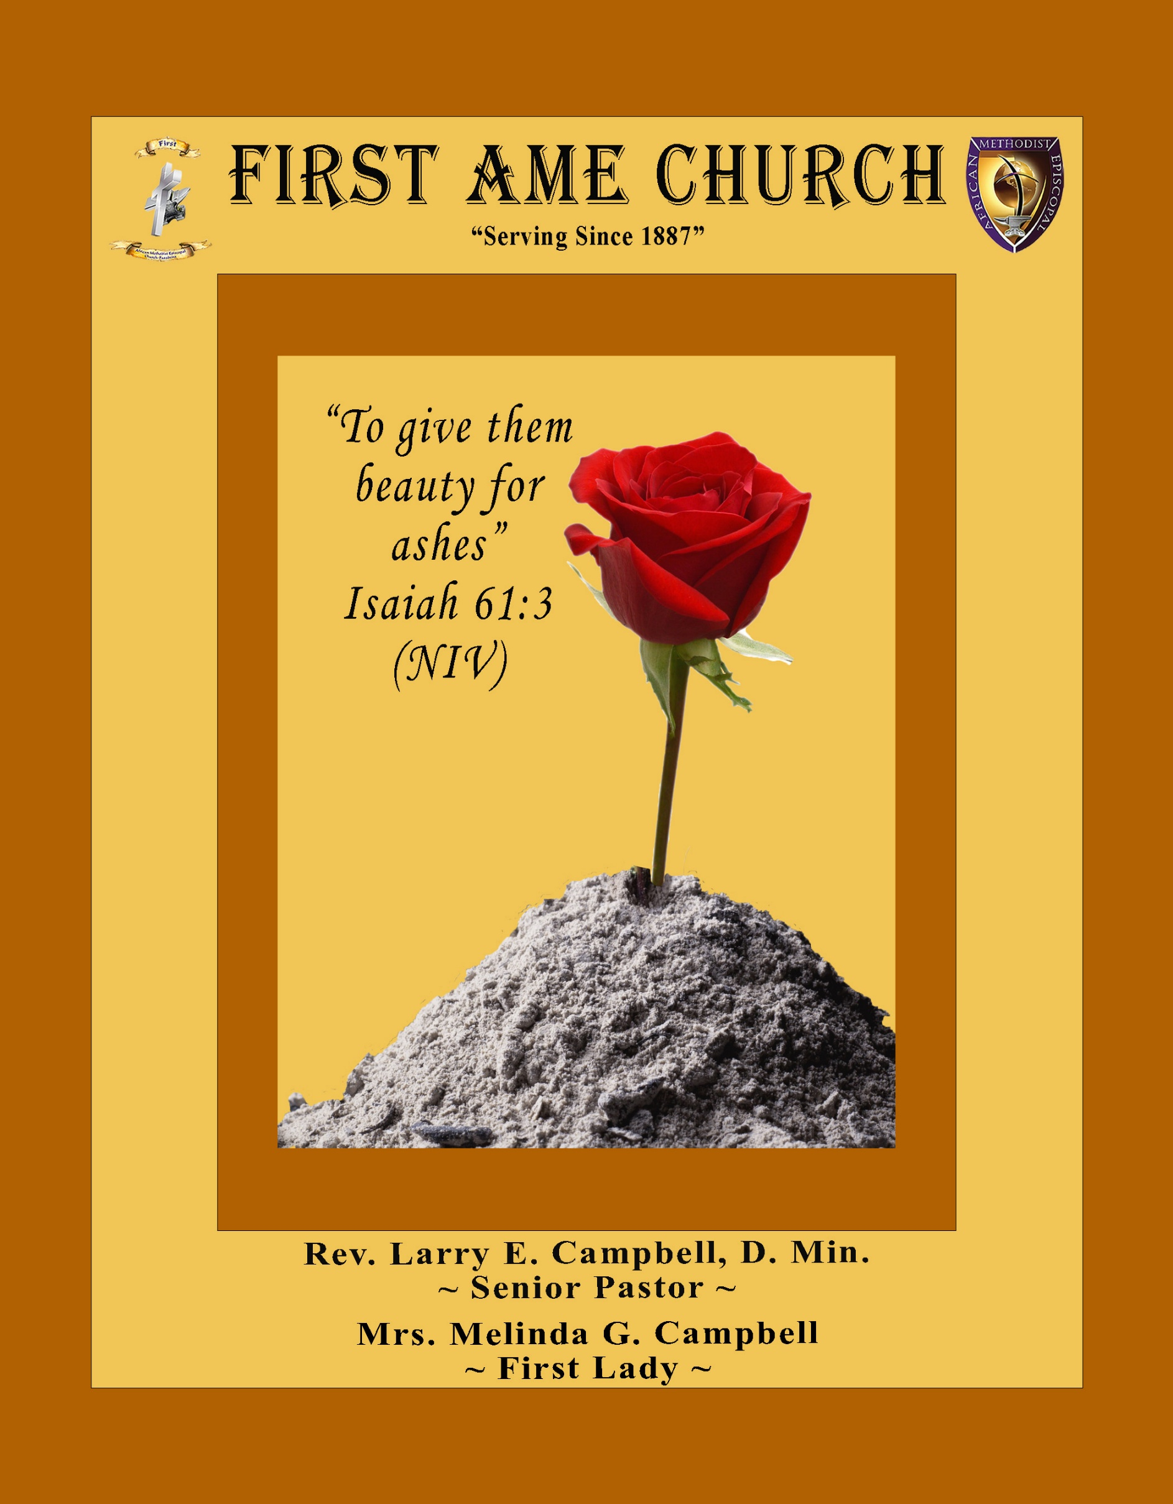
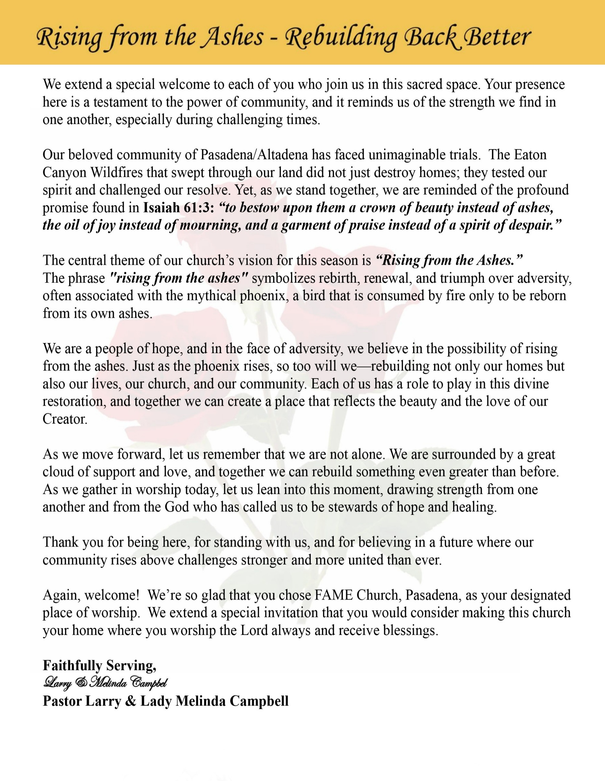

Sunday, February 22 2026 | 9:30 a.m.

Rt. Rev. Francine A. Brookins, Esq., Presiding Bishop
Rev. Miriam Burnett, MD, MPH, Supervisor of Missions
Rev. Roosevelt Lindsey, Jr. Presiding Elder

The Rev. Dr. Larry E. Campbell ~ Senior Pastor ~ Minister

Mobile: (951) 587-1894 ~ Email: larrycampbell@famepasadena.org

Our First Lady: Mrs. Melinda G. Campbell

The Reverend Dr. Jennifer Oliver ~ Itinerant Elder -
The Reverend Dr. Nikia Smith-Robert ~ Itinerant Elder (Affiliated)
The Reverend Lois Woodard ~ Itinerant Elder Superannuated (Retired)
The Reverend Rochelle Wright Moore ~ Itinerant Deacon
The Reverend Deborah West-Jones ~ Local Elder
The Reverend Philis J. Griffin, MDiv ~ Local Elder
Dr. Phyllis Beech ~ Evangelist
Sister Tessie Bonner ~ Deaconess

Community Resource Center Director ~ Ms. Kischchen Hazelton Venerable
Church Administrative Assistant: Ms. Letha Rhymes

Church Office Hours:
Tue - Wed 9:00 am - 5:00 pm, & Fri 9:00 am -3:00 pm.
Closed for Lunch Daily: 12:00 pm - 1:00 pm.

Music Ministry
Dr. Timothy Davis, Minister of Music
Bro. Jimmy Watlington, Percussionist ~ Bro. Carlos Caldwell, Organist
Bro. Darien Dorsey, Keyboardist
Sis. Karen Law, Women’s Chorus Director ~ Sis. Tonia Graham, Children’s Choir Director
Bro. J. Renard Washington, New Generation’s Choir

FREE WI-FI service is available on the FAME Campus by accessing FAME 1700
Password: 6267980503

-3-

~ Order of Worship Experience ~
Warning: This order of worship is subject to change without warning or prior notice --- everything is governed by the Sovereignty of the Holy Spirit.



+ + + The Altar Call +++
Praise & Worship

Doxology: “Praise God From Whom All Blessings Flow”

The Call to Worship Bro. Todd Skinner
Leader: I was glad when they said unto me, let us go into the house of the Lord, our feet shall stand within Thy gates O Jerusalem! (Psalm 122:1)

People: For a day in Thy courts is better than a thousand. I had rather be a doorkeeper in the house of my God than to dwell in the tents of wickedness. (Psalm 84:10)

Leader: Because of the house of the Lord our God, I will seek Thy good.
(Psalm 122:9)

People: Those that be planted in the house of the Lord, shall flourish in the courts of our God. (Psalm 92:13)

Leader: Blessed are they that dwell in Thy house. Lord, I have loved Thy habitation, the place where Thy honor dwelleth. (Psalm 26:8)

People: For the Lord is in His holy temple; let all the earth keep silence before Him.
(Habakkuk 2:20)

Leader: Let the words of my mouth and the meditation of my heart, be acceptable in Thy sight, O Lord my strength and my redeemer. (Psalm 19:14)

Unison: O Sing unto the Lord a new song, for He has done marvelous things. Make a
joyful noise unto the Lord, all the earth, sing His praises. (Psalm 98:1, 4)

-4-

The Hymn of Praise A.M.E. Hymnal #571

Lift Every Voice and Sing

James Weldon Johnson, 1871-1938

Lift every voice and sing, Till earth and heaven ring,
Ring with the harmonies of liberty;
Let our rejoicing rise High as the listening skies,
Let it resound loud as the rolling sea,
Sing a song full of the faith that the dark past had taught us,
Sing s song full of the hope that the present has brought us;
Facing the rising sun Of our new day begun,
Let us march on till victory is won.

Stony the road we trod, Bitter the chastening rod,
Felt in the days when hope unborn had died;
Yet with a steady beat, Have not our weary feet
Come to the place for which our fathers sighed?
We have come over a way that with tears has been watered,
We have come, treading our path through the blood of the slaughtered;
Out from the gloomy past, Till now we stand at last
Where the white gleam of our bright star is cast.

God of our weary years, God of our silent tears,
Thou who hast brought us thus far on the way;
Thou who hast by Thy might, Led us into the light,
Keep us forever in the path, we pray.
Lest our feet stray from the places, our God, where we met Thee,
Lest our hearts, drunk with the wine of the world, we forget Thee;
Shadowed beneath Thy hand, May we forever stand,
True to our God, True to our native land.

The Invocation Bro. Kenny McPheeters

Ministry of Music The Male Chorus

-5-

Black History Litany --- Using Exodus 16:1-18 Bro. Emerson Sharpe
(Please Stand for the Reading of God’s Words)
Leader: “The whole congregation set out into the wilderness.” Even in unfamiliar places,
God walks with the people.

People: God of our journeys, guide us through every wilderness season.

Leader: “The people complained against Moses and Aaron.” In hunger and uncertainty,
their voices cried out.

People: In our history of struggle, we too have cried out—And You heard us.

Leader: “Then the Lord said, I will rain bread from heaven for you.”

People: Provider God, You have sustained us from generation to generation.

Leader: Morning by morning the manna appeared, enough for each household to gather.

People: Thank You for daily bread— For strength, resilience, and hope renewed
each day.

Leader: “Gather as much as each of you needs.”

People: Teach us to trust Your provision and not live in fear of scarcity.

Leader: Some gathered much, some gathered little, yet all had enough.

People: Shape us into a community of justice, where no one is left in want.

Leader: The wilderness became a classroom of trust, and provision became a testimony.

People: Through deserts of oppression and seasons of change, you have been our
sustainer.

Leader: God of manna and mercy, help us remember Your faithfulness.

People: Until all are fed and dignity flourishes, we will trust, share, and give thanks.

Leader: Behold, God is our salvation; we will trust, and will not be afraid; for the
Lord God is our strength and our song, and He has become our salvation.

ALL: Faithful God, as You nourished Your people in the wilderness, nourish us
with courage, unity, and hope— Today and always. Amen.

-6-

The Summary of the Decalogue Bro. Rodney D. Wallace
LEADER: From all that dwell below the skies…
SUNG: From all that dwell below the skies, Let the Creator’s praise arise; Let the
Redeemer’s Name be sung, through every land, by every tongue.
LEADER: Hear what Christ our Savior saith, Thou shalt love the Lord thy God with all thy
heart, with all thy soul, and with all thy mind. This is the first and great
commandment. And the second is like unto it: Thou shalt love thy neighbor
as thyself. On these two commandments hang all the law and the prophets.
SUNG: Glory be to the Father, and to the Son, and to the Holy Ghost; as it was in
the beginning is now, and ever shall be, world without end. A~Men


Abbreviated Announcements/Black History Moments: Visitor’s Welcome Dr. Brian K. Venerable

The Children’s Praise Dance Ministry The Roses of Worship


Special Congregational Hymn (Sing along)
I Will Trust in the Lord
1 I will trust in the Lord, I will trust in the Lord, I will trust in the Lord till I die.
I will trust in the Lord, I will trust in the Lord, I will trust in the Lord till I die.

2 I'm gonna treat ev'rybody right, I'm gonna treat ev'rybody right,
I'm gonna treat ev'rybody right till I die.
I'm gonna treat ev'rybody right, I'm gonna treat ev'rybody right,
I'm gonna treat ev'rybody right till I die.

3 I'm gonna stay on the battlefield, I'm gonna stay on the battlefield,
I'm gonna stay on the battlefield till I die.
I'm gonna stay on the battlefield, I'm gonna stay on the battlefield,
I'm gonna stay on on the battlefield till I die.

4 I'm gonna stay on bended knee, I'm gonna stay on bended knee,
I'm gonna stay on bended knee till I die.
I'm gonna stay on bended knee, I'm gonna stay on bended knee,
I'm gonna stay on bended knee till I die.

-7-

The Offertory (Tithes ~ Gifts ~ Benevolent Offerings) Bro. Bill Matlock

The following Electronic GIVING Platforms are creditable methods to GIVE to FAME:

#1. GIVELIFY - Mobile Giving App available on the App Store. It’s easy to set up, just follow the guidelines.

#2. Cash App: $FirstAMEPASADENA

#3. Mail in your Tithes & Offering - If you would like to mail your tithes and offering by check or money order, please send it to: First AME Church, 1700 N. Raymond Avenue, Pasadena, CA 91103.

#4. Drop off your Tithes & Offering - During business hours in the basket outside of the office.

Choral Response: “All things come of Thee, O Lord; and of Thine own have we given Thee. Amen.”

Children’s Church Dismissal

Sermonic Selection The Male Chorus

Proclamation of The Word Pastor Larry E. Campbell

The Invitation (Public/Private)

How to Join First A.M.E. Church of Pasadena
PROFESSION OF FAITH. If you have never been a member of any church, you may join by professing Jesus Christ as your personal Lord and Savior.

RENEWAL OF VOWS. If you have been a member of a church at one time, but have been in active, you may join by renewing your faith in Jesus Christ as Lord and Savior.

TRANSFER. If you are a member of another African Methodist Episcopal Church and you are in good standing, you may join by requesting that your membership be transferred to the First African Methodist Episcopal Church of Pasadena.

AFFILIATE MEMBER. Sometimes an individual has reasons for keeping /his/her membership in another church but would like to be an active member of First African Methodist Episcopal Church, too. This is possible as an affiliate member. _______________________________________________________________________________

The Doxology

The Benediction

-8-

Scripture of the Day
Trusting God. “Some trust in chariots and some in horses, but we trust in the name of the Lord our God. - Psalm 20:7

Quote of the Day
“It wasn't me; it was the Lord! I always told Him, 'I trust to you. I do not know where to go or what to do, but I expect You to lead me,' and He always did".” Harriet Tubman

Thought of the Week
Scripture: “Those who wait for the Lord shall renew their strength; they shall mount up with wings like eagles, they shall run and not be weary, they shall walk and not faint.” — Isaiah 40:31
Trusting God often means waiting with hope, believing that renewal is coming even when the journey feels long. This promise has echoed through the Black experience — a reminder that God sustains us with strength beyond our own.
Educator and leader Mary McLeod Bethune trusted God’s provision as she founded schools and advocated for opportunity, often with limited resources but limitless faith. Her life shows us that trusting God empowers us to build, serve, and persevere.
As we honor the legacy of faith in action, may we trust that God is renewing our strength today — giving us courage for the work ahead and hope for the future.
Prayer:
Renewing God, lift our spirits when we grow weary. Help us trust Your timing, rely on Your strength, and move forward with faith. Amen.
Humor of the Week
The Minister of a local church was an avid golfer. Wouldn’t you know every weekday when he might be able to go golfing, it was rainy and every Sunday was a wonderful sunny day. This went on for weeks-on-end! Finally, another Sunday came along and it was a fabulous sunny day again. He could wait no longer and lied and called in sick and said he could not give the sermon that Sunday. He immediately threw his clubs in the car and went to a golf course out of town so he would not be recognized.
Meanwhile St. Peter and God are observing this from heaven. St. Peter is just outraged, and he asks God what he will be doing about a man of the “cloth” lying and deceiving his congregation. God said “He will be punished.”
The minister continued to play and on his next hole he got a hole-in-one!!!! The minister was jumping up and down with joy about his most likely once-in-a-lifetime experience. St Peter looked at God in shock. He said “Dear Lord you said he would be punished and you gave him a hole-in-one!!
God spoke calmly and stated with resolve, “Just let him try to tell anybody he knows about it!!”

HOME DAILY BIBLE READINGS
February 23, 2026 – March 1, 2026 (Week 23, Amos)
Monday Day 155 Isaiah 18-22, Psalm 65:9-13
Tuesday Day 156 Isaiah 23-27, Psalm 66:1-4
Wednesday Day 157 Isaiah 28-30, Psalm 66:5-12
Thursday Day 158 Isaiah 31-35, Psalm 66:13-20
Friday Day 159 Isaiah 36-41, Psalm 67
Saturday Day 160 Isaiah 42-44, Psalm 68:1-6
Sunday Day 161 Isaiah 45-48, Psalm 68:7-1

-9-

ANNOUNCEMENTS

Everyone is encouraged to join our weekly Christian Education Sessions

VIRTUAL ADULT CHURCH SCHOOL
Sunday Mornings at 8:00 a.m.
http://us02web.zoom.us/j/844840183?pwd-sm0w1yvmvhOvC13175urZ2vr7M3EtU.1

HYBRID PASTOR’S WEEKLY BIBLE STUDY
Wednesdays at 11:00 a.m.
https://us02web.zoom.us/j/84484840183?pwd=sm0w1yvmvhOvC13l75urZ2vr7M3EtU.1
Meeting ID: 844 8484 0183 | Passcode: 357260

WEEKLY TELECONFERENCE PRAYERS SESSIONS
Wednesdays at 5:30 a.m. and 6:00 p.m.
Conference Call Number: (530_ 881-1212
Access Code: 234575160#

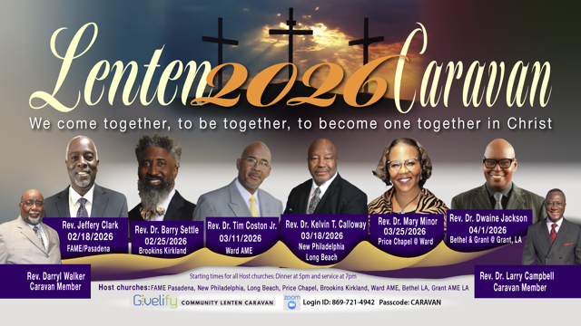

-10-

ANNOUNCEMENTS (Continued)

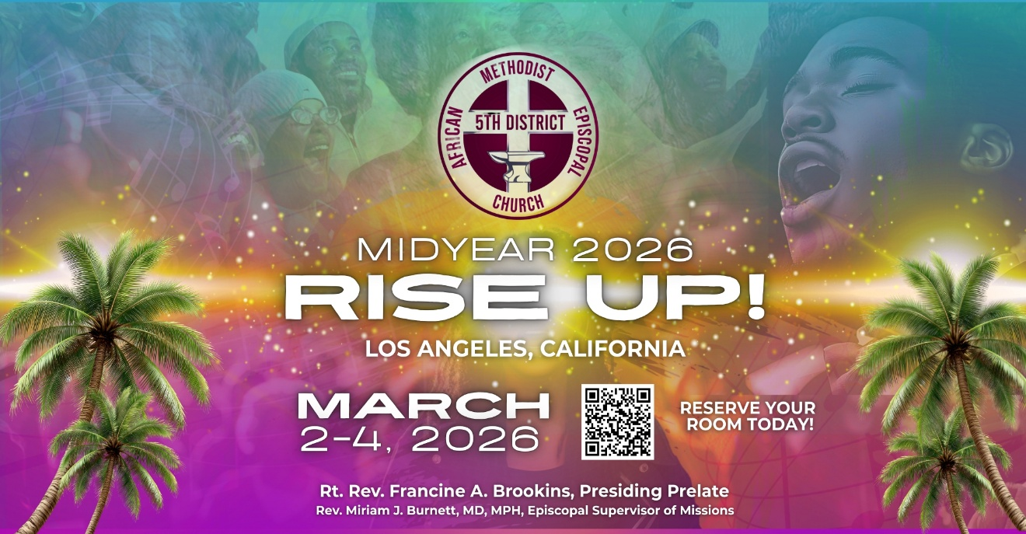

Men's Ministry - BIBLE STUDY
Time: Tuesday, MARCH 10, 2026 | 6:00 p.m.
Meeting ID: 894 7536 6487
Passcode: 465177
One tap mobile: +16699006833,,89475366487#,,,,*465177# US (San Jose)

Women's Ministry – BIBLE STUDY
Time: Tuesday– MARCH 10, 2026 | 6:00 p.m.
Meeting ID: 857 0061 9461; Passcode: 933892
One tap mobile +16699006833,,85700619461#,,,,,,0#,,933892# US (San Jose)

FIRST A.M.E. CHURCH — “Feed My Sheep” FOOD PANTRY
OPEN EVERY SECOND AND FOURTH FRIDAY
9:00 A.M. — 11:00 A.M.
Please consider making a financial donation in support of our Food Pantry

-11-

ANNOUNCEMENTS (Continued)

20/20 (14.0)
The 20/20 initiative is a Church-wide fundraising project managed by the Stewards. This project was established to assist with our Annual Connectional Budget. Financial gifts donated through the 20/20 initiative are added to our collected conference claims and assist greatly in meeting the first and second half of our Connectional Budgetary obligations. The Steward Board is requesting 150 participants for the conference year 2025-2026. The first half of our budget is due in February 2026. In addition to the 18 officers and we are asking 132 people to give 20 dollars per week for 20 weeks in addition to your regular tithes, gifts and offerings. Please mark your envelopes 20/20 and allocate $20.00. Our goal is to raise $60,000. Again, this will satisfy all budgetary needs on the conference level without utilizing any operational funds. Please see or contact any Steward to participate; we are looking forward to your commitment.

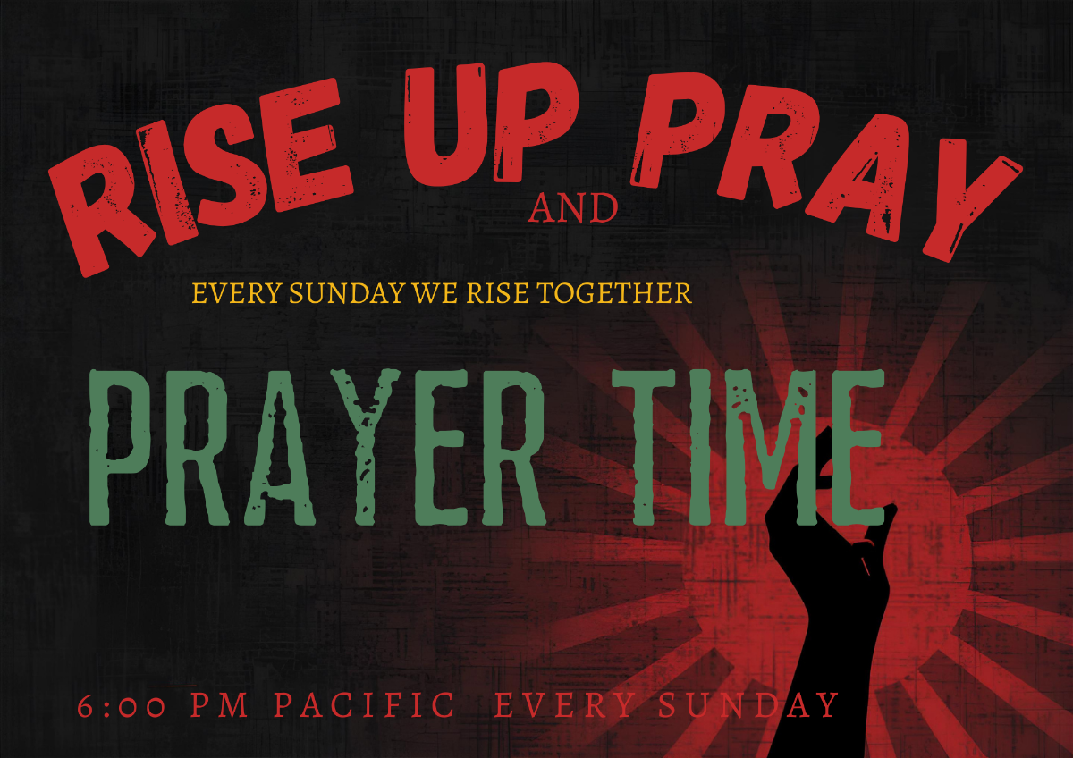
Rise Up and Pray!
Sundays · 6:00–6:30 PM Pacific
Beloved 5th District Family,
It's getting hot around the 5th District altar. There is evidence that God is hearing our prayers. Come on in the room tonight and join us as we Rise Up and Pray together.
The Southern California Annual Conference will be leading for the month of March
Meeting ID 817 7575 8872,
Password - Music
You may also follow this link: Launch Meeting - Zoom
Prayer changes things! Prayer changes us! God is change.

-12-

Prayer Request(s)
Please notify the Church Office of Sick & Shut-in additions, deletions, or status/address changes.

Bishop Francine A. Brookins, Esq. Supervisor Miriam Burnett, MD
Presiding Elder Roosevelt & Dr. Kaye Lindsey Rev. Dr. Larry & Melinda Campbell
Richard Craig Hazel Clark Erica Woodard Jason Shirley Joshua Shirley Julian Shirley Ayanna Terry Cheryl Jamerson Gwendolyn Flowers Andrea Anderson Ocilda Files Danielle Clark Donita Towler Rev. Charles Brooks Doris Bailey Kimberly Woods Cynithia Grace Zechariah Robinson Diane Jordan Christopher McCarthy Wilma Haynes Jewell Malloy Calle Burns Noel Johnson Brittney Petty Taylor Family Deborah Burton Nettie McChristen Jacquelyn Walker Carita Smith
Rev. Rochelle Moore Lorene Butler Stella Pulliam Collette Blizzard The Caple Family Donita Towler
The Eaton Canyon Fire Victims Selene Cox Mel Beech

College Students

Let’s continue to support and pray for our beloved College Students

Isaiah Crowell Alecia Davis Chase Johnson Grant Blizzard

Tyler Johnson Richard Jones Tyrikk Lawson Makia Rose Talbert Isaiah Ringo Journey Rogers Elyse Sharp Kylee Sharp Zion Otano Elise Tervalon Grace Jones Jordan Patterson Kimberly Robinson Donovan Williams Jasmine Collins Brandon Bates Gabriel Blizzard

Sick and Shut-Ins
Andrew Oliver 1405 N. Roosevelt Avenue. Pasadena, CA 91104
Bettina Ayers Pasadena Meadows Nursing Home, 150 Bellefontaine St., Pas., CA 91105
Bobby Thomas 1052 E. Morada Place, Altadena, CA 91001
Carrie Wynne Senior Living Heritage, 161 N. Hemet St., Hemet, CA 92545
Doris Curd 11619 Woodcock Avenue, San Fernando, CA 91340
Edmund Riddle Active Care Mission Bay, 2440 Grand Avenue, San Diego, CA 92109
Eleanor Towler 975 E. Union Street, Unit #417, Pasadena, CA 91106
Elois Blizzard P. O. Box 3646, So. Pasadena, CA 91031
Emily Cormier-Ross 2549 La Fiesta Avenue, Altadena, CA 91001
Ernestine English 26 W. Fair Oaks Drive, Pasadena, CA 91103
Fred Caple 51 North 15th Street Haledon, NJ 07508
Gloria Cubit Clay 11745 Pierce St., Lake View Terrace, CA 91342
Hugh Hamberry 19225 Chole Rd., Apple Valley, CA 92307
Jeff Thomas 603 Tocino Dr. Duarte, CA 91010 | Mountain View Terrace
Jessie Smith 3925 S Jones BL, Apt 2118 Las Vegas, NV 89103| Spring Valley Community
Josephine Brown 15607 Saddleback Rd, Riverside, CA 92506
Linnie G. Nollie 2250 E. New York Drive, Altadena, CA 91001
Malika G. Hendry P. O. Box 94082, Pasadena, CA 91109
Mildred Lewis C/O Hazel Rohr, 884 W. Jane Court, Upland, CA 91786
Norma Burnett 618 Fairview Avenue, Unit #228, Arcadia, CA 91007
Opal Hampton 1030 Chevron Court, Pasadena, CA 91103
Paul Ratliff P.O. Box 40407 Pasadena, CA 91114
Ruthie Hopkins 1155 Via Verde , San Dimas, CA 91773
Virlyn Grant 15122 Orange Ave., Paramount, CA 90723
Wanda Nelson 3618 N. Fair Oaks Avenue, Altadena, CA 91001
William Hilliard 7504 Wynstone Pl., Fontana, CA 92336
Zell L. Hill 375 Barthe Drive, Pasadena, CA 91103

-13-

Sermon Notations

Scripture: _____________________________________________________________

Subject: _______________________________________________________________

Points of the Message: ___________________________________________________
_______________________________________________________________________
_______________________________________________________________________
_______________________________________________________________________
_______________________________________________________________________
_______________________________________________________________________
_______________________________________________________________________

Main Ideas of the Sermon: ________________________________________________
_______________________________________________________________________
_______________________________________________________________________
_______________________________________________________________________
_______________________________________________________________________
_______________________________________________________________________

Illustrations I want to remember: _________________________________________
_______________________________________________________________________
_______________________________________________________________________
_______________________________________________________________________
_______________________________________________________________________
_______________________________________________________________________
_______________________________________________________________________

What should I do as a result of this Sermon? ________________________________

_____________________________________________________
_____________________________________________________
_____________________________________________________
_____________________________________________________

-14-

