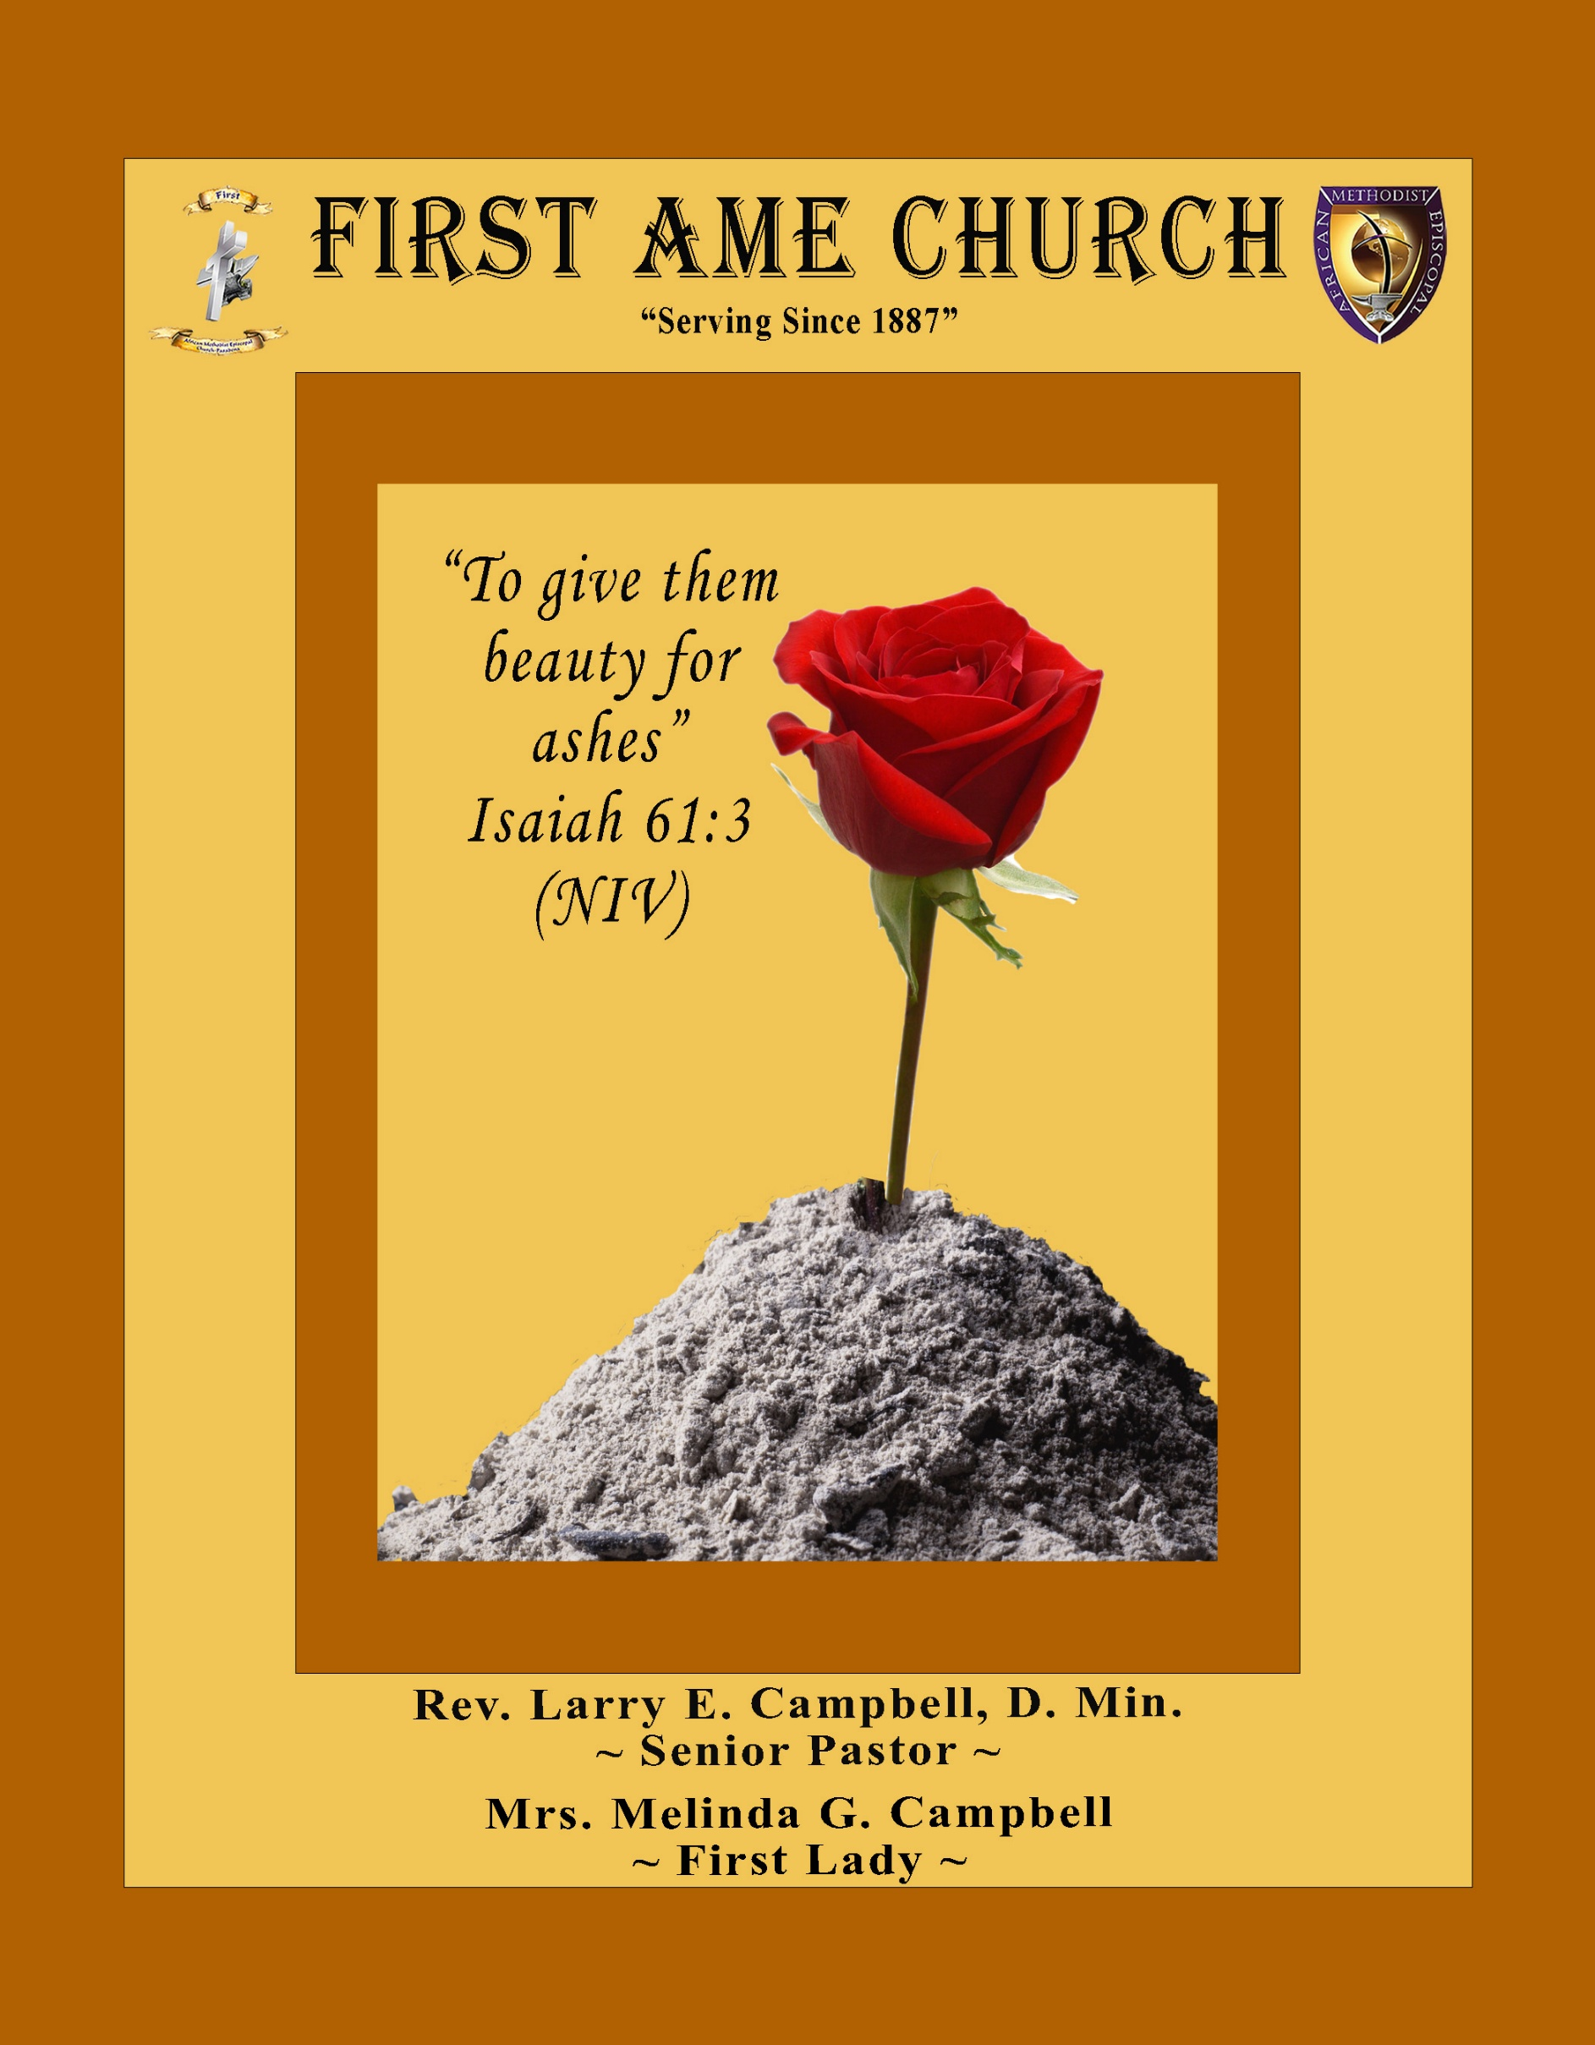
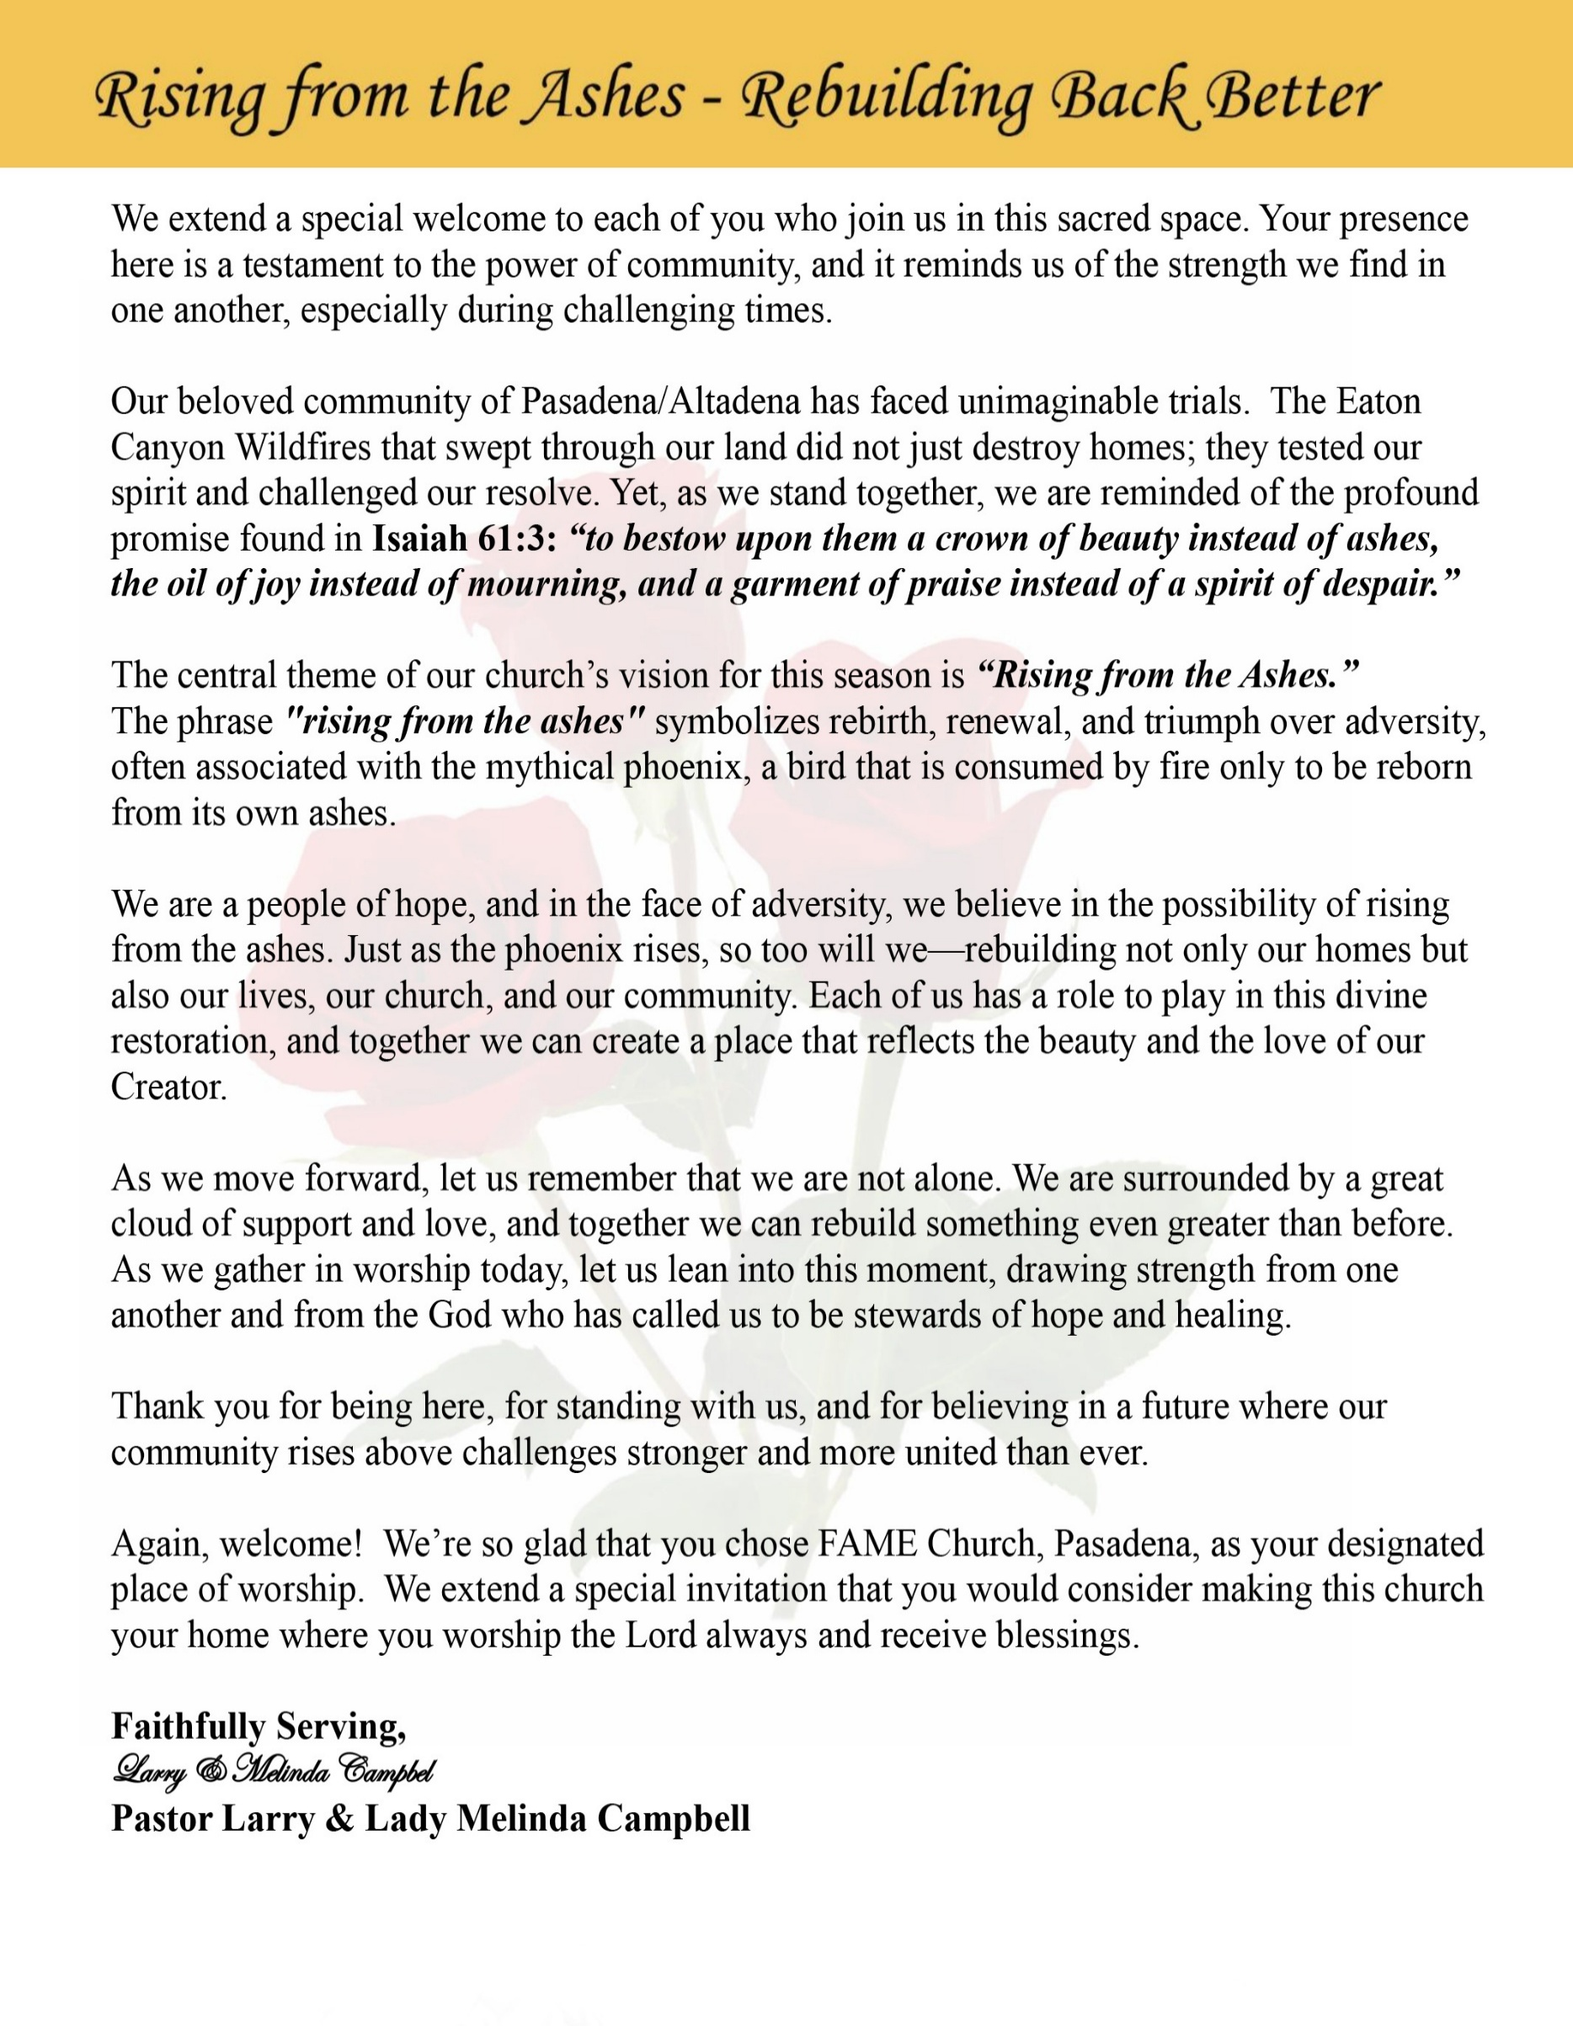

Sunday, February 8, 2026 | 9:30 a.m.

Rt. Rev. Francine A. Brookins, Esq., Presiding Bishop
Rev. Miriam Burnett, MD, MPH, Supervisor of Missions
Rev. Roosevelt Lindsey, Jr. Presiding Elder

The Rev. Dr. Larry E. Campbell ~ Senior Pastor ~ Minister

Mobile: (951) 587-1894 ~ Email: larrycampbell@famepasadena.org

Our First Lady: Mrs. Melinda G. Campbell

The Reverend Dr. Jennifer Oliver ~ Itinerant Elder -
The Reverend Dr. Nikia Smith-Robert ~ Itinerant Elder (Affiliated)
The Reverend Lois Woodard ~ Itinerant Elder Superannuated (Retired)
The Reverend Rochelle Wright Moore ~ Itinerant Deacon
The Reverend Deborah West-Jones ~ Local Elder
The Reverend Philis J. Griffin, MDiv ~ Local Elder
Dr. Phyllis Beech ~ Evangelist
Sister Tessie Bonner ~ Deaconess

Community Resource Center Director ~ Ms. Kischchen Hazelton Venerable
Church Administrative Assistant: Ms. Letha Rhymes

Church Office Hours:
Tue - Wed 9:00 am - 5:00 pm, & Fri 9:00 am -3:00 pm.
Closed for Lunch Daily: 12:00 pm - 1:00 pm.

Music Ministry
Dr. Timothy Davis, Minister of Music
Bro. Jimmy Watlington, Percussionist ~ Bro. Carlos Caldwell, Organist
Bro. Darien Dorsey, Keyboardist
Sis. Karen Law, Women’s Chorus Director ~ Sis. Tonia Graham, Children’s Choir Director
Bro. J. Renard Washington, New Generation’s Choir

FREE WI-FI service is available on the FAME Campus by accessing FAME 1700
Password: 6267980503

-3-

~ Order of Worship Experience ~
Warning: This order of worship is subject to change without warning or prior notice --- everything is governed by the Sovereignty of the Holy Spirit.



+ + + The Altar Call +++
Praise & Worship

Doxology: “Praise God From Whom All Blessings Flow”

The Call to Worship Sis. Teri Phillips
Leader: I was glad when they said unto me, let us go into the house of the Lord, our feet shall stand within Thy gates O Jerusalem! (Psalm 122:1)

People: For a day in Thy courts is better than a thousand. I had rather be a doorkeeper in the house of my God than to dwell in the tents of wickedness. (Psalm 84:10)

Leader: Because of the house of the Lord our God, I will seek Thy good.
(Psalm 122:9)

People: Those that be planted in the house of the Lord, shall flourish in the courts of our God. (Psalm 92:13)

Leader: Blessed are they that dwell in Thy house. Lord, I have loved Thy habitation, the place where Thy honor dwelleth. (Psalm 26:8)

People: For the Lord is in His holy temple; let all the earth keep silence before Him.
(Habakkuk 2:20)

Leader: Let the words of my mouth and the meditation of my heart, be acceptable in Thy sight, O Lord my strength and my redeemer. (Psalm 19:14)

Unison: O Sing unto the Lord a new song, for He has done marvelous things. Make a
joyful noise unto the Lord, all the earth, sing His praises. (Psalm 98:1, 4)

-4-

The Hymn of Praise A.M.E. Hymnal #513

Time Is Filled with Swift Transition
(Hold to God’s Unchanging Hand)

1 Time is filled with swift transition,
naught of earth unmoved can stand;
Build your hopes on things eternal,
hold to God’s unchanging hand!

Refrain:
Hold to God’s unchanging hand!
Hold to God’s unchanging hand!
Build your hopes on things eternal,
hold to God’s unchanging hand!

2 Trust in Him who will not leave you,
whatsoever years may bring;
If by earthly friends forsaken,
still more closely to Him cling.
[Refrain]

3 Covet not this world’s vain riches
that so rapidly decay;
Seek to gain the heav’nly treasures,
they will never pass away!
[Refrain]

4 When your journey is completed,
if to God you have been true,
fair and bright the home in glory,
your enraptured soul will view!
[Refrain]

The Invocation Bro. Versie Gaddis

Ministry of Music The Praise Team

-5-

Scripture Lesson Bro. Jodie Barnett
(Please Stand for the Reading of God’s Words)

Exodus 14:10-22 (New International Version) — Navigating Change and Transition
Leader: ¹⁰ As Pharaoh approached, the Israelites looked up, and there were the Egyptians,
marching after them. They were terrified and cried out to the Lord.

People: ¹¹ They said to Moses, “Was it because there were no graves in Egypt that
you brought us to the desert to die? What have you done to us by bringing us
out of Egypt? ¹² Didn’t we say to you in Egypt, ‘Leave us alone; let us serve
the Egyptians’? It would have been better for us to serve the Egyptians than
to die in the desert!”

Leader: ¹³ Moses answered the people, “Do not be afraid. Stand firm and you will see the
deliverance the Lord will bring you today. The Egyptians you see today you will
never see again. ¹⁴ The Lord will fight for you; you need only to be still.”

People: ¹⁵ Then the Lord said to Moses, “Why are you crying out to me? Tell the
Israelites to move on. ¹⁶ Raise your staff and stretch out your hand over the
sea to divide the water so that the Israelites can go through the sea on dry
ground.

Leader: ¹⁷ I will harden the hearts of the Egyptians so that they will go in after them. And I
will gain glory through Pharaoh and all his army, through his chariots and his
horsemen. ¹⁸ The Egyptians will know that I am the Lord when I gain glory
through Pharaoh, his chariots and his horsemen.”

People: ¹⁹ Then the angel of God, who had been traveling in front of Israel’s army,
withdrew and went behind them. The pillar of cloud also moved from in
front and stood behind them, ²⁰ coming between the armies of Egypt and
Israel.

Leader: Throughout the night the cloud brought darkness to the one side and light to the
other side; so neither went near the other all night long.

Unison: ²¹ Then Moses stretched out his hand over the sea, and all that night
the Lord drove the sea back with a strong east wind and turned it into dry
land. The waters were divided, ²² and the Israelites went through the sea on
dry ground, with a wall of water on their right and on their left.

-6-

Abbreviated Announcements/Visitor’s Welcome


Wedding

90 Plus Birthday Celebrations

February 9th----Barbara Buchanan will celebrate her 94th birthday.
February 20th—-Rosetta (Nonnie) Lynch will celebrate her 91th birthday.
February 22nd-- Jamie Smith will celebrate her 92nd birthday.

Birthdays Recognized for the Month


“The best Birthday wish that you can get for the day is that you may live each moment of your life to the very fullest, without any regrets.” Anonymous

Special Congregational Hymn (Sing along)
#361 Yes, God Is Real

Black History Litany for Gifts, Tithes, and Offerings Sis. Linda P. Wright

Leader: From fields we did not own, from wages we were denied, from blessings God multiplied in
spite of oppression—

People: We give thanks to the Lord, for God has been faithful.

Leader: Our ancestors gave praise without possessions, faith without fortune, and hope without
guarantees.

People: What we have, we give to God with grateful hearts.

Leader: For God made a way out of no way, opened doors no one could shut, and sustained us
through struggle and sacrifice.

People: We bring our tithes and offerings as a testimony.
[Continued on page 8]

-7-

Black History Litany for Gifts, Tithes, and Offerings [Continued]
Leader: The Scripture declares, “Honor the Lord with your substance and with the first fruits of all
your increase.” (Proverbs 3:9)

People: We honor God with what is in our hands.

Leader: Because God fed us in lean seasons, strengthened us in hard times, and blessed us beyond what systems allowed—

People: We will not withhold our praise or our giving.

Leader: Like those who built churches brick by brick, schools’ penny by penny, and movements
prayer by prayer—

People: We sow into God’s work with faith and courage.

Leader: For we remember the words of Scripture: “Give, and it will be given to you—pressed down,
shaken together and running over.” (Luke 6:38)

People: We give trusting God for increase and impact.

Leader: May these gifts uplift the community, strengthen the church, and advance justice, mercy,
and hope. Let our giving honor God and bless generations to come.

All Together: God of our ancestors, receive our gifts, our tithes, and our offerings. We give
because You first gave to us. Amen.

The following Electronic GIVING Platforms are creditable methods to GIVE to FAME:

#1. GIVELIFY - Mobile Giving App available on the App Store. It’s easy to set up, just follow the guidelines.

#2. Cash App: $FirstAMEPASADENA

#3. Mail in your Tithes & Offering - If you would like to mail your tithes and offering by check or money order, please send it to: First AME Church, 1700 N. Raymond Avenue, Pasadena, CA 91103.

#4. Drop off your Tithes & Offering - During business hours in the basket outside of the office.

Choral Response: “All things come of Thee, O Lord; and of Thine own have we given Thee. Amen.”

Children’s Church Dismissal

Sermonic Selection The Praise Team
The Preached Word Pastor Larry E. Campbell
The Doxology
The Benediction

-8-

Scripture of the Day
Navigating Change. “Forget the former things; do not dwell on the past. ¹⁹ See, I am doing a new thing! Now it springs up; do you not perceive it? I am making a way in the wilderness and streams in the wasteland.” Isaiah 43:18-19

Quote of the Day
“Change does not roll in on the wheels of inevitability but comes through continuous struggle.” — Dr. Martin Luther King Jr.

Thought of the Week
“The Lord will go before you, and the God of Israel will be your rear guard.” — Isaiah 52:12
Change often places us in the in-between—no longer where we were, not yet where we are going. That space can feel uncertain, even frightening. Yet Black history teaches us that God has always been present in the transition.
Our ancestors stepped into unknown futures with little more than faith, prayer, and a deep trust that God would not abandon them. Whether marching for civil rights, building schools with limited resources, or organizing communities when systems failed, they moved forward knowing God was both ahead of them and guarding what they left behind.
The same God who carried us through slavery, segregation, and struggle walks with us now—through shifting policies, economic uncertainty, and social unrest. Change does not mean God has left. It often means God is leading.
As Benjamin E. Mays wisely said, “Faith is taking God at His word and stepping out on it.” Today, we step forward trusting that God’s presence surrounds us on every side.
When the future feels unclear, remember—God is already there.

Humor of the Week
A husband had died and left his wife with $50,000,
After the funeral, she told her friends that she’s totally broke,
Her friends said, “How could you be broke, you said you have $50,000?.”
She said, “Well I spent $20,000 on the funeral and $30k on the memorial stone!.”
Her friends said, “Wow! That was some stone!, how big was it?.”
She lifts her hand and said, “3.5 carats!”

HOME DAILY BIBLE READINGS
February 9, 2026 – February 15, 2026 (Week 21, Hosea)
Monday Day 141 Job 14-16, Psalm 58:6-11
Tuesday Day 142 Job 17-20, Psalm 59:1-9
Wednesday Day 143 Job 21-23, Psalm 59:10-17
Thursday Day 144 Job 24-28, Psalm 60:1-4
Friday Day 145 Job 29-31, Psalm 60:5-12
Saturday Day 146 Job 32-34, Psalm 61:1-5
Sunday Day 147 Job 35-37, Psalm 61:5-8

-9-

ANNOUNCEMENTS

WELCOME! WELCOME! WELCOME! It is with great pleasure and joy that we officially welcome Jamia Chambers to the FAME Family kinship. We are truly blessed and very grateful for their presence and valued membership in our church family.
Souper Bowl of Caring Kick-Off
The YPD is kicking off its Community Service Project, Souper Bowl of Caring, this Sunday, February 8, 2026. We are seeking a donation of cereal for our church's Food Pantry. Packaged breakfast cereal boxes may be dropped off at the fellowship Hall in the box marked YPD Souper Bowl Sunday through-out February. Please support our YPD as we assist our community!
Dana Hazelton, YPD President, Gina Tervalon, YPD Director.

Senior Ministry In-Person Gathering
Please join us for Senior Ministry lunch and program on Tuesday, February 10, 2026, at 11:30 a.m. in the Fellowship Hall. Come and enjoy good fellowship, good food, and helpful information.
Socialize: 11:30-11:45 a.m., Program 11:45-12:45: We will be entertained by Pam Kay's Tap Chicks a dance troupe based out of the Pasadena Senior Center. They are an accomplished tap dance group founded by the late Pam Kay, a veteran performer, entertainer and choreographer. The Tap Chicks versatile style dance includes Broadway, Country, Jazz and popular music that has made them successful for many years. Lunch: served at 1:00 p.m. Come to have fun!! Bring a friend. I look forward to seeing you.

FIRST QUARTERLY CONFERENCE: The Presiding Elder’s First Quarterly Conference will be held on Wednesday, February 11, 2026, at 7:00 p.m.

Join Zoom Meeting
https://us02web.zoom.us/j/83726989921?pwd=EpefDhqaPX1GWBwf6LmDjanzL2BCD4.1
Meeting ID: 837 2698 9921 | Passcode: 765021
One tap mobile: +16699006833,,83726989921#,,,,*765021# US (San Jose)
+16694449171,,83726989921#,,,,*765021# US

20/20 (14.0)
The 20/20 initiative is a Church-wide fundraising project managed by the Stewards. This project was established to assist with our Annual Connectional Budget. Financial gifts donated through the 20/20 initiative are added to our collected conference claims and assist greatly in meeting the first and second half of our Connectional Budgetary obligations. The Steward Board is requesting 150 participants for the conference year 2025-2026. The first half of our budget is due in February 2026. In addition to the 18 officers and we are asking 132 people to give 20 dollars per week for 20 weeks in addition to your regular tithes, gifts and offerings. Please mark your envelopes 20/20 and allocate $20.00. Our goal is to raise $60,000. Again, this will satisfy all budgetary needs on the conference level without utilizing any operational funds. Please see or contact any Steward to participate; we are looking forward to your commitment.

-10-

-

ANNOUNCEMENTS (Continued)
Save the Date
February is Heart Month, Save your change and Save a life!
Get "Red-y" for Red Dress Sunday on Feb 15th. The Olivia Wilson Women's Missionary Society invites everyone to bring your loose change to donate to the American Heart Association and to wear red to raise awareness about heart disease- the leading cause of death in women.
Virtual Trustee Board Meeting
Tuesday, February 17, 2026 | 5:30 p.m.

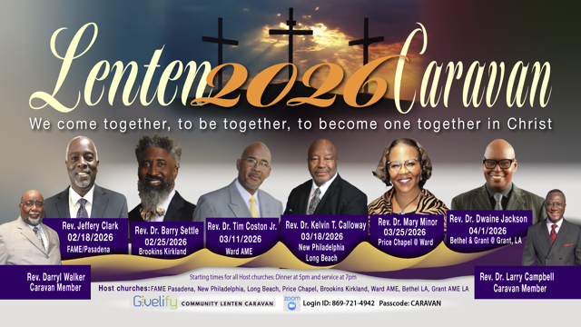

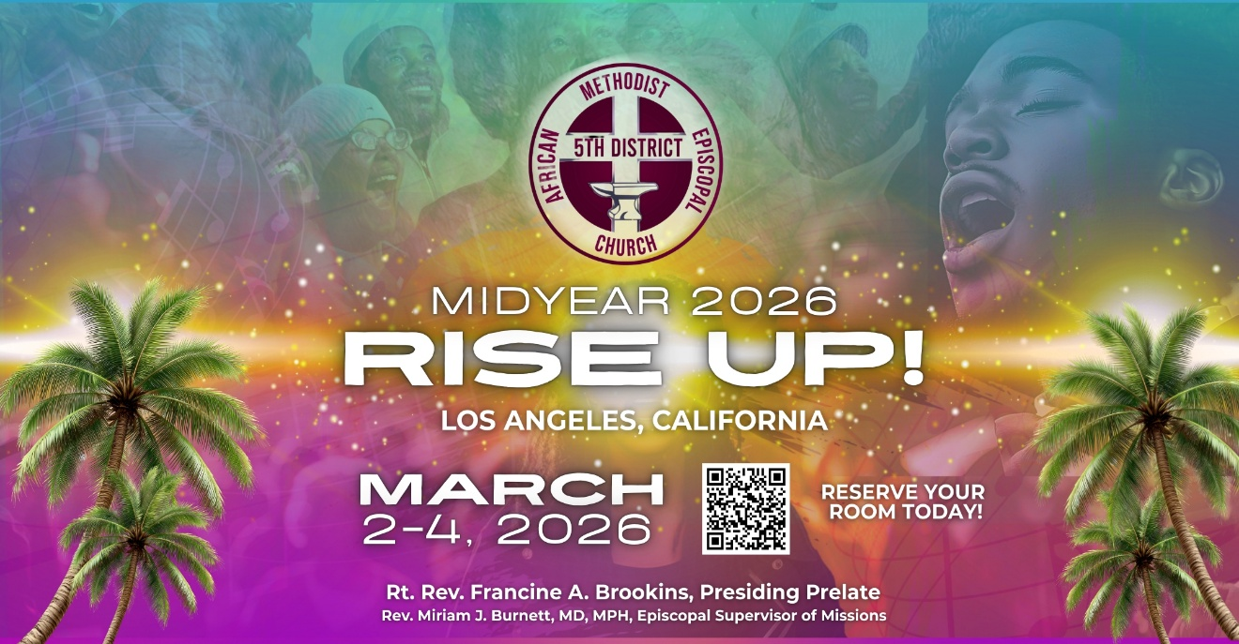

-11-

Stacey Abrams’ 10 Steps to Freedom & Power

- Commit
Understand what’s happening in your community—not just headlines, but how policies affect real lives—and commit to being part of the solution.
- Share
Stay informed and share facts, insights, and civic knowledge with friends, family, and social networks to build awareness and collective understanding.
- Organize
Bring people together—friends, neighbors, allies—around common goals and issues that matter, whether it’s voting rights, education, health care, or justice.
- Mobilize
Take consistent action as a group. This could include public events, conversations, advocacy efforts, and community support activities.
- Litigate
Use the legal system to defend rights and support those harmed; non-attorneys can still participate by serving as plaintiffs, witnesses, or advocates.
- Disrupt
Challenge systems of disinformation and compliance with nonviolent actions such as protests, documenting civil rights violations, and raising public awareness.
- Deny
Refuse to be complicit in narratives or practices that undermine democracy; build and strengthen community ties and support nonviolent civic engagement.
- Engage
Work directly with elected officials and public institutions by advocating for legislation, ballot initiatives, and responsive governance.
- Elect
Participate in elections at all levels—local, state, and federal—to ensure that representatives reflect the values of democratic participation and human dignity.
- Demand
Go beyond reclaiming what was lost: boldly declare the kind of country and society you want, and hold leaders accountable to those standards.

This framework is part of an effort to help Americans recognize threats to democratic institutions and build resilient, inclusive power in response. Abrams’ campaign emphasizes that defending democracy isn’t a single action—it’s a sustained commitment to awareness, organization, and collective civic engagement.

-12-

Prayer Request(s)
Please notify the Church Office of Sick & Shut-in additions, deletions, or status/address changes.

Bishop Francine A. Brookins, Esq. Supervisor Miriam Burnett, MD
Presiding Elder Roosevelt & Dr. Kaye Lindsey Rev. Dr. Larry & Melinda Campbell
Richard Craig Hazel Clark Erica Woodard Jason Shirley Joshua Shirley Julian Shirley Ayanna Terry Cheryl Jamerson Gwendolyn Flowers Andrea Anderson Ocilda Files Danielle Clark Donita Towler Rev. Charles Brooks Doris Bailey Kimberly Woods Cynithia Grace Zechariah Robinson Diane Jordan Christopher McCarthy Wilma Haynes Jewell Malloy Calle Burns Noel Johnson Brittney Petty Taylor Family Deborah Burton Nettie McChristen Jacquelyn Walker Carita Smith
Rev. Rochelle Moore Lorene Butler Stella Pulliam Cheryl Jameson The Caple Family Donita Towler
The Eaton Canyon Fire Victims Selene Cox Mel Beech Colette Blizzard

College Students

Let’s continue to support and pray for our beloved College Students

Isaiah Crowell Alecia Davis Jade Williams Chase Johnson Grant Blizzard

Tyler Johnson Richard Jones Tyrikk Lawson Makia Rose Talbert Isaiah Ringo Journey Rogers Elyse Sharp Kylee Sharp Zion Otano Elise Tervalon Grace Jones Jordan Patterson Kimberly Robinson Donovan Williams Jasmine Collins Brandon Bates Gabriel Blizzard

Sick and Shut-Ins
Andrew Oliver 1405 N. Roosevelt Avenue. Pasadena, CA 91104
Bettina Ayers Pasadena Meadows Nursing Home, 150 Bellefontaine St., Pas., CA 91105
Bobby Thomas 1052 E. Morada Place, Altadena, CA 91001
Carrie Wynne Senior Living Heritage, 161 N. Hemet St., Hemet, CA 92545
Doris Curd 11619 Woodcock Avenue, San Fernando, CA 91340
Edmund Riddle Active Care Mission Bay, 2440 Grand Avenue, San Diego, CA 92109
Eleanor Towler 975 E. Union Street, Unit #417, Pasadena, CA 91106
Elois Blizzard P. O. Box 3646, So. Pasadena, CA 91031
Emily Cormier-Ross 2549 La Fiesta Avenue, Altadena, CA 91001
Ernestine English 26 W. Fair Oaks Drive, Pasadena, CA 91103
Fred Caple 51 North 15th Street Haledon, NJ 07508
Gloria Cubit Clay 11745 Pierce St., Lake View Terrace, CA 91342
Hugh Hamberry 19225 Chole Rd., Apple Valley, CA 92307
Jeff Thomas 603 Tocino Dr. Duarte, CA 91010 | Mountain View Terrace
Josephine Brown 15607 Saddleback Rd, Riverside, CA 92506
Jessie Smith 3925 S Jones BL, Apt 2118 Las Vegas, NV 89103| Spring Valley Community
Linnie G. Nollie 2250 E. New York Drive, Altadena, CA 91001
Malika G. Hendry P. O. Box 94082, Pasadena, CA 91109
Mildred Lewis C/O Hazel Rohr, 884 W. Jane Court, Upland, CA 91786
Norma Burnett 618 Fairview Avenue, Unit #228, Arcadia, CA 91007
Opal Hampton 1030 Chevron Court, Pasadena, CA 91103
Paul Ratliff P.O. Box 40407 Pasadena, CA 91114
Ruthie Hopkins 1155 Via Verde , San Dimas, CA 91773
Virlyn Grant 15122 Orange Ave., Paramount, CA 90723
Wanda Nelson 3618 N. Fair Oaks Avenue, Altadena, CA 91001
William Hilliard 7504 Wynstone Pl., Fontana, CA 92336
Zell L. Hill 375 Barthe Drive, Pasadena, CA 91103

=13=

Sermon Notations

Scripture: _____________________________________________________________

Subject: _______________________________________________________________

Points of the Message: ___________________________________________________
_______________________________________________________________________
_______________________________________________________________________
_______________________________________________________________________
_______________________________________________________________________
_______________________________________________________________________
_______________________________________________________________________

Main Ideas of the Sermon: ________________________________________________
_______________________________________________________________________
_______________________________________________________________________
_______________________________________________________________________
_______________________________________________________________________
_______________________________________________________________________

Illustrations I want to remember: _________________________________________
_______________________________________________________________________
_______________________________________________________________________
_______________________________________________________________________
_______________________________________________________________________
_______________________________________________________________________
_______________________________________________________________________

What should I do as a result of this Sermon? ________________________________

_____________________________________________________
_____________________________________________________
_____________________________________________________
_____________________________________________________

-14-

