WELCOME TO
GRACE LUTHERAN CHURCH
OF LILY LAKE, IL
5N600 Hanson Road, St. Charles, IL 60175
OFFICE: 630-365-6751 * E-mail: general@graceoflilylake.com
Web Address: www.graceoflilylake.com
Sunday, December 6, 2020 * 9 AM * ONLINE

Second Sunday in Advent
INTRODUCTION – Prepare the Way (peace) John the Baptist calls the crowds into the journey of repentance and transformation. Similarly, we are called to prepare the way for God’s message of love and liberation to be shouted, heard, and received. Those who dream make way for righteousness and peace to kiss, for faithfulness to spring up from the ground (Ps. 85:10-11).

THANK YOU FOR JOINING US FOR SUNDAY MORNING FROM HOME.
Print out your bulletin or use it on your phone or tablet to follow along.
Announcements are televised or found on our website

Be creative how you worship and remember God during this time. It will calm your soul, give you peace and enliven your spirit.

Our community gathers in unity with others in-person and a virtual way.
We hope all people find it easy to follow along.

GOD GATHERS US
WELCOME & ANNOUNCEMENTS
Detailed Announcements are found on our website

PRELUDE

We invite you to read/respond to the texts, pray the prayers, using this as a meditation guide all week long.

Call to Worship²
P John the Baptist said, “Prepare the way.” So family of faith, how do we prepare our minds for worship?
ALL We silence the inner critic. We let go of busy thoughts.
We make space for God to speak.
P How do we prepare our hearts for worship?
ALL We bless all emotions. We feel what we feel.
We open ourselves up to be moved.
P How do we prepare our bodies for worship?
ALL We take in the scent, sight, and feel of where we are.
We breathe in God’s mercy. We exhale God’s love.
P How do we prepare our souls for worship?
ALL We bring our full selves into the present. We wear our hearts on our sleeves.
We trust that even now, God is here.
P Family of faith, what we practice in worship, we must live out in our daily lives.
ALL We prepare the way. Let us worship Holy God.
SANCTIFIED ART THOSE WHO DREAM WORDS FOR WORSHIP | “Adapted from a prayer by Sarah Are | A Sanctified Art LLC | sanctifiedart.org.”

CANDLE LIGHTING LITURGY The Candle of Peace STROM/BALLARD

OPENING SONG “Comfort, comfort Now my People!” ELW 256
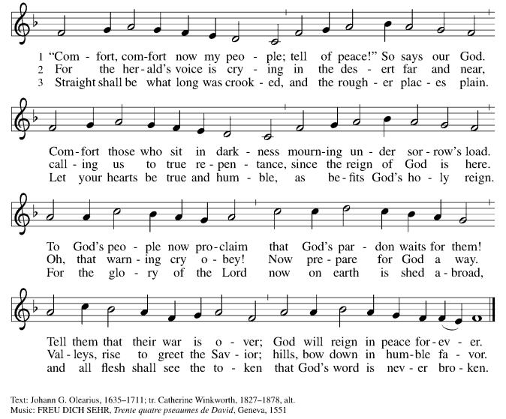

PRAYER OF THE DAY
P God of Peace, We must admit, there are a million things on our minds.
We would like to be as focused as John the Baptist—preparing the way,
gathering the crowd, spreading the word of your arrival.
Maybe then we’d know peace.
However, more often than not, we are a swirling compilation of shopping lists,
text messages, e-mails, and over-referenced to-do lists.
So today, we ask for your help in preparing the way.
Could you start with our ears, and then maybe move to our hearts?
We’d like to hear you more clearly.
Maybe then we’ll know peace. Gratefully we pray,
ALL Amen.

SHARING OF PEACE
P May you know comfort. May you know peace.
ALL May you also.

GOD’S WORD
FIRST READING Isaiah 40:1-11
Introduction – In grand, flowing, poetic lines, the prophet announces that the exile of God’s people in Babylon is over. God will deliver Israel and will care for her as a shepherd cares for the sheep. This word can be trusted, because the only enduring reality in life is the word of God.

40 “Comfort, comfort my people,” says your God.
² “Speak tenderly to Jerusalem. Tell her that her sad days are gone and her sins are pardoned.
Yes, the Lord has punished her twice over for all her sins.”
³ Listen! It’s the voice of someone shouting, “Clear the way through the wilderness for the Lord!
Make a straight highway through the wasteland for our God! ⁴ Fill in the valleys, and level the mountains and hills. Straighten the curves, and smooth out the rough places. ⁵ Then the glory of the Lord will be revealed,
and all people will see it together. The Lord has spoken!”^{[a]}
⁶ A voice said, “Shout!”
I asked, “What should I shout?”
“Shout that people are like the grass. Their beauty fades as quickly as the flowers in a field.
⁷ The grass withers and the flowers fade beneath the breath of the Lord.
And so it is with people. ⁸ The grass withers and the flowers fade, but the word of our God stands forever.”
⁹ O Zion, messenger of good news, shout from the mountaintops!
Shout it louder, O Jerusalem.^{[b]} Shout, and do not be afraid.
Tell the towns of Judah, “Your God is coming!”
¹⁰ Yes, the Sovereign Lord is coming in power. He will rule with a powerful arm.
See, he brings his reward with him as he comes.
¹¹ He will feed his flock like a shepherd. He will carry the lambs in his arms, holding them close to his heart.
He will gently lead the mother sheep with their young

R Word of God; Word of Life. All Thanks be to God.

“Cleaning & Clearing”

What is Pastor cooking up today?

THE HOLY GOSPEL according to St. Mark, the thirteenth chapter. Mark 1:1-8

ALL Alleluia. Show us your steadfast love, O Lord,* and grant us your salvation. Alleluia. (Ps. 85:7)

Introduction -The Gospel of Mark does not begin with a story of Jesus’ birth but with the voice of one crying out in the wilderness: Prepare the way of the Lord.

1The beginning of the good news of Jesus Christ, the Son of God.
2As it is written in the prophet Isaiah,
“See, I am sending my messenger ahead of you,
who will prepare your way;
3the voice of one crying out in the wilderness:
‘Prepare the way of the Lord,
make his paths straight,’ ”
4John the baptizer appeared in the wilderness, proclaiming a baptism of repentance for the forgiveness of sins. 5And people from the whole Judean countryside and all the people of Jerusalem were going out to him, and were baptized by him in the river Jordan, confessing their sins. 6Now John was clothed with camel’s hair, with a leather belt around his waist, and he ate locusts and wild honey. 7He proclaimed, “The one who is more powerful than I is coming after me; I am not worthy to stoop down and untie the thong of his sandals. 8I have baptized you with water; but he will baptize you with the Holy Spirit.”

P The Gospel of the Lord All Praise to You O Christ.

MESSAGE FOR ALL
“Those Who Dream….Re-making Roads and Routes”
Pastor Dawn Roucka

REFLECTION QUESTIONS

- Consider roadwork where you live. What are real-life examples of preparing the way?

- What roads do you find yourself on right now? Describe your journey and the roadwork over the last year. 20 years!?

- When has a (good or bad) dream interrupted or re-routed your life?

RESPONDING TO GOD’S GOODNESS
AFFIRMATION OF FAITH
P We believe that a voice cried out in the wilderness, Saying, “Prepare the way of the Lord.”
Even on cold, blustery days. Even when we worship from home.
All We march toward justice.
We roll up our sleeves.
We plant trees for our children.
We make art. We choose hope.
We gather at the Table and set an extra plate for those we miss.
We sing loudly, with joy.
We share stories and wisdom.
We celebrate children.
We fall together. We rise together. We love together.
P We do all these things because we believe that God loves us so much that God shows up here.
So we prepare and prepare for that next beautiful day.
ALL May it be so. Amen.

OFFERING IS WELCOMED
P God calls us to love with all our hearts, souls, minds, and strength, and to love our neighbors as
ourselves. Our offerings are a symbol of that commitment and one of our contributions to our congregation’s witness in our neighborhood, in our region, and in our world. You are invited to give generously.

PLEASE CONSIDER IN THIS TIME OF NEED, TO CONTINUE TO SUPPORT YOUR CHURCH, IF POSSIBLE, AND SUPPORT OTHERS AS WELL BY BEING AS GENEROUS WITH YOUR TIME, YOUR TALENTS AND YOUR VARIOUS TREASURES.

You may mail offerings to Grace at 5N600 N. Hanson Road, St. Charles, IL 60175
or send through your bank or online; there is also a DONATE on our website or a plate by the entryway.

OFFERTORY PRAYER
P Let us pray. Generous God, you have created all that is, and you provide for us in every season.
Bless all that we offer, that through these gifts the world will receive your blessing.
In the name of Jesus, Emmanuel, we pray.
ALL Amen.

PRAYERS OF GOD’S PEOPLE
See list of those Grace is currently praying for at end of this document or online. Please let us know your prayer needs.

Please respond accordingly
P O God of hosts, ALL Restore us; let your face shine upon us.
THE LORD’S PRAYER

(Traditional) (Modern)
Our Father, who art in heaven, Our Father in heaven,
hallowed be thy name, hallowed be your name,
thy kingdom come, your kingdom come,
thy will be done, your will be done,
on earth as it is in heaven. on earth as in heaven.
Give us this day our daily bread; Give us today our daily bread.
and forgive us our trespasses, as we Forgive us our sins as we forgive those forgive those who trespass against us; who sin against us.
and lead us not into temptation, Save us from the time of trial
but deliver us from evil. And deliver us from evil.
For thine is the kingdom, and the power, For the kingdom, the power, and the glory
and the glory, forever and ever. Amen. are yours, now and forever. Amen

GOD SENDS US
COMISSION & BENEDICTION

P The Creator of the stars bless your Advent waiting, the long-expected Savior fill you with love,
and the unexpected Spirit guide your journey and dreaming, ☩ now and forever.
ALL Amen!

CLOSING SONG “Prepare a Royal Highway” ELW 264, vs 1, 2, 4
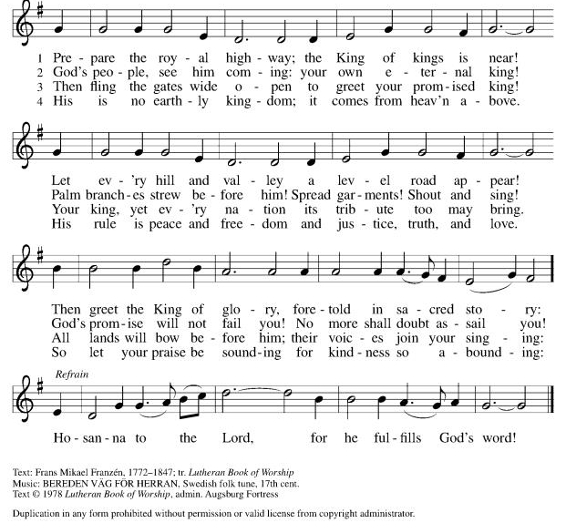

DISMISSAL P Go in peace . Prepare the way of the Lord,
ALL Thanks be to God. Amen.

ANNOUCEMENTS
December 6, 2020

ZOOM FELLOWHIP WILL CONTINUE WEEKLY AT 10 AM on Sundays following our online worship services. Join our Grace family for sharing news, prayers information and more. Don’t miss out! Check your eblast for details.

~~~~*~~~~*~~~~*~~~~
We hope you are using and enjoying your Advent devotions. Share your thoughts at our Zoom gathering.
Bags include a weekly Advent Devotion activity easy for all ages. They also have a fuller Advent Devotion Booklet themed “Those Who Dream”, our Advent series that includes prayers, reflections, and activities.

Sunday, November 29 – HOPE Monday, Dec 21, 2020 – Longest Night Service
Sunday, Dec. 6, 2020 – PEACE (Opportunity to lament the losses and grief of 2020)
Sunday Dec. 13, 2020 – JOY Thursday, Dec. 24, 2020 Christmas Eve
Sunday Dec. 20, 2020 – LOVE Join us for a special parking lot service! Time: TBA

ADVENT & CHRISTMAS SERVICES WILL ALSO ALL BE ONLINE!
Get all access through our website! Share with a friend

~~~~*~~~~*~~~~*~~~~
See Website for Christmas GIVING OPPORTUNITIES
Giving Tree
ELCA Barnyard
Don’t forget to return your Giving Tree Gifts by Friday, December 11th!
Check website for drop-off details.
~~~~*~~~~*~~~~*~~~~

Please consider turning in your 2021 Commitment Card today – online, in the mail or drop it by church today.
~~~~*~~~~*~~~~*~~~~
Annual Reports due – December 28th
send to Cathy Whiteside by/on December 28th. If you need re-typed, leave copy in Cathy’s box.
Annual Meeting – January 31st
Save the date

REAL NEWS TO USE DURING THESE TIMES

VISIT OUR Website www.graceoflilylake.com FOR THE LATEST NEWS AND SERVICES
Check out our updated website. Get ALL the news you NEED there – including our weekly services
And our FACEBOOK PAGE or Youtube page for activities and posts of interest:
https://www.facebook.com/GraceOfLilyLake/
https://youtube.com/graceoflilylake.com
630-365-6751

THOSE TO KEEP IN YOUR PRAYERS
FOR THE WHOLE CHURCH
* God’s Church in all time and place, that God be seen and heard.
* As we face these times both together and while apart, keep us from fear, suffering and death.
* Ministries of the ELCA and Metro Chicago Synod, especially Bishop Yehiel Curry.
* Efforts of Lutheran World Relief, ELCA World Hunger, and Disaster Relief

FOR THE WORLD
- For every living person facing the threat of coronavirus – it affects us all, our loved ones and our worldwide neighbors together.
- For those facing natural disasters of wildfires, hurricanes, earthquakes

FOR OUR CONGREGATION
* For God's Spirit to guide Pastor Dawn, Vision Team, and whole congregation as we face transition and change.
* As we begin Advent, help us dream powerful dreams and watch and wait with God..

FOR THOSE IN THE MILITARY (members, relatives, and friends of members of our congregation)
* Glenn Adams, son of Mark and Renee Adams * Lucy Adams, daughter-in-law of Mark & Renee Adams
* Adam Sajdak, grandson of Bill and Lori U’Ren * William Delmer, grandson of Kirk and Kathy Hooey
(If you know of someone currently serving our country, please share their information with the Church office.)

FOR ALL
* The continued support of our members * For all members of healthcare around the world
* For those serving as first responders and in the military * For our Nation, that extend peace in all things.

FOR THOSE SICK IN BODY, MIND OR SPIRIT
Fred Altstadt, Vicki Barclay, Carl Ekstrom, Carol Hammers, Jamie Hext, Manfred Kaufman, Jeannine Luchs, Joan Mortensen, Donald Overby, Ken Deutschman, Ken Patterson, Nicole Puralewski, Darlene Rentner, Pastor Rex, The Reynolds Family, Chris Richards, Nancy Schaefer, John Schnaitman, Shirley Turner, Pete and Carol Prevanas, Lisa Leyden, Pat Hill, Paul Kinsel, Pam Bohlin’s brother, Dottie’s brother, Paul Mantsch, Mike Meyer, Katie, Nancy Corbige

FOR THOSE WHO GRIEVE

Please let us know your prayer requests for inclusion in our public prayers.
Type them in the comments or send them to the church office via our prayer card on our website.

GRACE’S MISSION IS
To share God’s GRACE with all through our rich traditions of faith, family, and community.
Gospel – God’s love shared in all we say & do
Respect for all God’s people & creation
Action – response to the Gospel
Community – Loving God, neighbor, & self
Everyone – we are all God’s children

GRACE LUTHERAN CHURCH OF LILY LAKE
5N600 Hanson Road, St. Charles, IL 60175
Office: 630-365-6751
E-mail: general@graceoflilylake.com
Web Address: www.graceoflilylake.com

