WELCOME TO
GRACE LUTHERAN CHURCH
OF LILY LAKE, IL
5N600 Hanson Road, St. Charles, IL 60175
OFFICE: 630-365-6751 * E-mail: general@graceoflilylake.com
Web Address: www.graceoflilylake.com
Sunday, December 20, 2020 * 9 AM * ONLINE

those who dream... are not alone (hope)

Fourth Sunday in Advent

INTRODUCTION – This week, we recognize what preceded Mary’s song of praise: news that was disorienting and bewildering, possibly threatening her life. Together, Mary and Elizabeth find courage and comfort in spite of their unusual circumstances. We, too, are called to carry, support, and encourage one another’s impossible dreams.

THANK YOU FOR JOINING US FOR SUNDAY MORNING FROM HOME.
Print out your bulletin or use it on your phone or tablet to follow along.
Announcements are televised or found on our website

Be creative how you worship and remember God during this time. It will calm your soul, give you peace and enliven your spirit.

Our community gathers in unity with others in-person and a virtual way.
We hope all people find it easy to follow along.

GOD GATHERS US
WELCOME & ANNOUNCEMENTS
Announcements are found on our website

PRELUDE He Shall Feed His Flock Handel

We invite you to read/respond to the texts, pray the prayers, using this as a meditation guide all week long.

Call to Worship²
P I knew joy, but when I heard the laugh of a child,
ALL Suddenly, joy was overflowing.
P I knew love, but when you held my hand,
ALL Suddenly, love was overflowing.
P I knew God, but when you showed me grace,
when you forgave me,
when you loved me,
when you raised me,
ALL Suddenly, God was overflowing.
P So, let us worship Holy God together as a reminder that God has made a home here and we are never
alone.
ALL This is community.
P This is the body of Christ.
ALL Welcome home.
SANCTIFIED ART THOSE WHO DREAM WORDS FOR WORSHIP | “Adapted from a prayer by Sarah Are | A Sanctified Art LLC | sanctifiedart.org.”

Candle Lighting Liturgy | The Candle of Love ANDERSON

OPENING SONG “Love Has Come” ELW 292
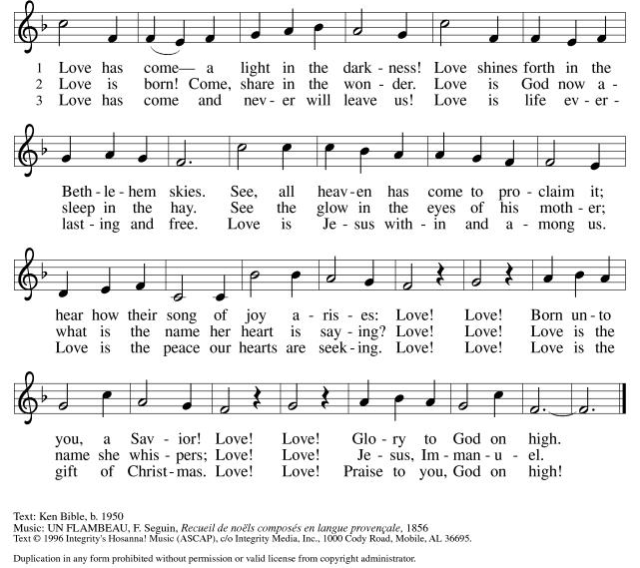

PRAYER OF THE DAY
P God of Good News, Leaping in wombs, kicking, stretching, jumping for joy.
You have always found a way to show up, make yourself at home, in our midst,
Particularly on our fearful or lonely days.
We ask that you would move in again. Stir in us. Speak to us. Fill us with the Holy Spirit.
And if we are not able to hear your Word clearly, then give us Elizabeth’s
Who will point out your presence in delight and joy.
So here and now, Creator God, we are listening.
ALL Amen.

SHARING OF PEACE
P May you know comfort. May you know peace.
ALL May you also.

GOD’S WORD
FIRST READING 2 Samuel 7:1-11, 16
Introduction – Instead of David building a house (temple) for God, God promises to establish David’s house (dynasty) forever. Centuries later, after the Babylonian exile, no king sat on the throne. Even then, however, the people of Israel remembered this promise and continued to hope for a king, the messiah, God’s anointed.

1Now when the king was settled in his house, and the Lord had given him rest from all his enemies around him, 2the king said to the prophet Nathan, “See now, I am living in a house of cedar, but the ark of God stays in a tent.” 3Nathan said to the king, “Go, do all that you have in mind; for the Lord is with you.”
4But that same night the word of the Lord came to Nathan: 5Go and tell my servant David: Thus says the Lord: Are you the one to build me a house to live in? 6I have not lived in a house since the day I brought up the people of Israel from Egypt to this day, but I have been moving about in a tent and a tabernacle. 7Wherever I have moved about among all the people of Israel, did I ever speak a word with any of the tribal leaders of Israel, whom I commanded to shepherd my people Israel, saying, “Why have you not built me a house of cedar?” 8Now therefore thus you shall say to my servant David: Thus says the Lord of hosts: I took you from the pasture, from following the sheep to be prince over my people Israel; 9and I have been with you wherever you went, and have cut off all your enemies from before you; and I will make for you a great name, like the name of the great ones of the earth. 10And I will appoint a place for my people Israel and will plant them, so that they may live in their own place, and be disturbed no more; and evildoers shall afflict them no more, as formerly, 11from the time that I appointed judges over my people Israel; and I will give you rest from all your enemies. Moreover the Lord declares to you that the Lord will make you a house. 16Your house and your kingdom shall be made sure forever before me; your throne shall be established forever.
R Word of God; Word of Life. All Thanks be to God.

What is Pastor cooking up today?

“Not Alone!”

THE HOLY GOSPEL according to St. Luke. Luke 1:26-38

ALL Alleluia. Show us your steadfast love, O Lord,* and grant us your salvation. Alleluia. (Ps. 85:7)

Introduction -In this annunciation, Luke makes clear that God comes with good news for ordinary people from little known places. This king will not be born to royalty in a palace, but to common folk in a stall. Here Luke highlights the role of the Spirit, a special emphasis in this gospel.

26In the sixth month the angel Gabriel was sent by God to a town in Galilee called Nazareth, 27to a virgin engaged to a man whose name was Joseph, of the house of David. The virgin’s name was Mary. 28And he came to her and said, “Greetings, favored one! The Lord is with you.” 29But she was much perplexed by his words and pondered what sort of greeting this might be. 30The angel said to her, “Do not be afraid, Mary, for you have found favor with God. 31And now, you will conceive in your womb and bear a son, and you will name him Jesus. 32He will be great, and will be called the Son of the Most High, and the Lord God will give to him the throne of his ancestor David. 33He will reign over the house of Jacob forever, and of his kingdom there will be no end.” 34Mary said to the angel, “How can this be, since I am a virgin?” 35The angel said to her, “The Holy Spirit will come upon you, and the power of the Most High will overshadow you; therefore the child to be born will be holy; he will be called Son of God. 36And now, your relative Elizabeth in her old age has also conceived a son; and this is the sixth month for her who was said to be barren. 37For nothing will be impossible with God.” 38Then Mary said, “Here am I, the servant of the Lord; let it be with me according to your word.” Then the angel departed from her.

P The Gospel of the Lord All Praise to You O Christ.

MESSAGE FOR ALL
“Those Who Dream….Carry Dreams Home”
Pastor Dawn Roucka

REFLECTION QUESTIONS

- We have been dreaming with God’s people for weeks. Today we hear dreams of God’s dwelling places. What dreams have you had?

- And to ask again, what dreams have you carried into this Advent season? What dreams over the past year have been unraveled or deferred? What new dreams must be nurtured this season?

- The Lord is “making you a house” or making you (and me) the residence for the King. God’s Kingdom will have no end. How does that idea – the Lord birthed in you – shape your life anew this year?

RESPONDING TO GOD’S GOODNESS
AFFIRMATION OF FAITH
ALL We believe that this world is hard— Harder than it has to be.
When the world falls apart around us,
We believe in listening for the angels that say, “Do not be afraid,”
And in seeking out the Elizabeths in our lives—
Those who laugh with joy at our arrival and throw open the doors to their homes.
We believe that healthy relationships can offer healing,
Through the laughter of cousins,
The joy shared between siblings,
And the home found in partnership.
Therefore, we believe in church families,
In chosen families,
And in the love that extends beyond family.
We believe in friendships, In neighbors,
And in leaning on each other when the going gets tough.
We believe in the Triune God—
Lover, Beloved, and Love itself—
Inherently relational, always connected, and never alone.
We believe that that same belovedness exists for us.
We believe that we are loved and claimed,
And never alone.
Thanks be to God for a love like that.

OFFERING IS WELCOMED
P God calls us to love with all our hearts, souls, minds, and strength, and to love our neighbors as
ourselves. Our offerings are a symbol of that commitment and one of our contributions to our congregation’s witness in our neighborhood, in our region, and in our world. You are invited to give generously.

PLEASE CONSIDER IN THIS TIME OF NEED, TO CONTINUE TO SUPPORT YOUR CHURCH, IF POSSIBLE, AND SUPPORT OTHERS AS WELL BY BEING AS GENEROUS WITH YOUR TIME, YOUR TALENTS AND YOUR VARIOUS TREASURES.

You may mail offerings to Grace at 5N600 N. Hanson Road, St. Charles, IL 60175
or send through your bank or online; there is also a DONATE on our website or a plate by the entryway.

OFFERTORY PRAYER
P Let us pray. Generous God, you have created all that is, and you provide for us in every season.
Bless all that we offer, that through these gifts the world will receive your blessing.
In the name of Jesus, Emmanuel, we pray.
ALL Amen.

PRAYERS OF GOD’S PEOPLE
See list of those Grace is currently praying for at end of this document or online. Please let us know your prayer needs.

Please respond accordingly
P O God of hosts, All Restore us; let your face shine upon us.

THE LORD’S PRAYER
(Traditional) (Modern)
Our Father, who art in heaven, Our Father in heaven,
hallowed be thy name, hallowed be your name,
thy kingdom come, your kingdom come,
thy will be done, your will be done,
on earth as it is in heaven. on earth as in heaven.
Give us this day our daily bread; Give us today our daily bread.
and forgive us our trespasses, as we Forgive us our sins as we forgive those forgive those who trespass against us; who sin against us.
and lead us not into temptation, Save us from the time of trial
but deliver us from evil. And deliver us from evil.
For thine is the kingdom, and the power, For the kingdom, the power, and the glory
and the glory, forever and ever. Amen. are yours, now and forever. Amen

GOD SENDS US
COMISSION & BENEDICTION

P The Creator of the stars bless your Advent waiting, the long-expected Savior fill you with love,
and the unexpected Spirit guide your journey and dreaming, ☩ now and forever.
ALL Amen!

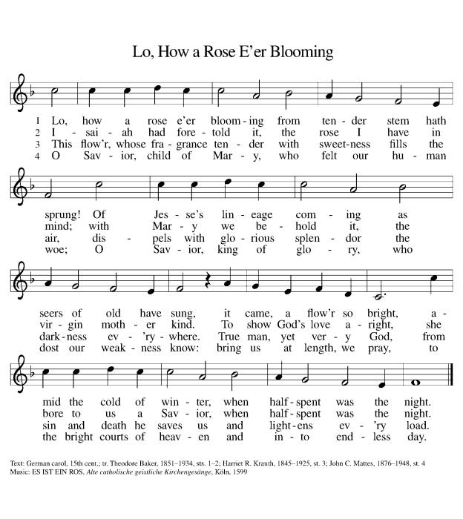
CLOSING SONG “Lo, How a Rose E’er Blooming” ELW 272

DISMISSAL
P Go in peace . Prepare the way of the Lord,
ALL Thanks be to God. Amen.

POSTLUDE Fantasia on "O Little Town of Bethlehem" Broughton

ANNOUNCEMENTS
December 20, 2020

ZOOM FELLOWHIP WILL CONTINUE WEEKLY AT 10 AM on Sundays following our online worship services. Join our Grace family for sharing news, prayers information and more. Don’t miss out! Check your eblast for details.
~~~~*~~~~*~~~~*~~~~
Monday, Dec 21, 2020 – Longest Night Service (Opportunity to lament the losses and grief of 2020)
MORE INFO ON LONGEST NIGHT ON WEBSITE – this will be a live service online

Thursday, Dec. 24, 2020 Christmas Eve Join us for a special parking lot service! Time: 3 PM & 5PM

CHRISTMAS SERVICES WILL ALSO BE ONLINE!
Get all access through our website! Share with a friend

~~~~*~~~~*~~~~*~~~~
See Website for Christmas GIVING OPPORTUNITIES

~~~~*~~~~*~~~~*~~~~

Annual Reports due – December 28th
send to Cathy Whiteside by/on December 28th. If you need re-typed, leave copy in Cathy’s box.
Annual Meeting – January 31st
Save the date

REAL NEWS TO USE DURING THESE TIMES

VISIT OUR Website www.graceoflilylake.com FOR THE LATEST NEWS AND SERVICES
Check out our updated website. Get ALL the news you NEED there – including our weekly services
And our FACEBOOK PAGE or Youtube page for activities and posts of interest:
https://www.facebook.com/GraceOfLilyLake/
https://youtube.com/graceoflilylake.com
630-365-6751
THOSE TO KEEP IN YOUR PRAYERS
FOR THE WHOLE CHURCH
* God’s Church in all time and place, that God be seen and heard.
* As we face these times both together and while apart, keep us from fear, suffering and death.
* Ministries of the ELCA and Metro Chicago Synod, especially Bishop Yehiel Curry.
* Efforts of Lutheran World Relief, ELCA World Hunger, and Disaster Relief

FOR THE WORLD
- For every living person, including the First Family and staff, facing the threat of coronavirus – it affects us all, our loved ones and our worldwide neighbors together.
- For those facing natural disasters of wildfires, hurricanes, earthquakes

FOR OUR CONGREGATION
* For God's Spirit to guide Pastor Dawn, Vision Team, and whole congregation as we face transition and change.
* As we begin Advent, help us dream powerful dreams and watch and wait with God..

FOR THOSE IN THE MILITARY (members, relatives, and friends of members of our congregation)
* Glenn Adams, son of Mark and Renee Adams * Lucy Adams, daughter-in-law of Mark & Renee Adams
* Adam Sajdak, grandson of Bill and Lori U’Ren * William Delmer, grandson of Kirk and Kathy Hooey
(If you know of someone currently serving our country, please share their information with the Church office.)

FOR ALL
* The continued support of our members * For all members of healthcare around the world
* For those serving as first responders and in the military * For our Nation, that extend peace in all things.

FOR THOSE SICK IN BODY, MIND OR SPIRIT
Fred Altstadt, Vicki Barclay, Carl Ekstrom, Carol Hammers, Jamie Hext, Manfred Kaufman, Jeannine Luchs, Joan Mortensen, Donald Overby, Ken Deutschman, Ken Patterson, Nicole Puralewski, Darlene Rentner, Pastor Rex, The Reynolds Family, Chris Richards, Nancy Schaefer, John Schnaitman, Shirley Turner, Pete and Carol Prevanas, Lisa Leyden, Pat Hill, Paul Kinsel, Pam Bohlin’s brother, Paul Mantsch, Mike Meyer, Katie Tarr, Linda Theros

FOR THOSE WHO GRIEVE
Kathy Fritschel, upon her husband Glenn’s death. We grieve with her.

Please let us know your prayer requests for inclusion in our public prayers.
Type them in the comments or send them to the church office via our prayer card on our website.

GRACE’S MISSION IS
To share God’s GRACE with all through our rich traditions of faith, family, and community.
Gospel – God’s love shared in all we say & do
Respect for all God’s people & creation
Action – response to the Gospel
Community – Loving God, neighbor, & self
Everyone – we are all God’s children

GRACE LUTHERAN CHURCH OF LILY LAKE
5N600 Hanson Road, St. Charles, IL 60175
Office: 630-365-6751
E-mail: general@graceoflilylake.com
Web Address: www.graceoflilylake.com

