GRACE LUTHERAN CHURCH OF LILY LAKE
CHRISTMAS COOKIES,
BAKED GOODS & BAZAAR
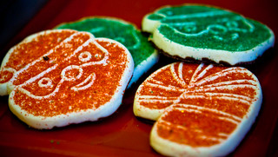
This Photo by Unknown Author is licensed under CC BY-NC-ND
Saturday, December 17
9 am to 1 pm
COOKIES - $6.00 PER POUND
*Avon  *Christmas Décor  *Frontier Soups  *Local Honey  *Handmade Winter Scarves  *Mary Kay | *Scentsy  *Silpada/Grace & Heart Jewelry  *Stampin’ Up Cards  *Young Living/  Chair Massage
Children may decorate a cookie. Take your picture with Santa.

Grace Lutheran Church:
Parking at rear of church, lower level entrance
5N600 Hanson Rd, St. .Charles, IL (Lily Lake, IL)
East of IL 47 on Empire Rd & immediate right on Hanson Rd

