OCTOBER 2022, VOL. 34
AMAZING
GRACE
CONNECTIONS
Faith > Family > Community
Grace Lutheran Church of Lily Lake
5N600 Hanson Rd, St. Charles, IL 60175
Pastor David Mercurio

Worship indoors every Sunday at 9 am
with Communion
Sunday, October 2, Worship and Sunday School
Sunday, October 9, Worship
Sunday, October 16, Worship and Sunday School
Sunday, October 23, Worship
Sunday, October 30, Worship, Reformation Sunday
(The nursery is available on Sundays for use by any parent when
Sunday School is not in session.)

REFORMATION SUNDAY, OCTOBER 30

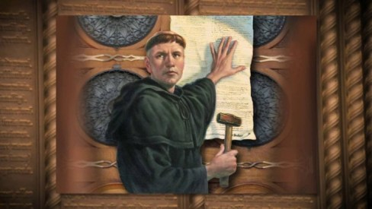
This Photo by Unknown Author is licensed under CC BY
Reformation Sunday honors Martin Luther’s bold action on October 31st, 1517
when he posted his statement of faith, known as the 95 theses on the door of
Castle Church in Wittehberg, Germany, thus beginning the Protestant Reformation.

COVID-19 Safety Protocols
We follow the recommendations of the CDC, ELCA and the IL Department of Health. Face masks are recommended, but optional. We will continue to practice social distancing in the back half of the sanctuary. If you wish to sit closer with others the front half the sanctuary is open If you don’t feel comfortable worshipping with others we invite you to join us virtually for worship via our website.

PASTOR’S MESSAGE

A Message from Pastor David for October 2022

Dear Beloved,

We certainly live in strange and discouraging times. Every day, our traditional values and our Christian world view are coming under attack and ridiculed by an increasingly humanistic and angry world. The same social media that was promised to unite society into supportive communities has in fact isolated it into tribal pools of vitriol.

The reason I mention this is to remind us how important it is to stay active and involved in our Grace community. As Jesus tells us, he is the true vine; we are the branches. Attend our weekly Sunday service consistently; join the established groups that meet regularly outside our worship such as Rebecca Circle; jump into volunteer opportunities like the Food Bank volunteer days; attend and support our special events like the bi-annual Rummage Sale; invite your neighbor or co-worker to church; let young families know about our Sunday School program that teaches Godly principles.
Why are these important? I leave you with this quote from the writer of Hebrews:

And let us consider how we may spur one another on toward love and good deeds,
not giving up meeting together, as some are in the habit of doing, but encouraging
one another—and all the more as you see the Day approaching.
Blessings to you,
Pastor David
Pastor’s Hours at church
Tuesdays and Thursdays from 6 pm – 9 pm
Saturdays from 9 – noon Sundays from 8:30 am for 3-4 hours

SEPTEMBER VISION TEAM REPORT
The Vision Team meets on the second Tuesday of each month. If you have items you feel should be discussed by the team, please send them to Marty by the first Tuesday of the month.
- Discussed the need to keep our monthly shortfall in front of our members. .A letter to be sent to members to keep them apprised of our financial situation.
- Approved estimate to make repairs on flat roof sections that are leaking.
- Nick Rex discussed our heating system, boiler and needed water filter. One of the boiler pumps quit on the Saturday of Labor Day weekend. Marty Bradley and Linda Smykowshi were able to shut it off after a good deal of hunting for the switch. Discussed possible alternatives to heating the basement.
- Noted that many light bulbs need to be replaced in the Sanctuary and parking lot.
- Sunday School kick off was September 18th and the two classes went very well.
In Christ, Marty Bradley

FINANCIAL MATTERS – September 2022
Financial Matters – October 2022
- Noisy Offering continues to be collected and our next goal is to help offset the expenses of having the (specialized) lightbulbs replaced in our sanctuary and the front and back parking lots, & possibly the rental cost of a lift to get to the high ceilings. As of Sept. 15, we have collected $439. Look for the “Noisy Offering” buckets as we will graciously accept those heavy coins in your pocket.

- We are trying to track your donations for goods and supplies that our members do not ask for/want reimbursement for. We are grateful for these donations, and ask that you submit a copy of your receipt(s) to Tricia, so we can try to tally the ‘extra costs’ for the many activities at Grace (you will keep your own receipts for tax purposes – these ‘donations’ are not reflected on your Giving statements.) We are hopeful to have a tally at year-end to report.

Brief recap on our August financials:
 |  |  |  | 2022 |  | 2021
 |  | July, 2022 |  | Year-to-Date |  | Year-to-Date
INCOME |  | $ 12,122.90 |  | $110,208.26 |  | $110,466.02
EXPENSES |  | $15,460.67 |  | $138,796.41 |  | $118,310.34
NET +/- |  | -$3,337.77 |  | -$28,588.15 |  | -$7,844.32

In Peace ~ Your Fellow Grace Member,
Tricia Painter, Treasurer
.Sunday School meets the first & third Sundays.
- Ages 3 - 6 will meet during the entire worship service time.
- Ages 7 - 11 will meet at the beginning of the worship service and will come to the sanctuary for communion at the close of the service.
Please contact Marty Bradley, Kelly Diehl or Pat Penfold if you have questions.

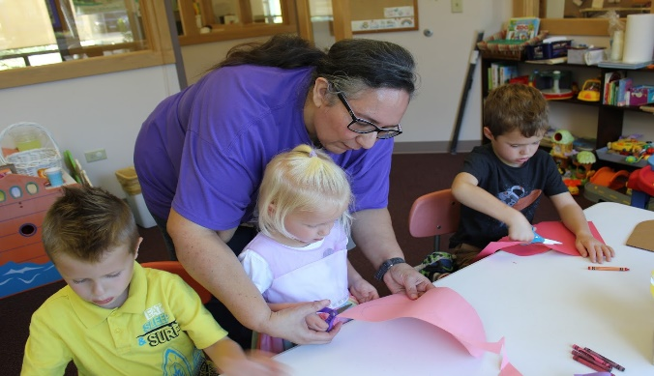

NORTHERN ILLINOIS FOOD BANK EVENT, OCT 15TH

Again, we are partnering with Bethlehem Lutheran for a volunteer event at Northern Illinois Food Bank on October 15th. Dennis Finney is heading this up and wants those who plan on volunteering to send him their names and email information. The shift time is 9:00 am – 12:00 pm at the West Suburban location 273 Dearborn Court, Geneva, IL. If you have any questions please see George Theros or send your information to DennisRFinney@aol.com. A sign up sheet is available in the narthex.

MANY THANKS AND PRAYERS TO THOSE WHO HAVE RECENTLY DONATED THEIR TIME AND TALENTS, including, but not limited to:

- All those who helped with the funeral on Saturday, September 7th and the luncheon following.
- Tricia Painter for all her hard work in putting the October Rummage Sale together and to all those who donate and work during the sale.
- Linda Smykowski and husband, Ted for assistance with boiler pump issue.
- Linda Smykowski for the wonderful community garden and bounty that was shared.
- Kathy Hooey and Helen Gruber for setting up communion every Sunday.
- Kathy Hooey for putting together the announcement half sheet every Sunday.

CONTACT A VISION TEAM MEMBER IF YOU WISH TO VOLUNTEER
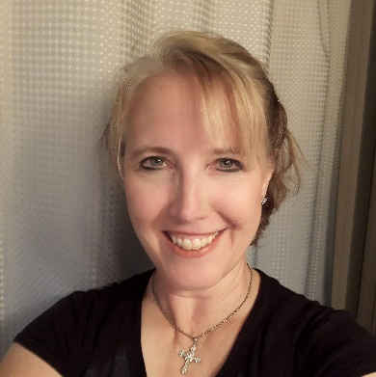
Getting to know Nancy Corbige

Greetings from Nancy Corbige,
Nancy became a member of Grace in August 2021, and she has been attending for a couple of years before that. She came to live neighboring the church June 2018 (four years ago). She has been attending church regularly and has now more recently begun to assist in the new season of Sunday school. She also represents our church in the partnership of churches for Potawatomie Habitat for Humanity. Nancy also participated in the call committee, placing our new pastor and regularly volunteers working with the rummage sale.
Nancy grew up in Morton Grove and attended a Catholic church in Niles up until 16 years old, when her parents divorced, and then hadn’t attended church for 10 years. Once married, she attended a Methodist church in Glenview and lived in Rolling Meadows before moving to our neighborhood.
Nancy has a daughter, Laura, who is 25 years old and just beginning her fourth year of grad school in Boston, with focus on Forensic Psychology. She will be called Dr. Corbige in 2024.
As a Licensed Massage Therapist (12 years), Nancy is actively working to grow her practice here in Lily Lake, with locations also in Hoffman Estates and DesPlaines. She worked 18 years for AT&T (in Desktop Publishing and as an Administrative Assistant) until her layoff in 2008. That was her opportunity to go back to school for a year to become certified, gaining her Illinois State License and is also Nationally Board Certified for Therapeutic Massage & Bodywork (BCTMB).
Nancy says, “I am so grateful to be a part of the Grace Lutheran family, and I look forward to helping the church grow. To love God and to love one another is what it’s all about. Hopefully we all keep it as simple as that and spread that love around. I’m so grateful to be with those wanting to do just that same thing. Thank you!”

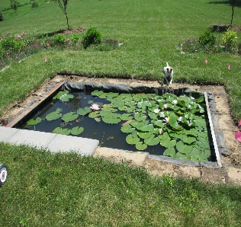
Invitation from Grace Neighbors to All Members
This Photo by Unknown Author is licensed under CC BY
Jamie and Trevor, who live at 5N537 IL Route 47, Maple Park, IL 60151 (right across the church's west driveway) have invited the folks of Grace Lutheran Church to come to their "Pond Party." Trevor, as part of his work, makes these ponds and now has constructed one in their backyard. In Jamie's words, they are "super excited" to have everyone see it, and they graciously invited all of us to come by on Saturday, October 8th at 4pm.
.
Autumn Rummage Sale - OCTOBER 7 & 8
We look forward to the continued support and assistance from all of our volunteers – in whatever time allotments you are able. Many hands make the tasks ‘at hand’ come to fruition, please note where you can help!
Donations we are not able to accept: items that are NOT in working order, older TVs (only flat screens), entertainment centers. Please consider if items are not in good shape, i.e. ask yourself “would I buy this?” – if not, please pass it along yourself before bringing it to Grace -- we simply do not have the manpower/nor hours to look through someone’s clutter. Thank you for your assistance & consideration.

Drop off donations: Sunday, Oct. 2 – after church service (**coffee hour also).
Tuesday, Oct. 4 – 1pm – 5pm
Wednesday, Oct. 5 – 5pm - 8pm
Thursday, Oct. 6 – donations accepted 9am – 3pm;
Thursday, Oct. 6 - 9am – 6/7pm? - set up all day -- volunteers needed
Friday, Oct 7 – sale hours are 9am – 4pm -- volunteers needed
Saturday, Oct 8 – sale hours are 9am – 2pm (**12noon is ½ price sale) - volunteers needed -

Please contact Tricia Painter with any questions: Email: trishe60@gmail.com ~ ~ Cell: Text/leave message: 708-624-0400

POTTAWATOMIE HABITAT FOR HUMANITY
Grace Lutheran Representative is Nancy Corbage

News: This is the 25th anniversary of the Pottawatomie Habitat for Humanity Partnership – building homes for families in need of affordable housing in the Northern Fox Valley area. The latest build on Spuhler Drive in Batavia was just completed and are looking to start the next build on Stanton Drive in St. Charles. The partnership is asking all of us to join in their work in any of these four ways: Contribute funds, Provide volunteers, Help locate a concrete contractor, Help find new property for new affordable houses.
Contributions may be made on their fundraising page, www.chicagelandhabitat.org/pottawatomie or mailed to Habitat for Humanity of Northern Fox Valley, 56 S Grove Ave, Elgin, IL 60120.

MINISTRY NEWS
Many thanks to all who have donated to the following programs:
Homeless in Chicago: jeans, hoodies, sweat shirts, suitcases, back packs, bags and hand sanitizer.
Jesus’s Closet at Newlife Covenant Church Elgin IL: Clothing for the homeless.
Redeemer Fellowship Church in St. Charles: a free clothes closet once a month for those in need, including linens and blankets.
See Cathy Whiteside for more information and how you might be able to help.

Ongoing donations are welcome!

CONTACTS:
For emergencies please contact Marty Bradley, President, at 640-777-1074 or leave a message at the church office at 630-365-6751.
For prayer requests or other needs please call Kathy Hooey at 630-341-2293 or leave a message at the church office at 630-365-6751. Messages are checked daily at noon & 5 pm.

ELCA MISSION WEBSITES

LUTHERAN DISASTER RESPONSE:
https://www.elca.org/our-work/relief-and-development/lutheran-disaster-response
ELCA WORLD HUNGER APPEAL:
https://www.elca.org/Our-Work/Relief-and-Development/ELCA-World-Hunger
LUTHERAN WORLD RELIEF:
https://lwr.org/
REFUGEE ONE https://www.refugeeone.org/

Information for the November . newsletter will be due by October 25th – please send it to Cathy Whiteside Cathy@imotay.com Thank you!

