
Apps

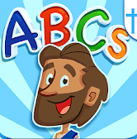
“Bible ABCs for Kids! let's your child learn their ABCs while discovering the Bible! Let your child enjoy tracing uppercase and lowercase letters while animated friends cheer them on! Reveal beautifully illustrated characters from the Bible!”

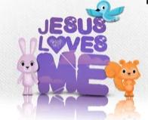
The Bible ABCs for Kids!
“Watch the original animated music video for the song Jesus Loves Me. Sing Along & record karaoke style to different remixes of the song "Jesus Loves Me" and share with your family and friends. Watch 6 animated shorts featuring Jack & Scarlett. They are teaching simple Bible verses pertaining to God's love in a fun, kid friendly format. Play a fun card matching game featuring the characters from the video.”
Jesus Loves Me

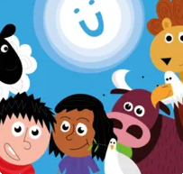
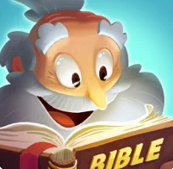
“Join Noah, his sons, and a bunch of ark animals as you learn 25 Bible verses from the Old and New Testament! Each verse runs through 5 stages of increasing difficulty allowing the player to process and store each verse into long term memory.”
Noah’s Bible Memory
God for Kids
“Who is God and What is God Like? Step-by-step explore God’s character with interactive puzzles, games and thought-provoking questions based around one Bible verse, one characteristic at a time. Ideal for kids and their grown-ups to explore spiritual questions about God together and safe for your child to play alone (no ads here!)”

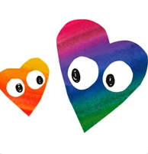
Kingdom Keys
“Complete Bible lessons to earn gems. Slowly reveal a hidden picture as the Bible passage is read. Play a catapult game to learn Bible geography. Answer questions about the meaning and application of the Bible to earn gems.”
“Explore a safe world of high quality worship music, fun games, makes, stories, prayers, Bible quotes and studies to help you and your child discover God together.”
Little Worship Company



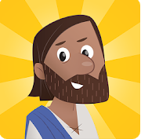
“Prepare for an epic adventure as you explore the amazing stories of the Bible. Choose your Guardian hero, then train and learn the ways of the Guardians before setting off into the world of Ancora. Explore the ancient world of the Bible, meet Jesus and return light to the city of Ancora.”
Guardians of Ancora
“Through interactive adventures and beautiful animations, kids explore the big stories of the Bible. The Bible App for Kids is a delight-filled experience designed to encourage kids to return again and again. It’s the beginning of a lifelong love of God’s Word.”
The Bible App for Kids
“This FREE Kids Bible App brings the Bible to life for the entire family with an easy to understand Bible, videos and fun engaging Bible games. Featuring 39 full-length, free episodes from the exciting Superbook animation series that includes David and Goliath, Daniel in the Lions’ Den, the Miracles of Jesus, The First Christmas, He Is Risen and more!.”

Superbook Kids Bible


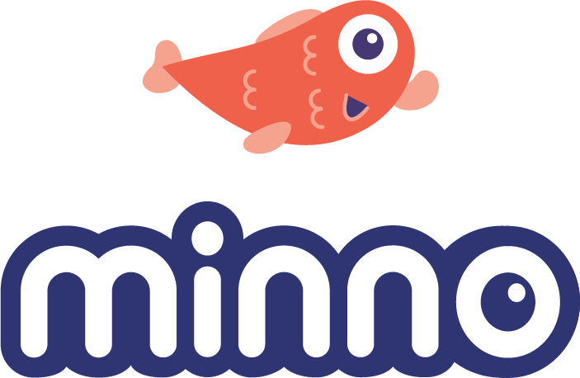

“You've read the story! Now tap, tilt and swipe through it with David in this interactive story combined with mini-games! Dozens of immersive story chapters including over 100 achievements and 7 mini-games along the way. Spend hours unlocking and mastering all the challenges!”
David vs Goliath
“Instantly stream or download thousands of hand-picked episodes that reflect your faith and values.”
Minno Kids
“Take a ride on Noah’s pet elephant as he stampedes his way around the ark! See how long you can run without being caught by Noah’s sons in this fun and exciting Bible memory game!”
Noah’s Elephant in the Room

