
Parent Handbook
2022-2023
Broadway Baptist Church
2329 E. Broadway Ave.
Maryville, TN 37804
(865) 982-6012
bbcmaryville.org

Dear Families,
We are excited to be implementing Awana this year, adding Sparks and T&T clubs to the already existing Puggles and Cubbies. Awana is a program used throughout the world as a tool to disciple children by helping them memorize and understand scripture. Awana (Approved Workmen Are Not Ashamed) is an acronym that comes from 2 Timothy 2:15, “Do you best to present yourself to God as one approved, a worker who has no need to be ashamed, rightly handling the word of truth.” We are thankful that you are entrusting us with your precious children as we strive to come alongside you as you teach your children according to Deuteronomy 6:6-9.
Please read through this handbook and keep it for future reference. You will find information about each club and a calendar with all the theme nights.

Emergencies
If you need to contact someone in Awana during club hours, please call Wendy Henson at (559) 232-9014 or Job Morales at (707) 631-7845.One of them will be able to take your call and assist you with your needs.

Puggles are our youngest Clubbers, designed for children ages two to three. They will learn four main truths: God Made Everything, God is Great, God Loves Us, and We Give Thanks. Please check in and pick up your children from their classrooms.
Cubbies is a two-year club for children the two years before they enter kindergarten. They learn basic truths about God and the Bible, working through the Honeycomb handbook one year and the Appleseed handbook the next. They learn simple Bible verses and are rewarded with patches that are displayed on their vests. Much of their learning comes through play, songs, and crafts. Please check in and pick up your children from their classroom.
Sparks is a three year club for children in Kindergarten, 1st, and 2nd grades. They will work through one book each year along with Sparky, the firefly. The HangGlidder handbook highlights Genesis through Joshua. Wingrunner goes from Judges to the birth of Christ, and Skystormer takes them from the birth of Christ to Revelation. Sparks takes on a more structured format. The club time is divided into three sections: small group time, large group time and game time.
Sparks will begin by completing a Flight 3:16 booklet and attending club for two weeks. At that point they will earn their uniform vest and get their handbook. Awards are earned to be place on their vests as they complete sections in the handbook. We provided a calendar with the theme night for each week, along with the handbook sections that will be worked on each night. Please help your child prepare by going over the section(s) during the week before coming to club. It really helps if your child does the memorization at home. Their leaders will review the lesson and listen to the children recite their verses. If they can say them with no more than two helps, the section will be signed off. If your child misses club nights, he may make up sections, just know that priority will be given to the current sections.
Sparks will be playing many games that involve running. Please send them in appropriate shoes. We will award BBC Bucks to help encourage them. They can also earn BBC Bucks for completing sections in their books, wearing their uniform, bringing their books, and many other things. Children will meet in the Fellowship Hall for the opening ceremony and be picked up in the Jungle Room.


T&T (Truth and Training) is a four-year club for children in 3rd to 6th grades. The children work through a series of four handbooks that focus on the grace of God. This year’s book is Mission: Grace in Action, which explores who God is, what the Bible does, who Jesus is, and what grace is. The book is designed so that a child needs to do one section each week. A section consists of a devotional style question and answer section, a memory verse, and a review verse. To get signed off on a section, a clubber must answer all questions and recite the verses to their leader with no more than two helps. Please encourage your child to come prepared. If your child struggles with reading or writing, it is okay to help by reading the material to and writing your child’s answers. Just make sure you record your child’s words.
T&T Clubbers will start off each year with a Start Zone booklet. Once this is completed, they will receive their books and T-shirt. Their awards can be displayed on the T-shirts. Running games are a part of the club night, so please have your child wear appropriate shoes. BBC Bucks will be giving for attendance, completing sections, wearing the T-shirt and appropriate shoes, bringing handbooks, and many other things. Children will meet in the Fellowship Hall for the opening ceremony and be picked up in the Jungle Room.
Cost
We are asking for a contribution of $30 per child. Your child will be provided with a handbook, vest or T-shirt, a bag, awards, and more. You may pay it all at once or a little at a time. If the cost is a problem, do not hesitate to ask for a scholarship. We do not want the cost to keep your child away from Awana.
Handbooks
Children will be working through their handbooks each week. They are scheduled to do one or two sections each week. See the calendar for the schedule. Ideally, a clubber will work on the section during the week with parent help as needed and come to club ready to recite the verse and go over what they learned at home with their leader. Of course, we will help your child if he or she is not prepared, but the scriptures will stay in their hearts better if they are studied at home as well as at church.
Schedule
Puggles
6:00 Free Play
6:20 Story Time
Cubbies
6:00 Story Time
6:30 Handbooks
7:00 Games
T&T and Sparks

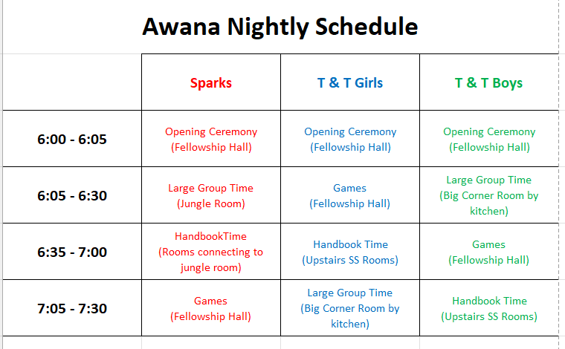
Date | CALENDAR  Theme | T & T | Sparks
Aug. 10 | Club Color | SZ Part 1 | FL 1-5
Aug. 17 | Duct Tape | SZ Part 2 | FL 6-7
Aug. 24 | BARF | 1.1 | RK 1-2 RJ 1.1
Aug. 31 | Crazy Socks | 1.2 | RK 3
Sept. 7 | Career Dress Up | 1.3 | RK 4
Sept. 14 | Apple Decorating Contest | 1.4 | RK 5
Sept. 21 | Neon | 1.5 | RK 6
Sept. 28 | Crazy Hat | 1.6 | RK 7-8
Oct. 5 | No Club - Fall Break
Oct. 12 | Superhero | 2.1 | RJ 1.2
Oct. 19 | Potato Decorating | 2.2 | RJ 1.3
Oct. 26 | Pumpkin Games | 2.3 | RJ 1.4 & GJ 1.1
Nov. 2 | Red, White, & Blue | 2.4 | GJ 1.2
Nov. 9 | Operation Christmas Child | 2.5 | GJ 1.3
Nov. 16 | Thanksgiving Theme | 2.6 | GJ 1.4 & RJ 2.1
Nov. 23 | No Club - Thanksgiving
Nov. 30 | Fruit & Veggie Decorating | 2.7 | RJ 2.2
Dec. 7 | Ugly Christmas Sweater | 2.8 | RJ 2.3
Dec. 14 | Christmas Character | 3.1 | RJ 2.4
Dec. 21 & 28 | No Club - Christmas Break
Date  Jan. 4 | Theme  Favorite Sport | T & T  3.2 | Sparks  GJ 2.1,2,3,4*
Jan. 11 | Crazy Hair | 3.3 | RJ 3.1,2
Jan. 18 | BARF | 3.4 | RJ 3.3
Jan. 25 | Cookie Decorating | 3.5 | RJ 3.4
Feb. 1 | Begin Awana GO | 3.6 | GJ 3.1
Feb. 8 | Hershey Kiss Night | 3.7 | GJ 3.2
Feb. 15 | Crazy Scarf | 3.8 | GJ 3.3
Feb. 22 | Pajama Night | 4.1 | GJ3.4
Mar. 1 | End Awana GO | 4.2 | RJ 4.1 GJ 4.3*
Mar. 8 & 15 | No Club - Spring Break
Mar. 22 | Favorite Stuffed Animal | 4.3 | RJ 4.2
Mar. 29 | Backwards Night | 4.4 | RJ 4.3
Apr. 5 | Easter Theme - Decorate egg | 4.5 | RJ 4.4
Apr. 12 | Copycat | 4.6 | GJ 4.1
Apr. 19 | Favorite Toy | 4.7 | GJ 4.2
Apr. 26 | Black & White | 4.8 | GJ 4.4
May 3 | Pinata | Make up | Make up
May 10 | Awards night
SZ = Start Zone FL= Flight 3:16 RK=Rank Path RJ=Red Jewel GJ=Green Jewel
*Need to be done at home with parent help

