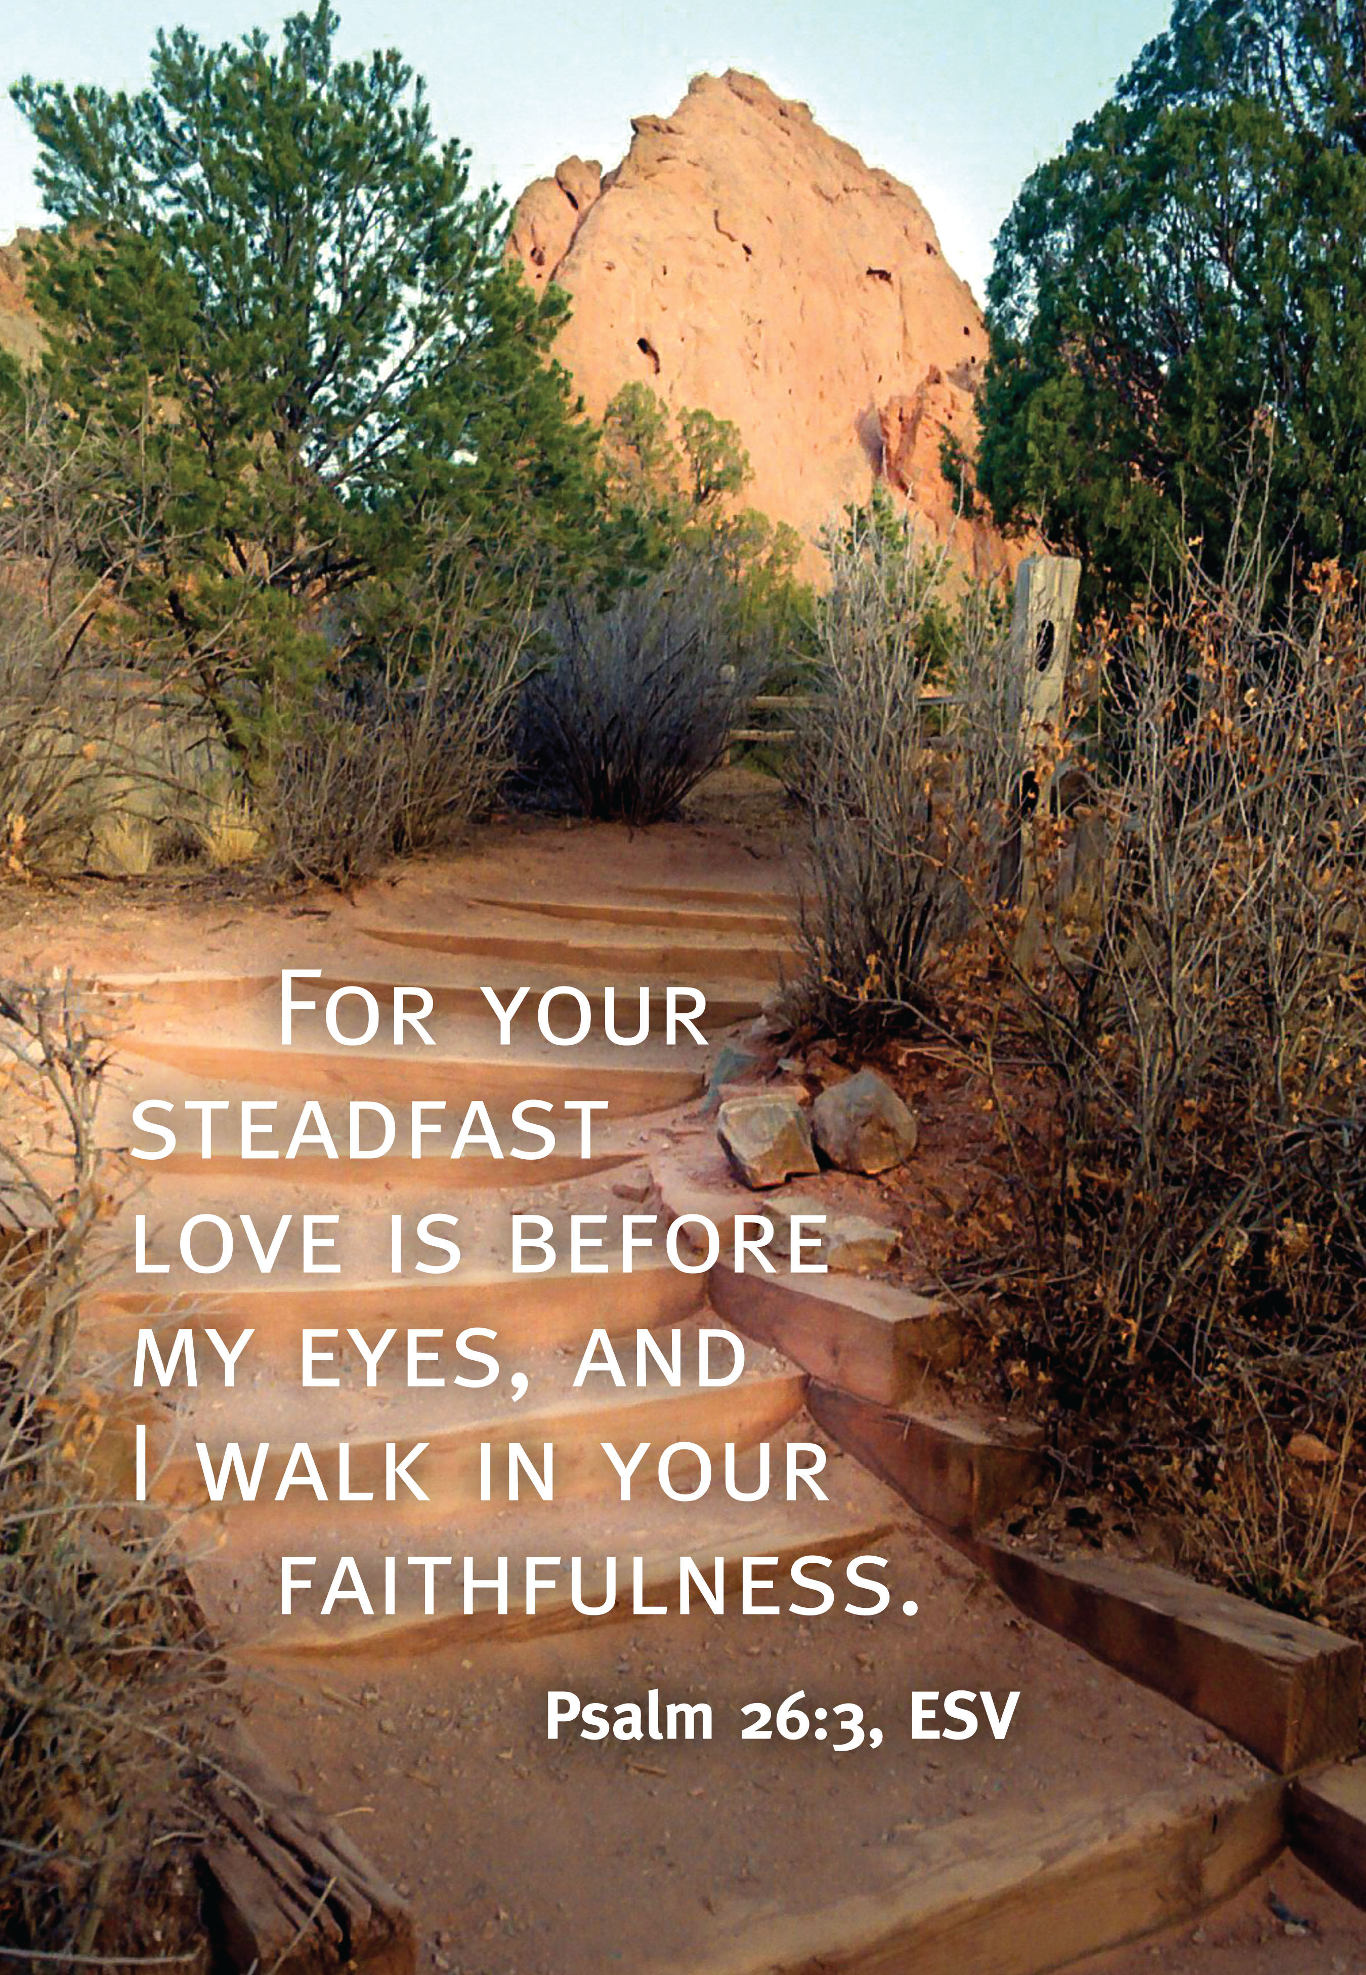

|  |
| --- |
| **Sermon Notes: 10/10/2021** |
|  |
|  |
|  |
|  |
|  |
|  |
|  |
|  |
|  |
|  |
|  |
|  |
|  |
|  |
|  |
|  |
|  |

**What’s Happening?**

**Wednesdays Nights**

Our regular family nights have resumed with the fund raiser dinners at 5:30 and groups at 6:30.

**Online Study**

Each Thursday morning in our Church App, Website, and YouTube account, Pastor Ryan is teaching his series: **Notes On The End, a study of Revelation**.

Notes for this study are available upon request through the office.

**October Pastor Appreciation Month**

Each Sunday in the month of October we will be honoring one of the Ministry leaders in our church.

- Oct. 3rd: Kids Ministry: Julia Morrow

**- Oct. 10th: Youth Ministry: Pastor Jake - TODAY**

- Oct. 17th: Church: Pastor Ryan

- Oct. 17th: Church Potluck following the service

**Annual Harvest Fest**

**October 27th 5:30pm** is our Annual Harvest Fest! Many great things are being planned! Come and be a part of the family! If you are planning on dressing up, we ask that you keep it **Old Fashioned Farmer themed** since we are in the harvest season!

**We are collecting candy**

**for the games for this event!**

Services

Sunday:

Sunday School Classes – 9am

Morning Service, Nursery (0-3) & Children’s Ministry (4-11) – 10am

Corporate Prayer – 6pm

Other Sunday Service viewing options:

* Radio broadcast in the parking lot at 88.9FM
* Message will be posted on our Facebook Page: [www.facebook.com/AlbertLeaAssemblyofGod.org](http://www.facebook.com/AlbertLeaAssemblyofGod.org)

Wednesday Family night!

5:30pm Fundraiser Dinner – 6:30pm Groups

- Adult Classes

- 4 – 10 years old – SuperKidz

- 11 – 18 years old – Youth Service

**We Care about You!**

If you or someone you know within the church is in need of care, please let us know! We want to be able to direct caring members of the church to call, pray or just send a little encouragement your way.

To share prayers and needs, please call the church office at 507-373-7989 or call Pam Virchow 507-383-1041 or Edie Miller 507-852-3116

Giving   
Tithes and offerings are collected during the Sunday Service. You can also mail in your tithes to the church office or text “alag1942” to 888-364-4483 to give online. Thank you for your faithful giving; because of you we are able to continue blessing our church family and our community!

**Assembly of God Church**  
1540 S Shore Dr  
Albert Lea, MN 56007

Lead Pastor – Ryan Quigley

507.373.7989

alag2016@outlook.com