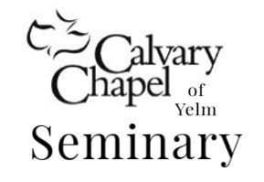
CCY Seminary Syllabus 2026 Cohort

REQUIRED VIEWING
- Pastor Nick’s Teaching Video on CCY Website: www.calvarychapelyelm.org/seminary.html
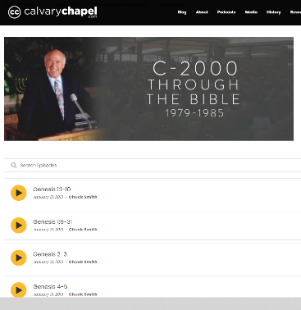
- *Not required if you attend Pastor Nick’s message outline teaching
REQUIRED READING
- The Philosophy of Ministry: Book by Chuck Smith
REQUIRED LISTENING
- Chuck Smith Audio Messages: https://calvarychapel.com/posts/c2000/
- *See page 2 for Listening Schedule under “Course Work Schedule”
REQUIRED ASSIGNMENTS: PART A and B Components
Assignments are to be submitted weekly by email to your mentor for review. Feedback will be sent back by email. Mentors will be available for questions by email/ phone.

Two Components

A. Listening Essay: Compose 1 Weekly Essay based on required listening
- 8 Total essays per course. One due at the end of each week
- Essays will include the following subtitles:

      - Overview
      - Major Doctrinal Concepts
      - Application
      - New Things Learned

- See Essay and Outline Format document for essay format guidelines
- Send your weekly listening essay to your mentor each Saturday
Objective: Learn how to communicate the Word of God

B. Message Outline: Create 1 Monthly Outline on a Bible chapter of choice
- Two total Outlines per course. One due at the end of each month
- Choose a Bible Chapter to Outline and Present [Except chapters from assigned listening]
- Section/Add cross references/Add commentary/Add personal experience
- Outline material must be sufficient to fill a 45-minute message [5-7 pages]
- Actual presentation will be a 15-minute message using partial outline material
- Send In-Progress outline to your mentor each Saturday to be completed in 4 weeks
- See Essay and Outline Format document for format guidelines
Objective: Learn to read/study and teach the Word of God in context utilizing cross references, commentaries, listening assignments and personal experience
2026 COURSE WORK Assignment Schedule*
*Correlates to Calendar

Week 1
A: Listening and Essay 1 February 2-6 Jeremiah 1-14
B: Message Outline Draft 1
Week 2
A. Listening and Essay 2 February 9-13 Jeremiah 14-25
B. Message Outline Draft 2
Week 3
A. Listening and Essay 3 February 16-20 Jeremiah 26-37
B: Message Outline Draft 3
Week 4
A. Listening and Essay 4 February 23-28 Jeremiah 38-52
B. Message Outline COMPLETED

Presentation Day Saturday February 28th 9am to 2pm
-----------------------------------------------------------------------------------------------------------------------

Week 5
A. Listening and Essay 1 March 2-6 John 1-5
B: Message Outline Draft
Week 6
A. Listening and Essay 2 March 9-13 John 6-10
B. Message Outline Draft
Week 7
A. Listening and Essay 3 March 16-20 John 11-15
B: Message Outline Draft
Week 8
A. Listening and Essay 4 March 23-27 John 16-21
B. Message Outline COMPLETED

Presentation Day Saturday March 28th 9am to 2pm

