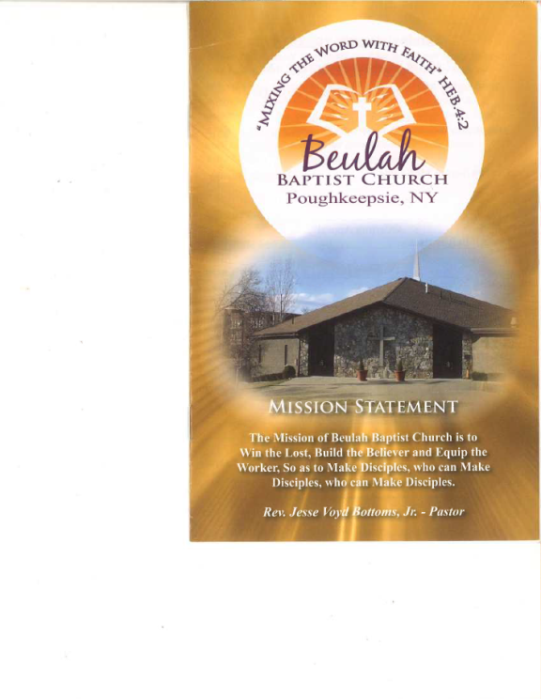**FGMM**

**FINE GOLD MEN’S MINISTRY SCHOLARSHIP APPLICATION**

The Beulah Baptist Church Men’s Ministry is a dynamic group of men consisting of all ages and backgrounds who have come together to provide leadership and stability in our church and community. The scholarship is for young men who are active members of Beulah Baptist Church and have demonstrated their commitment to God, their community and family. A $500.00 scholarship will be rewarded.

**Scholarship Requirements:**

* High school seniors or continuing education students with a minimum GPA of 2.0
* You must provide documentation of enrollment to a full time accredited college.
* Applicants must be an **active member (or parent(s)) of Beulah Baptist Church**
* An Action Plan detailing the steps for a young man to follow to achieve the following objectives:

1. How to gain favor with God.
2. How to maintain stability in your family life.
3. How to improve relations within your community.

* Your Action plan must be at least 500-750 words; Typed at 12 Font
* Your most recent high school or college transcript
* A current letter of recommendation from teachers/guidance counselor or clergy.

**SCHOLARSHIP APPLICANT INFORMATION**

FIRST NAME_____________________________ LAST NAME____________________________

ADDRESSS_____________________________________________________________________

CITY______________________________________ STATE____________ ZIP__________________

CELL PHONE #____________________________ EMAIL___________________________________

PARENT #_____________________________________

HIGH SCHOOL____________________________________

GRADUATION DATE___________________

**College Information:**

Career Interest or Major Field of Study:_____________________________________________

Name of college or university (**accepted**) that you plan to attend.

Name of Institution: ___________________________________________________________

ADDITIONAL BACKGROUND

Extracurricular Activities – (You may attach a separate sheet, if necessary)

List school activities in which you have participated. Include Awards/Honors or Office held

____________________________________________________________________________________________________________________________________________________________________________________________________________________________________________________________________________________________________________________________________________________________________________________________________________________________________________________________________________________

Community Service – (You may attach a separate sheet, if necessary)

List all community volunteer services you have performed. Include any Special Awards/ Honors.

____________________________________________________________________________________________________________________________________________________________________________________________________________________________________________________________________________________________________________________________________________________________________________________________________________________________________________________________________________________

(Optional) Please include any significant circumstances that you would like the committee to consider when reviewing your application.

________________________________________________________________________________________________________________________________________________________________________________________________________________________________________________________________________________________________________________________

I certify that the information on this form is true and complete to the best of my knowledge.

**__________________________________________________________________**

Student Signature and Date

With your completed and signed application you must include the following:

* Your Action Plan
* High School or College Transcript
* A current letter of recommendation

**Applications must be postmarked by May 6, 2022. Please send to:**

**Attn.: Leola Ruffin-McPhee**

**Beulah Baptist Church Scholarship Ministry**

**92 Catherine Street**

**Poughkeepsie, NY 12601**

**Scan and email to: ruffinly@gmail.com**