
HOLDING ON TO HOPE
Hebrews 10:23 | Isaiah 41:10
- Trusting God with the year ahead – plans, changes, and unknowns
- Renewed faith – courage to walk in obedience
- Hope-filled expectation – confidence in God’s promises.
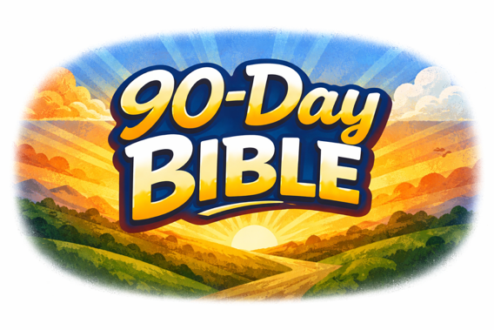

JOIN US IN THE 90-DAY BIBLE READING PLAN
Beginning January 11th, we are also launching a church-wide 90-Day Bible Reading Plan designed to help us stay consistent in God’s Word and learn to recognize the voice of God together. This week’s Prayer & Fasting scriptures are also integrated into this plan!

The 90-Day Bible Reading Plan is available in the Greater Lansing First APP. Download the app using the link below to get started:

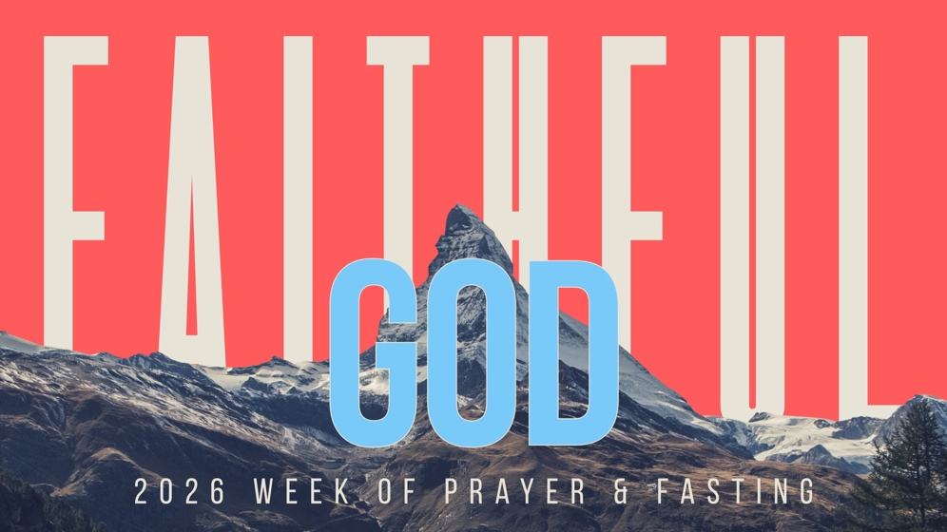

Week of Prayer & Fasting | January 11–17, 2026
“The faithful love of the LORD never ends! His mercies never cease. Great is his faithfulness; his mercies begin afresh each morning.”
— Lamentations 3:22–23 (NLT)
This week of prayer and fasting is about fixing our eyes on who God is. He is FAITHFUL. We pray not out of fear, but out of confidence in a God who has always been faithful—in our lives, our church, our city, and every generation.
Each day this week, we pray not about how faithful we can be, but about how faithful God already is.

REMEMBERING GOD’S FAITHFULNESS
Lamentations 3:22-26 | Psalm 77:11-15
- Thank God for past provision, protection, and answered prayer
- Recall specific moments where God carried you through difficult seasons
- Express gratitude for His faithfulness over the last year



FAITHFULNESS IN OUR PERSONAL LIVES
Psalm 37:3-5 | Proverbs 3:5-6
- Family needs – relationships, health, unity, and peace
- Financial and work decisions – provision, wisdom, integrity
- Personal growth – spiritual renewal and deeper trust in God


FAITHFULNESS IN THE CHURCH
1 Corinthians 1:8-9 | Hebrews 10:24-25
- Church leadership – wisdom, humility, and spiritual clarity
- Unity in the body – love, grace, and healthy relationships
- Mission and discipleship – reaching people and growing in faith

FAITHFULNESS IN OUR CITY
Jeremiah 29:7 | Matthew 5:14-16
- Neighborhoods and families – safety, healing, and restoration
- Local leaders and public servants – wisdom and integrity
- Churches and ministries – cooperation and spiritual impact



FAITHFULNESS TO FUTURE GENERATIONS
Psalm 145:1-4 | Deuteronomy 6:4-7
- Children and students – protection, identity, and faith
- Schools and teachers – strength, patience, and influence
- Parents and mentors – wisdom to lead the next generation well


FAITHFULNESS IN OUR NATION
Proverbs 21:1 | 1 Timothy 2:1-4
- National leaders – wisdom, humility, and moral courage
- Healing from division – unity, truth, and peace
- Spiritual renewal – repentance, humility, and a return to God

