

LEADER OVERVIEW

Volume Overview—My Journey Begins
In these sessions, kids will learn about the promise fulfilled through the baptism in the Holy Spirit and how the Early Church came together and grew. They will look at the change that happens when they recognize Jesus as Lord and know that God is always with them.

SESSION 1: Baptism in the Holy Spirit—  Acts 1:8; 2:1–12  Faith Fact: The Holy Spirit empowers me. | SESSION 2: The Church Begins—Acts 2:42–47  Faith Fact: The church helps me grow.
SESSION 3: Saul on the Damascus Road—  Acts 9:1–22  Faith Fact: God changes my life. | SESSION 4: Paul and Silas in Prison—  Acts 16:16–34  Faith Fact: With God, I am never alone.

SESSION OVERVIEW
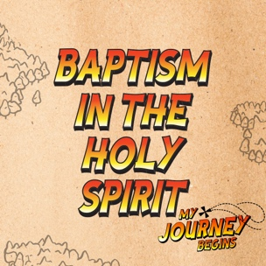

In this session, kids will learn about the promise Jesus made to His followers before going back to heaven. They will see the promise fulfilled through the baptism in the Holy Spirit and learn that the Holy Spirit is available to them.

Bible Lesson | Faith Fact
Baptism in the Holy Spirit  Acts 1:8; 2:1–12 | The Holy Spirit empowers me.
Faith Verse
Acts 1:8 (NLT)
“But you will receive power when the Holy Spirit comes upon you. And you will be my witnesses, telling people about me everywhere—in Jerusalem, throughout Judea, in Samaria, and to the ends of the earth.”

Listen Kids is part of an entire kids’ discipleship strategy. Get access at KidminRoadmap.com.
PREPARING FOR THE SESSION
You Will Need | Getting Ready
Large Group  - Bible  - Worship songs (Song suggestions: “Zeal” by The Belonging Co; “Way Maker” by Hillsong; “See a Victory” by Elevation Worship; “Yes and Amen” by Chris Tomlin)  - Spicy cinnamon candy, two boxes  - Water, two bottles  - Poster board, three sheets  - Marker  - For groups not using a phone or tablet only, add:  - Projector or TV  - Laptop  - Countdown 5-Minute Video  - Theme Intro Video  - Faith Fact Slide or Motion Graphic  - Countdown60 Video  - Game Time Slide or Motion Graphic  - Bible Lesson Slide 1  - Bible Lesson Video A  - Bible Lesson Video B  - Faith Verse Video or Slide  Small Group  - Red or orange ball  - Bibles, one per kid  - Small Group Faith Verse Review, one per team  - Scissors  - Smartphone or timer  - Small Group Activity Page, one per kid  - Colored pencils | Large Group  - Download videos and slides if needed.  - Select worship song(s) and have them ready to play.  - Write one of the following phrases on each sheet of poster board: "Empowers you," "Helps you witness," and "Prays for you."  Small Group  - Print the Small Group Faith Verse Review, one per team.  - Cut apart the Faith Verse segments.  - Print the Small Group Activity Page, one per kid.
Check out all the promotional and extra media files available for this theme. To access the Bible Engagement Project from a computer, visit App.BibleEngagementProject.com.

Find the corresponding Bible Fact-Pak® question numbers for this session in the Volume Additional Assets on the mobile or Web app.

LARGE GROUP (30 Minutes)
See what’s needed at the beginning of the session.

INTRODUCTION
- Optional: Play the Countdown 5-Minute Video.



Welcome

Welcome! I’m so glad you’re here! We’re starting a whole new series today, and it’s all about what happened after Jesus went back to heaven. Let’s watch this video, and then we’ll get started.
- Play Theme Intro Video.

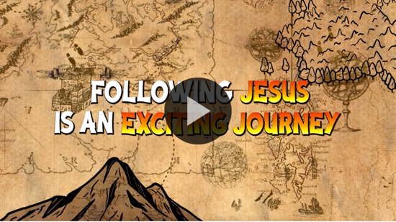

Remember how Jesus came to earth to die for our sins? (Group response) Well, when Jesus had done that, it was time for Him to go back to Heaven. Can you imagine how His disciples might have felt when they realized Jesus was leaving them? (Allow responses.) I’m sure they were scared and not sure what they were going to do without Him.

Jesus knew that they would feel these emotions, so He made them a very special promise that would happen shortly after He returned to heaven. That promise wasn’t just for the disciples who were around back then. It’s for all of us, too. Jesus was going to send the gift of the Holy Spirit to empower believers to be His witnesses and continue growing His Church.

Faith Fact
- Show the Faith Fact Slide or Motion Graphic.

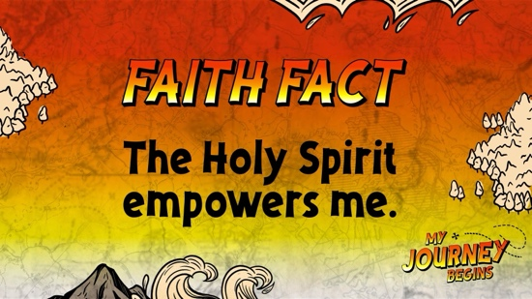

Today’s Faith Fact tells us that we can be empowered by the Holy Spirit. The Faith Fact is The Holy Spirit empowers me. We are going to say the Faith Fact together. I want you to flex your muscles while you say the Faith Fact today. The Holy Spirit empowers me. Let’s say it two more times. Ready? The Holy Spirit empowers me. Great job!

GAME | Cinnamon Candy Challenge
You Will Need | Getting Ready
- Spicy cinnamon candy, two boxes  - Water, two bottles | No prep is needed for this activity.

- Show the Game Time Slide or Motion Graphic.


The believers had what looked like flames on their heads, but someone’s mouth is about to be on fire. Who likes cinnamon candy? (Group response) I need two people who think they can quickly finish a box of spicy cinnamon candy. You can’t spit them out or have anything to drink until the candy is gone.
- Choose two kids, who have no food allergies, to come up to the front and give each of them a box of candy.

Let’s see if you are up for the challenge. You’ll have one minute. The one who eats the most candy is the winner. Everyone, help me count them down to start the challenge. Three, two, one, go!
- The two volunteers can’t have anything to drink or spit out the candy during the challenge or they lose.
- Cheer them on and encourage the kids to cheer.
- The game is over when a kid finishes a box of candy.
- Give each kid a bottle of water at the end of the challenge.
- Play Countdown60 Video-60 seconds.

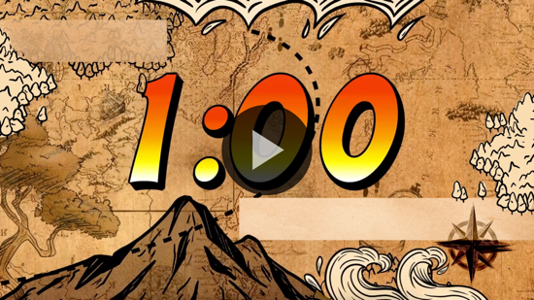

WORSHIP

Did you know that if we have asked Jesus to forgive us for the wrong things we’ve done, then the Holy Spirit is with us? God knew that we might feel lonely and sad sometimes, so He gave us the Holy Spirit. The Holy Spirit lives inside Christians, and He is here to comfort us and help us. Those are great reasons to worship God.
- Lead the kids in singing one or two praise songs. See suggestions at the beginning of the session.

BIBLE LESSON | Baptism in the Holy Spirit (Acts 1:8; 2:1–12)

- See Preparing for the Session on page 2 for items needed here.

I love singing and worshipping God with all of you! Today’s Bible story is so important because it tells us how we can be empowered. Let’s pray and ask God to help us be open to the gift He wants to give to us today.

Prayer

Dear God, thank You for sending the Holy Spirit to live inside us. Help us to receive something new from Your Spirit today. Amen.

Video Intro

Before we get started with the Bible story, let’s check in with the Challenge Accepted team and see what they’re up to.
- Play Bible Lesson Video A.

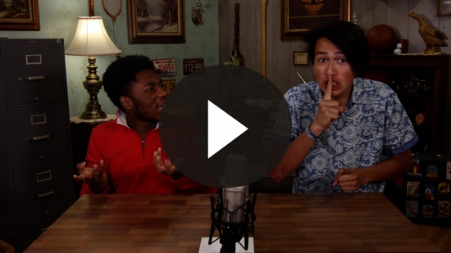

Wow! Would you try that challenge? (Group response) That’s such a fun way to start our Bible story today!

Teaching Time
(Open the Bible to Acts 1:8.) If you have your Bible, turn with me to Acts 1:8. (Allow time for the kids to turn to the passage in their Bible.)

Over the past few sessions, we’ve heard about Jesus’ death on the Cross and His resurrection. Jesus died for our sins, but He defeated death when He rose from the dead. Jesus’ work on earth was finished, but before He ascended to heaven, He had a special message for His followers. Let’s read this verse together.
- Read Acts 1:8.

That verse is extra important because it was the last thing we know Jesus said to His disciples before He went back to heaven. That’s a big deal. Now, this verse can be a bit confusing because it says that we will receive power when the Holy Spirit comes on us. Don’t we already have the Holy Spirit living inside of us? (Allow response.)

Yes! The Holy Spirit lives in us when we follow Jesus and receive salvation. That’s not what this verse is talking about. This is something different. This verse is talking about the baptism in the Holy Spirit. This was a new gift that no one had ever experienced before. Now, we have to go to chapter 2 to see the first time the disciples experienced it.

Jesus had given very clear instructions for the disciples to wait in Jerusalem until they received the power of the Holy Spirit. Can you imagine how hard it must have been to wait? They had seen Jesus die on the Cross and then saw Him after He rose from the dead. They saw Him ascend into heaven. I imagine they wanted to tell everyone they knew about how amazing Jesus is.

But Jesus told them to wait, so they waited, and they waited, and they waited some more. It was about ten days after Jesus had ascended to heaven and fifty days after Jesus had risen from the dead when the Holy Spirit filled the disciples with His power. Let’s read what happened.
- Read Acts 2:1–4.

What just happened? (Allow responses.) The believers were meeting and praying together, and what sounded like a giant windstorm filled the house. Things that looked like flames of fire were on top of their heads, and they were filled with the Holy Spirit and began speaking in other languages that they had never learned. Nothing like this had ever happened before. This was the fulfillment of Jesus’ promise to send the Holy Spirit.
- Show Bible Lesson Slide 1.

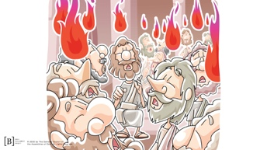

People from all over the world who spoke different languages heard them and understood what they were saying.
- Read Acts 2:7–11.

The people listening to the disciples were amazed but also confused because they had no clue how this was happening. What would you have thought if you had been there? (Group response)

The story didn’t end there though. The streets were packed full of people because of the special festival that was happening in Jerusalem. The disciples had created quite a stir among the people with their joy and celebration. One of the disciples, Peter, spoke to the crowd. He was full of courage because the Holy Spirit was helping him. Peter told them of the incredible things Jesus had done.

On that special day, about three thousand people decided to follow Jesus because of Peter’s message. Something special had begun and the power of the Holy Spirit was helping the disciples have the boldness to speak and do the things God was leading them to do.

Let’s talk about three reasons you should want to be baptized in the Holy Spirit. Who wants to be powerful for Jesus? (Allow responses.) All of us want that, but we can't be powerful on our own. We need the power of the Holy Spirit. The Holy Spirit will empower you to witness, share what you believe with others, and live for Jesus.
- Have a kid volunteer hold up the “Empowers you” poster board.

The believers who were filled with the Holy Spirit spoke in other languages. The believers didn't know what they were saying, but the people who heard them speaking understood the languages the believers were speaking. They said the believers were talking about all the wonderful things God had done.

Peter went on to preach to the people who had gathered, and more than three thousand people came to believe in Jesus because of the boldness and power that came from the Holy Spirit. The Holy Spirit can help you witness and share your faith with others with the same boldness and power Peter had.
- Have another kid hold up the “Helps you witness” poster board.

How many of you sometimes struggle with knowing what to pray? (Group response) The Holy Spirit can help you with that, too.
- Read Romans 8:26–27.
- Have a third kid volunteer hold up the “Prays for you” poster board.

If you’re a follower of Jesus, you already have the Holy Spirit living inside of you. But don’t you want to receive the power of being baptized in the Holy Spirit? When you are baptized in the Holy Spirit, you will receive God’s power, the Holy Spirit will help you witness, and the Holy Spirit will pray for you when you don't know what to pray.
- Have the three kids with poster board return to their seats.

Faith Verse
Our Faith Verse reminds us that Jesus wants us to receive the gift of the baptism in the Holy Spirit so we can be empowered to tell others about Him. Let’s learn the actions together.
- Show the Faith Verse Video or Slide.

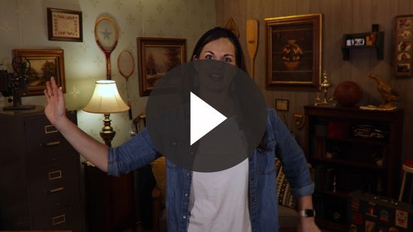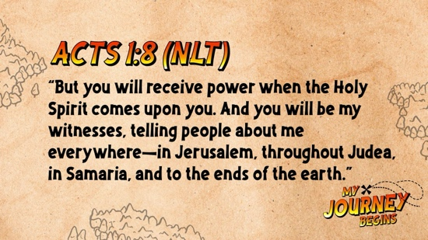

Acts 1:8 (NLT)
“But you will receive power when the Holy Spirit comes upon you. And you will be my witnesses, telling people about me everywhere—in Jerusalem, throughout Judea, in Samaria, and to the ends of the earth.”

We can all receive the gift of the baptism in the Holy Spirit today.

PRAYER AND RESPONSE
You Will Need | Getting Ready
No supplies are needed for this activity. | No prep is needed for this activity.

Consider playing a worship song softly in the background while kids pray.

Do you want to be empowered by the Holy Spirit today and every day? Ask God to baptize you in the Holy Spirit. When you receive this gift, you’ll speak in a new language that you haven’t learned. You can pray to God with this new language.

If you are given new words or sounds to speak, then speak them out. Remember, you won't understand it, but it is the Holy Spirit praying for you. You can continue to use your new prayer language in your personal time with God at home or at church.
- Give kids time to pray. Then introduce the worship song. This could play in the background while kids pray or could be a worship song to sing together.

Worship Song
Play one or two worship songs.

Video Wrap-Up

Before we go to our small group activities, let’s see how the Challenge Accepted team’s challenge worked out.
- Play Bible Lesson Video B.

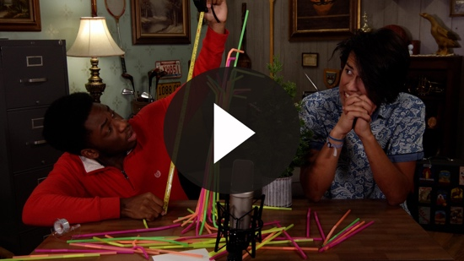

We just spent time praying for God to baptize us in the Holy Spirit. If you didn’t receive that gift from God today, it’s fine. Just accept the challenge that the team gave us and continue to ask God to baptize you in the Holy Spirit.
- Show the Faith Fact Slide or Motion Graphic.

Our Faith Fact is an important reminder of why we want to be baptized in the Holy Spirit. Say it with me. The Holy Spirit empowers me. I am so thankful we have the Holy Spirit living inside us. And we all can receive the power of the Holy Spirit. God wants to give each of us this special gift.

I can’t wait to see you all again next time when we take a look at what it means to be a part of the Church.
- Dismiss kids to Small Group time or to go home if your group time ends here.

SMALL GROUP (30 Minutes)
This section can be done in conjunction with the large group, or on its own if you do small groups with your kids. During Small Group time, the goal is to connect the kids with the Word of God and to each other. All activities are led by the small group leader.

GROUP CONNECTION | Ball of Fire
You Will Need | Getting Ready
- Red or orange ball | No prep is needed for this activity.

We are going to pretend this ball is a ball of fire. That means you want to catch it because it represents the incredible power of the Holy Spirit. I will sit in the middle of the group with my eyes closed. I will say, “Go,” and you will pass the ball of fire around the circle as quickly as you can. We want as many people as possible to experience the power of the Holy Spirit! When I say, “Stop,” and open my eyes, whoever has the ball of fire must share something they want the Holy Spirit to help them with. Let's play!
- Keep playing until most of the kids have had a chance to answer.
- Give kids ideas and examples of the things they could mention, for example, boldness or confidence.

BIBLE LESSON RECAP | The Baptism in the Holy Spirit (Acts 1:8; 2:1–12)
You Will Need | Getting Ready
- Bibles, one per kid | No prep is needed for this activity.

It was time for Jesus to return to heaven. Can you imagine how sad and scared the disciples were? (Allow responses.) Jesus knew they would be scared and would need help with the job He had given them. That’s why He promised to send them a gift to help and empower them to continue the work He started on earth. Let’s read about His promise and see how it was fulfilled.
- Divide the Bible reading into smaller chunks for volunteers to read aloud: Acts 1:8; 2:1–6, 7–12.

What is one thing that you remember about our Bible story? (Allow responses.)

Faith Fact

God wants us all to receive the baptism in the Holy Spirit just like the disciples. He has given us all access to the Holy Spirit. We just need to ask God for this awesome gift and open our hearts to Him. Then we can be empowered by God’s Holy Spirit.
- Show the Faith Fact Slide or Motion Graphic.

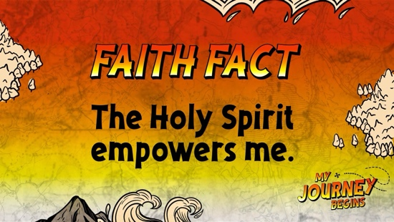

Say the Faith Fact with me: The Holy Spirit empowers me.

GROUP DISCUSSION

Feel free to use all or just a few questions as a jumping-off place for good discussion. Questions marked with * are designed for more conversation. Adjust the questions based on the age or maturity of your group. Typically, older kids will be able to dive a little deeper than younger ones.

Questions

Why do you think Jesus wanted the disciples to wait for the Holy Spirit?

Who preached to the crowd after the believers were baptized in the Holy Spirit?

Do you feel powerful or weak? Why?

* When do you feel the most powerful? When do you feel the weakest?

* Who is the strongest person you know? What makes them strong?

Do you want to be filled with the Holy Spirit’s power? Why or why not?

How can you receive the Holy Spirit’s power?

* What is something the Holy Spirit can help you with?

Do you need more help knowing how to tell your friends about Jesus or knowing what to pray for?

* Have you ever missed an opportunity to tell someone about Jesus? What happened?

APPLICATION AND RESPONSE

I’m sure the disciples felt lonely after Jesus went back to heaven. We all can feel that way sometimes. That’s why it’s so important to remember that the Holy Spirit is living inside of us and that He is with us all the time. God wants to empower us by His Holy Spirit so we can do bold and courageous things we could never do in our own strength. Are you ready to receive power from the Holy Spirit today?

Make It a Habit
Select a simple visual reminder of the session’s Faith Fact.

Remember our Faith Fact? Let's say it together. The Holy Spirit empowers me. Fire is very powerful. You can find fire or heat at work almost anywhere—the sun, your stove or microwave, the dryer, when your mom lights a candle, or in your fireplace. Those are just a few examples. Heat and fire empower things and light them up. When you see fire or heat at work this week, take a moment to pray and ask God's Spirit to empower you and fill you.

What else could we use to remember?
- Make notes of what the kids share.

Prayer

Let’s pray and ask the Holy Spirit to fill us and empower us.

Dear God, thank You for giving the Holy Spirit. Please help us to be bold enough to ask for the gift of the baptism in the Holy Spirit. Amen.

FAITH VERSE REVIEW
You Will Need | Getting Ready
- Faith Verse Review, one per team  - Scissors  - Timer | - Print the Faith Verse Review, one per team.  - Cut apart the Faith Verse segments.

Our Faith Verse for today is Acts 1:8. It reminds us that Jesus promised to send the Holy Spirit to fill us with His power. Let’s say the Faith Verse and do the actions for the verse together.
- Show the Faith Verse Video or Slide.

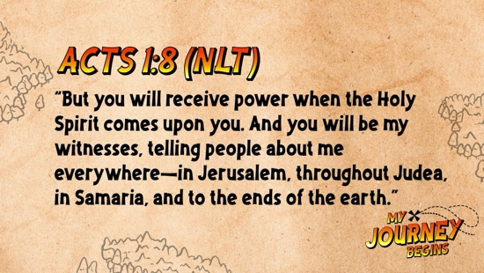

Acts 1:8 (NLT)

“But you will receive power when the Holy Spirit comes upon you. And you will be my witnesses, telling people about me everywhere—in Jerusalem, throughout Judea, in Samaria, and to the ends of the earth.”

Faith Verse Fun | Your Verse Is on Fire

Let’s go over the Faith Verse together as a group a couple of times. Remember to say it as loud as possible so everyone can hear you!

Acts 1:8 (NLT)

“But you will receive power when the Holy Spirit comes upon you. And you will be my witnesses, telling people about me everywhere—in Jerusalem, throughout Judea, in Samaria, and to the ends of the earth.”
How fast do you think you could say the Faith Verse? (Group response) We’re going to form two teams, and the teams will compete against each other and the clock. In each round, you will attempt to put the verse in order before the other team and before the time runs out. The time will get shorter for each round.
- Have each team stand in a circle.
- Give each kid a slip with words from the Faith Verse on it.
- For the first round, give the kids sixty seconds to get their verse in order. If they beat the clock, play a second round.
- For the second round, mix up the verse again and give the teams forty-five seconds to get their verse in order.
- Play more rounds, decreasing the time for each round until the kids can no longer beat the clock.

ACTIVITY PAGE | The Baptism in the Holy Spirit
You Will Need | Getting Ready
- Activity Page, one per kid  - Colored pencils | - Print copies of the Activity Page, one per kid.

There is a special name for the day when the disciples were first filled with the Holy Spirit. It’s Pentecost. We are going to spend some time coloring our pictures of the Day of Pentecost. As we do that, let’s talk about times at church and at home when we have seen the power of the Holy Spirit at work.
- While the kids are coloring, ask them about their experiences at church and home with the Holy Spirit.
- Leaders should also share stories from when they have experienced God’s power.

Prayer

Dear God, thank You for giving us the Holy Spirit to fill us and empower us to do what You have called us to do. Amen.

FAITH FACT RECAP
- Display the Faith Fact Slide or Motion Graphic as parents are coming into the room.
- Maximize the time you have with your kids, so that parents see what their kids have learned. Have the kids repeat the Faith Fact, and then dismiss them to their parents.

This is the answer to the question your adults are going to ask: “What did you learn today?” Let’s say the Faith Fact together: The Holy Spirit empowers me.

DISMISSAL
- Send home the Activity Page.
- Remind parents that there are Family Devotions available on the app to do with their kid.
- Tell everyone the date and time for the next session.

