

LEADER OVERVIEW

Volume Overview—My Journey Begins
In these sessions, kids will learn about the promise fulfilled through the baptism in the Holy Spirit and how the Early Church came together and grew. They will look at the change that happens when they recognize Jesus as Lord and know that God is always with them.

SESSION 1: Baptism in the Holy Spirit—  Acts 1:8; 2:1–12  Faith Fact: The Holy Spirit empowers me. | SESSION 2: The Church Begins—Acts 2:42–47  Faith Fact: The church helps me grow.
SESSION 3: Saul on the Damascus Road—  Acts 9:1–22  Faith Fact: God changes my life. | SESSION 4: Paul and Silas in Prison—  Acts 16:16–34  Faith Fact: With God, I am never alone.

SESSION OVERVIEW
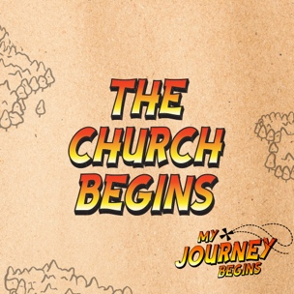

In this session, kids will learn about how the Early Church came together and grew. They will learn about the importance of being a part of the Church for themselves and for others.

Bible Lesson | Faith Fact
The Church Begins  Acts 2:42–47 | The church helps me grow.
Faith Verse
Acts 1:8 (NLT)
“But you will receive power when the Holy Spirit comes upon you. And you will be my witnesses, telling people about me everywhere—in Jerusalem, throughout Judea, in Samaria, and to the ends of the earth.”
Listen Kids is part of an entire kids’ discipleship strategy. Get access at KidminRoadmap.com.

Find the corresponding Bible Fact-Pak® question numbers for this session in the Volume Additional Assets on the mobile or Web app.
PREPARING FOR THE SESSION
You Will Need | Getting Ready
Large Group  - Bible  - Worship songs (Song suggestions: “Zeal” by The Belonging Co; “Way Maker” by Hillsong; “See a Victory” by Elevation Worship; “Yes and Amen” by Chris Tomlin)  - Poster board, one sheet  - Marker  - Scissors  - For groups not using a phone or tablet only, add:  - Projector or TV  - Laptop  - Countdown 5-Minute Video  - Theme Intro Video  - Faith Fact Slide or Motion Graphic  - Countdown60 Video  - Game Time Slide or Motion Graphic  - Bible Lesson Video A  - Bible Lesson Video B  - Faith Verse Video or Slide  Small Group  - Mini marshmallows, one or two bags per group  - Large marshmallows, one or two bags per group  - Toothpicks, one box per group  - Paper plates, one per kid  - Plastic bags, one per kid  - Bibles, one per kid  - Small Group Faith Verse Review, one set per team  - Large building blocks, two sets, twenty per set  - Scissors  - Tape  - Small Group Activity Page, one per kid  - Colored pencils | Large Group  - Download videos and slides if needed.  - Select worship song(s) and have them ready to play.  - Create a four-piece puzzle with the poster board. Divide the poster board into four pieces by drawing four large puzzle pieces. Cut the pieces out, but don’t cut any excess poster board off. Write one word or phrase on each of the puzzle pieces: Apostles’ Teaching, Fellowship, Eating Together, Prayer.  Small Group  - Separate the marshmallows and toothpicks into individual plastic bags for each kid. Place the same number of each type of marshmallow and toothpicks into each bag.  - Print copies of the Small Group Faith Verse Review, one set per team. Cut apart the Faith Verse segments, keeping each set separate.  - Attach these slips to the building blocks with tape and keep the two sets of blocks separate.  - Print the Small Group Activity Page, one per kid.
Check out all the promotional and extra media files available for this theme. To access the Bible Engagement Project from a computer, visit App.BibleEngagementProject.com.

LARGE GROUP (30 Minutes)
See what’s needed at the beginning of the session.

INTRODUCTION
- Optional: Play the Countdown 5-Minute Video.



Welcome

Welcome! I’m so glad you’re here! Last time we talked about how followers of Jesus received the baptism in the Holy Spirit. Today we’ll discover how the Church began as the first believers gathered together to learn and grow. Let’s watch this video, and then we’ll get started.
- Play Theme Intro Video.

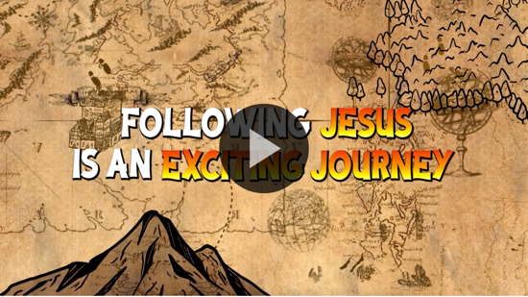

When I say that we’ll be talking about the Church, I don’t really mean a building. I mean people, all of us. Everyone who is a real follower of Jesus is part of the true Church. Can we still be the Church if we aren’t in a church building? (Group response) Of course, we can. In fact, God wants us to be the Church everywhere we go.

The Church has been around since Jesus went back to heaven. Remember, last time we heard that Jesus went back to God the Father in heaven. He sent His followers the gift of the baptism in the Holy Spirit to help them since He was no longer with them. Peter stepped forward after being baptized in the Holy Spirit, and preached to the people in Jerusalem. Three thousand people were saved. That was the beginning of the Church. It has grown into what we have today.

Faith Fact
- Show the Faith Fact Slide or Motion Graphic.

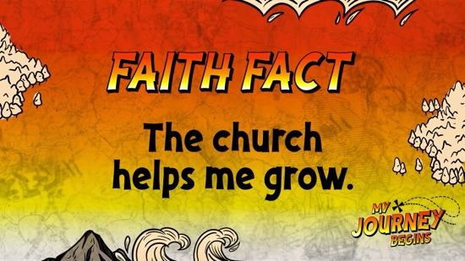

Today’s Faith Fact tells us that the Church is not only growing, but the Church also helps us grow. We are going to say the Faith Fact together, and we will pretend to grow as we say it. Crouch down close to the floor and slowly stand up while saying the Faith Fact. Let’s practice. The church helps me grow. Let’s say it a couple of more times. (Allow time for kids to repeat.)

GAME | Grow a Row
You Will Need | Getting Ready
- Countdown60 Video | No prep is needed for this activity.

- Show the Game Time Slide or Motion Graphic.


The Early Church started with 120 people meeting together to wait for the gift of the Holy Spirit after Jesus went back to heaven. However, it quickly grew to thousands because these followers went out and shared what they believed with others. They set the example for all of us to always be growing the Church. We are going to see how fast you can work together to grow a row. You will have one minute.
- If there are any guests, have each kid quickly state his or her name.
- Choose two kids to begin the game. Have them stand on opposite sides of the room from each other. They will have one minute to grow their row bigger than the other team's row.
- When the leader says, “Go,” the two kids will call out one name at a time.
- The kid who is called will run up and link arms with the first kid.
- If you have kids with the same name, they can all go up at the same time when that name is called. This will add multiple kids in one round that way.
- When the timer goes off, the team with the longest row wins.
- Play Countdown60 Video.



I’m thankful for the example of the Early Church in the Book of Acts. They did so many of the things we still do today to grow closer to each other and help each other grow in Christ. One of the things the Early Church did that we still do today is worship.

WORSHIP

Worshipping is always a great way to grow closer to God, but there is just something special and powerful about worshipping God together as the Church. We are going to do that right now by singing together.
- Lead the kids in singing one or two praise songs. See suggestions at the beginning of the session.

BIBLE LESSON | The Church Begins (Acts 2:42–47)

- See Preparing for theSession on page 2 for items needed here.

Worship time was amazing! Do you prefer worshipping alone or together? (Allow responses.) Worship is a great way to come together and grow as the Church. Let’s pray and ask God to open our ears and our hearts to learn something new about how we can grow by being a part of the Church.

Prayer

Dear God, thank You for giving us the example of the Church in the Bible. We don’t have to wonder what we should do to grow because we can look to Your Word for the answers. Help us to learn something new from Your Word today. Amen.

Video Intro

Before we get started with the Bible story, let’s check in with the Challenge Accepted team and see what they’re up to.
- Play Bible Lesson Video A.

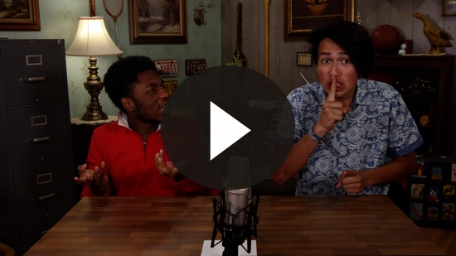

Oh boy! Those two are something else! Would you like to accept that challenge? (Group response) I’m not sure how that connects to our Bible story today, but I guess we’ll find out.

Teaching Time
If you have your Bible, turn with me to Acts 2:42–47. (Allow time for the kids to turn to the passage in their Bible.)

When you get there, hold that spot, and we will come back to it in a couple of minutes. Today's Bible story happened soon after the disciples were baptized in the Holy Spirit for the first time. Peter stepped forward to preach with boldness, empowered by the Holy Spirit.

About three thousand people were added to the Church just in that one day. The disciples could have been satisfied with that number and stopped there. Three thousand people is a pretty big church. But Jesus’ followers didn't stop. They knew there were many more people out there who didn't know anything about Jesus, and they had to spread the word.

They formed a community, which was the first Church. It didn't look exactly like the churches we have today. There wasn't a fancy building, microphones, or lights. It was just a group of people who loved Jesus. They wanted to continue to grow and learn more about Him together.

When people decided to follow Jesus, this was a big deal. Many of those who chose to follow Jesus were Jewish, and they risked their relationship with their family and the respect of the community for choosing to believe that Jesus was the Messiah.

Jesus had been killed by the Romans because many of the Jewish leaders didn’t like what He had to say. Everyone knew that it was risky to follow Jesus, but the Holy Spirit gave them boldness and courage to speak out anyway.

The Early Church was a big family. Have you ever been a part of a club or a sports team? (Allow response.) When you are on a team, you spend lots of time together, you learn skills together, and you celebrate together. You get really close to your teammates, and you would do anything for them. This was exactly what the Early Church was like.

Let's read about the Early Church together in Acts 2:42–47.
- Read Acts 2:42–47.

The Early Church was totally committed to following Jesus, but they were also totally committed to taking care of each other. They met together, shared everything they had, worshipped together, ate together, and did everything together. They weren't one of those groups that no one could get into either. They welcomed new people into their church daily.

I want to be more like the people in the Early Church. How about you? Let's go back to verse 42 and take a closer look at the four things the Early Church devoted themselves to. Being devoted to something means that you are focused on that particular thing. What you focus on is very important.
- Read Acts 2:42.
- Have four kid volunteers stand beside you and hold up each puzzle piece as you talk about each thing the Early Church was devoted to.

They were devoted to the apostles’ teaching. That means they wanted to learn more about Jesus and what it meant to follow Him. How do we do that in our churches today? (Allow responses.)

They were devoted to fellowship with each other. That means they enjoyed meeting together because they shared the same beliefs. How do we do that in our churches today? (Allow responses.)

They were devoted to eating together. Who can get behind this one? (Group response) How do we do that in our churches today? (Allow responses.)

Finally, they were devoted to prayer and spending time with God. How do we do that in our churches today? (Allow responses.) If we devote ourselves to these four things, we will see our church grow because others will want to be a part of it.
- Thank volunteers as they return to their seats.

Faith Verse
Our Faith Verse reminds us that God wants us to continue to grow and that He wants us to continue to grow His church by telling others about Him. Let’s say the verse and do the actions together
- Show the Faith Verse Video or Slide.

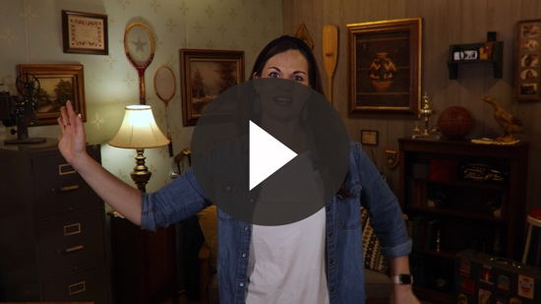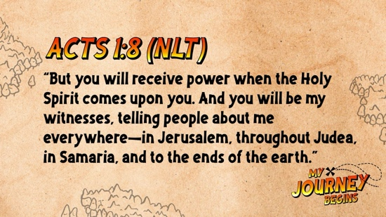

Acts 1:8 (NLT)
“But you will receive power when the Holy Spirit comes upon you. And you will be my witnesses, telling people about me everywhere—in Jerusalem, throughout Judea, in Samaria, and to the ends of the earth.”

We need to remember that we are all responsible for helping the Church to grow and telling others about Jesus. Don’t wait for someone else to tell them.

PRAYER AND RESPONSE
You Will Need | Getting Ready
No supplies are needed for this activity. | No prep is needed for this activity.

Consider playing a worship song softly in the background while kids pray.

If you are being honest, maybe you don’t really understand the purpose of being a part of the Church or going to church. I think if we are honest, all of us have days that we don’t feel like getting up and going to church. God created us to need each other. If the Early Church needed each other to grow, then we can learn from their example. That’s why God included it in His Word. Let’s pray and ask God to give us a new love for the Church and for Him today.
- Give kids time to pray. Then introduce the worship song. This could play in the background while kids pray or could be a worship song to sing together.

Worship Song
Play one or two worship songs.

Video Wrap-Up

Before we go to our small group activities, let’s see how the challenge worked out for the Challenge Accepted team.
• Play Bible Lesson Video B.

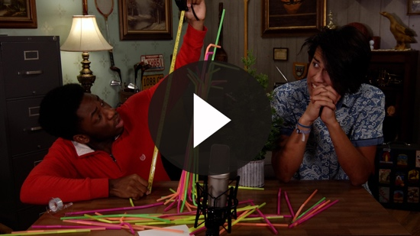

I love those guys. They always make me laugh and challenge me to grow.
- Show the Faith Fact Slide or Motion Graphic.

Let’s go over our Faith Fact one more time. Say it with me. The church helps me grow.

God never intended for you to do life alone. We need each other to grow. God wants us to grow closer to Him, but He also wants us to grow closer to others who love Him. Find a way to connect with someone from our church this week and grow together. Try to do this outside of regular church time. See you next time.
- Dismiss kids to Small Group time or to go home if your group time ends here.

SMALL GROUP (30 Minutes)
This section can be done in conjunction with the large group, or on its own if you do small groups with your kids. During Small Group time, the goal is to connect the kids with the Word of God and to each other. All activities are led by the small group leader.

GROUP CONNECTION | Marshmallow Structures
You Will Need | Getting Ready
- Mini marshmallows, one or two bags per group  - Large marshmallows, one or two bags per group  - Toothpicks, one box per group  - Paper plates, one per kid  - Plastic bags, one per kid | - Separate the marshmallows and toothpicks for each kid into individual plastic bags. Place the same number of each type of marshmallow and toothpicks into each bag

Who likes to build things? (Group response) Today, we are going to attempt to build structures out of something really squishy—marshmallows. The goal is to use all the marshmallows and toothpicks to build the biggest or tallest structure on your plate. Imagine that you’re building the Church. Every marshmallow you add is another person, and the more you add, the better.
- Give each kid a plate and a bag with each type of marshmallow and toothpicks.
- Make it a competition if the kids are older to motivate them to get involved in the activity.

BIBLE LESSON RECAP | The Church Begins (Acts 2:42–47)
You Will Need | Getting Ready
- Bibles, one per kid | No prep is needed for this activity.

Last time, we talked about what happened after Jesus went back to heaven. The believers were gathered together praying, and God sent the gift of the Holy Spirit to baptize them for the first time. They were all empowered by the Holy Spirit. Peter preached a sermon, and three thousand people were added to the Church in one day.

That was the beginning of the Church. We are going to talk about some practical ideas of how we can grow together and be the Church today from the example of the Early Church in Acts. Turn with me to Acts 2:42–47 to review what the Early Church did to grow as individuals and as a group.
- Choose one kid to read Acts 2:42–44 and another kid to read Acts 2:45–47.

What is one thing that you remember about our Bible story? (Allow responses.)

Faith Fact

God doesn’t want you to go through life alone. That’s part of why the Church exists. We are meant to do life together, and we help each other grow. That’s why our Faith Fact is so true.
- Show the Faith Fact Slide or Motion Graphic.

Say it with me. The church helps me grow.

GROUP DISCUSSION

Feel free to use all or just a few questions as a jumping-off place for good discussion. Questions marked with * are designed for more conversation. Adjust the questions based on the age or maturity of your group. Typically, older kids will be able to dive a little deeper than younger ones.

Questions

What were some of the things that the Early Church did?

* Do you think being part of a church is important? Why or why not?

Do you have close friends who are Christians?

* How does having Christian friends help you in your faith?

* What is your favorite thing about being part of a church?

Do you see any of the people from your church outside of the church?

How important is being part of a church and attending church services to you?

* What is something you need to spend less time on?

* What is something you need to spend more time on?

* What can you devote yourself to that would help you grow closer to God?

* What is something you can give to the church right now?
APPLICATION AND RESPONSE

Just because you aren’t an adult doesn’t mean that you aren’t an important part of the Church right now. You can already begin being part of the Church. You can help the Church grow by telling your friends about Jesus. You can serve by leading by example. You can find ways to use your talents and gifts to serve in our church right now. You can help the Church grow, and the Church can help you grow.

Make It a Habit
Select a simple visual reminder of the session’s Faith Fact

Remember our Faith Fact today? Let's say it together. The church helps me grow. If you go outside and look around, you will see lots of things growing. You may not notice it right away, but every plant, tree, and animal you see is growing and changing every single day. Every time you see something that grows this week, write it down or make a list, either in writing or on your phone/device. Be specific.

Take a look at how long the list is at the end of the week. Allow it to remind you that you need to grow, too. The Church and the people in it can help you grow spiritually. We all need each other. That's how God made us.

Prayer

Let’s pray and ask God to help us grow.

Dear God, thank You for the Church. Please forgive us for the times when we didn’t understand the importance of being a part of the Church. Help us to help others grow and to grow from the example of others. Amen.

FAITH VERSE REVIEW
You Will Need | Getting Ready
- Faith Verse Review, one set per team  - Large building blocks, two sets, twenty per set  - Scissors  - Tape | - Print copies of the Faith Verse Review, one set per team. Cut apart the Faith Verse segments, keeping each set separate.  - Attach these slips to the building blocks with tape and keep the two sets of blocks separate.

Our Faith Verse is Acts 1:8. It reminds us that Jesus wants us to get out there and help His Church grow. Let’s say the Faith Verse and do the actions together.

- Show the Faith Verse Video or Slide.

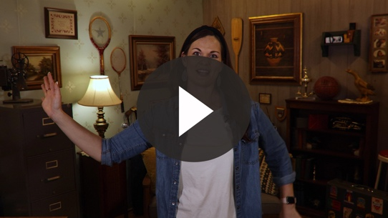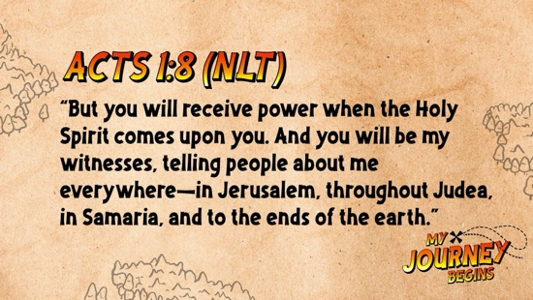

Acts 1:8 (NLT)

“But you will receive power when the Holy Spirit comes upon you. And you will be my witnesses, telling people about me everywhere—in Jerusalem, throughout Judea, in Samaria, and to the ends of the earth.”

Let’s go over the Faith Verse together as a group a couple of times. Remember to say it loud so all the other small groups can hear you.

Faith Verse Fun | Verse Towers

How many of you love playing with blocks or enjoyed it when you were younger? (Group response) My favorite thing to do with blocks is to try and build the biggest, tallest tower. Then, I love to knock it over and start again. You are going to build a verse tower using blocks today. The first team to build their tower in the correct order of the verse without it falling down wins.
- Divide the group into two teams and give each team a set of building blocks with the verse labels on them.

ACTIVITY PAGE | Church Friends and Leaders
You Will Need | Getting Ready
- Activity Page, one per kid  - Colored pencils | - Print copies of the Activity Page, one per kid.

There are so many ways the Church can help us grow. It’s easy for us to think about church as a place we go to, but really the Church is all the people who follow Jesus. It’s not about a building. That’s just the place we go to meet and help each other grow.

Let’s spend some time drawing our family and our church friends outside the church building. Then around the outside of the building, let’s write down or draw some of the ways those friends and leaders help us grow.
- Give kids suggestions of people they can draw and statements they can write, if needed.

Prayer

Dear God, thank You for giving us a church to be a part of. Help us to do our part to build Your Church and help it grow so more people can know about Jesus. Amen.

FAITH FACT RECAP
- Display the Faith Fact Slide or Motion Graphic as parents are coming into the room.
- Maximize the time you have with your kids so that parents see what their kids have learned. Have the kids repeat the Faith Fact, and then dismiss them to their parents.

Who can say today’s Faith Fact? (Group response) Let’s say it one more time as a group. Remember, we are better together.

This is the answer to the question your adults are going to ask: “What did you learn today?” Let’s say the Faith Fact together: The Church helps me grow.

DISMISSAL
- Send home the Activity Page.
- Remind parents that there are Family Devotions available on the app to do with their kid.
- Tell everyone the date and time for the next session.

