

LEADER OVERVIEW

Volume Overview—My Journey Begins
In these sessions, kids will learn about the promise fulfilled through the baptism in the Holy Spirit and how the Early Church came together and grew. They will look at the change that happens when they recognize Jesus as Lord and know that God is always with them.

SESSION 1: Baptism in the Holy Spirit—  Acts 1:8; 2:1–12  Faith Fact: The Holy Spirit empowers me. | SESSION 2: The Church Begins—Acts 2:42–47  Faith Fact: The church helps me grow.
SESSION 3: Saul on the Damascus Road—  Acts 9:1–22  Faith Fact: God changes my life. | SESSION 4: Paul and Silas in Prison—  Acts 16:16–34  Faith Fact: With God, I am never alone.

SESSION OVERVIEW
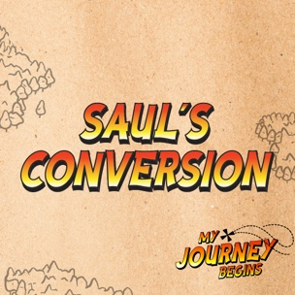
In this session, kids will hear the account of Saul’s encounter with Jesus on the Damascus Road. They will look at Saul’s background and the change that happened when he recognized Jesus as Lord. Just like God changed Saul’s life for the better, kids will discover that God can change their life too.

Bible Lesson | Faith Fact
Saul on the Damascus Road  Acts 9:1–22 | God changes my life.
Faith Verse
Acts 1:8 (NLT)
“But you will receive power when the Holy Spirit comes upon you. And you will be my witnesses, telling people about me everywhere—in Jerusalem, throughout Judea, in Samaria, and to the ends of the earth.”

Listen Kids is part of an entire kids’ discipleship strategy. Get access at KidminRoadmap.com.
PREPARING FOR THE SESSION
You Will Need | Getting Ready
Large Group  - Bible  - Worship songs (Song suggestions: “Zeal” by The Belonging Co; “Way Maker” by Hillsong; “See a Victory” by Elevation Worship; “Yes and Amen” by Chris Tomlin)  - Envelopes  - Toy handcuffs or piece of rope  - Spotlight/bright light  - Blindfold  - Chair  - For groups not using a phone or tablet only, add:  - Projector or TV  - Laptop  - Countdown 5-Minute Video  - Theme Intro Video  - Faith Fact Slide or Motion Graphic  - Game Time Slide or Motion Graphic  - Bible Lesson Slides 1–3  - Bible Lesson Video A  - Bible Lesson Video B  - Faith Verse Video or Slide  Small Group  - Small Group Faith Verse Review Page, two copies  - Scissors  - Small Group Activity Page, one per kid  - Crayons, markers, or colored pencils | Large Group  - Download videos and slides if needed.  - Select worship song(s) and have them ready to play.  Small Group  - Print two copies of the Small Group Faith Verse Review Page.  - Cut apart the verse segments and make two sets.  - Print the Small Group Activity Page, one per kid.
Check out all the promotional and extra media files available for this theme. To access the Bible Engagement Project from a computer, visit App.BibleEngagementProject.com.

Find the corresponding Bible Fact-Pak® question numbers for this session in the Volume Additional Assets on the mobile or Web app.

LARGE GROUP (30 Minutes)
See what’s needed at the beginning of the session.

INTRODUCTION
- Optional: Play the Countdown 5-Minute Video.



Welcome

Welcome! I’m so glad you’re here! We’ve been talking about events in the Book of Acts. Those events show us how the Holy Spirit empowers us and how the Church helps us grow. Let’s watch this video, and then we’ll get started.
- Play Theme Intro Video.

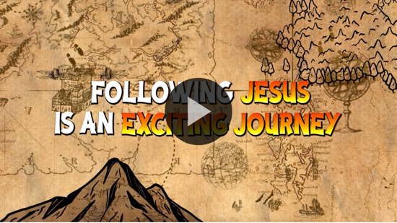

Today, we are going to meet one of the most important people in the New Testament. He actually wrote about half of the books that make up the New Testament. Can anyone guess who I’m talking about? (Allow responses.) That’s right! I’m talking about Paul. When we first meet Paul in the Bible, he was going by the Hebrew version of his name, Saul. Later, he used the Greek version of his name, Paul.

It’s kind of like your name might be James, but your family calls you Jimmy. Or your name is Elizabeth, but you use the name Betsy.

Saul wasn’t always on God’s side. Saul was against the Christians, which is what followers of Jesus were later called. His biggest goal in life was to hunt down all of the Christians and have them thrown in jail, or worse, killed. That doesn’t exactly sound like the kind of guy I would recruit to become a Christian, but God doesn’t see things or people the way we see them. God knew Saul’s mind and life would change when Saul met Jesus.

Faith Fact
- Show the Faith Fact Slide or Motion Graphic.
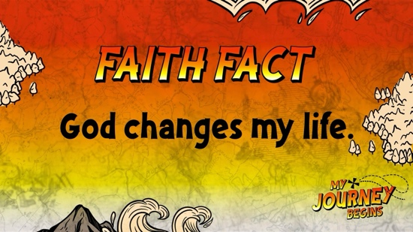

Today’s Faith Fact reminds us that God has the power and ability to change anyone! The Faith Fact is God changes my life. We are going to say the Faith Fact together. I want you to spin around in a circle while saying our Faith Fact. Ready? God changes my life. Let’s say it a couple more times. (Allow kids to say Faith Fact and spin in a circle.) Whew! I need to rest!

GAME | Change It Up
You Will Need | Getting Ready
No supplies are needed for this activity. | No prep is needed for this activity.

- Show the Game Time Slide or Motion Graphic.



Now, we are going to get up and move. You can do anything you want—spin, jump, run in place, or skip. Just don’t bump into the person next to you. It doesn’t matter what you do, you just have to keep moving. I’ll give you instructions on how and when to change up your moves.

When I say, “Freeze,” stop moving and stay in the exact position you were in. When I say, “Slow-mo,” do the movement super slow. When I say, “Speed it up,” do the movement as fast as possible. And when I say, “Change it up,” do a completely different movement. Keep moving and follow my instructions to stay in the game!
- Watch for kids who stop moving or don’t follow instructions and call them out for the round.
- Play multiple rounds, allowing everyone to be back in the game as time allows.
That was a fun game and a great reminder that things can always change, including us. God can change our life for the better if we choose to follow His plan for our life.

WORSHIP

One of the ways God can change your life is through worship! Worship can be a life-changing experience when we spend time in the presence of God. Let’s give God 100 percent today as we worship Him by singing!
- Lead the kids in singing one or two praise songs. See suggestions at the beginning of the session.

BIBLE LESSON | Saul on the Damascus Road (Acts 9:1–22)

- See Preparing for the session on page 2 for items needed here.

That was an incredible time of worship! Let’s pray and ask God to show us what parts of our life need to change so we can grow closer to Him.

Prayer

Dear God, thank You for never giving up on us when we make mistakes and choose not to follow Your plan. Help us to see what we need to change or get rid of in our life so we can follow You better. Amen.

Video Intro

Before we get started with the Bible story, let’s check in with the Challenge Accepted team and see what they’re up to.
- Play Bible Lesson Video A.



Really, that seems like a pretty easy challenge! Would you accept that challenge? (Group response) That’s a great way to lead into our Bible story today.

Teaching Time

If you have your Bible, turn with me to Acts 9:1–22 (Allow time for the kids to turn to the passage in their Bibles.) At this point in the Book of Acts, the Early Church has been growing strong for a year or two, but some people didn’t like that at all. Some people even hated Jesus’ followers and tried to have them thrown in prison or killed.

One of those men was named Saul, but his life plans were about to change because of a surprising encounter. I need someone to play Saul in our Bible story today.
- Choose a kid or leader to play Saul.

Saul didn’t like Jesus’ followers. In fact, the Bible says he threatened the Christians and wanted to kill them. Saul was part of the reason for the death of one Christian named Stephen.
- Show the Bible Lesson Slide 1.

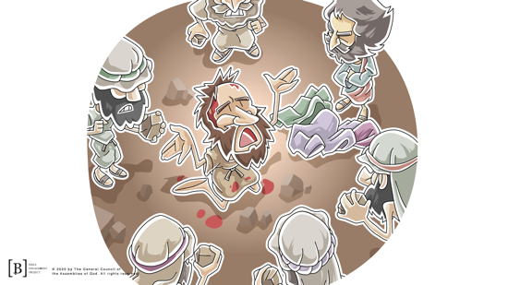

One day, Saul went to the high priest, who was one of the most powerful and important Jewish leaders. Saul asked for letters that would allow him to travel across the region to synagogues in the city of Damascus. Synagogues were special places of worship for Jewish people. Saul wanted their support so he could arrest any of Jesus’ followers in Damascus.
- Hand the volunteer the envelopes and then handcuffs.

Saul got the high priest’s permission and started on the road to Damascus. This was a long journey, and it didn’t go as Saul expected.
- Have the volunteer walk around the room.

Let’s read about what happened next as Saul approached Damascus at the end of this long journey.
- Read Acts 9:3–4.
- Shine a light or spotlight while the volunteer falls to the ground.
- Show the Bible Lesson Slide 2.



How do you think Saul must have felt? (Group response) I think he was afraid of what would happen next. The Voice who spoke knew Saul’s name, but the question was not one that Saul would have wanted to hear.

“Saul! Saul! Why are you persecuting me?” Saul had been bullying the Christians and making life miserable for them, but who was this Person talking to him? That is exactly what Saul wanted to find out.
- Read Acts 9:5–6.

Jesus was speaking to Saul from heaven. Jesus wanted Saul to know exactly who He was, and He wanted Saul to know why he was making a big mistake hurting the Christians. How do you think this made Saul feel? (Allow responses.) Let’s keep reading to find out what happened next.
- Read Acts 9:7–9.
- Blindfold the volunteer and lead him or her a few steps to sit on a chair.

That could have been the end of the story. Saul probably deserved to live the rest of his life blind because of the things he had done to the Christians, but God had a plan to change him for the better. At the same time, God also spoke to another man named Ananias in a vision. God told him to go to the house where Saul was staying, place his hands on Saul, and pray for him to be healed.

Ananias was scared to go because he had heard about everything Saul had done to other Christians, and he knew Saul could arrest him. God told Ananias that He had chosen Saul to take His message to the people who didn’t know Him yet.
- Show the Bible Lesson Slide 3.

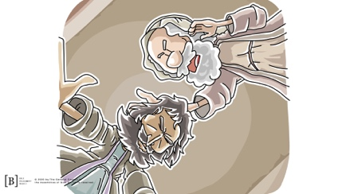

So Ananias went to Saul, laid his hands on him, and prayed for him to be healed.
- Lay a hand on the volunteer, then remove the blindfold.
- Read Acts 9:18.

God completely changed and turned Saul’s life around from that day forward. Saul went from hurting Jesus’ followers to becoming one of Jesus’ followers. Before, Saul did everything he could to hurt Jesus’ followers. Now, Saul gave his whole life to doing everything he could to tell people about Jesus! Later, Saul started using the Greek form of his name, Paul.
- Read Acts 9:20–22.

Let’s give a hand for our Saul!
- Lead kids in clapping for the volunteer as he returns to his seat.

What a change! Saul is one of the best examples in the Bible of the fact that God can change anything and anyone for the better. God can turn around people’s lives no matter how many bad things they have done. No one who wants to come to Jesus is too broken or too sinful to be forgiven. Maybe you have struggled with thinking that you aren’t good enough to be a Christian or that you have messed up too many times to be forgiven.

Saul is proof that God can change anyone’s life! God won’t change your life unless you ask Him to. He has given all of us something called free will. That means that we have the ability to make choices both good and bad. Our choices determine the direction of our lives. If you want to make a choice that will change your life for the better, choose to follow Jesus and allow Him to change your life today.

Faith Verse
Our Faith Verse reminds us that He wants to give us extra power to live for Him and be His witnesses. If we are a follower of Jesus, God has changed our life and He wants to change others, too. The gift of the Holy Spirit will help us tell others about Jesus so He can change their lives. Let’s say the verse and do the actions together.
- Show the Faith Verse Video or Slide.

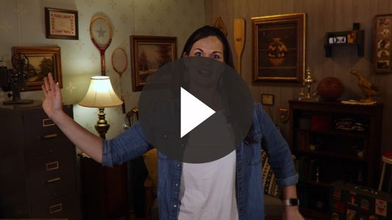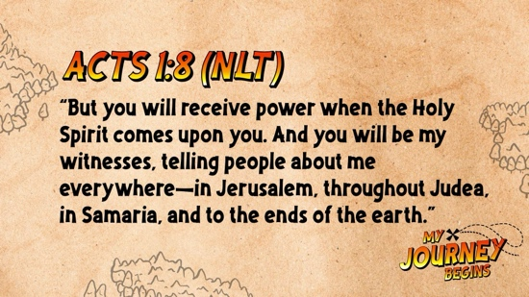

Acts 1:8 (NLT)
“But you will receive power when the Holy Spirit comes upon you. And you will be my witnesses, telling people about me everywhere—in Jerusalem, throughout Judea, in Samaria, and to the ends of the earth.”

God loves everyone, no matter where they are or what they have done. He wants to forgive them all and change their lives for the better.

PRAYER AND RESPONSE
You Will Need | Getting Ready
No supplies are needed for this activity. | No prep is needed for this activity.

Consider playing a worship song softly in the background while kids pray.

Maybe you have never asked Jesus to forgive your sin and change your life, and you want to make that choice today. That’s a big life change that you will never regret. Inviting Jesus into your life means that you have God’s Spirit living inside you. He will help guide you to make the right choices, but you have to listen and follow Him. Let’s pray and ask God to make a positive change in each of us today.
- Give kids time to pray.
- Lead them in a salvation prayer.
- Introduce the worship song. This could play in the background while kids pray or could be a worship song to sing together.

Worship Song
Play one or two worship songs.

Video Wrap-Up

Before we go to our small group activities, let’s see how the challenge worked out for the Challenge Accepted team.
• Play Bible Lesson Video B.
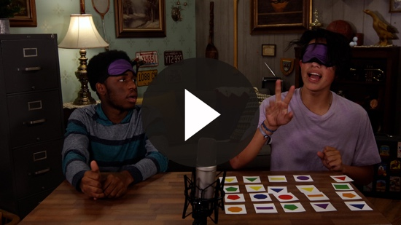

Let’s all accept the challenge that the team gave us. We can ask God for His help if we need to have a new perspective on something.
- Show the Faith Fact Slide or Motion Graphic.

Say it with me. God changes my life. God can take anyone’s life, no matter how many mistakes he or she has made, and change their life for good. Saul’s life is a great example of how God can completely turn a life around. We can’t wait to see you again next time for our last session in the Book of Acts.
- Dismiss kids to Small Group time or to go home if your group time ends here.

SMALL GROUP (30 Minutes)
This section can be done in conjunction with the large group, or on its own if you do small groups with your kids. During Small Group time, the goal is to connect the kids with the Word of God and to each other. All activities are led by the small group leader.

GROUP CONNECTION | What Changed
You Will Need | Getting Ready
No supplies are needed for this activity. | No prep is needed for this activity.

Are you good at noticing the details? Let’s find out. Choose a partner and take a few moments to study all the details about his or her physical appearance. I’ll give you 15–20 seconds to study your partner. Then, both will turn around and change one small detail about your appearance. When you face each other again, we will see who can spot what changed.
- Have the group divide into pairs. (It may be best to have girls pair up with girls and boys pair up with boys for this game.)
- Play several rounds. Option: Have the kids switch partners after a couple of rounds.

BIBLE LESSON RECAP | Saul on the Damascus Road (Acts 9:1–22)
You Will Need | Getting Ready
- Bibles, one per kid | No prep is needed for this activity.

Last time, we heard about how the Early Church started and began to grow. The Church continued to grow and add new believers every day. Unfortunately, some people were not fans of Jesus’ followers. They wanted to get rid of them and stop them from spreading the good news about Jesus. One of those people was a man named Saul.

Saul had one goal, and it was to stop people from following Jesus by killing them or putting in prison all the Christians. Until one day, God showed up and completely changed Saul’s life. Let’s read about that incredible life-changing experience together in Acts 9:1–22.
- Choose one kid to read Acts 9:1–9, choose another kid to read Acts 9:10–16, and choose another kid to read Acts 9:17–22.

What is one thing that you remember about our Bible story? (Allow responses.)

Faith Fact

You can never mess up so many times that God gives up on you. God wants to change your life the same way that He changed Saul’s life. That’s why our Faith Fact is so important to remember.
- Show the Faith Fact Slide or Motion Graphic.

Say it with me. God changes my life. Let’s try it again. Everyone whose birthday is in January through June, say it with me. God changes my life. Not bad, not bad. Now everyone whose birthday is in July through December, see if you can say it louder. God changes my life. Wow! That may have been a tie!

GROUP DISCUSSION

Feel free to use all or just a few questions as a jumping-off place for good discussion. Questions marked with * are designed for more conversation. Adjust the questions based on the age or maturity of your group. Typically, older kids will be able to dive a little deeper than younger ones.

Questions

How do you think Saul felt after he encountered Jesus on the road to Damascus?

What was the name of the man in Damascus who God used to pray for Saul?

What is something you wish you could change about your personality?

* What is something you wish you could change about your life?

*How does following Jesus make you different from someone who isn’t following Jesus?

How does following Jesus change how you think?

How does following Jesus change how you talk?

* How does following Jesus change how you live your life?

* What is something you did in the past that you wish you could go back and change?

How can you make sure you don’t do it again?

* How can you help others make a change in their life?

APPLICATION AND RESPONSE

There is an immediate change that happens in a person’s life when they make the decision to follow Jesus. However, that isn’t the end of the change. If you continue to follow Jesus, God will continue to change your life. You will become more and more like Jesus every single day that you choose to listen to Him and follow His plan. You will know when you allow yourself to get offtrack. God will always forgive you. Just ask.

Make It a Habit
Select a simple visual reminder of the session’s Faith Fact.

Remember our Faith Fact today? Let’s say it together. God changes my life. Close your eyes and think of a time when something in your life changed for the better. God had His hand in that situation, and He made that change for you. Write down what you thought of on a piece of paper or a sticky note when you get home and put it somewhere you will see it every day. When you see it, remember to thank God for changing your life.

What else could we use to remember our Faith Fact?
- Make notes of what the kids share.

Prayer

Let’s pray and ask God to help us grow to be more like Jesus.

Dear God, thank You for changing my life. Please forgive me for the times when I got off track and went my own way. Help me to live for You every single day. Amen.

FAITH VERSE REVIEW
You Will Need | Getting Ready
- Faith Verse Review, two copies  - Scissors | - Print two copies of the Faith Verse Review.  - Cut apart the verse segments and make two sets.

Our Faith Verse is Acts 1:8. It reminds us that Jesus wants us to go and tell others about Him so He can change their life, too. Let’s say the Faith Verse and do the actions.
- Show the Faith Verse Video or Slide.

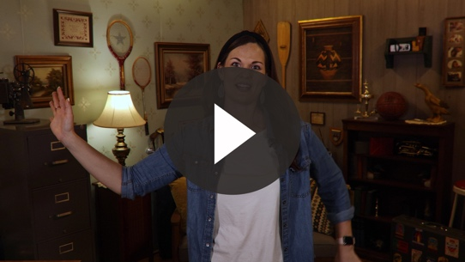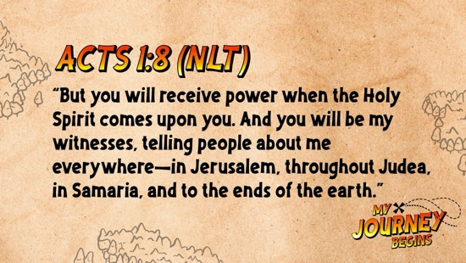

Acts 1:8 (NLT)

“But you will receive power when the Holy Spirit comes upon you. And you will be my witnesses, telling people about me everywhere—in Jerusalem, throughout Judea, in Samaria, and to the ends of the earth.”

Let’s say the Faith Verse together again. Remember to say it loud so all the other groups can hear you.

Faith Verse Fun | Wait for the Change

Who likes waiting? (Group response) People just don’t like waiting. But have you ever heard that old saying, “Good things come to those who wait”? (Group response) Change isn’t always instant. A caterpillar doesn’t become a butterfly instantly; it has to spend time in a cocoon. Your baby brother or sister or cousin won’t grow up in just a day. Change happens at its own pace. We have to be willing to keep on working and wait patiently for change to come.

Today, we are going to put our patience to the test with a game. You may be very familiar with the Faith Verse by now, but you won’t be able to just put it in order as quickly as you can. You have to be patient. You can look at the verse, but you can only move one card each time the leader says, “Make a change.” If you move a card too soon or move too many cards at once, your team loses the game, and we will start again.
- Form two teams and give each team a set of verse cards from the Faith Verse Review.
- Team members can look at the cards to determine their next change, but they can’t touch the card until the leader tells them. They can only move one card each time the leader says, “Make a change.”
- Keep playing until a team thinks they have the verse in order. The first team to get their verse in order wins.
- Option: You can begin saying, “Make a change,” at longer intervals or speeding up near the end of the verse. Begin the first round saying, “Make a change,” at regularly timed intervals. As the kids do more rounds, speed up the intervals for saying, “Make a change.”

ACTIVITY PAGE | What’s the Difference?
You Will Need | Getting Ready
- Activity Page, one per kid  - Crayons, markers, or colored pencils | - Print the Activity Page, one per kid

Saul’s life completely changed after he met Jesus. Meeting Jesus has that kind of effect on people. We should never be the same after we get to know Jesus. We should always want to grow and change and become more like Him. For this activity we are going to circle the nine differences in the two pictures. Then, you can color the picture.

While we are looking for all of the differences, let’s talk about the ways God has changed our life and the lives of others we know.
- Tell the kids your story of how you came to follow Jesus. Ask them if they have decided to follow Jesus like Saul.

Prayer

Dear God, thank You for changing my life. Help me to be challenged to go out and tell others about You so You can change their lives, too! Amen.

FAITH FACT RECAP
- Display the Faith Fact Slide or Motion Graphic as parents are coming into the room.
- Maximize the time you have with your kids, so that parents see what their kids have learned. Have the kids repeat the Faith Fact, and then dismiss them to their parents.

This is the answer to the question your adults are going to ask: “What did you learn today?” Let’s say the Faith Fact together: God changes my life.

Don’t forget that God is still changing your life every single day for the better when you choose to follow Him.

DISMISSAL
- Send home the Activity Page.
- Remind parents that there are Family Devotions available on the app to do with their kid.
- Tell everyone the date and time for the next session.

