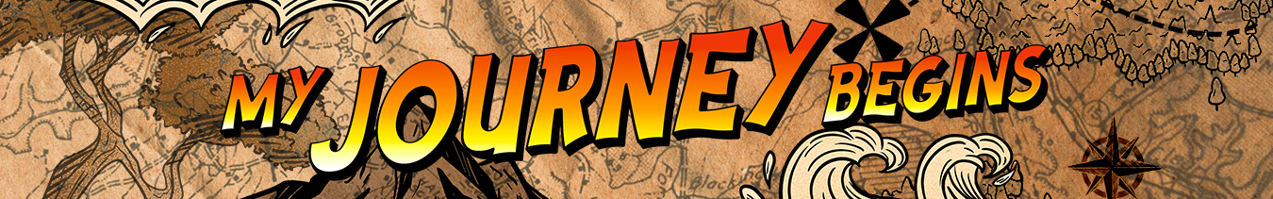LEADER OVERVIEW

Volume Overview—My Journey Begins
In these sessions, kids will learn about the promise fulfilled through the empowerment of the Holy Spirit and how the Early Church came together and grew. They will look at the change that happens when they recognize Jesus as Lord and know that God is always with them.

SESSION 1: Baptism in the Holy Spirit—  Acts 1:8; 2:1–12  Faith Fact: The Holy Spirit empowers me. | SESSION 2: The Church Begins—  Acts 2:42–47  Faith Fact: The church helps me grow.
SESSION 3: Saul’s Conversion—  Acts 9:1–22  Faith Fact: God changes my life. | SESSION 4: Paul and Silas in Prison—  Acts 16:16–34  Faith Fact: With God, I am never alone.

SESSION OVERVIEW
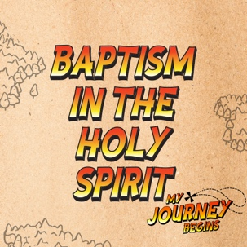
In this session, preschoolers will hear about the Holy Spirit’s important role and how He empowers us to be God’s helpers!

Note: Kids, Youth, and Adult explore the baptism in the Holy Spirit in more detail than Preschool.

Bible Lesson | Faith Fact
Baptism in the Holy Spirit  Acts 1:8; Acts 2:1–12 | The Holy Spirit empowers me.
Faith Verse
Acts 1:8 (NLT)
“But you will receive power when the Holy Spirit comes upon you. And you will be my witnesses, telling people about me everywhere—in Jerusalem, throughout Judea, in Samaria, and to the ends of the earth.”

Bible Engagement Project Preschool curriculum is connected with the intentional, yearlong ministry strategy for kids available at KidminRoadmap.com.
PREPARING FOR THE SESSION
You Will Need | Getting Ready
Preservice Activities  - Spray cheese  - Crackers  - Toys  Large Group  - Bible  - Worship songs (Song suggestions: “Fruit of the Spirit” by KidSpring; “Holy Spirit” by Worship Together Kids)  - For groups not using a phone or tablet only, add:  - Projector or TV  - Laptop  - Countdown 5-Minute Video  - Theme Intro Video  - Bible Lesson Video A  - Bible Lesson Video B  - Faith Fact Slide or Motion Graphic  - Faith Fact Sound video (bell ringing)  - Faith Verse Slide or Motion Graphic  Small Group  - Beach ball or small ball  - Small Group Activity Page, one per kid plus an extra  - Crayons  - Small Group Hands-On Learning Page, one per four kids  - Floor-safe tape, such as painter’s tape  - Scissors  - Construction paper, any color  - Stapler  - Glue, optional  - Red, yellow, and orange tissue paper, optional | Preservice Activities  - Set out toys and snacks.  - Squirt cheese onto crackers in an upright cone shape to look like fire.  Large Group  - Download videos and slides if needed.  - Select worship song(s) and have them ready to play.  Small Group  - Print copies of the Small Group Activity Page, one per kid plus an extra.  - Make a sample of the Small Group Activity Page.  - Tape five large Xs on the floor in a straight line or fairly close together in a random pattern so kids can jump to each one.  - Print the Small Group Hands-On Learning Page, one per four kids. Cut out the flames, one per kid.  - Cut strips of construction paper for the headbands, at least two per kid.  - Make a sample headband with flame.  - If you will use the tissue paper option, cut the tissue paper into small squares.

Check out all the promotional and extra media files available for this theme. To access Bible Engagement Project from a computer, visit App.BibleEngagementProject.com.

PRESERVICE ACTIVITIES (30 Minutes)
See what’s needed at the beginning of the session.

Bible Story Warm-Up
As preschoolers are coming in, have them try to do different exercises.

Who thinks they can do a jumping jack? (Group response) Let me see your best jumping jack. Now let’s see how many you can do in a row. Ready? Get set. Go! Wow! That was so many jumping jacks. Doing exercises like this helps give our body more strength and power. Today, we are going to learn about how the Holy Spirit empowers us to be God’s helpers. Let’s see if you can do a few more exercises.
- Have kids try more exercises that are appropriate for their age, such as jumping as high as they can, stretching as high as they can, lunges, and knee bends.
- To get the kids prepared for the session, start asking them questions like these:
  - Who can give us power to be God’s helpers?
  - What do muscles do in our body?
  - Can you flex your muscles?

Our muscles help to give us physical power and make us strong. The Holy Spirit can give us spiritual power and make us spiritually strong in a lot of ways.

Snack: Fire-shaped Cheese
As kids are eating the snack, share the following:

Today, we are going to eat a yummy snack: crackers and cheese. What shape is the cheese in? (Group response) You’re right. It looks like fire. When the Holy Spirit first came to give the disciples power, they saw flames. Isn’t that cool? We are going to hear all about the Holy Spirit today.

Free Play
Any extra time can be spent playing with toys.

LARGE GROUP (25 Minutes)
See what’s needed at the beginning of the session.

INTRODUCTION
- Optional: Play the Countdown 5-Minute Video.
- Use this time to pick up toys and transition to the large group area.



Welcome
Hi kids! I’m so happy to see you. Today, we are going to learn a very cool lesson from God’s Word, the Bible. (Hold up the Bible.) We are going to learn about the Holy Spirit. We are going to learn how the Holy Spirit still gives us power to be God’s helpers. Are you ready to learn? (Group response)
- Play the Theme Intro Video.

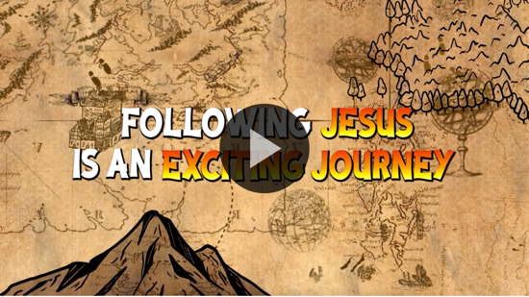

BIBLE TIME | Baptism in the Holy Spirit (Acts 1:8; 2:1–12)

Bible Video A

Did you know that God has a special plan for your life? He will help you do it. Today, we are going to learn about the Holy Spirit. He was sent by God to give us power to be God’s helpers and tell everyone about Jesus. The Holy Spirit comes to Jesus’ followers in a special way. Let’s see what Lizzy and her grandpa are up to.
- Play Bible Lesson Video A.

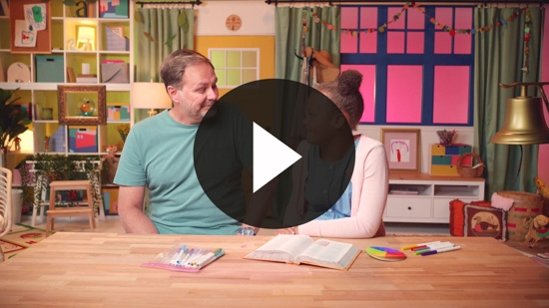

Faith Fact
That was such a fun video to watch. Good job of paying attention and helping Lizzy with the clues.
  - Play the Faith Fact Sound video.

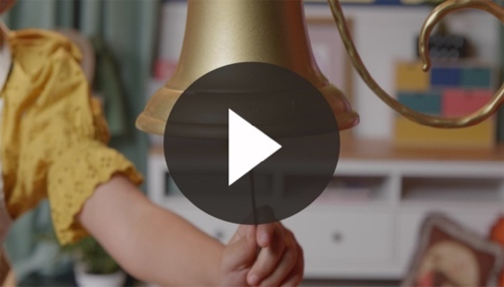

Did you hear the bell? (Group response) It was our Faith Fact bell. Our Faith Fact today is the Holy Spirit empowers me. Empowers is a big word that means to give power. When we say empower, let’s flex our muscles. (Flex your muscles to give them an example.)
- Show the Faith Fact Slide or Motion Graphic.
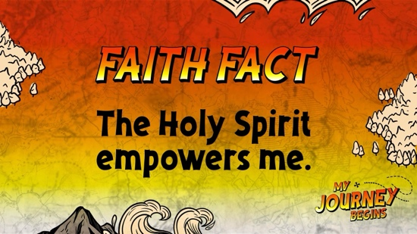

Can you say it with me? The Holy Spirit empowers me. Good job, everyone!

WORSHIP
I’m so happy that the Holy Spirit gives us power. Let’s take a moment to praise God with our words.

Praise
Are you glad God gave the Holy Spirit? Wave your hands up high. (Group response)
Are you glad the Holy Spirit empowers you? Wave your hands down low. (Group response)
Are you glad the Holy Spirit lives in you? Wave your hands up high. (Group response)
Who wants to thank God? Wave your hands down low. (Group response)

Prayer
Let’s bow our heads and pray. Repeat after me.

Dear God, thank You so much for sending the Holy Spirit to help me and give me power to be Your helper! Amen.

Sing
Now let’s worship God by singing with our whole hearts.
- Lead the kids in singing one or two songs. See suggestions at the beginning of the session.

BIBLE TIME continued | Baptism in the Holy Spirit (Acts 1:8; 2:1–12)

Bible Video B
That was so awesome! Great job, boys and girls! I know that God loved your worship. Let’s see what Lizzy is doing.
- Play Bible Lesson Video B.

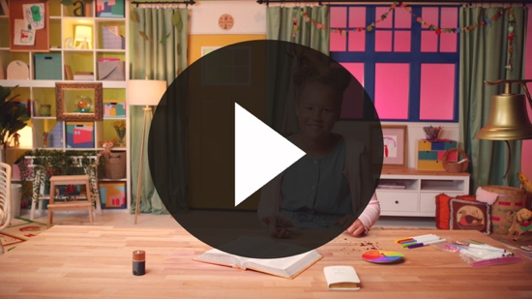

Awesome job! I love hearing about the power of the Holy Spirit. Now it’s time for us to learn a new Faith Verse! Are you ready to practice with me? Let’s practice the first part of the verse that Lizzy just taught us.

Faith Verse
- Show the Faith Verse Slide or Motion Graphic.

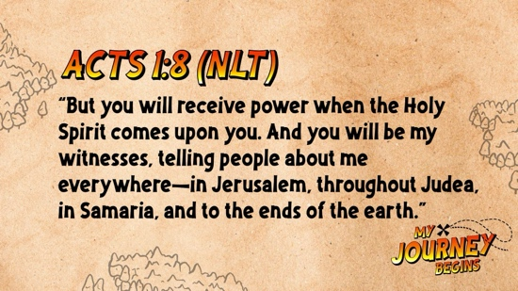

Acts 1:8 (NLT)
“But you will receive power when the Holy Spirit comes upon you. And you will be my witnesses, telling people about me everywhere.”
Flex your muscles when we say power like we do with the Faith Fact. Repeat it after me and do the actions.
- Say the Faith Verse and do the actions with the kids.

Great job! We’ll keep practicing, and eventually we will have the whole verse memorized.

Response Time

Consider playing a worship song softly in the background while kids pray.

Today we learned how the Holy Spirit empowers us to be God’s helpers. If you want to pray and ask God to baptize you in the Holy Spirit when you are ready, then raise your hand. (Pause for kids to respond.) Put your hands together and bow your heads. Pray these words after me.

Dear God, thank You so much for sending the Holy Spirit to empower me. Please baptize me in the Holy Spirit when I’m ready. Amen.

Closing
Awesome job, everyone! It’s almost time for our small groups! Let’s say the Faith Fact one more time before we go.
- Play the Faith Fact Sound video.

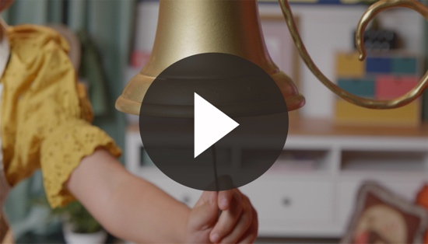

- Show the Faith Fact Slide or Motion Graphic.

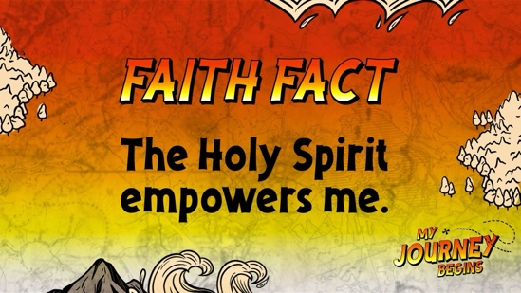

Let’s say our Faith Fact now. Remember to flex those muscles. The Holy Spirit empowers me. You really have learned that Faith Fact well!

Dismissal to Small Groups
Now it’s time to head to small group with your friends and do some more fun activities.

We’ll keep learning about the Holy Spirit.
- Dismiss the kids by groups.

Leader Tip: This can be done by assigning colors to teams or by age groups. Note that some preschoolers may not know their age. Using a colored sticker, jersey, or wristband will help separate the kids and help identify their small groups.

SMALL GROUP (25 Minutes)
See supplies and prep instructions at the beginning of the session or in each activity below.

Leader Tip: All groups can do each activity at the same time. If you choose to rotate, you will need at least one leader per group.

Circle 1

GROUP CONNECTION

Faith Verse Review
You Will Need | Getting Ready
- Beach ball or small ball | No prep is needed for this activity.

Goal: Kids will practice the Faith Verse as they play a game.

Kids, today we started learning a new Faith Verse. We’re going to play a game to help us remember it. The first time we play we’re going to learn each other’s names. I’m going to start with the ball and say my name. I’m going to hand it to my friend on my right. When you get the ball, jump up and say your name before passing it to the next friend.
- Allow kids to play the name round.

Now, we are going to play it again. Instead of saying your name, you will say the next word of the Faith Verse. Let’s practice the Faith Verse one time first. Remember that we’re just working on the first part of the verse today.
- Show the Faith Verse Slide or Motion Graphic.

Acts 1:8 (NLT)
“But you will receive power when the Holy Spirit comes upon you. And you will be my witnesses, telling people about me everywhere.”

- You may need to help the kids know what word is next in the verse.
- Once everyone has played, review the entire verse all together.

Circle 2

ACTIVITY PAGE TIME

Holy Spirit Activity Page
You Will Need | Getting Ready
- Activity Page, one per kid plus an extra  - Crayons | - Print copies of the Activity Page, one per kid plus an extra.  - Make a sample to show the kids.

Goal: Kids will review the lesson about the Holy Spirit by drawing a picture.
Boys and girls, who can remember the story we heard today? (Group response) That’s right! We learned about the Holy Spirit. What did the disciples see? (Allow responses.) That’s right! They saw fire. Do you remember the big thing we said the Holy Spirit can give us? (Allow responses.) You’re right again. He gives us power to be God’s helper! One of the ways you can be God’s helper is by telling people about Jesus. Today, you’re going to draw a picture of two people. First, draw yourself and then someone who you can talk to about Jesus.
- Help the kids as needed and be sure to write their names on their Activity Page.
- During the activity, interrupt and practice the Faith Fact: The Holy Spirit empowers me.
- Play the Faith Fact Sound video.

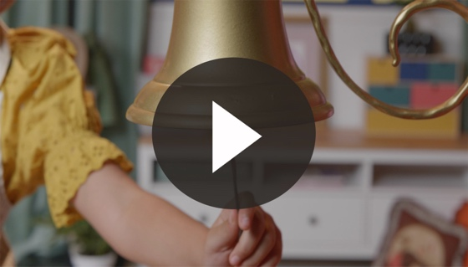

- Show the Faith Verse Slide or Motion Graphic.

Say the Faith Fact with me: The Holy Spirit empowers me. That was great!

Circle 3
FEET-TO-FLOOR GAME TIME
Hop and Shout Game
You Will Need | Getting Ready
- Floor-safe tape, such as painter’s tape | - Tape five large Xs on the floor in a straight line or fairly close together in a random pattern so kids can jump to each one.

Goal: Kids will review the Faith Fact as they play an active game.

Today, we learned a very special Faith Fact: The Holy Spirit empowers me. Do you see the Xs on the floor? We are going to take turns jumping onto the Xs and saying a word of the Faith Fact while the other kids help. When we get to the word empowers, we need to flex and show our muscles. Let me show you how.
- Demonstrate the activity.
- As each kid does the activity, encourage the others to say the Faith Fact, too.
- Show the Faith Fact Slide or Motion Graphic.

Circle 4

HANDS-ON LEARNING

Flames of Fire Headband
You Will Need | Getting Ready
- Hands-On Learning Page, one per every four kids.  - Crayons  - Scissors  - Construction paper, any color  - Stapler  - Glue, optional  - Red, yellow, and orange tissue paper, optional | - Print the Hands-On Learning Page, one per every four kids. Cut out the flames, one per kid.  - Cut strips of construction paper for the headbands, at least two per kid.  - Make a sample headband with flame.  - If you use the tissue paper option, cut the tissue paper into small square pieces.

Goal: Kids will review the Bible story and the importance the Holy Spirit.

Today, we learned about the Holy Spirit. The Holy Spirit gives us power to be God’s helpers and tell others about Jesus. Now, something special happened when the Holy Spirit came to empower the disciples. What did they see? That’s right! Flames of fire appeared. We are going to make our own Flames of Fire Headband.
- Write each kid’s name on their headband.
- Have the kids color their flame.
- Using a stapler, attach the flames to the headbands and adjust headbands if needed to fit each kid.
- If you use the tissue paper option, give the kids the colored tissue paper squares and have them glue the tissue paper to the flame. You need to staple the flames to the headbands prior to the kids using glue. The headband can be fitted and stapled to size when the kids are finished gluing.

FAITH FACT RECAP
- Display the Faith Fact Slide or Motion Graphic as parents are coming into the room.
- Maximize the time you have with your kids, so that parents see what their kids have learned. Have the kids repeat the Faith Fact and then dismiss them to their parents.

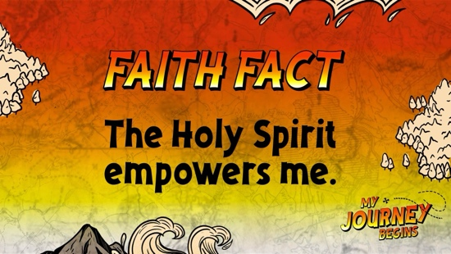

One thing I want you to remember from today is our Faith Fact. Say it with me. The Holy Spirit empowers me.

DISMISSAL
- Send home the Activity Page and headband with each kid.
- Remind parents that there are Family Devotions available on the app to do with their kid.
- Tell everyone the date and time for the next session.

