LEADER OVERVIEW

Volume Overview—My Journey Begins
In these sessions, kids will learn about the promise fulfilled through the empowerment of the Holy Spirit and how the Early Church came together and grew. They will look at the change that happens when they recognize Jesus as Lord and know that God is always with them.

SESSION 1: Baptism in the Holy Spirit—  Acts 1:8; 2:1–12  Faith Fact: The Holy Spirit empowers me. | SESSION 2: The Church Begins—  Acts 2:42–47  Faith Fact: The church helps me grow.
SESSION 3: Saul’s Conversion—  Acts 9:1–22  Faith Fact: God changes my life. | SESSION 4: Paul and Silas in Prison—  Acts 16:16–34  Faith Fact: With God, I am never alone.

SESSION OVERVIEW
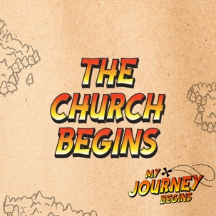
In this session, preschoolers will learn about how special the church is to God. They will learn how important it is to be part of the church for their whole lives because the church helps us grow.

Bible Lesson | Faith Fact
The Church Begins  Acts 2:42–47 | The church helps me grow.
Faith Verse
Acts 1:8 (NLT)
“But you will receive power when the Holy Spirit comes upon you. And you will be my witnesses, telling people about me everywhere—in Jerusalem, throughout Judea, in Samaria, and to the ends of the earth.”

Bible Engagement Project Preschool curriculum is connected with the intentional, yearlong ministry strategy for kids available at KidminRoadmap.com.
PREPARING FOR THE SESSION
You Will Need | Getting Ready
Preservice Activities  - Fruit-flavored snacks  - Toys  - “Read Your Bible, Pray Every Day” song  Large Group  - Bible  - Worship songs (Song suggestions: “Fruit of the Spirit” by KidSpring; “Holy Spirit” by Worship Together Kids)  - For groups not using a phone or tablet only, add:  - Projector or TV  - Laptop  - Countdown 5-Minute Video  - Theme Intro Video  - Bible Lesson Video A  - Bible Lesson Video B  - Faith Fact Slide or Motion Graphic  - Faith Fact Sound video (bell ringing)  - Faith Verse Slide or Motion Graphic  Small Group  - Small Group Activity Page, one per kid  - Crayons  - Small Group Hands-On Learning Pages 1 and 2, one copy of each page per group  - Scissors  - Tape | Preservice Activities  - Set out toys and snacks.  - If you don’t know the song “Read Your Bible, Pray Every Day,” find it online.  Large Group  - Download videos and slides if needed.  - Select worship song(s) and have them ready to play.  Small Group  - Print copies of the Small Group Activity Page, one per kid.  - Print a copy of Small Group Hands-On Learning Pages 1 and 2, one copy of each page per group.  - Cut out the items on Small Group Hands-On Learning Page 2 for kids to tape to the paper doll.

Check out all the promotional and extra media files available for this theme. To access Bible Engagement Project from a computer, visit App.BibleEngagementProject.com.

PRESERVICE ACTIVITIES (30 Minutes)
See what’s needed at the beginning of the session.

Bible Story Warm-Up
To get the kids prepared for the Bible story, teach them the song “Read Your Bible, Pray Every Day.” Then ask the questions below.

Today, we’re going to learn a fun song that goes along with what we will be talking about in the Bible lesson. It’s very easy. Who is ready to learn it? (Group response)

First, I’ll show you the actions. When I say, “Read your Bible,” pretend you’re reading a book like this. (Demonstrate action.) When I say, “Pray every day,” put your hands in this praying position. (Demonstrate action.) Finally, when I say, “Grow,” start low to the ground and stand a little taller every time I say it. (Demonstrate action.) I am going to show you the whole song, and then we can all try it together. (Demonstrate song.) Who is ready to sing this song?
- Practice singing the song with actions several times. Then ask the following questions.
  - Where are we today?
  - What is the church?
  - Who is the church?
  - Why do we come to church?

We are all here today to grow in God together. It’s going to be so much fun! Let’s have snack time.

Snack: Fruit-Flavored Snacks
As kids are eating the snack, share the following:

God wants the people in the church to work together. It’s important that we share and help each other. Today, we are going to practice sharing by passing packages of fruit snacks to our friends. I’ll pass a fruit snack to the person next to me, and they will pass it to the next person until we make it to the kid on the other side of me. We will keep going until everyone has a package of fruit snacks.

We will talk a lot about the church today, so it’s important that we share with each other like the church does. Let’s eat our yummy snack!

Free Play
Any extra time can be spent playing with toys.

LARGE GROUP (25 Minutes)
See what’s needed at the beginning of the session.

INTRODUCTION
- Optional: Play the Countdown 5-Minute Video.
- Use this time to pick up toys and transition to the large group area.



Welcome
Hi, boys and girls! It’s so great to see you. Where do we learn about God? (Group response) That’s right! We can learn about God at our church. We have a special place that we meet and we call it a “church.” It’s important that we go to church. But the church is more than just a special place.

Really, the church is the people who come to worship and serve God together. The people in our church help us grow in God. Today, we will learn about the church from God’s Word, the Bible. (Hold up the Bible.) Are you ready to have fun and grow in God today? (Allow responses.)
- Play the Theme Intro Video.

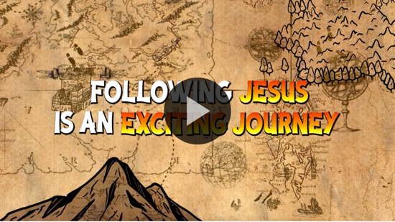

BIBLE TIME | The Church Begins (Acts 2:42–47)

Bible Video A

I’m so glad that you all came today. The church is very special to God. When we come to church, we get to learn more about God and grow together. I think Lizzy has something to tell us about that today. Let’s see what Lizzy and her grandpa have for us today.
- Play Bible Lesson Video A.

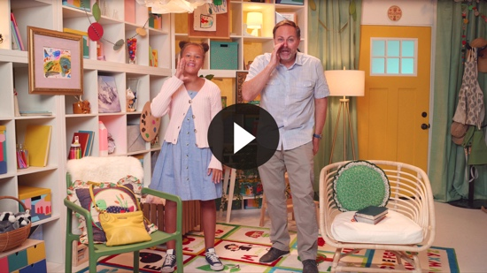

Great job helping Lizzy with the Faith Verse, everyone!

Faith Verse
- Show the Faith Verse Slide or Motion Graphic.

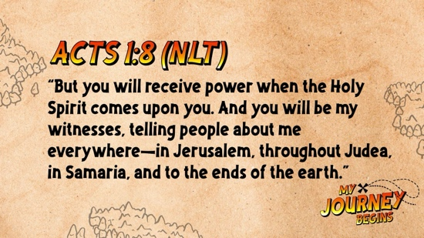

Let’s practice just the first part of the verse for now. Say it with me and do the actions.

Acts 1:8 (NLT)
“But you will receive power when the Holy Spirit comes upon you. And you will be my witnesses, telling people about me everywhere.”

Great job! I think we pretty much have the first part down. Next time, we will work on the rest of the verse.

WORSHIP
One of my favorite things we get to do when we come to church is worship together.

Praise
Are you glad to be with others at church? Wave your hands up high. (Group response)
Are you glad the church helps you grow? Wave your hands down low. (Group response)
Are you glad God loves the church? Wave your hands up high. (Group response)
Who wants to thank God? Wave your hands down low. (Group response)

Prayer
Let’s pray and give thanks to God with our words. Repeat after me.

Dear God, thank You so much for giving me the church so that I can learn and grow together with my friends. Amen.

Sing
Great job! Now let’s worship by singing to God.
- Lead the kids in singing one or two songs. See suggestions at the beginning of the session.

Now we’re all warmed up. I’m ready to hear our Bible story. How about you? (Group response)

BIBLE TIME continued | The Church Begins (Acts 2:42–47)

Bible Video B
Worshipping together is one of my favorite things we get to do at church. I know that God loved your worship. Let’s see what Lizzy is up to now.
• Play Bible Lesson Video B.

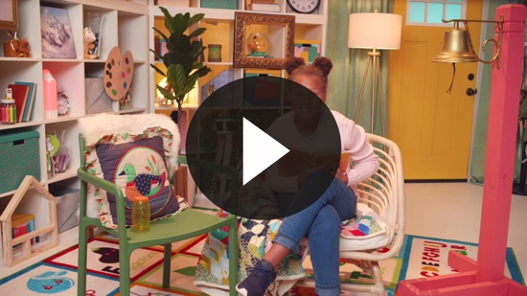

That was so much fun! Church is a great place to learn more about God’s Word. Now let’s see who remembers the Faith Fact.

Faith Fact
  - Play the Faith Fact Sound video.

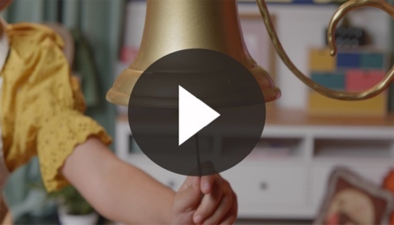

- Show the Faith Fact Slide or Motion Graphic.

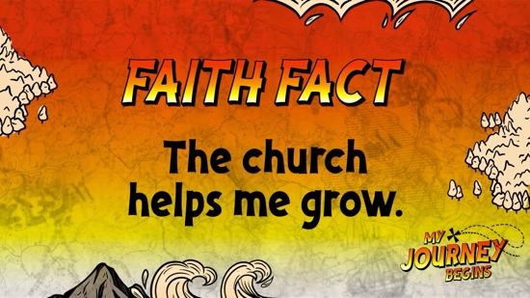

Did you hear that? (Group response) It was our Faith Fact bell. Every time it rings, we have a Faith Fact to say. Today’s Faith Fact is the church helps me grow. Let’s say it together a couple of times. Good job, kids!

Response Time

Consider playing a worship song softly in the background while kids pray.

Today, we talked about how the church helps us grow. The first church ate together, helped those who were in need, and prayed and worshipped together. Let’s pray and ask God to help us with everything we need to learn.
  - Pause to allow kids time to respond.

Put your hands together and bow your heads. Repeat after me.

Dear God, thank You so much that I have people in our church to teach me more about You. Help me to grow and become who You made me to be. Amen.

Closing
This was so much fun. Let’s say the Faith Fact again before we go to our small groups.
  - Play the Faith Fact Sound video.

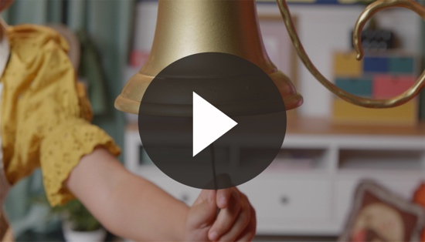

- Show the Faith Fact Slide or Motion Graphic.

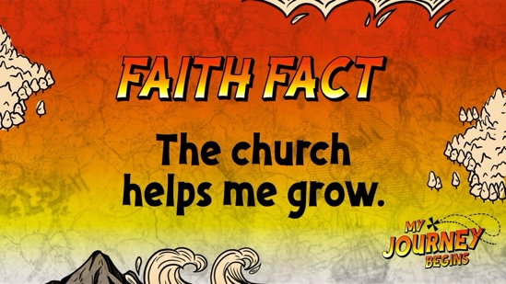

Let’s say our Faith Fact together. The church helps me grow. Awesome job!

Dismissal to Small Groups
Now it’s time to head to small group with your friends and do some more fun activities.
- Dismiss the kids by groups.

Leader Tip: This can be done by assigning colors to teams or by age groups. Note that some preschoolers may not know their age. Using a colored sticker, jersey, or wristband will help separate the kids and help identify their small groups.

SMALL GROUP (25 Minutes)
See supplies and prep instructions at the beginning of the session or in each activity below.

Leader Tip: All groups can do each activity at the same time. If you choose to rotate, you will need at least one leader per group.

Circle 1

GROUP CONNECTION

I Spy!
You Will Need | Getting Ready
No supplies are needed for this activity. | No prep is needed for this activity

Goal: Kids will play a familiar game, spying things around the room that remind them of going to church.

Today, we learned about church. Sometimes I see something, and it reminds me of church. We’re going to play a game we all love, called “I Spy!”

When it’s your turn, you will choose something in our room that reminds you of church. Then, you will say, “I spy with my little eye,” and describe that item by giving us a color or shape. Then, we will guess it.
- Give an example to get the game started.
- Play enough rounds that everyone has the chance to spy something.

Circle 2

ACTIVITY PAGE TIME

The Church Helps Me Grow
You Will Need | Getting Ready
- Activity Page, one per kid  - Crayons | - Print copies of the Activity Page, one copy per kid.

Goal: Kids will talk about the church while coloring a picture of a church.

Boys and girls, today we talked about what a church is and why it’s so important to God. The church, the people who worship God with us, helps us grow. While we color today’s picture, let’s talk about things we like about our church. What are some things you enjoy doing at church? (Group response) Those are all great ideas. What have you learned at church? (Allow responses.) What do you want to learn at church? (Allow responses.) When you finish coloring the church, draw a picture of yourself in front of our church building.
- Help the kids as needed and be sure to write their names on their Activity Page.
- During the activity, interrupt and practice the Faith Fact. The church helps me grow.
  - Play the Faith Fact Sound video.

Do you remember what we’re supposed to do when we hear that sound? (Shout out the Faith Fact.)
- Show the Faith Fact Slide or Motion Graphic.

Come on and say it with me now: The church helps me grow. That was great!

Circle 3
FEET-TO-FLOOR GAME TIME
Worship, Learn, Grow, Pray, Play!
You Will Need | Getting Ready
No supplies are needed for this activity. | No prep is needed for this activity.

Goal: Kids will be reminded about why it’s important for us to go to church.

Today, we learned a very special Faith Fact: The church helps me grow. The church helps us grow in so many ways. Can you think of some? (Allow responses.) Great job! The church helps us learn to worship, helps us learn from the Bible, helps us grow in God, helps us learn to talk to God through prayer, and grow closer together by playing with other kids.

We are going to play a game! Every time I say “Worship,” lift your hands up and say “Worship!” Every time I say “Learn,” use your hands to make a Bible and say “Learn!” Every time I say “Grow,” jump up, point to God, and say “Grow!” Every time I say “Pray,” put your hands together like you are praying and say “Pray!” Every time I say “Play,” start jumping around and yell “Play!” Let’s try it.
- Be sure to do the motions when you say the words.
- Play several rounds and mix up the order of the words.

Circle 4

Hands-On Learning

The Church Helps Me Grow
You Will Need | Getting Ready
- Hands-On Learning Pages 1 and 2, one copy of each per group  - Scissors  - Tape | - Print a copy of Hands-On Learning Page 1 and 2, one copy of each page per group.  - Cut out the items on Hands-On Learning Page 2 for kids to tape to the paper doll.

Goal: Kids will think of ways they can grow at church.

Kids, today we talked about ways the church helps us grow. I have this little paper doll who is ready for church. What are some things that this kid might do or learn in church to help them grow? (Allow responses.)
- If a kid names one of the following, have them come up and tape the cut-out item to the paper doll.
- Worship—Microphone
- Prayer—Mouth and ears
- Reading the Bible—Bible
- Loving others—Heart
- Offering—Money bag
- Kids may need to be directed to those phrases with questions.
  - What is something we read at church? (Bible)
  - How do we talk to God? (Pray)
  - What does God ask us to do? (Love others)
  - What is one way we show thanks to God? (Worship or giving in the offering)
- If the group is small, have everyone work together.
- If the group is large, break into smaller groups of three to four kids.
- During the game, interrupt and practice the Faith Fact: The church helps me grow.
  - Play the Faith Fact Sound video.

Do you remember what we’re supposed to do when we hear that sound? (Shout out the Faith Fact.)
- Show the Faith Fact Slide or Motion Graphic.

FAITH FACT RECAP
- Display the Faith Fact Slide or Motion Graphic as parents are coming into the room.
- Maximize the time you have with your kids, so that parents see what their kids have learned. Have the kids repeat the Faith Fact, and then dismiss them to their parents.

One thing I want you to remember from today is our Faith Fact. Say it with me. The church helps me grow.

DISMISSAL
- Send home the Activity Page.
- Remind parents that there are Family Devotions available on the app to do with their kid.
- Tell everyone the date and time for the next session.

