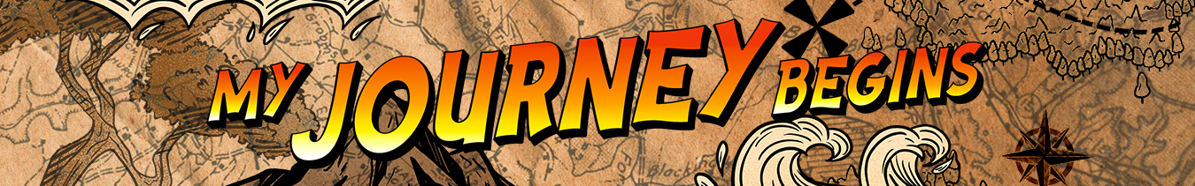LEADER OVERVIEW

Volume Overview—My Journey Begins
In these sessions, kids will learn about the promise fulfilled through the empowerment of the Holy Spirit and how the Early Church came together and grew. They will look at the change that happens when they recognize Jesus as Lord and know that God is always with them.

SESSION 1: Baptism in the Holy Spirit—  Acts 1:8; 2:1–12  Faith Fact: The Holy Spirit empowers me. | SESSION 2: The Church Begins—  Acts 2:42–47  Faith Fact: The church helps me grow.
SESSION 3: Saul’s Conversion—  Acts 9:1–22  Faith Fact: God changes my life. | SESSION 4: Paul and Silas in Prison—  Acts 16:16–34  Faith Fact: With God, I am never alone.

SESSION OVERVIEW
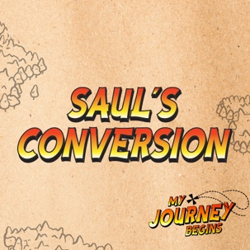
In this session, preschoolers will hear how Saul’s life forever changed on the road to Damascus. They will discover that God gave Saul a fresh new start. Kids will hear that God still changes lives.

Bible Lesson | Faith Fact
Saul’s Conversion  Acts 9:1–22 | God changes my life.
Faith Verse
Acts 1:8 (NLT)
“But you will receive power when the Holy Spirit comes upon you. And you will be my witnesses, telling people about me everywhere—in Jerusalem, throughout Judea, in Samaria, and to the ends of the earth.”

Bible Engagement Project Preschool curriculum is connected with the intentional, yearlong ministry strategy for kids available at KidminRoadmap.com.
PREPARING FOR THE SESSION
You Will Need | Getting Ready
Preservice Activities  - Fruit roll snacks (homemade or store-bought)  - Toys  - Floor-safe tape, such as painter’s tape  Large Group  - Bible  - Worship songs (Song suggestions: “Fruit of the Spirit” by KidSpring; “Holy Spirit” by Worship Together Kids)  - For groups not using a phone or tablet only, add:  - Projector or TV  - Laptop  - Countdown 5-Minute Video  - Theme Intro Video  - Bible Lesson Video A  - Bible Lesson Video B  - Faith Fact Sound video (bell ringing)  - Faith Fact Slide or Motion Graphic  - Faith Verse Slide or Motion Graphic  Small Group  - Craft clay  - Rolling Pins  - Plastic cookie cutters  - Small Group Activity Page, one per kid  - Crayons  - Small Hands-On Learning Page, one per every two kids plus an extra  - Scissors  - Glue  - Large googly eyes | Preservice Activities  - Set out toys and snacks.  - Create a pattern with the floor-safe tape on the floor for kids to follow.  Large Group  - Download videos and slides if needed.  - Select worship song(s) and have them ready to play.  Small Group  - Print copies of the Small Group Activity Page, one per kid.  - Print copies of the Hands-On Learning Page, one per two kids plus an extra. Cut apart the pictures of Saul and give one to each kid.  - Make a sample picture of Saul to show the kids.

Check out all the promotional and extra media files available for this theme. To access Bible Engagement Project from a computer, visit App.BibleEngagementProject.com.

PRESERVICE ACTIVITIES (30 Minutes)
See what’s needed at the beginning of the session.

Bible Story Warm-Up
To get the kids prepared for the Bible lesson, play this game and then discuss it.

Today, we are going to hear a story about a man who suddenly became blind on his way to a place called Damascus. Can you all say “Damascus”? (Group response) We are going to play a game where you will close your eyes, and a friend will have to help you follow this tape trail on the floor.
- Let the pairs walk the trail with one leading and one with closed eyes. Then, let the kids switch roles.
- The goal is to walk along the tape line without stepping off.

Have you ever made a mistake or done something wrong? (Group response) We all have. Sometimes when we are going through something hard, we may feel like we are stuck forever. But that isn’t true. Who helps us change and grow? (Allow responses.) That’s right! God does. The Bible is full of examples of God helping people and changing lives. We are going to hear one of those stories today. But first, let’s have a snack.

Snack: Fruit Snack Rolls
As kids are eating the snack, share the following:

You know what I like about these fruit rolls? You can pull them apart and change their shape. That’s what God does for us. He can change us and our lives. God makes our lives so much better. Let’s eat our yummy snack.

Free Play
Any extra time can be spent playing with toys.

LARGE GROUP (25 Minutes)
See what’s needed at the beginning of the session.

INTRODUCTION
- Optional: Play the Countdown 5-Minute Video.
- Use this time to pick up toys and transition to the large group area.



Welcome
Hi, kids! I am so happy that you are here today! Today, we are going to hear one of the amazing stories from God’s Word, the Bible. (Hold up the Bible.) It’s the story of God helping a man named Saul change into who God made him to be. Who wants to learn about Saul? (Allow responses.) I’m so excited to see what we can learn today.
- Play the Theme Intro Video.

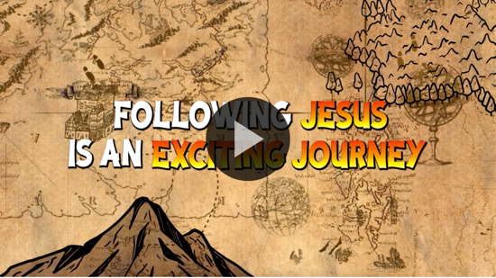

BIBLE TIME | Saul’s Conversion (Acts 9:1–22)

Bible Video A
I am so thankful that God changed my life, and He will change yours, too. God makes everything better. Lizzy and her grandpa have more for us to learn about that. Let’s see what she is up to.
- Play Bible Lesson Video A.

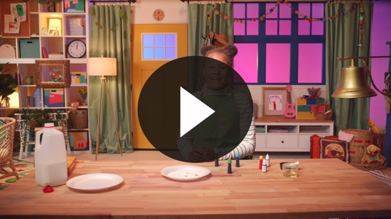

That was a great story! Who is happy that God changed Saul’s life? (Group response) Because God changed Saul’s life, he went on to live an amazing life for God.

Faith Fact
  - Play the Faith Fact Sound video.

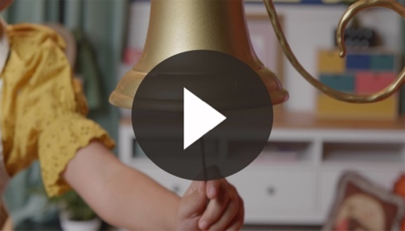

- Show the Faith Fact Slide or Motion Graphic.

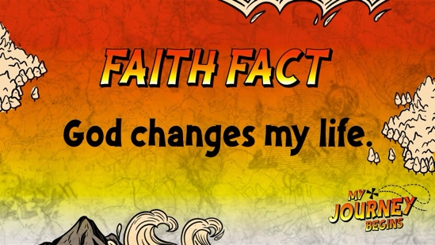

Was that the Faith Fact bell? (Group response) It was! Every time it rings, we are to say our Faith Fact! Just like Lizzy told us, our Faith Fact today is God changes my life. Can you say it after me? God changes my life. That was great!

WORSHIP
Let’s spend some time singing songs and thanking God for changing our lives.

Praise
Are you glad God changes your life? Wave your hands up high. (Group response)
Are you glad God makes us new? Wave your hands down low. (Group response)
Are you glad God loves us? Wave your hands up high. (Group response)
Who wants to thank God for listening to our prayers? Wave your hands down low. (Group response)

Prayer
I’m so thankful for all God does for us. Are you thankful, too? If so, let’s pray and prepare our hearts for worshipping Jesus. Say it after me.

Dear God, thank You for always being there for me and changing my life. I love You and want to obey You. Amen.

Sing
Awesome job! Who wants to give God thanks by singing and worshipping Him? (Group response) Me too! Let’s worship God together.
- Lead the kids in singing one or two songs. See suggestions at the beginning of the session.

BIBLE TIME continued | Saul’s Conversion (Acts 9:1–22)

Bible Video B
I love that God can change our lives. He is so good. It’s time to check back in with Lizzy to see what she is up to now.
• Play Bible Lesson Video B.

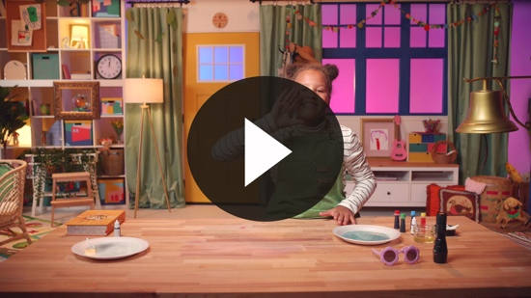

That was so much fun! Who thinks they remember the new part of the Faith Verse that Lizzy taught us? Let’s practice the whole verse and actions together.

Faith Verse
- Show the Faith Verse Slide or Motion Graphic.

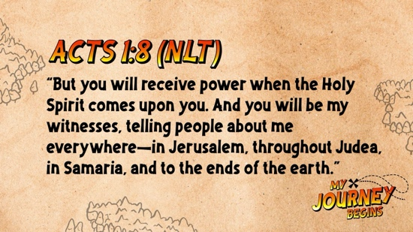

Acts 1:8 (NLT)
“But you will receive power when the Holy Spirit comes upon you. And you will be my witnesses, telling people about me everywhere—in Jerusalem, throughout Judea, in Samaria, and to the ends of the earth.”

Say it with me a couple of times to help us all keep it deep in our heart.
- Practice the Faith Verse several times with the kids.

Nice job! We almost have it memorized.

Response Time

Consider playing a worship song softly in the background while kids pray.

Today, we heard how God changed Saul’s life and how He can change our lives, too. After meeting Jesus on the Damascus Road, Saul taught people all around the world that Jesus could change their lives and that He loved them. Raise your hand if you would like to ask God to change your life. (Pause for kids to respond.)

Put your hands together and bow your heads. Say the words after me.

Dear God, I know that You can change people’s lives. Please change my life and help me to tell others about You like Saul did. Amen.

Closing
Awesome job! Wasn’t today amazing? Let’s say the Faith Fact again before we go to our small groups.
  - Play the Faith Fact Sound video.

- Show the Faith Fact Slide or Motion Graphic.

Let’s say our Faith Fact now. God changes my life.

Dismissal to Small Groups
I’m so proud of all of you! Each of you did such a great job today. Now it’s time to head to small group with your friends and do some more fun activities.
- Dismiss the kids by groups.

Leader Tip: This can be done by assigning colors to teams or by age groups. Note that some preschoolers may not know their age. Using a colored sticker, jersey, or wristband will help separate the kids and help identify their small groups.

SMALL GROUP (25 Minutes)
See supplies and prep instructions at the beginning of the session or in each activity below.

Leader Tip: All groups can do each activity at the same time. If you choose to rotate, you will need at least one leader per group.

Circle 1

GROUP CONNECTION

Craft Clay Time
You Will Need | Getting Ready
- Craft clay  - Rolling pins  - Plastic cookie cutters | No prep is needed for this activity.

Goal: Kids will play with craft clay to reinforce the story of God changing Saul’s life.

Today, we heard how God completely changed Saul’s life. God can change your life, too. What happens when we roll craft clay? (Group response) What happens when we cut out craft clay? (Group response) We can change the shape using the rolling pin and the cookie cutters. God can change our lives too. We just need to ask Him to help us. Let’s have fun making some cool shapes with our craft clay.
- Give each kid some craft clay.
- Let the kids have fun and help them if they need it.
- Ask them what they are making and encourage them.
- At some point, interrupt and practice the Faith Fact: God changes my life.
- Play the Faith Fact Sound video.

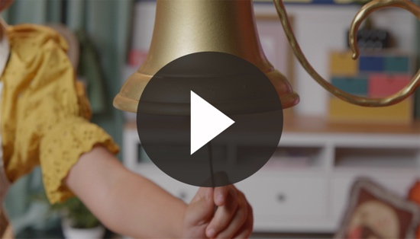

- Show the Faith Fact Slide or Motion Graphic.

Can you say it with me? God changes my life.

Circle 2

ACTIVITY PAGE TIME

Road to Damascus Coloring Page
You Will Need | Getting Ready
- Activity Page, one per kid  - Crayons | - Print copies of the Activity Page, one per kid.
Goal: Kids will review the story and ask questions while coloring the page.

Today, we discovered how God changed Saul’s life forever on the road to Damascus. Take a look at the picture.

Saul was on his way to Damascus to fight against people who loved Jesus. All of a sudden, there was a bright light, and Saul heard Jesus talking to him. Saul was now blind. Jesus sent him to Damascus where Saul waited. God sent Ananias to pray for Saul, and when he did, God healed Saul’s eyes so he could see again. Saul asked Jesus to forgive his sin, and God changed his life.

Do you remember our Faith Fact? (Allow responses.) That’s right. God changes my life. Let’s color the picture so you can tell others Saul’s story.
- Help the kids as needed and be sure to write each kid’s name on their Activity Page.

Circle 3
FEET-TO-FLOOR GAME TIME
Long Distance Telephone
You Will Need | Getting Ready
No supplies are needed for this activity. | No prep is needed for this activity.

Goal: Kids will review the Faith Fact, while getting up and moving.

Today, Lizzy taught us a very special Faith Fact: God changes my life. He changes our lives and the lives of others. We want the whole world to know about Jesus and how He can make people’s lives better.

We are going to play a game. Everyone needs to spread out around our area. I will whisper a message to the friend next to me. That friend will hop to the next friend and whisper the message. We will go around the room until the last friend hops to me to whisper the message.
- Phrases to whisper to the kids:
  - God changes my life.
  - God loves me.
  - Tell the world about Jesus.
  - I love Jesus.
- At the end of the game, have everyone as a group practice the Faith Fact: God changes my life.
- Play the Faith Fact Sound video.

- Show the Faith Fact Slide or Motion Graphic.

Say it with me. God changes my life. That was great!

Circle 4

HANDS-ON LEARNING

Blind to Sight Activity
You Will Need | Getting Ready
- Hands-On Learning Page, one per every two kids plus one for a sample  - Scissors  - Crayons  - Glue  - Large googly eyes | - Print copies of the Hands-On Learning Page, one per two kids plus an extra. Cut apart the pictures of Saul and give one to each kid.  - Make a sample picture of Saul to show the kids.

Goal: Kids will delve deeper into Saul’s story while exploring it in a creative way.

Today, we heard about God changing Saul’s life. (Hold up the sample Hands-On Learning picture of Saul with his eyes closed.) We heard that Saul went blind, and that God sent Ananias to pray for him. Ananias obeyed, and God healed Saul’s sight. (Hold up the googly eyes.) Today, we are going to make our own Saul so that we can tell our friends and family all about the story. Let’s color Saul and then glue these eyes on him to remind us that God changed Saul’s life and can change our lives, too.
- Be sure to write each kid’s name on their picture of Saul.
- You may need to help the kids glue on the eyes.

FAITH FACT RECAP
- Display the Faith Fact Slide or Motion Graphic as parents are coming into the room.
- Maximize the time you have with your kids, so that parents see what their kids have learned. Have the kids repeat the Faith Fact and then dismiss them to their parents.

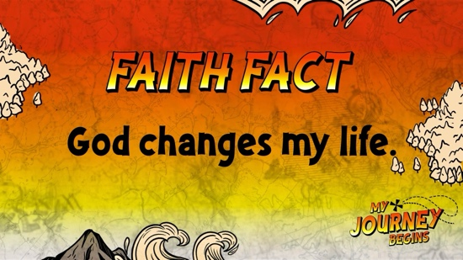

One thing I want you to remember from today is our Faith Fact. Say it with me. God changes my life.

DISMISSAL
- Send home the Activity Page and Hands-On Learning craft.
- Remind parents that there are Family Devotions available on the app to do with their kid.
- Tell everyone the date and time for the next session.

