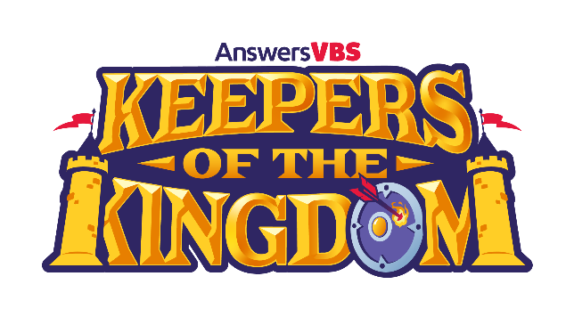
VBS Registration Form

Calvary Chapel of Palm Harbor
32676 US Hwy 19 North, Palm Harbor, FL 34684 Phone: 727-786-7969

www.ccpalmharbor.org

Child Name: ________________________________ Age: _____ Date of Birth: ___/___/___

Street Address: _______________________________________________________________

City: ____________________________________State: __________ZIP: _________________

Phone: (_____)__________________ Grade ENTERING Fall 2023 - PK4 K 1 2 3 4 5

Legal Parent/Guardian Names: __________________________________________________

Food or Other Allergies: ________________________________________________________

Permission Slip

As the legal parent/guardian of the child named above, I hereby give my permission for this child to participate in all Vacation Bible School activities at Calvary Chapel of Palm Harbor and for the posting on social media of any photographs or video taken of my child during the week of
June 19, 2023 to June 23, 2023
I give permission to the leaders of the above VBS to render First Aid, should the need arise. In the event of an emergency, I also give permission to the physician, selected by the adult leader in charge, to hospitalize, secure proper anesthesia, order injection, or secure other medical treatment, as needed.
I further agree to hold the above named church and its leaders blameless for any accidents that might occur during this activity except for clear acts of negligence or non-adherence to church policies and guidelines.
In case of emergency, I can be reached by phone at ___________________ or __________________
If I cannot be reached, please contact _____________________________ at ____________________
In addition to Parent/Guardian, I authorize the following ADULTS(s) to sign my child out from this event:
__________________________________________________________________________________

Signed: __________________________________________ Date: _____________________
(Legal Parent/Guardian)

