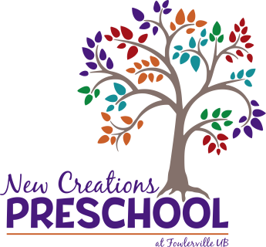

Dear Preschool Families,

I’m so glad you are considering New Creations Preschool for this coming school year. I want to take this time to tell you a bit about our preschool program.

New Creations has been a part of Fowlerville UB church since 1992. We have four classrooms; two for children who are 4 years old, one for those who are 3 years old by September 1, and one room for our mixed age (3 and 4 yr. old) half-day students. We have two teachers in each classroom. Three classrooms are licensed for 19 children each day and one classroom is licensed for 15 children.

Our schedule is Monday-Thursday, 9 am-3 pm (full days) or 9 am- 11:30 am (half days). You can choose 2,3, or 4 full or half days. School begins on Tuesday, September 3, 2024, and ends on Thursday, May 22, 2025. Half day spots are limited. We follow the Fowlerville school calendar for days off throughout the year.

New Creations preschool uses a theme-based, play-based, hands-on curriculum. Each day includes circle time, singing and movement, calendar, math, science, art, writing, small and large motor activities, cooperative play, outside play, and Bible stories. We also do P.E., sign language and library once a week. Within the curriculum, the children learn everything they need to know to prepare them for kindergarten and beyond.

I look forward to meeting each of you! There will be an open house prior to the beginning of the school year. If you would like to schedule a tour, or have any questions, you can call the church office at 517-223-9490 or email me at Tammy@Fowlervilleub.org. Registration forms and payments can be turned in at the church office during regular business hours. (M-Th, 9 am- 4 pm).

Tammy DeRuyver
Director
New Creations Preschool

