ST. PAUL’S
ANGLICAN CHURCH
VISALIA, CALIFORNIA

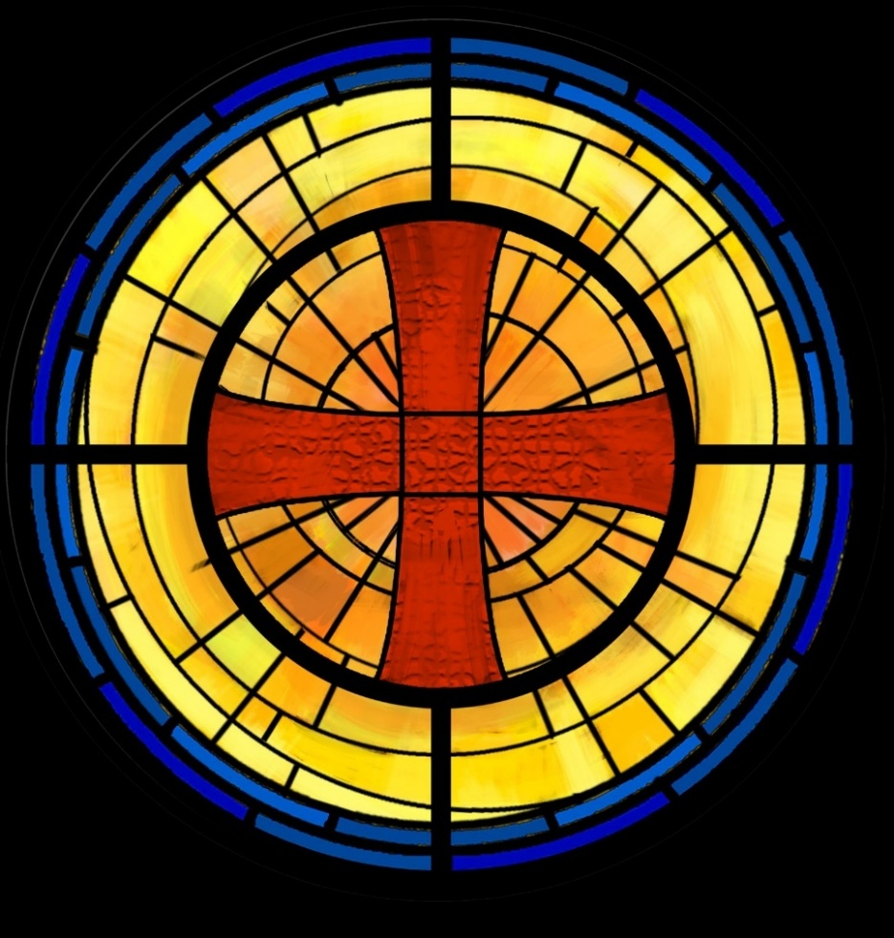

HOLY EUHARIST
WITH CONFIRMATIONS AND REAFFIRMATION

The Third Sunday of Epiphany
January 25, 2026
10:30 AM

Welcome!
St. Paul’s Anglican Church extends a warm welcome to all visitors and newcomers, whether worshiping in person or at home via livestream.

Visitors’ Guide

St. Paul’s Church is a parish in the Diocese of San Joaquin of the Anglican Church in North America, which includes both Catholic and Protestant traditions. We accept Jesus Christ as Savior, and we promise to follow him as Lord. We believe in One God,

- the Father who created us and all things,
- the Son who redeems us from sin and death,
- the Holy Spirit who renews and sanctifies us.

We believe the Holy Scriptures to be the Word of God and to contain all things necessary for salvation, and we accept the Apostles’ and Nicene Creeds as essential beliefs of the Christian faith.

All followers of Jesus who are baptized in the name of the Trinity are invited to receive Holy Communion. If for whatever reason you feel you cannot receive communion, we invite you to come forward to receive a blessing. Please indicate you’d like a blessing by crossing your arms. All people are welcome at the Altar of the Lord.

Visitors are invited to sign the guest book at the entrance table and introduce themselves to the clergy following the service.

The Holy Eucharist

Postlude:” Prelude: Psalm 19” Marcello
Opening Hymn: #7 - “Christ Whose Glory Fills the Skies” p. 4
Opening Acclamation p. 5
Confession and Absolution p. 5
The Comfortable p. 6
Collect of the Day p. 6
Lesson: Amos 3:1-11 p. 6
Gradual: Psalm 139:1-18 p. 8
Epistle: 1 Corinthians 1:10-17 p. 9
Sequence Hymn: #530 “Spread, O Spread Thou Mighty Word” p. 10
Gospel: Matthew 4:12-22 p. 10
Sermon: Rt. Rev. Eric Menees
Nicene Creed p. 11
The Presentation, Exhortation and Examination p. 12
Prayers and Laying on of Hand p. 14
The Peace p. 15
Offertory Anthem: “Give Me Jesus” Choir
The Offertory p. 15
Sanctus p. 16
The Lord’s Prayer p. 19
Fraction p. 20
Prayer for Humble Access p. 20
Agnus Dei p. 20
Communion Praise Songs
“Come to the Table” p. 21
“You Are My in All” p. 22
Post communion Prayer p. 23
Blessing p. 23
Closing Hymn: #518 - “Christ is Made the Sure Foundation” p. 24
Dismissal p. 25
Prelude: “Allegro Maestoso (Water Music)” Handel

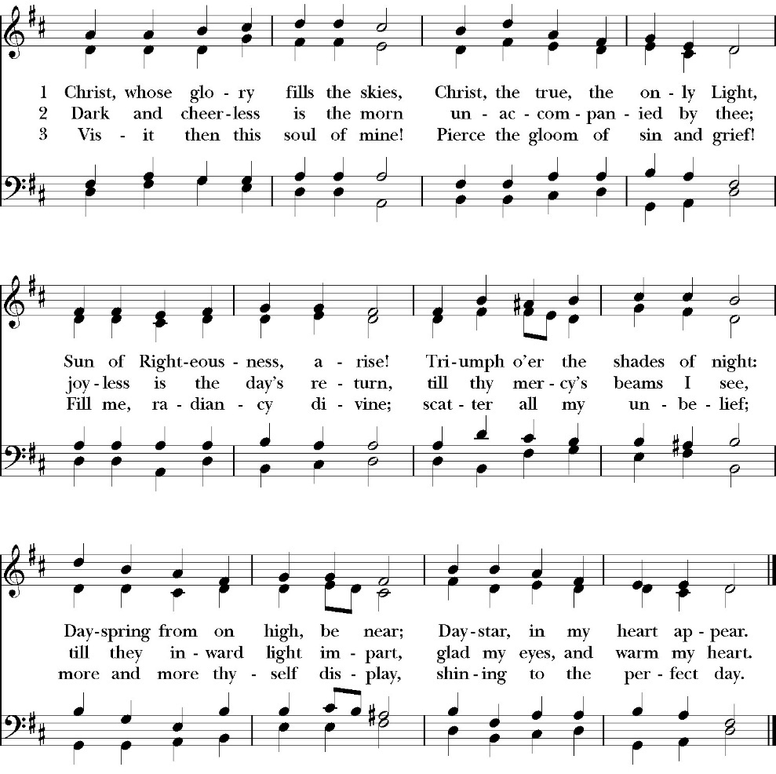
Opening Hymn: Christ Whose Glory Fills the Skies

Opening Acclamation

Bishop The Lord will pour out his Spirit upon all flesh,
People And your sons and daughters shall prophesy.
Bishop Your old men shall dream dreams,
People And your young men shall see visions.
Bishop You shall know that the Lord is in the midst of his
people,
People That he is the Lord and there is none else.
Bishop And it shall come to pass
People That everyone who calls on the name of the Lord
shall be saved.

Bishop The Lord be with you.
People And with your spirit.
Bishop Let us pray.

Confession and Absolution

Let us humbly confess our sins to Almighty God.

Most merciful God,
we confess that we have sinned against you
in thought, word and deed,
by what we have done, and by what we have left undone.
We have not loved you with our whole heart;
we have not loved our neighbors as ourselves.
We are truly sorry and we humbly repent.
For the sake of your Son Jesus Christ,
have mercy on us and forgive us;
that we may delight in your will, and walk in your ways,
to the glory of your Name. Amen.

Almighty God, our heavenly Father, who in his great mercy has
promised forgiveness of sins to all those who sincerely repent and
with true faith turn to him, have mercy upon you, pardon and deliver
you from all your sins, confirm and strengthen you in all goodness,
and bring you to everlasting life; through Jesus Christ our Lord.
Amen.

The comfortable word

Hear the Word of God to all who truly turn to him.
Come to me, all who labor and are heavy laden, and I will give
you rest.
Matthew 11:28

God so loved the world, that he gave his only-begotten Son,
that whoever believes in him should not perish but have eternal
life. John 3:16

God so loved the world, that he gave his only-begotten Son, that
whoever believes in him should not perish but have eternal life.
John 3:16

The saying is trustworthy and deserving of full acceptance, that
Christ Jesus came into the world to save sinners.
1 Timothy 1:15

If anyone sins, we have an advocate with the Father, Jesus
Christ the righteous. He is the propitiation for our sins, and not
for ours only, but also for the sins of the whole world.
1 John 2:1-2

The Collect of the Day

Give us grace, O Lord, to answer readily the call of our Savior Jesus Christ and proclaim to all people the Good News of his salvation, that we and the whole world may perceive the glory of his marvelous works; who lives and reigns with you and the Holy Spirit, one God, for ever and ever. Amen.

Lesson: Amos 3:1-11
Hear this word that the Lord has spoken against you, O people of Israel, against the whole family that I brought up out of the land of Egypt:
² “You only have I known
of all the families of the earth;
therefore I will punish you
for all your iniquities.
³ “Do two walk together,
unless they have agreed to meet?
⁴ Does a lion roar in the forest,
when he has no prey?
Does a young lion cry out from his den,
if he has taken nothing?
⁵ Does a bird fall in a snare on the earth,
when there is no trap for it?
Does a snare spring up from the ground,
when it has taken nothing?
⁶ Is a trumpet blown in a city,
and the people are not afraid?
Does disaster come to a city,
unless the Lord has done it?
⁷ “For the Lord God does nothing
without revealing his secret
to his servants the prophets.
⁸ The lion has roared;
who will not fear?
The Lord God has spoken;
who can but prophesy?”
⁹ Proclaim to the strongholds in Ashdod
and to the strongholds in the land of Egypt,
and say, “Assemble yourselves on the mountains of Samaria,
and see the great tumults within her,
and the oppressed in her midst.”
¹⁰ “They do not know how to do right,” declares the Lord,
“those who store up violence and robbery in their strongholds.”
¹¹ Therefore thus says the Lord God:
“An adversary shall surround the land
and bring down your defenses from you,
and your strongholds shall be plundered.”
Reader The Word of the Lord
People Thanks be to God

Gradual: Psalm 139:1-18
1 O Lord, you have searched me out and known me; *
you know my sitting down and my rising up; you understand
my thoughts from afar.
2 You examine my path and my places of rest, *
and are acquainted with all my ways.
3 Indeed, there is not a word on my tongue, *
but you, O Lord, know it altogether.
4 You have enclosed me behind and before, *
and have laid your hand upon me.
5 Such knowledge is too wonderful for me, *
so excellent I cannot attain to it.
6 Where shall I go then from your Spirit, *
or where shall I flee from your presence?
7 If I climb up to heaven, you are there; *
if I make my bed in the Grave, you are there also.
8 If I take the wings of the morning *
and dwell in the uttermost parts of the sea,

9 Even there shall your hand lead me, *
and your right hand shall hold me.

10 If I say, “Surely the darkness shall cover me,” *
then shall my night be turned to day.

11 Even the darkness is not dark to you, and the night is as clear as
the day; *
the darkness and the light to you are both alike.
12 For you yourself made my inmost parts; *
you knit me together in my mother’s womb.

13 I will give thanks to you, for I am fearfully and wonderfully
made;*
marvelous are your works, and my soul knows it very well.

14 My bones were not hidden from you *
when I was made in secret and fashioned in the depths of the
earth.

15 Your eyes beheld my substance, while I was yet unformed; *
and in your book were all my members written,
16 Which day by day were fashioned, *
when as yet there was none of them.

17 How dear to me are your thoughts, O God. *
How great is the sum of them!
18 If I were to count them, they would be more in number than the
sand. *
When I wake up, I am present with you.

Glory be to the Father, and to the Son, and to the Holy Spirit;
as it was in the beginning, is now, and ever shall be, world without end. Amen
Epistle: 1 Corinthians 1:10-17
¹⁰ I appeal to you, brothers, by the name of our Lord Jesus Christ, that all of you agree, and that there be no divisions among you, but that you be united in the same mind and the same judgment. ¹¹ For it has been reported to me by Chloe's people that there is quarreling among you, my brothers. ¹² What I mean is that each one of you says, “I follow Paul,” or “I follow Apollos,” or “I follow Cephas,” or “I follow Christ.” ¹³ Is Christ divided? Was Paul crucified for you? Or were you baptized in the name of Paul? ¹⁴ I thank God that I baptized none of you except Crispus and Gaius, ¹⁵ so that no one may say that you were baptized in my name. ¹⁶ (I did baptize also the household of Stephanas. Beyond that, I do not know whether I baptized anyone else.) ¹⁷ For Christ did not send me to baptize but to preach the gospel, and not with words of eloquent wisdom, lest the cross of Christ be emptied of its power.

Reader The Word of the Lord
People Thanks be to God

Sequence Hymn: Spread, O Spread Thou Mighty Word
(vs. 1-3 before the Gospel, v. 4- 5 after)

Clergy: The Gospel of the Lord, according to St. Matthew
People: Glory to you, Lord God

Gospel: Matthew 4:12-22

¹² Now when he heard that John had been arrested, he withdrew into Galilee. ¹³ And leaving Nazareth he went and lived in Capernaum by the sea, in the territory of Zebulun and Naphtali, ¹⁴ so that what was spoken by the prophet Isaiah might be fulfilled:
¹⁵ “The land of Zebulun and the land of Naphtali,
the way of the sea, beyond the Jordan, Galilee of the Gentiles—
¹⁶ the people dwelling in darkness
have seen a great light,
and for those dwelling in the region and shadow of death,
on them a light has dawned.”
¹⁷ From that time Jesus began to preach, saying, “Repent, for the kingdom of heaven is at hand.”
¹⁸ While walking by the Sea of Galilee, he saw two brothers, Simon (who is called Peter) and Andrew his brother, casting a net into the sea, for they were fishermen. ¹⁹ And he said to them, “Follow me, and I will make you fishers of men.” ²⁰ Immediately they left their nets and followed him. ²¹ And going on from there he saw two other brothers, James the son of Zebedee and John his brother, in the boat with Zebedee their father, mending their nets, and he called them. ²² Immediately they left the boat and their father and followed him.

Clergy The Gospel of the Lord
People Praise to you, Lord Christ.

Sermon
Rt. Rev. Eric V. Menees

The Nicene Creed

We believe in one God,
the Father, the Almighty,
maker of heaven and earth,
of all that is, visible and invisible.

We believe in one Lord, Jesus Christ,
the only-begotten Son of God,
eternally begotten of the Father,
God from God, Light from Light,
true God from true God,
begotten, not made,
of one Being with the Father.
through him all things were made.
For us and for our salvation he came down from heaven:
was incarnate from the Holy Spirit and the Virgin Mary,
and was made man.
For our sake he was crucified under Pontius Pilate;
he suffered death and was buried.
On the third day he rose again in accordance with the
Scriptures;
he ascended into heaven
and is seated at the right hand of the Father.
He will come again in glory to judge the living and the dead,
and his kingdom will have no end.

We believe in the Holy Spirit, the Lord, the giver of life,
who proceeds from the Father [and the Son],
who with the Father and the Son is worshiped and glorified.
who has spoken through the Prophets.
We believe in one holy catholic and apostolic Church.
We acknowledge one Baptism for the forgiveness of sins.
We look for the resurrection of the dead,
and the life of the world to come. Amen.

The Presentation, Exhortation and Examination
Only a bishop may confirm. The Bishop customarily sits in a chair in front of the Altar Table. The candidates and presenters stand facing the Bishop as their presenters say
Presenters Right Reverend Father in God, we present these persons
to receive the laying on of hands.
Bishop Have they been adequately prepared?
Presenters They have.
The Bishop then shall say

Dearly beloved, it is essential that those who wish to be Confirmed in this Church must publicly confess Jesus Christ as their Lord and Savior; become his disciple; know and affirm the Nicene Creed, the Lord’s Prayer, and the Ten Commandments; and have received instruction in the Holy Scriptures of the Old and New Testaments and the Catechism of the Church. God’s grace is imparted in baptism
where we are made God’s children by adoption and given the Holy Spirit. Through the power of the Spirit, manifested in gifts and fruit, we are enabled to be God’s people for the sake of the world.
Now, these candidates here desire publicly to confess their faith in Jesus Christ as Savior and their commitment to follow him as Lord. They also desire the strengthening of grace through the laying on of
hands that the Holy Spirit may fill them more and more for their ministry in the Church and in the world.

The Bishop then addresses the candidates
Do you, here in the presence of God and the Church, renew the solemn promises and vows made at your Baptism and commit to keep them?
Candidates I do.
Bishop Do you renounce the Devil and all the spiritual forces of
wickedness that rebel against God?
Candidates I renounce them.
Bishop Do you renounce the empty promises and deadly deceits
of this world which corrupt and destroy the creatures of
God?
Candidates I renounce them.
Bishop Do you renounce the sinful desires of the flesh that draw
you from the love of God?
Candidates I renounce them.
Bishop Do you turn to Jesus Christ and confess him as your
Lord and Savior?
Candidates I do.
Bishop Do you joyfully receive the Christian Faith, as revealed in
the Holy Scriptures of the Old and New Testaments?
Candidates I do.
Bishop Will you obediently keep God’s holy will and
commandments, and walk in them all the days of your
life?
Candidates I will, the Lord being my helper.
The Bishop then addresses the congregation, first inviting them to stand.
Will you who witness these vows do all in your power to support these persons in their life in Christ?

The Congregation responds: We will.
Prayer and the Laying on of Hands
Let us pray.

Almighty and everliving God, we ask you to strengthen these your servants for witness and ministry, through the power of your Holy Spirit. Daily increase in them the gift of your grace and the fruit of
your Spirit; through Jesus Christ our Lord. Amen.

For Confirmation
Each confirmand kneels in front of the Bishop. The Bishop, then laying his hands upon the person’s head, shall pray
Defend, O Lord, this your servant N. with your heavenly grace, that he may continue yours for ever, and daily increase in your Holy Spirit more and more until he comes into the fullness of your everlasting kingdom.
People Amen.
Or this
Strengthen, O Lord, your servant N. with your Holy Spirit; empower him for your service; and sustain him all the days of his life.
People Amen.
For Reaffirmation
The Bishop may also accept with the laying on of hands the Reaffirmation of vows by a person who has previously been Confirmed or Received in this Church.

N., the Holy Spirit, who has begun a good work in you, direct and empower you by his grace, that you may continue in the service of our Lord Jesus Christ all the days of your life.

People: Amen.

The Bishop may make the sign of the Cross with the Oil of Chrism on the forehead of any receiving the laying on of hands, and may say,

N., I sign you with the Cross of our Lord Jesus Christ in the Name of the Father, and of the Son, and of the Holy Spirit.

The Bishop then says, with all the People standing
Almighty and everliving God, let your fatherly hand be upon these your servants; let your Holy Spirit ever be with them; and so lead them in the knowledge and obedience of your Holy Word, that they
may faithfully serve you in this life, and joyfully dwell with you in the life to come; through Jesus Christ our Lord. Amen

Celebrant The Peace of the Lord be always with you.
People And with your spirit.

offertory anthem
Give me Jesus -choir

Offertory

Celebrant All things come from you, O Lord,
People And of your own have we given you.

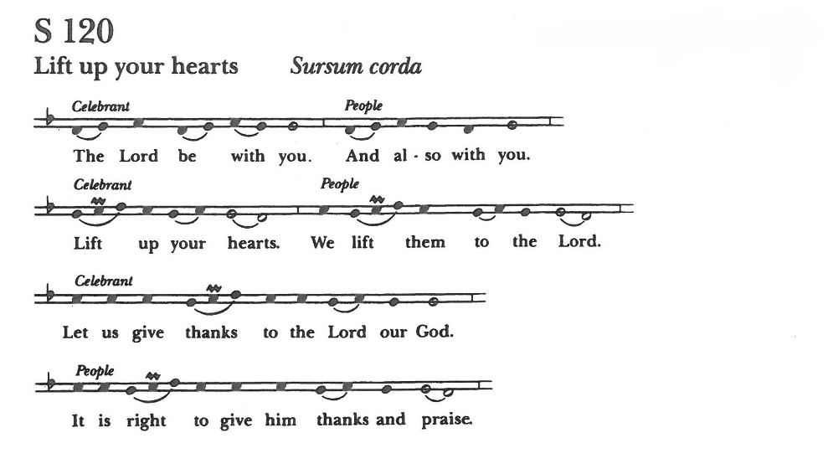
Eucharistic Liturgy

It is right, our duty and our joy, always and everywhere to give thanks to you, Father Almighty, Creator of heaven and earth.

Through Jesus Christ our Lord, who took on our mortal flesh to reveal his glory; that he might bring us out of darkness and into his own glorious light.

Therefore we praise you, joining our voices with angels and archangels and with all the company of heaven, who forever sing this hymn to proclaim the glory of your Name:

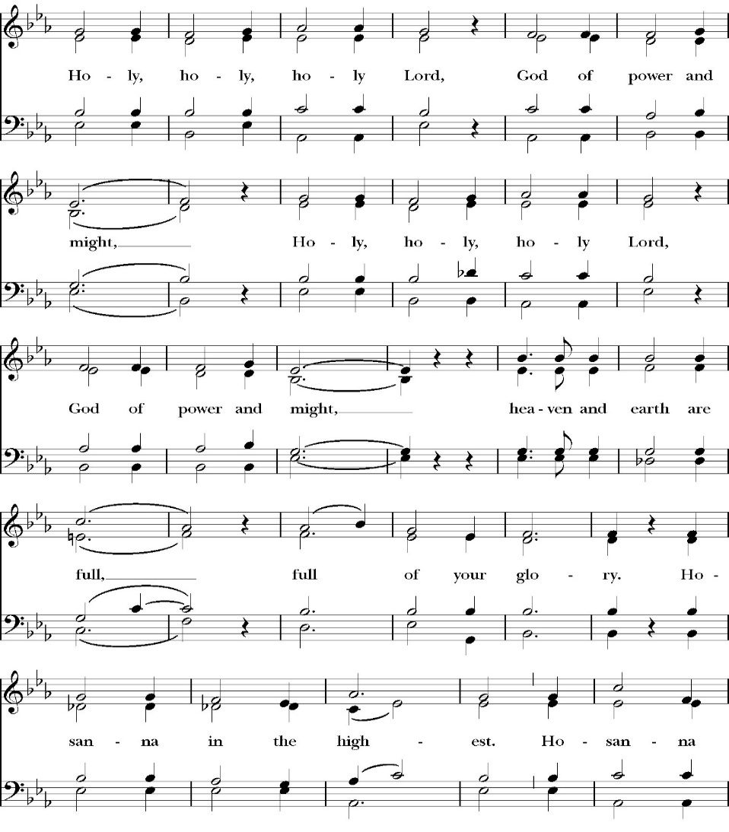
Sanctus

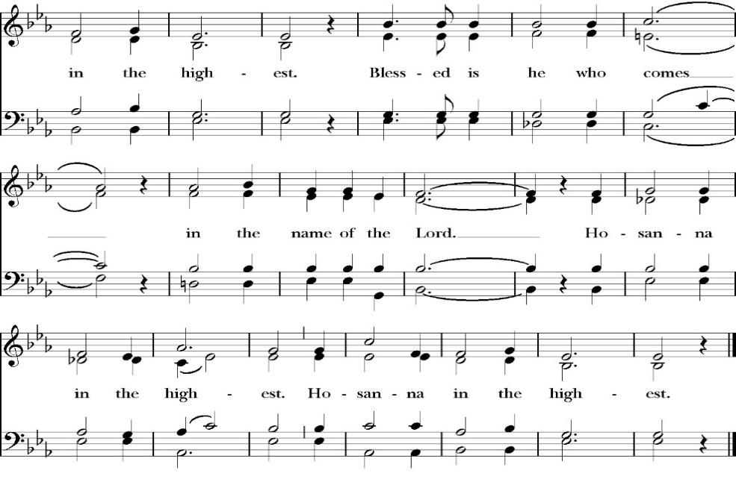
Holy and gracious Father: In your infinite love you made us for yourself; and when we had sinned against you and become subject to evil and death, you, in your mercy, sent your only Son Jesus Christ into the world for our salvation. By the Holy Spirit and the Virgin Mary he became flesh and dwelt among us. In obedience to your will, he stretched out his arms upon the Cross and offered himself once for all, that by his suffering and death we might be saved. By his resurrection he broke the bonds of death, trampling Hell and Satan under his feet. As our great high priest, he ascended to your right hand in glory, that we might come with confidence before the throne of grace.

At the following words concerning the bread, the Celebrant is to hold it, or lay a hand upon it, and here* may break the bread; and at the words concerning the cup, to hold or place a hand upon the cup and any other vessel containing the wine to be consecrated.

On the night that he was betrayed, our Lord Jesus Christ took bread; and when he had given thanks, he broke it, * and gave it to his disciples, saying, “Take, eat; this is my Body, which is given for you: Do this in remembrance of me.”

Likewise, after supper, Jesus took the cup, and when he had given thanks, he gave it to them, saying, “Drink this, all of you; for this is my Blood of the New Covenant, which is shed for you, and for many, for the forgiveness of sins: Whenever you drink it, do this in remembrance of me.”

Therefore we proclaim the mystery of faith:

Christ has died.
Christ is risen.
Christ will come again.

We celebrate the memorial of our redemption, O Father, in this sacrifice of praise and thanksgiving, and we offer you these gifts.

Sanctify them by your Word and Holy Spirit to be for your people the Body and Blood of your Son Jesus Christ. Sanctify us also, that we may worthily receive this holy Sacrament, and be made one body with him, that he may dwell in us and we in him. In the fullness of time, put all things in subjection under your Christ, and bring us with all your saints into the joy of your heavenly kingdom, where we shall see our Lord face to face.

All this we ask through your Son Jesus Christ: By him, and with him, and in him, in the unity of the Holy Spirit, all honor and glory is yours, Almighty Father, now and for ever. Amen.

And now, as our Savior Christ has taught us, we are bold to pray,

Our Father, who art in heaven,
hallowed be thy Name,
thy kingdom come,
thy will be done,
on earth as it is in heaven.
Give us this day our daily bread.
And forgive us our trespasses,
as we forgive those
who trespass against us.
And lead us not into temptation,
but deliver us from evil.
For thine is the kingdom,
and the power, and the glory,
for ever and ever. Amen.

Celebrant Alleluia! Christ our Passover is sacrificed for us.
People Therefore let us keep the feast. Alleluia!

The Prayer for Humble Access

We do not presume to come to this your table, O merciful Lord,
trusting in our own righteousness,
but in your abundant and great mercies.
We are not worthy so much as to gather up
the crumbs under your table;
but you are the same Lord
whose character is always to have mercy.
Grant us, therefore, gracious Lord,
so to eat the flesh of your dear Son Jesus Christ,
and to drink his blood,
that our sinful bodies may be made clean by his body,
and our souls washed through his most precious blood,
and that we may evermore dwell in him, and he in us.
Amen.

Agnus Dei
The Ministration of Communion

The gifts of God for the People of God. Take them in remembrance that Christ died for you and feed on him in your hearts by faith, with thanksgiving.
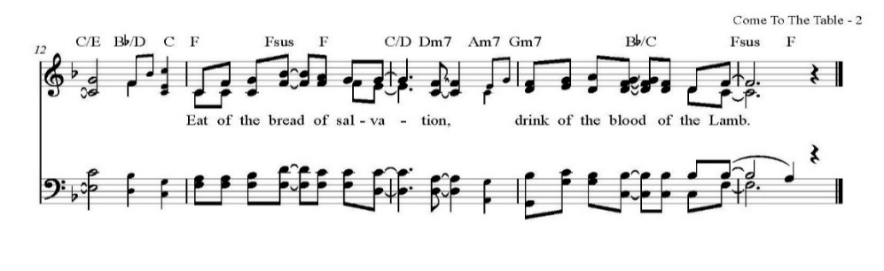
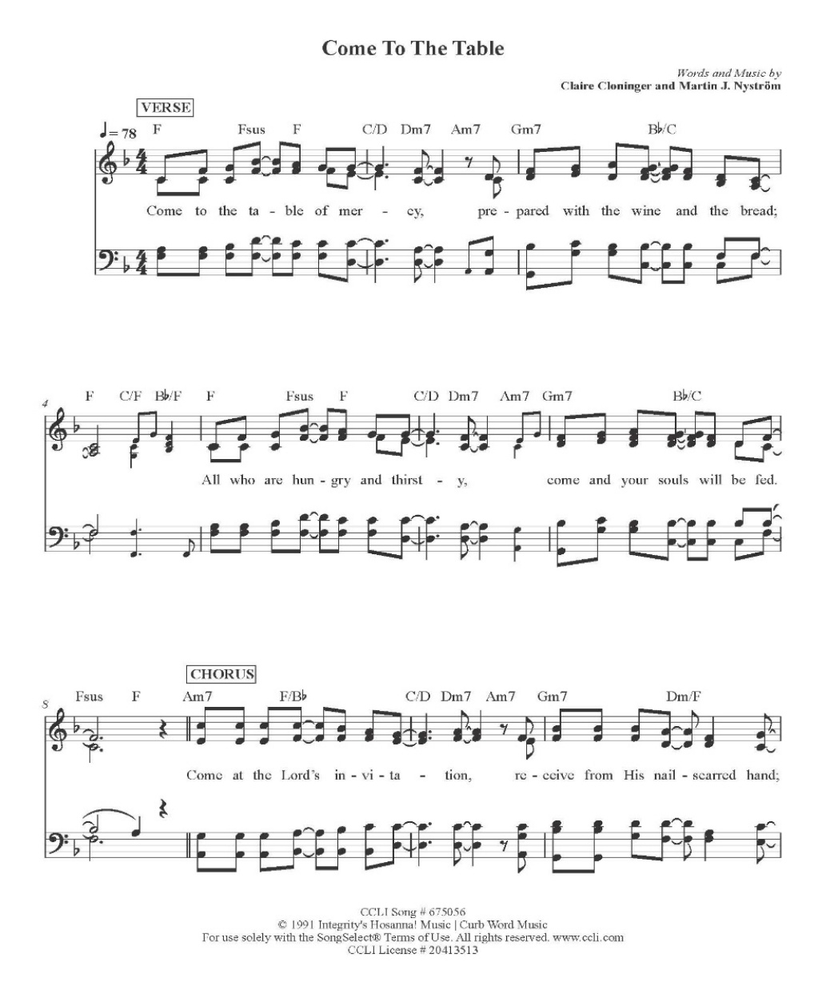
Communion Praise Songs
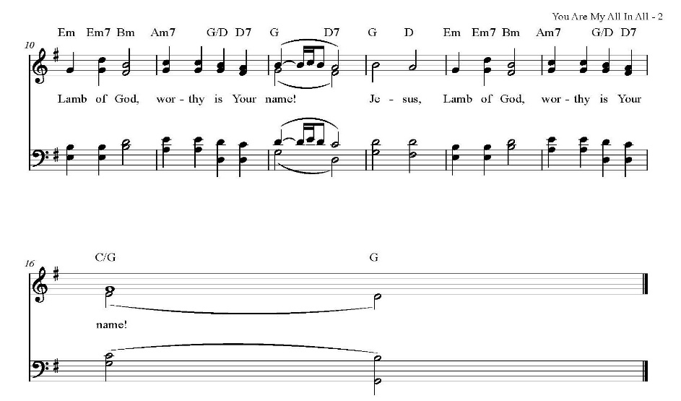
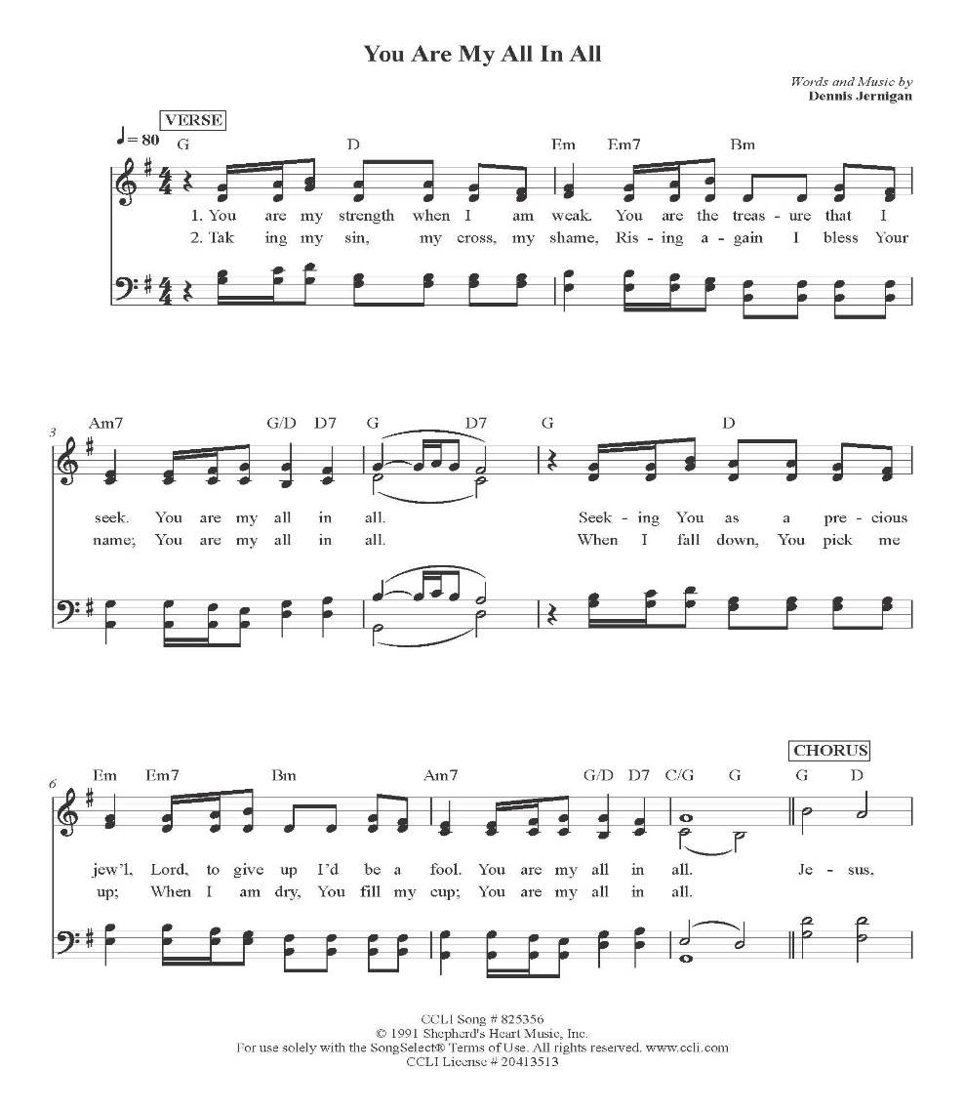
CCLI Song # 825356 CCLI Liscence # 20413513
The Post Communion Prayer

Let us pray.

Heavenly Father,
We thank you for feeding us with the spiritual food
of the most precious Body and Blood
of your Son our Savior Jesus Christ;
and for assuring us in these holy mysteries
that we are living members of the body of your Son,
and heirs of your eternal Kingdom.
And now, Father, send us out to do the work you have
given us to do,
to love and serve you as faithful witnesses of Christ our
Lord.
To him, to you, and to the Holy Spirit,
be honor and glory, now and for ever. Amen.

The Blessing

Go forth into the world in peace; be of good courage; fight the good fight of faith; that you may finish your course with joy; and the blessing of God Almighty, the Father, the Son, and the Holy Spirit, be among you, and remain with you always. Amen.

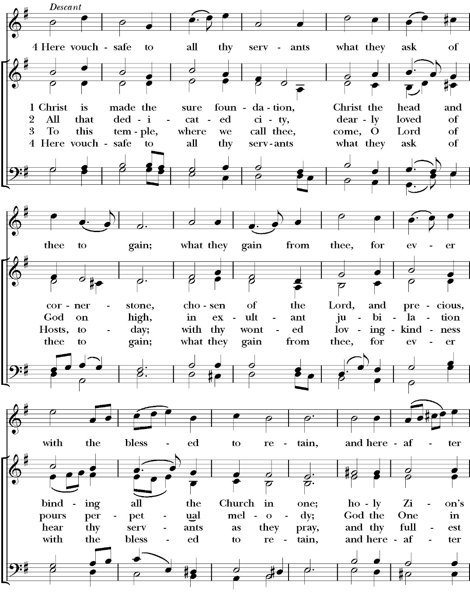
Closing Hymn: Christ is Made the Sure Foundation

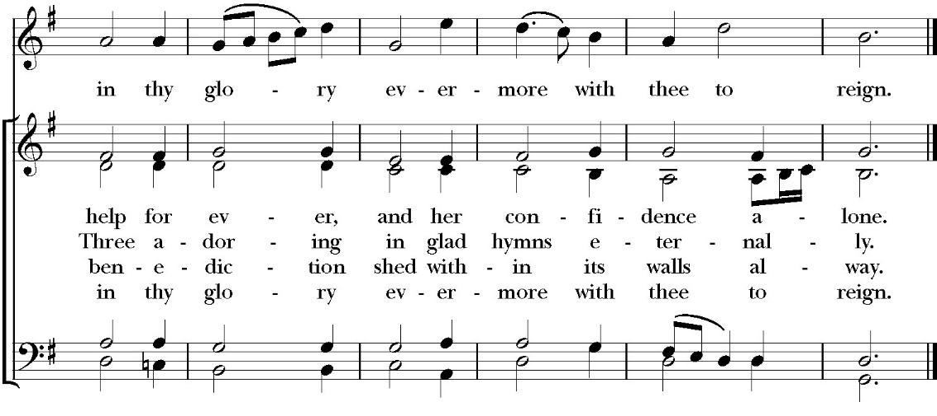

Celebrant Alleluia! Go in peace to love and serve the Lord.
People Thanks be to God. Alleluia! Alleluia!

A warm welcome to
The Rt. Rev. Eric V. Menees

Those being Confirmed and Received at today’s worship service:

Confirmed
Justin Qualls

Reaffirmation
Caroline Starr

Paul’s Parish Calendar
Sunday January 25 – Sunday February 1

SUNDAY, January 25 – Third Sunday of Epiphany
9:15 AM Sunday Funday, Youth Room
9:15 AM Anglican Catechism Class, Conference room
9:30 AM Vocal Choir rehearsal, Chapel
10:30 AM Children’s Sunday School, Chapel
Pre-K –2nd Grade, Sunday School Room.
3rd -5th Grade, Youth Room
10:30 AM Holy Eucharist, Church

MONDAY, January 26

TUESDAY, January 27
6:00 PM Bell Choir Practice, Music Room

WEDNESDAY, January 28
9:30 AM Holy Eucharist with healing prayer, Chapel
10:15 AM Bible Study, Conference Room
7:00 PM Vocal Choir Rehearsal, Church

THURSDAY, January 29

FRIDAY, January 30
6:30 AM Men’s Bible Study, Valhalla Restaurant

SATURDAY, January 31

SUNDAY, February 1 – Fourth Sunday of Epiphany
9:15 AM Sunday Funday, Youth Room
9:15 AM Anglican Catechism Class, Conference room
9:30 AM Vocal Choir rehearsal, Chapel
10:30 AM Children’s Sunday School, Chapel
Pre-K –2nd Grade, Sunday School Room.
3rd -5th Grade, Youth Room
10:30 AM Holy Eucharist, Church
12:00 PM Annual Meeting

Church Office Hours
Monday-Thursday 8:00 AM-4:00 PM
Announcements

Forum on the Laying a Firm Foundation Vision and
Capital Campaign with Rt. Rev. Eric Menees at Coffee hour today
Join Bishop Eric Menees at coffee hour where he will be sharing about the Diocesan Capital Campaign called “Laying a Firm Foundation” at a forum after the worship service.

Annual Meeting of St. Paul’s Anglican Church
Sunday, February 1, after the Worship Service
The annual meeting of St. Paul’s Anglican Church is an opportunity
to celebrate the ministries of the church, present the year-end budget
for 2025 and the budget approved by the Vestry of the church for
2026, and elect new vestry members and delegates to the 2026
convention of the Anglican Diocese of San Joaquin. A sandwich
lunch and childcare will be provided.

Nominations for Vestry and Delegates for 2026 Convention of
the Anglican Diocese of San Joaquin
The nominations committee (a subcommittee of the vestry) put
forward a slate of nominees to the Vestry at the January 13th meeting.
The following were approved by vestry to stand for election for
vestry and delegates to the 2026 Convention of the Anglican Diocese
of San Joaquin.

Vestry class of 2029 (Four vestry seats open)

Don Fowler
Joey Haas
Wendy Johns
Justin Qualls

Delegates to 2026 Convention of the Anglican Diocese of San
Joaquin (Three delegates and one alternate to be elected)

David Francis (Delegate)
Janet Robinson (Delegate)
Kim Robinson (Delegate)
Jim Doe (Alternate)

Additional nominations may be presented by confirmed voting members the
congregation on the floor of the annual meeting on Sunday, February 1

Catechism Class, Becoming Like Christ: The Ten Commandments, Justification and Sanctification
Sundays, 9:15AM-10:00 January 11-February 15
The Anglican Catechism invites us to explore how we can connect
the authority of God’s word to our everyday Christian walk. This is
the final section of our Anglican catechism class, but does not require
previous attendance. We will explore how to live more fully
according to the law of God while also living according to the person
and teachings of Jesus.

February 1 Commandments 5 & 6
February 8 Commandments 7 & 8
February 15 Commandments 9 & 10 and Summary

The schedule may be modified based on weekly progress. No matter how far we get, the class will finish on Sunday, February 15.

So…. This Is the Bible” Program
Wednesdays January 28, February 4, and
February 11

Potluck, 6PM
Attendees are encouraged to bring a casserole, salad or side to share. No RSVP required.

"So...This is the Bible": A four week overview of the Bible
6:30-7:30PM
Have you ever read the Bible and found yourself to be very confused because you have no idea what is going on in the scripture you’re reading?

Have you ever been asked questions about the Bible by a non-Christian friend and found yourself grasping at straws and wishing you could give a better answer?

Is growing in your knowledge of the Bible and in your faith a consistent goal in your life that seems to fall to the bottom of your priority list year after year?

If the answer to these questions is yes, then you are in good company. So many people, even devoted Christians, struggle to read the Bible and know less about the Bible than they might want to admit. If you would like to make 2026 the year that you learn more about the Bible for personal study, spiritual growth, and so you can more effectively share your faith - then this is the class for you!

In four sessions we will cover a number of topics including how the Bible was formed, how we can be sure the Bible is reliable, the overarching storyline of the Bible, how to study the Bible, and more! We hope that you will consider coming out and joining us! Children’s programming and nursery care will be available at the same time as this class. Our first session dates are all on Wednesday evenings on 1/28, 2/4, and 2/11. Stay tuned for exact timing and details.

St. Paul’ Anglican Church
6436 W Hurley Ave

Visalia, CA

Friday March 6, 8:00 AM to 4:00 PM
Saturday March 7, 8:00 AM to 2:00 PM
Drop Off Donated Items in James Hall on:
Wednesday March 4 and Thursday March 5
Between 9:00 AM – 4:00 PM
Items need to be in Good Condition, Clean, gently worn clothing, household items, toys in working order gladly accepted!

Volunteers Needed for Set Up
Wednesday, March 4 and Thursday March 5
Between 9:00 AM – 4:00 PM
Proceeds will Go Toward the New Gate Project and
To Support our Medical Student in Honduras
If you have any questions,
Contact: Mary Murray at 799-6973

St. Paul’s Anglican Church
Parish Office
6436 W. Hurley Ave
Visalia, California 93291
559-732-4821
Office Hours: 8:00 – 4:00
Monday – Thursday

Worship: Sundays at 10:30AM
Livestream: Link at spvisalia.com
and on our Facebook page
Please be advised that this service is being recorded for broadcast
and/or archival purposes. By attending, you consent
to the inclusion of your likeness in these recordings.

St. Paul’s Clergy and Staff
The Rev. Robert Longbottom, Rector
rector@spvisalia.com
(559)802-2928
The Rev. John Iseman, Pastoral Associate for Family Ministries
family@spvisalia.com
The Rev. Kashy Rowland-Smith, Deacon
kashyrs@aol.com
Antoinette Horsting, Parish Administrator
bookkeeper@spvisalia.com
Marguerite Crownover, Organist and Accompanist
Cynthia Culp, Choral Director
Jackie Iseman, Nursery Coordinator
Shane Motl, Sexton

St. Paul’s is a member church of the
Anglican Diocese of San Joaquin
The Rt. Rev. Eric V. Menees, Bishop

Next Week’s Lessons
Micah 6:1-8
Psalm 37:1-11
1 Corinthians 1:18-31
Matthew 5:1-12

