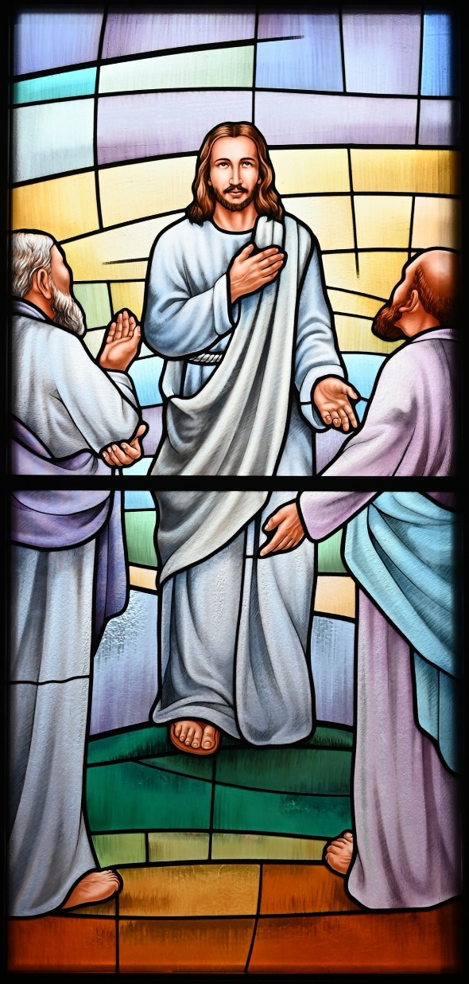
St. Paul’s Anglican Church
Visalia, California

Last Sunday of Epiphany
Transfiguration Sunday
February 15, 2026
10:30 AM

Welcome!

St. Paul’s Anglican Church extends a warm welcome to all visitors and newcomers, whether worshiping in person or at home via livestream.

Visitors’ Guide

St. Paul’s Church is a parish in the Diocese of San Joaquin of the Anglican Church in North America, which includes both Catholic and Protestant traditions. We accept Jesus Christ as Savior, and we promise to follow him as Lord. We believe in One God,

- the Father who created us and all things,
- the Son who redeems us from sin and death,
- the Holy Spirit who renews and sanctifies us.

We believe the Holy Scriptures to be the Word of God and to contain all things necessary for salvation, and we accept the Apostles’ and Nicene Creeds as essential beliefs of the Christian faith.

Holy Communion is open to all baptized Christians who have examined their lives, repented of their sins, and desire to live
in love and charity with all people.

Those not desiring to receive Holy Communion, and those who have not been baptized into the Christian faith, are invited to cross their arms across their chest, and a blessing will be given instead.

Visitors are invited to sign the guest book at the entrance table and introduce themselves to the clergy following the service.

The Holy Eucharist

Prelude: “Joyful, Joyful We Adore Thee” Wood
Opening Hymn: #618 – “Ye Watchers and Ye Holy Ones” p. 4
Acclamation p. 5
The Collect for Purity p. 5
Summary of the Law p. 5
Kyrie p. 5
Gloria p. 6
Collect of the Day p. 7
Lesson: Exodus 24:12-18 p. 7
Gradual: Psalm 99 p. 8
Epistle: Philippians 3:7-14 p. 8
Sequence Hymn: #173 - “O Wonderous Type! O Vision Fair” p. 9
Gospel: Matthew 17:1-9 p. 10
Sermon: Rev. Robert Longbottom
Nicene Creed p. 11
Prayers of the People p. 12
Confession and Absolution p. 13
The Peace p. 14
Offertory Bell Choir – “Wonderful, Merciful Savior” by Dawn Rodgers and Eric
The Offertory p. 14
Sanctus p. 15
The Lord’s Prayer p. 17
Prayer for Humble Access p. 18
Agnus Dei p. 18
Communion Hymn: (Praise Song) – “In Christ Alone” p. 19
Post Communion Prayer p. 21
Blessing p. 21
Closing Hymn: #427- “When Morning Gilds the Skies” p. 22
Dismissal p. 22
Postlude: “Trumpet Tune” Johnson

Opening Hymn: Ye Watcher and Ye Holy Ones
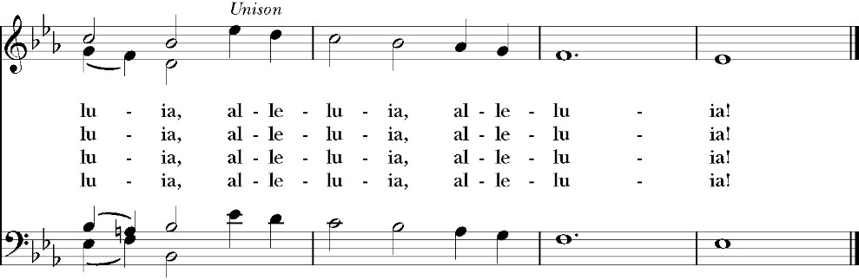
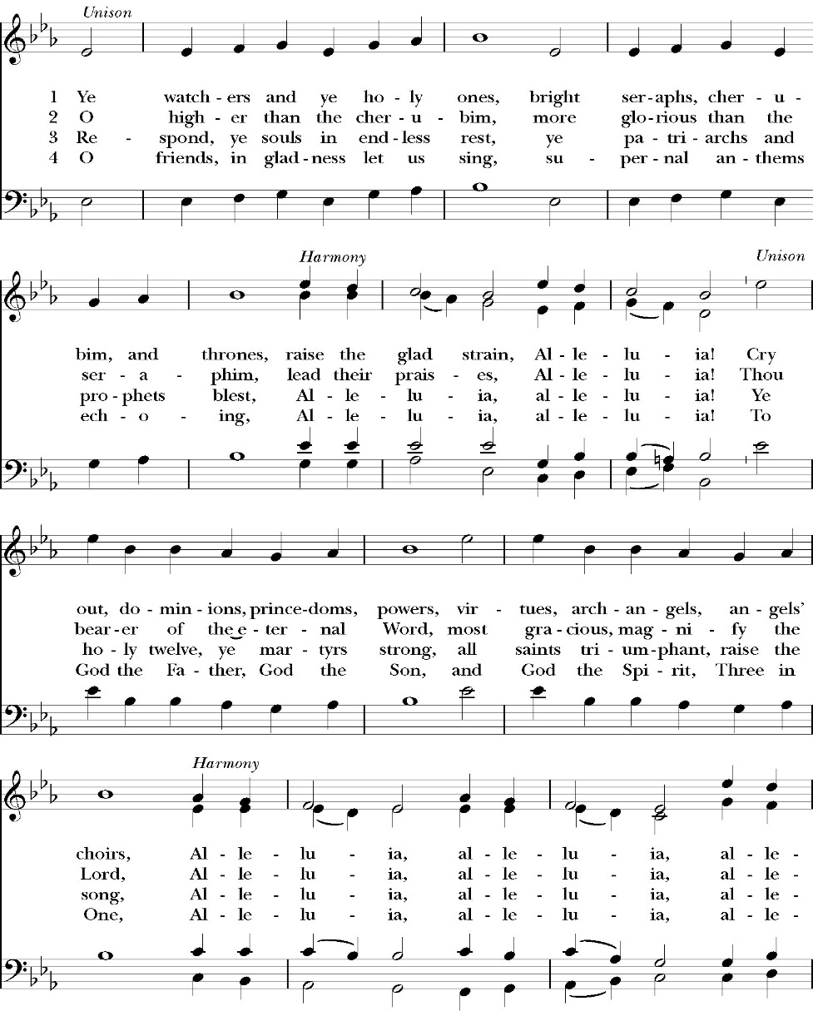

The Acclamation

Celebrant I will make you as a light for the nations,
People That my salvation may reach to the end of the earth.

The Collect for Purity

Almighty God, to you all hearts are open, all desires known, and from you no secrets are hid: Cleanse the thoughts of our hearts by the inspiration of your Holy Spirit, that we may perfectly love you, and worthily magnify your holy Name through Christ our Lord. Amen.

The Summary of the law

Hear what our Lord Jesus Christ says: You shall love the Lord your God with all your heart and with all your soul and with all your mind. This is the first and great commandment. And the second is like it: You shall love your neighbor as yourself. On these two commandments depend all the Law and the Prophets.

The Kyrie

The Gloria

Officiant The Lord be with You.
People And with your spirit.
Officiant Let us pray:

The Collect of the Day

O God, who before the passion of your only-begotten Son revealed
his glory upon the holy mountain: Grant that we, beholding by faith the light of his countenance, may be strengthened to bear our cross, and be changed into his likeness from glory to glory; through Jesus Christ our Lord, who lives and reigns with you and the Holy Spirit, one God, for ever and ever. Amen.

Lesson: Exodus 24:12-18
¹² The Lord said to Moses, “Come up to me on the mountain and wait there, that I may give you the tablets of stone, with the law and the commandment, which I have written for their instruction.” ¹³ So Moses rose with his assistant Joshua, and Moses went up into the mountain of God. ¹⁴ And he said to the elders, “Wait here for us until we return to you. And behold, Aaron and Hur are with you. Whoever has a dispute, let him go to them.”
¹⁵ Then Moses went up on the mountain, and the cloud covered the mountain. ¹⁶ The glory of the Lord dwelt on Mount Sinai, and the cloud covered it six days. And on the seventh day he called to Moses out of the midst of the cloud. ¹⁷ Now the appearance of the glory of the Lord was like a devouring fire on the top of the mountain in the sight of the people of Israel. ¹⁸ Moses entered the cloud and went up on the mountain. And Moses was on the mountain forty days and forty nights.
Reader The Word of the Lord
People Thanks be to God

Gradual: Psalm 99
1 The Lord is King; let the peoples tremble; *
he sits between the cherubim; let the earth shake.
2 The Lord is great in Zion *
and high above all peoples.

3 They shall give thanks unto his Name, which is great and
wonderful; *
holy is he and mighty, a King who loves justice.
4 You have established equity; *
you have executed judgment and righteousness in Jacob.
5 O magnify the Lord our God, *

and fall down before his footstool, for he is holy.
6 Moses and Aaron among his priests, and Samuel among those
who call upon his Name, *
they called upon the Lord, and he heard them.
7 He spoke to them out of the cloudy pillar, *

for they kept his testimonies and the law that he gave them.
8 You heard them, O Lord our God; *

you forgave them, O God, yet punished their evildoings.
9 O magnify the Lord our God, and worship him upon his holy
hill, *

for the Lord our God is holy.
Glory be to the Father, and to the Son, and to the Holy Spirit;
as it was in the beginning, is now, and ever shall be, world without end. Amen
Epistle: Philippians 3:7-14
⁷ But whatever gain I had, I counted as loss for the sake of Christ. ⁸ Indeed, I count everything as loss because of the surpassing worth of knowing Christ Jesus my Lord. For his sake I have suffered the loss of all things and count them as rubbish, in order that I may gain Christ ⁹ and be found in him, not having a righteousness of my own that comes from the law, but that which comes through faith in Christ, the righteousness from God that depends on faith— ¹⁰ that I may know him and the power of his resurrection, and may share his sufferings, becoming like him in his death, ¹¹ that by any means possible I may attain the resurrection from the dead.

¹² Not that I have already obtained this or am already perfect, but I press on to make it my own, because Christ Jesus has made me his own. ¹³ Brothers, I do not consider that I have made it my own. But one thing I do: forgetting what lies behind and straining forward to what lies ahead, ¹⁴ I press on toward the goal for the prize of the upward call of God in Christ Jesus.

Reader The Word of the Lord
People Thanks be to God

Sequence Hymn: O Wonderous Type! O Vision Fair
(vs. 1-3 before the Gospel, v. 4-5 after)

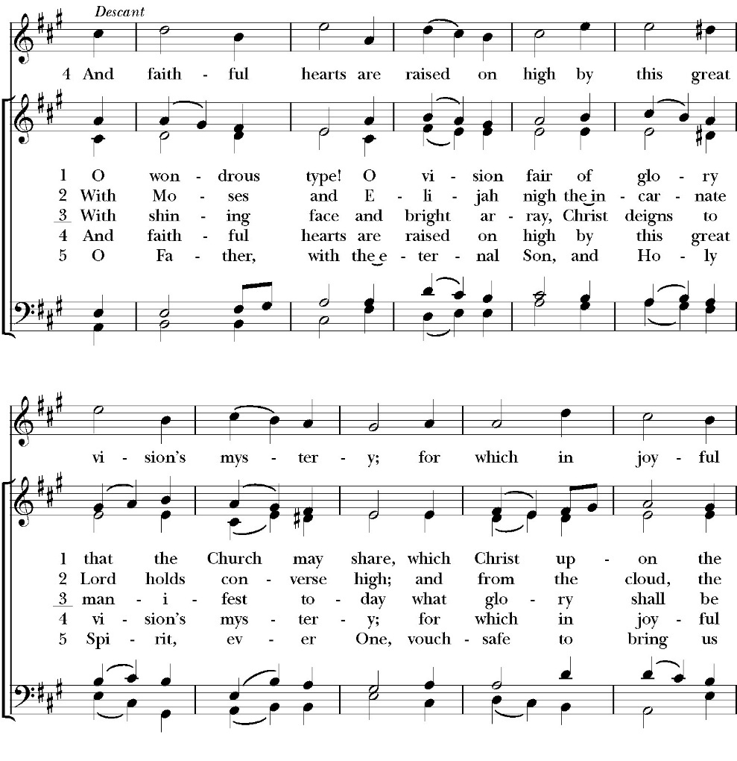

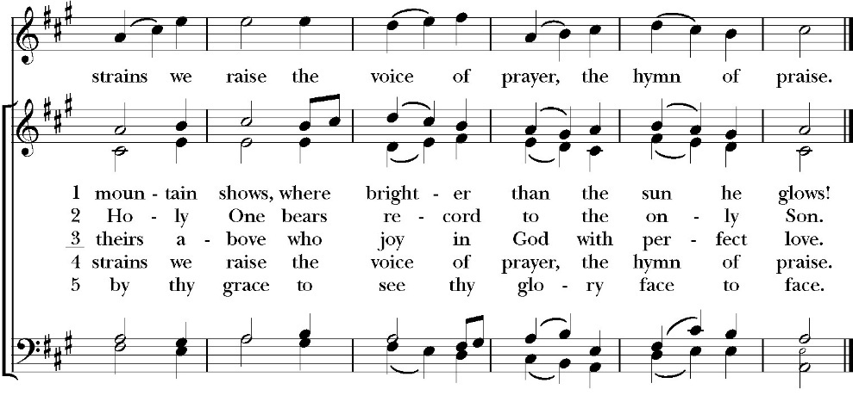
Clergy The Holy Gospel of Our Lord Jesus Christ, according to
St. Matthew.
People Glory to you, Lord Christ.

Gospel: Matthew 17:1-9
And after six days Jesus took with him Peter and James, and John his brother, and led them up a high mountain by themselves. ² And he was transfigured before them, and his face shone like the sun, and his clothes became white as light. ³ And behold, there appeared to them Moses and Elijah, talking with him. ⁴ And Peter said to Jesus, “Lord, it is good that we are here. If you wish, I will make three tents here, one for you and one for Moses and one for Elijah.” ⁵ He was still speaking when, behold, a bright cloud overshadowed them, and a voice from the cloud said, “This is my beloved Son, with whom I am well pleased; listen to him.” ⁶ When the disciples heard this, they fell on their faces and were terrified. ⁷ But Jesus came and touched them, saying, “Rise, and have no fear.” ⁸ And when they lifted up their eyes, they saw no one but Jesus only.
⁹ And as they were coming down the mountain, Jesus commanded them, “Tell no one the vision, until the Son of Man is raised from the dead.”

Clergy The Gospel of the Lord
People Praise to you, Lord Christ.

Sermon
Rev. Robert Longbottom

The Nicene Creed

We believe in one God,
the Father, the Almighty,
maker of heaven and earth,
of all that is, visible and invisible.

We believe in one Lord, Jesus Christ,
the only-begotten Son of God,
eternally begotten of the Father,
God from God, Light from Light,
true God from true God,
begotten, not made,
of one Being with the Father.
through him all things were made.
For us and for our salvation he came down from heaven:
was incarnate from the Holy Spirit and the Virgin Mary,
and was made man.
For our sake he was crucified under Pontius Pilate;
he suffered death and was buried.
On the third day he rose again in accordance with the
Scriptures;
he ascended into heaven
and is seated at the right hand of the Father.
He will come again in glory to judge the living and the dead,
and his kingdom will have no end.

We believe in the Holy Spirit, the Lord, the giver of life,
who proceeds from the Father [and the Son],
who with the Father and the Son is worshiped and glorified.
who has spoken through the Prophets.
We believe in one holy catholic and apostolic Church.
We acknowledge one Baptism for the forgiveness of sins.
We look for the resurrection of the dead,
and the life of the world to come. Amen.

The Prayers of the People

Leader Let us pray for the Church and for the world, saying, “hear our prayer.”
For the peace of the whole world, and for the well-being and unity of the people of God.
Lord, in your mercy:
People Hear our prayer.

Leader For Stephen our archbishop and Eric, our bishop. For Fr. Rob, Deacon John, Deacon Kashy, and for all the clergy and people of our diocese and congregation and for the worldwide Anglican Communion.
Lord, in your mercy:
People Hear our prayer.

Leader For all those who proclaim the Gospel at home and abroad; and for all who teach and disciple others.
Lord, in your mercy:
People Hear our prayer.

Leader For our brothers and sisters in Christ who are persecuted for their faith.
Lord, in your mercy:
People Hear our prayer.

Leader For our nation, for those in authority, and for all in public service especially Donald our president and Gavin our Governor.
Lord, in your mercy:
People Hear our prayer.

Leader: In the St. Paul’s cycle of prayer, we lift up the ministries of pastoral care, all our members who are in the hospital, care facilities or who are shut into their own homes. We pray for those who are recovering from recent surgeries and for those who are in crisis.
Lord, in your mercy:
People Hear our prayer.

Leader In the ACNA Cycle of Prayer, today we pray for the Anglican Diocese of the South, Archbishop Foley Beach and his wife, Allison; and Bishop Frank Lyons and his wife, Shawnee.
Lord, in your mercy:
People Hear our prayer.

Leader For all those who are in trouble, sorrow, need, sickness, or any other adversity [especially _____________]. We also pray for all who are currently serving in our armed forces and serving as first responders.
Lord, in your mercy:
People Hear our prayer.

Leader For all those who have departed this life in the certain hope of the resurrection, (we pray especially for ____________), in thanksgiving let us pray.
Lord, in your mercy:
People Hear our prayer.

Celebrant will add a concluding prayer

The Confession and Absolution

Celebrant Let us humbly confess our sins to Almighty God.

Most merciful God,
we confess that we have sinned against you
in thought, word and deed,
by what we have done, and by what we have left undone.
We have not loved you with our whole heart;
we have not loved our neighbors as ourselves.
We are truly sorry and we humbly repent.
For the sake of your Son Jesus Christ,
have mercy on us and forgive us;
that we may delight in your will, and walk in your ways,
to the glory of your Name. Amen.

Almighty God, our heavenly Father, who in his great mercy has
promised forgiveness of sins to all those who sincerely repent and
with true faith turn to him, have mercy upon you, pardon and deliver
you from all your sins, confirm and strengthen you in all goodness,
and bring you to everlasting life; through Jesus Christ our Lord.
Amen.
Come to me, all who labor and are heavy laden, and I will give you
rest. Matthew 11:28

Celebrant The Peace of the Lord be always with you.
People And with your spirit.

Offertory Anthem
Bell Choir
Wonderful, Merciful Savior
by Dawn Rodgers and Eric

The Offertory

Celebrant All things come from you, O Lord,
People And of your own have we given you.

The Eucharistic Liturgy

Celebrant The Lord be with you.
People And with your spirit.
Celebrant Lift up your hearts.
People We lift them up to the Lord.
Celebrant Let us give thanks to the Lord our God.
People It is right to give him thanks and praise.

It is right, our duty and our joy, always and everywhere to give thanks to you, Father Almighty, Creator of heaven and earth.

Because in the mystery of the Word made flesh, you have caused a
new light to shine in our hearts, to give the knowledge of your glory
in the face of your Son Jesus Christ our Lord.

Therefore we praise you, joining our voices with angels and archangels and with all the company of heaven, who forever sing this hymn to proclaim the glory of your Name:

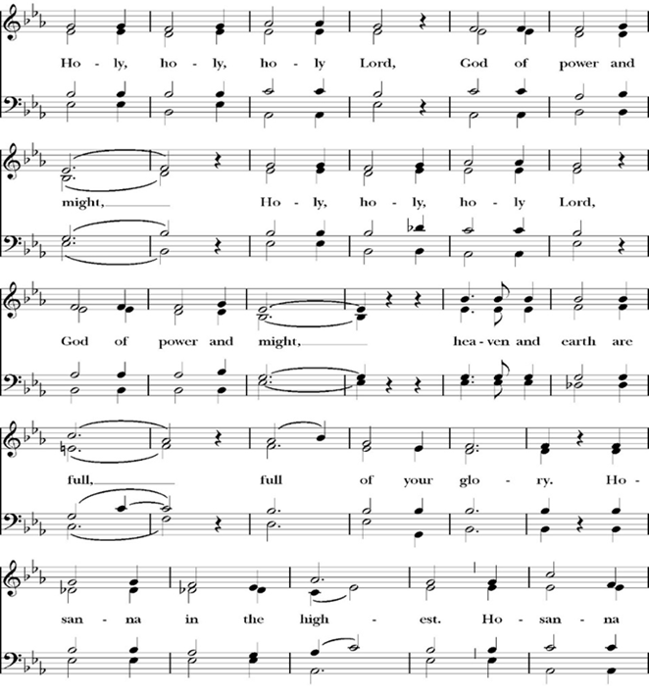
The Sanctus

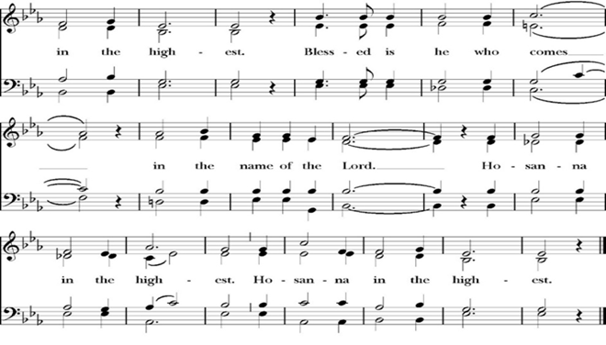
Holy and gracious Father: In your infinite love you made us for yourself; and when we had sinned against you and become subject to evil and death, you, in your mercy, sent your only Son Jesus Christ into the world for our salvation. By the Holy Spirit and the Virgin Mary he became flesh and dwelt among us. In obedience to your will, he stretched out his arms upon the Cross and offered himself once for all, that by his suffering and death we might be saved. By his resurrection he broke the bonds of death, trampling Hell and Satan under his feet. As our great high priest, he ascended to your right hand in glory, that we might come with confidence before the throne of grace.

On the night that he was betrayed, our Lord Jesus Christ took bread; and when he had given thanks, he broke it, * and gave it to his disciples, saying, “Take, eat; this is my Body, which is given for you: Do this in remembrance of me.”

Likewise, after supper, Jesus took the cup, and when he had given thanks, he gave it to them, saying, “Drink this, all of you; for this is my Blood of the New Covenant, which is shed for you, and for many, for the forgiveness of sins: Whenever you drink it, do this in remembrance of me.”

Therefore we proclaim the mystery of faith:

Christ has died.
Christ is risen.
Christ will come again.

We celebrate the memorial of our redemption, O Father, in this sacrifice of praise and thanksgiving, and we offer you these gifts.

Sanctify them by your Word and Holy Spirit to be for your people the Body and Blood of your Son Jesus Christ. Sanctify us also, that we may worthily receive this holy Sacrament, and be made one body with him, that he may dwell in us and we in him. In the fullness of time, put all things in subjection under your Christ, and bring us with all your saints into the joy of your heavenly kingdom, where we shall see our Lord face to face.
All this we ask through your Son Jesus Christ: By him, and with him, and in him, in the unity of the Holy Spirit, all honor and glory is yours, Almighty Father, now and for ever. Amen.

And now, as our Savior Christ has taught us, we are bold to pray,

Our Father, who art in heaven,
hallowed be thy Name,
thy kingdom come,
thy will be done,
on earth as it is in heaven.
Give us this day our daily bread.
And forgive us our trespasses,
as we forgive those
who trespass against us.
And lead us not into temptation,
but deliver us from evil.
For thine is the kingdom,
and the power, and the glory,
for ever and ever. Amen.

Celebrant Alleluia! Christ our Passover is sacrificed for us.
People Therefore let us keep the feast. Alleluia!

We do not presume to come to this your table, O merciful Lord,
trusting in our own righteousness,
but in your abundant and great mercies.
We are not worthy so much as to gather up
the crumbs under your table;
but you are the same Lord
whose character is always to have mercy.
Grant us, therefore, gracious Lord,
so to eat the flesh of your dear Son Jesus Christ,
and to drink his blood,
that our sinful bodies may be made clean by his body,
and our souls washed through his most precious blood,
and that we may evermore dwell in him, and he in us.
Amen.

Agnus Dei
The Ministration of Communion

The gifts of God for the People of God. Take them in remembrance that Christ died for you and feed on him in your hearts by faith, with thanksgiving.

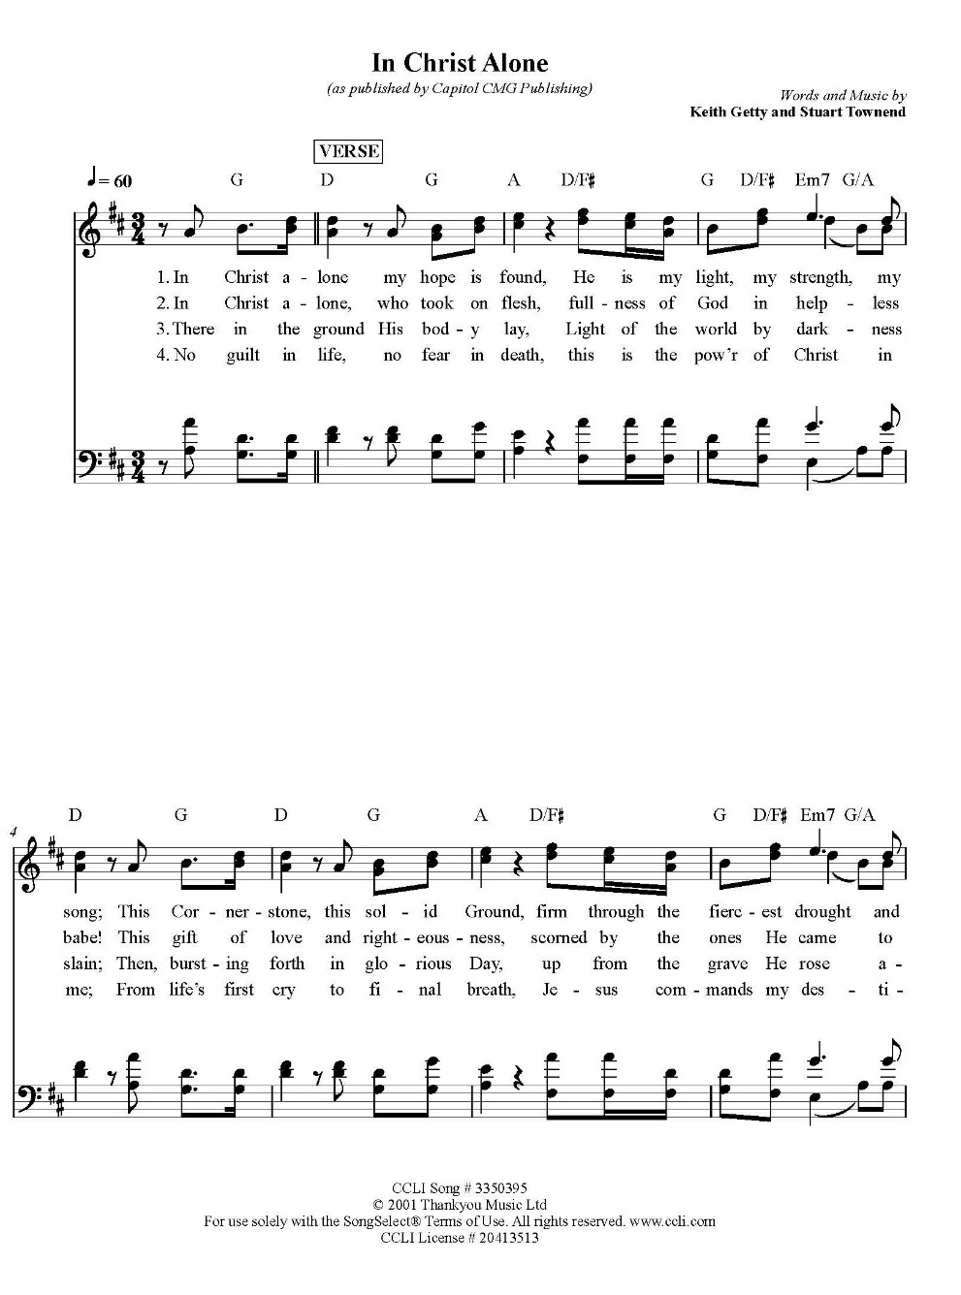
Communion Hymn: Praise Song
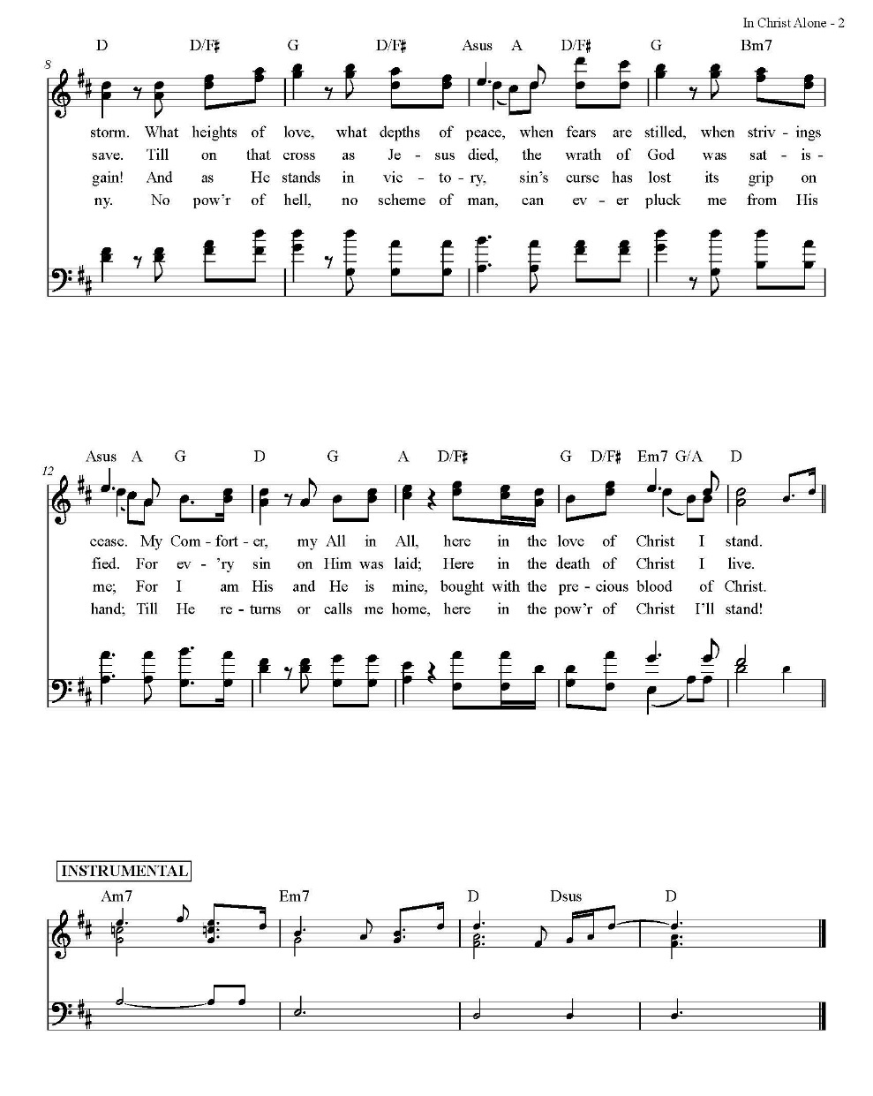

The Post Communion Prayer

Let us pray.

Heavenly Father,
We thank you for feeding us with the spiritual food
of the most precious Body and Blood
of your Son our Savior Jesus Christ;
and for assuring us in these holy mysteries
that we are living members of the body of your Son,
and heirs of your eternal Kingdom.
And now, Father, send us out to do the work you have
given us to do,
to love and serve you as faithful witnesses of Christ our
Lord.
To him, to you, and to the Holy Spirit,
be honor and glory, now and for ever. Amen.

The Blessing

The peace of God, which passes all understanding, keep your hearts
and minds in the knowledge and love of God, and of his Son Jesus
Christ our Lord; and the blessing of God Almighty, the Father, the
Son, and the Holy Spirit, be among you, and remain with you always.
Amen.

Closing Hymn: When Morning Gilds the Skies

Celebrant Alleluia! Go in peace to love and serve the Lord.
People Thanks be to God. Alleluia! Alleluia!
St. Paul’s Parish Calendar
Sunday February 15 – Sunday February 22

SUNDAY, February 15 – Last Sunday of Epiphany
9:15 AM Sunday Funday, Youth Room
9:15 AM Anglican Catechism Class, Conference room
9:30 AM Bell Choir rehearsal, Chapel
10:30 AM Children’s Sunday School, Chapel
Pre-K –2nd Grade, Sunday School Room.
3rd -5th Grade, Youth Room
10:30 AM Holy Eucharist, Church

MONDAY, February 16 – Office Closed for Presidents’ Day

TUESDAY, February 17
4:30 – 6:30 PM Shrove Tuesday Pancake Dinner, James Hall
6:00 PM Bell Choir Practice, Music Room

WEDNESDAY, February 18
7:00 AM Imposition of Ashes, Chapel
12:00 PM Holy Eucharist with Imposition of Ashes, Church
2:30 - 3:30 PM Neighborhood Market, Church Parking Lot
7:00 PM Holy Eucharist with Imposition of Ashes
Choir and Music, Church

THURSDAY, February 19

FRIDAY, February 20
6:30 AM Men’s Bible Study, Valhalla Restaurant
6:00 PM Stations of the Cross, Church

SATURDAY, February 21

SUNDAY, February 22 – First Sunday in Lent
9:15 AM Sunday Funday, Youth Room
9:15 AM Gospel of John bible study, Conference room
9:30 AM Vocal Choir rehearsal, Chapel
10:30 AM Children’s Sunday School, Chapel
Pre-K –2nd Grade, Sunday School Room.
3rd -5th Grade, Youth Room
10:30 AM Holy Eucharist, Church
Office Closed on Monday, February 16, for Presidents’ Day

Church Office Hours
Monday-Thursday 8:00 AM-4:00 PM

Announcements

Ash Wednesday, February 18
Imposition of Ashes and Holy Eucharist
7:00 AM Imposition of Ashes
(A brief prayer service with imposition of ashes)
12:00 NOON Holy Eucharist with imposition of ashes
7:00 PM Holy Eucharist with imposition of ashes,
Choir and Music

Catechism Class, Becoming Like Christ: The Ten Commandments, Justification and Sanctification
Sundays, 9:15AM-10:00 January 11-February 15
The Anglican Catechism invites us to explore how we can connect
the authority of God’s word to our everyday Christian walk. This is
the final section of our Anglican catechism class, but does not require
previous attendance. We will explore how to live more fully
according to the law of God while also living according to the person
and teachings of Jesus.

February 15 Commandments 9 & 10 and Summary

The schedule may be modified based on weekly progress. No matter how far we get, the class will finish on Sunday, February 15.

Lenten Stations of the Cross Beginning Friday, February 20, and Ending March 27
Jesus Christ died on a cross for the sins of the world. Stations of the Cross is a meditative journey that, in a span of thirty minutes, allows the pilgrim to walk the way of the cross into the way of life and peace. All members are invited to join us for this beautiful and impactful devotional practice on Fridays at 6PM throughout Lent.

Practicing The Way, The Prayer Practice:
Pursue a deeper life of union with God
This is a Lenten opportunity for discipleship and spiritual growth in Jesus Christ. To pray is to open your heart to God. Prayer is simply the medium through which we communicate and commune with God. The practice of prayer is learning to set aside dedicated time to intentionally be with God in order to become like him and partner with him in the world. The prayer practice small group is a video-based class on prayer developed by John Mark Comer, author and facilitator of Practicing the Way and its resources. There will be two opportunities to participate on Wednesday evenings. The 5PM small group will be led by Fr. Rob Longbottom. The 6:45PM small group will be led by Deacon John Iseman.

February 25 Session 1: Talking to God
March 4 Session 2: Talking with God
March 11 Session 3: Listening to God
March 18 Session 4: Being with God
March 25 Prayer and Praise in the church. An hour of prayer and praise music as we lift our prayers and hearts to God in worship.

Lenten Soup Supper will begin February 25, at 5:45 PM
A sign-up sheet will be available beginning February 8 for those who wish to bring their favorite soup to share with others. This is a wonderful opportunity for the entire family to come together and share in the Lenten experience.

Lenten Wednesday Evening Schedule
5:00 PM Prayer small group led by Father Rob

6:00 PM Soup Suppers

6:45 PM Prayer small group class led by Deacon John

6:4 5PM Children’s class on prayer led by Deacon Kashy and
Fr. Rob
7:00 PM Vocal Choir Rehearsal

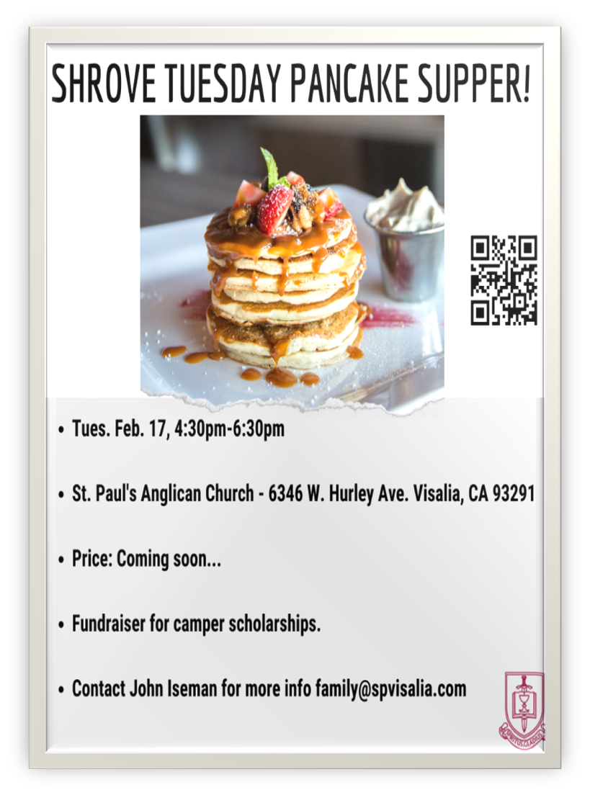

A Food Bank for Hurley Families
The next Neighborhood Market to benefit students at Hurley School will be Wednesday, February 18, from 2:30 PM to 3:30 PM at St Paul’s Church parking lot. If you are interested in helping that day, please contact Sue Nyberg. My home phone number is 559-733-8244.

PROVIDED BY VISALIA EMERGENCY AID
AND ST. PAUL’S CHURCH
Wednesday, February 18, 2026
From 2:30 PM to 3:30 PM
LOCATION:
ST. PAUL'S CHURCH PARKING LOT
ACROSS THE STREET FROM HURLEY



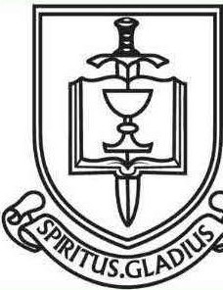

ST. PAUL'S ANGLICAN CHURCH
"WHERE GOD BUILDS THINGS"
-

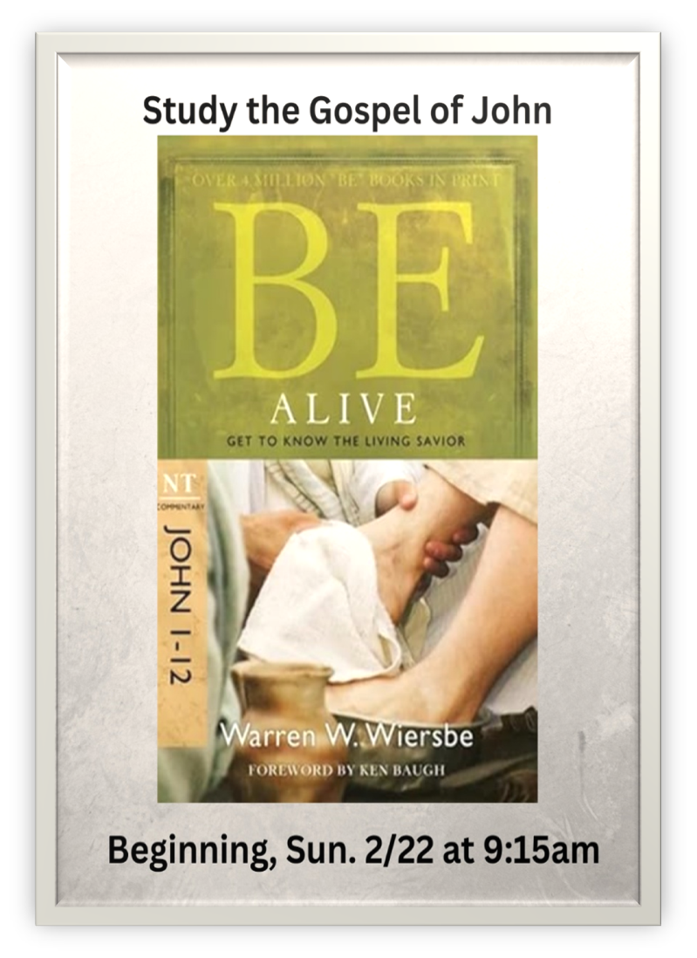

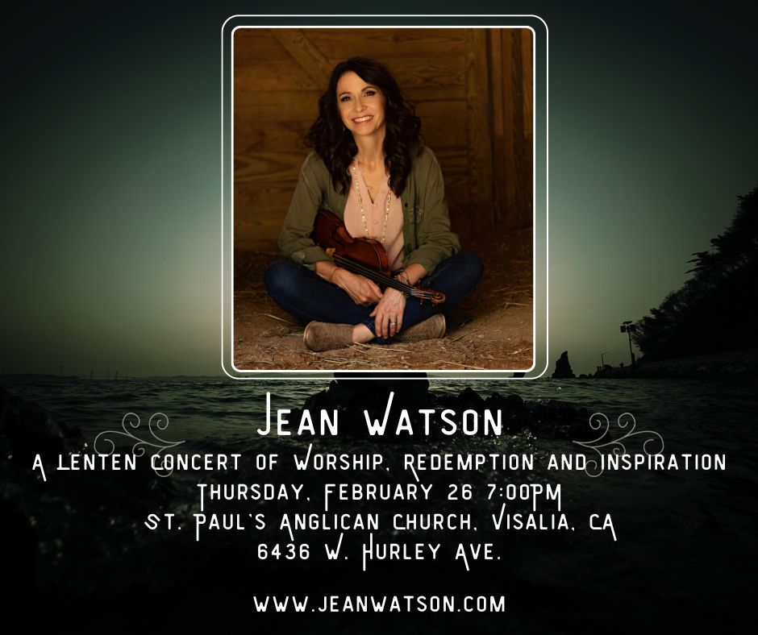
Jean Watson is a violinist/singer songwriter/speaker/writer who is passionate about bringing the sound of heaven to earth through words and music.

For the past 20 years, she has been traveling the globe sharing the love of Christ with whomever will listen.

Join us at St. Paul’s Anglican Church for a Lenten concert of
hope, redemption and the cross of Christ.

“It’s not always been easy, and I’ve walked through my share of struggles! Maybe you have too. One thing I’ve learned, however, is that God is faithful. Though we may fail Him, the Lord’s love will never fail us!” -Jean Watson

Special Irish Stew Dinner with Jean Watson before her
Lenten Concert
Thursday, February 26, 6:00PM

A Wonderful Wednesday style dinner serving Irish Stew will take place before the Lenten concert with Jean Watson. Jean will be with us at the meal and take a brief time to share about her influences and prepare us for what to expect at the concert.

RSVPs for this event are very important.
Please RSVP by calling the church office.

Like all Wonderful Wednesday dinners, a free-will offering will take place to cover costs of the meal.



St. Paul’s Anglican Church
6436 W Hurley Ave
Visalia, CA


Friday March 6, 8:00 AM to 4:00 PM
Saturday March 7, 8:00 AM to 2:00 PM
Drop Off Donated Items in James Hall on:
Wednesday March 4 and Thursday March 5
Between 9:00 AM – 4:00 PM
Items need to be in Good Condition, Clean, gently worn clothing, household items, toys in working order gladly accepted!

Volunteers Needed for Set Up
Wednesday, March 4 and Thursday March 5
Between 9:00 AM – 4:00 PM
Proceeds will Go Toward the New Gate Project and
To Support our Medical Student in Honduras
If you have any questions,
Contact: Mary Murray at 799-6973

St. Paul’s Anglican Church
Parish Office
6436 W. Hurley Ave
Visalia, California 93291
559-732-4821
Office Hours: 8:00 – 4:00
Monday – Thursday

Worship: Sundays at 10:30AM
Livestream: Link at spvisalia.com
and on our Facebook page
Please be advised that this service is being recorded for broadcast
and/or archival purposes. By attending, you consent
to the inclusion of your likeness in these recordings.

St. Paul’s Clergy and Staff
The Rev. Robert Longbottom, Rector
rector@spvisalia.com
(559)802-2928
The Rev. John Iseman, Pastoral Associate for Family Ministries
family@spvisalia.com
The Rev. Kashy Rowland-Smith, Deacon
kashyrs@aol.com
Antoinette Horsting, Parish Administrator
bookkeeper@spvisalia.com
Marguerite Crownover, Organist and Accompanist
Cynthia Culp, Choral Director
Jackie Iseman, Nursery Coordinator
Shane Motl, Sexton

St. Paul’s is a member church of the
Anglican Diocese of San Joaquin
The Rt. Rev. Eric V. Menees, Bishop

Next Week’s Lessons
Genesis 2:4-9, 15-17, 25-3:7
Psalm 51
Romans 5:12-21
Matthew 4:1-11

