St. Paul’s Anglican Church
Visalia, California
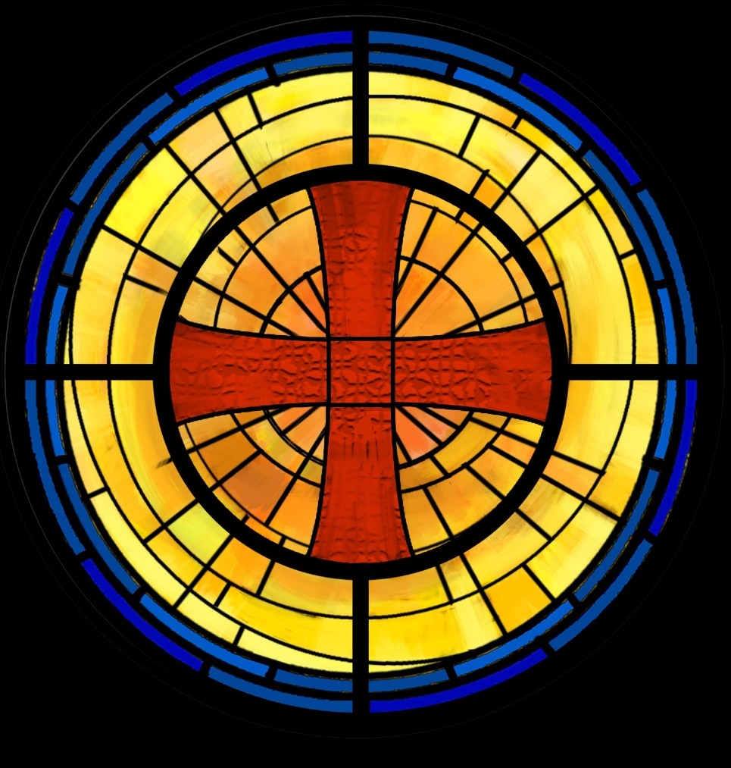

Fourth Sunday of Epiphany
February 1, 2026
10:30 AM

Welcome!

St. Paul’s Anglican Church extends a warm welcome to all visitors and newcomers, whether worshiping in person or at home via livestream.

Visitors’ Guide

St. Paul’s Church is a parish in the Diocese of San Joaquin of the Anglican Church in North America, which includes both Catholic and Protestant traditions. We accept Jesus Christ as Savior, and we promise to follow him as Lord. We believe in One God,

- the Father who created us and all things,
- the Son who redeems us from sin and death,
- the Holy Spirit who renews and sanctifies us.

We believe the Holy Scriptures to be the Word of God and to contain all things necessary for salvation, and we accept the Apostles’ and Nicene Creeds as essential beliefs of the Christian faith.

Holy Communion is open to all baptized Christians who have examined their lives, repented of their sins, and desire to live
in love and charity with all people.

Those not desiring to receive Holy Communion, and those who have not been baptized into the Christian faith, are invited to cross their arms across their chest, and a blessing will be given instead.

Visitors are invited to sign the guest book at the entrance table and introduce themselves to the clergy following the service.

The Holy Eucharist

Postlude: ‘Hail This Brightest Day of Days’ Bach
Opening Hymn: #542 – “Christ is the World’s True Light” p. 4
Acclamation p. 5
The Collect for Purity p. 5
Summary of the Law p. 5
Kyrie p. 5
Gloria p. 6
Collect of the Day p. 7
Lesson: Micah 6:1-8 p. 7
Gradual: Psalm 37:1-11 p. 8
Epistle: 1 Corinthians 1:18-31 p. 9
Sequence Hymn: #656 - “Blest Are the Pure in Heart” p. 10
Gospel: Matthew 5:1-12 p. 10
Sermon: Rev. Robert Longbottom
Nicene Creed p. 11
Prayers of the People p. 12
Confession and Absolution p. 14
The Peace p. 14
Offertory Hymn: #554 – “Tis a Gift to Be Simple” p. 15
The Offertory p. 15
Sanctus p. 16
The Lord’s Prayer p. 18
Prayer for Humble Access p. 19
Agnus Dei p. 19
Communion Hymn: #335 – “I am the Bread of Life” p. 20
Post Communion Prayer p. 22
Blessing p. 22
Closing Hymn: #441 – “In the Cross of Christ I Glory” p. 23
Dismissal p. 23
Prelude: “Now Thank We All Our God” Karg-Elert

Opening Hymn: Christ is the World’s True Light

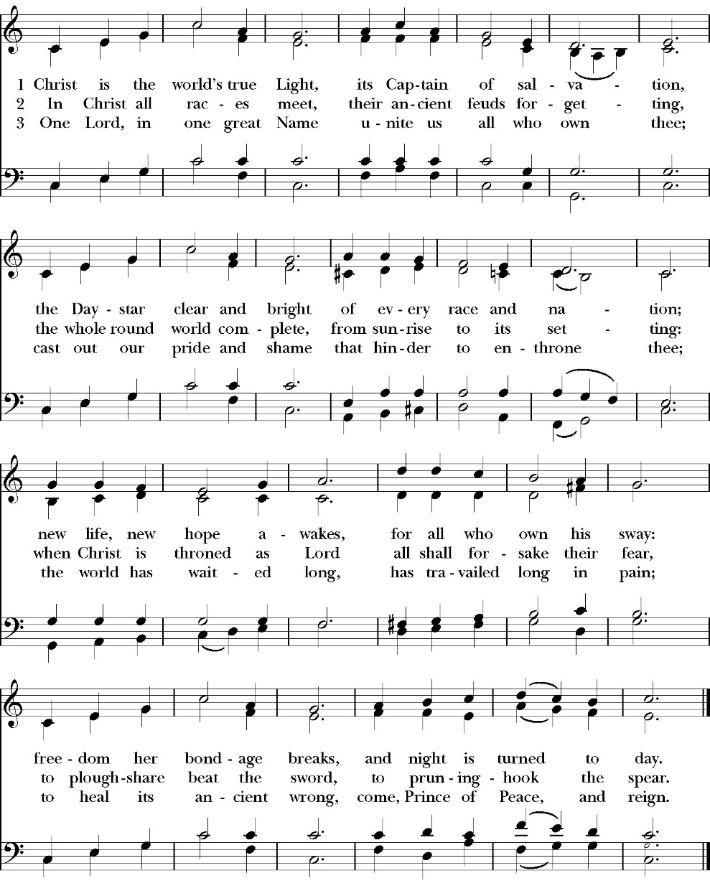

The Acclamation

Celebrant I will make you as a light for the nations,
People That my salvation may reach to the end of the earth.

The Collect for Purity

Almighty God, to you all hearts are open, all desires known, and from you no secrets are hid: Cleanse the thoughts of our hearts by the inspiration of your Holy Spirit, that we may perfectly love you, and worthily magnify your holy Name through Christ our Lord. Amen.

The Summary of the law

Hear what our Lord Jesus Christ says: You shall love the Lord your God with all your heart and with all your soul and with all your mind. This is the first and great commandment. And the second is like it: You shall love your neighbor as yourself. On these two commandments depend all the Law and the Prophets.

The Kyrie
The Gloria

Officiant The Lord be with You.
People And with your spirit.
Officiant Let us pray:

The Collect of the Day

O God, you know that we are set in the midst of many grave dangers,
and because of the frailty of our nature we cannot always stand upright: Grant that your strength and protection may support us in all dangers and carry us through every temptation; through Jesus Christ our Lord, who lives and reigns with you and the Holy Spirit, one God, for ever and ever. Amen.

Lesson: Micah 6:1-8
Hear what the Lord says:
Arise, plead your case before the mountains,
and let the hills hear your voice.
² Hear, you mountains, the indictment of the Lord,
and you enduring foundations of the earth,
for the Lord has an indictment against his people,
and he will contend with Israel.
³ “O my people, what have I done to you?
How have I wearied you? Answer me!
⁴ For I brought you up from the land of Egypt
and redeemed you from the house of slavery,
and I sent before you Moses,
Aaron, and Miriam.
⁵ O my people, remember what Balak king of Moab devised,
and what Balaam the son of Beor answered him,
and what happened from Shittim to Gilgal,
that you may know the righteous acts of the Lord.”
⁶ “With what shall I come before the Lord,
and bow myself before God on high?
Shall I come before him with burnt offerings,
with calves a year old?
⁷ Will the Lord be pleased with thousands of rams,
with ten thousands of rivers of oil?
Shall I give my firstborn for my transgression,
the fruit of my body for the sin of my soul?”
⁸ He has told you, O man, what is good;
and what does the Lord require of you
but to do justice, and to love kindness,
and to walk humbly with your God?
Reader The Word of the Lord
People Thanks be to God

Gradual: Psalm 37:1-11
1 Fret not yourself because of the ungodly, *
neither be envious of those who are evildoers.
2 For they shall soon be dried up like the grass, *
and be withered even as the green herb.
3 Put your trust in the Lord, and do good; *
dwell in the land, and surely you shall be fed.
4 Delight yourself in the Lord, *
and he shall give you your heart’s desire.
5 Commit your way unto the Lord and put your trust in him, *
and he shall bring it to pass.
6 He shall make your righteousness as clear as the light *
and your just dealing as the noonday.
7 Be still before the Lord and wait patiently for him; *
do not grieve yourself over the one whose way prospers, over
the one who carries out evil counsels.
8 Refrain from wrath, and let go of anger; *
fret not yourself, lest you be moved to do evil.
9 For evildoers shall be rooted out, *
but those who wait patiently for the Lord, they shall inherit the
land.
10 Yet a little while, and the ungodly shall be clean gone; *
you shall look for their place, and they shall not be there.
11 But the meek-spirited shall possess the land *
and shall be refreshed with an abundance of peace.

Glory be to the Father, and to the Son, and to the Holy Spirit;
as it was in the beginning, is now, and ever shall be, world without end. Amen
Epistle: 1 Corinthians 1:18-31
¹⁸ For the word of the cross is folly to those who are perishing, but to us who are being saved it is the power of God. ¹⁹ For it is written,
“I will destroy the wisdom of the wise,
and the discernment of the discerning I will thwart.”
²⁰ Where is the one who is wise? Where is the scribe? Where is the debater of this age? Has not God made foolish the wisdom of the world? ²¹ For since, in the wisdom of God, the world did not know God through wisdom, it pleased God through the folly of what we preach to save those who believe. ²² For Jews demand signs and Greeks seek wisdom, ²³ but we preach Christ crucified, a stumbling block to Jews and folly to Gentiles, ²⁴ but to those who are called, both Jews and Greeks, Christ the power of God and the wisdom of God. ²⁵ For the foolishness of God is wiser than men, and the weakness of God is stronger than men.
²⁶ For consider your calling, brothers: not many of you were wise according to worldly standards, not many were powerful, not many were of noble birth. ²⁷ But God chose what is foolish in the world to shame the wise; God chose what is weak in the world to shame the strong; ²⁸ God chose what is low and despised in the world, even things that are not, to bring to nothing things that are, ²⁹ so that no human being might boast in the presence of God. ³⁰ And because of him you are in Christ Jesus, who became to us wisdom from God, righteousness and sanctification and redemption, ³¹ so that, as it is written, “Let the one who boasts, boast in the Lord.”

Reader The Word of the Lord
People Thanks be to God

Sequence Hymn: Blest are the Pure in Heart
(vs. 1-2 before the Gospel, v. 3-4 after)

Clergy The Holy Gospel of Our Lord Jesus Christ, according to St.
Matthew.
People Glory to you, Lord Christ.

Gospel: Matthew 5:1-12
Seeing the crowds, he went up on the mountain, and when he sat down, his disciples came to him.
² And he opened his mouth and taught them, saying:
3 “Blessed are the poor in spirit, for theirs is the kingdom of heaven.
4 “Blessed are those who mourn, for they shall be comforted.
5 “Blessed are the meek, for they shall inherit the earth.
6 “Blessed are those who hunger and thirst for righteousness, for they shall be satisfied.
7 “Blessed are the merciful, for they shall receive mercy.
8 “Blessed are the pure in heart, for they shall see God.
9 “Blessed are the peacemakers, for they shall be called sons of God.
10 “Blessed are those who are persecuted for righteousness' sake, for theirs is the kingdom of heaven.
11 “Blessed are you when others revile you and persecute you and utter all kinds of evil against you falsely on my account. 12 Rejoice and be glad, for your reward is great in heaven, for so they persecuted the prophets who were before you.

Clergy The Gospel of the Lord
People Praise to you, Lord Christ.

Sermon
Rev. Robert Longbottom

The Nicene Creed

We believe in one God,
the Father, the Almighty,
maker of heaven and earth,
of all that is, visible and invisible.

We believe in one Lord, Jesus Christ,
the only-begotten Son of God,
eternally begotten of the Father,
God from God, Light from Light,
true God from true God,
begotten, not made,
of one Being with the Father.
through him all things were made.
For us and for our salvation he came down from heaven:
was incarnate from the Holy Spirit and the Virgin Mary,
and was made man.
For our sake he was crucified under Pontius Pilate;
he suffered death and was buried.
On the third day he rose again in accordance with the
Scriptures;
he ascended into heaven
and is seated at the right hand of the Father.
He will come again in glory to judge the living and the dead,
and his kingdom will have no end.
We believe in the Holy Spirit, the Lord, the giver of life,
who proceeds from the Father [and the Son],
who with the Father and the Son is worshiped and glorified.
who has spoken through the Prophets.
We believe in one holy catholic and apostolic Church.
We acknowledge one Baptism for the forgiveness of sins.
We look for the resurrection of the dead,
and the life of the world to come. Amen.

The Prayers of the People

Leader Let us pray for the Church and for the world, saying, “hear our prayer.”
For the peace of the whole world, and for the well-being and unity of the people of God.
Lord, in your mercy:
People Hear our prayer.

Leader For Stephen our archbishop and Eric, our Bishop. For Fr. Rob, Deacon John, Deacon Kashy, and for all the clergy and people of our diocese and congregation and for the worldwide Anglican Communion.
Lord, in your mercy:
People Hear our prayer.

Leader For all those who proclaim the Gospel at home and abroad; and for all who teach and disciple others.
Lord, in your mercy:
People Hear our prayer.

Leader For our brothers and sisters in Christ who are persecuted for their faith.
Lord, in your mercy:
People Hear our prayer.

Leader For our nation, for those in authority, and for all in public service especially Donald our president and Gavin our Governor.
Lord, in your mercy:
People Hear our prayer.

Leader: In the St. Paul’s cycle of prayer, we pray for our Sunday morning worship and welcoming ministries. We pray for the Altar Guild, our Lay Eucharistic Ministers, our Lectors, and our Acolytes. We pray for our music ministry and the musicians and vocalists. We pray for our ushers, greeters, and prayer table ministries.
Lord, in your mercy:
People Hear our prayer.

Leader In the ACNA Cycle of Prayer, today we pray for the Anglican Province of South America and The Most Rev. Brian Williams, Acting Primate.
Lord, in your mercy:
People Hear our prayer.

Leader For all those who are in trouble, sorrow, need, sickness, or any other adversity [especially _____________]. We also pray for all who are currently serving in our armed forces and serving as first responders.
Lord, in your mercy:
People Hear our prayer.

Leader For all those who have departed this life in the certain hope of the resurrection, (we pray especially for ____________), in thanksgiving let us pray.
Lord, in your mercy:
People Hear our prayer.

Celebrant will add a concluding prayer

The Confession and Absolution

Celebrant Let us humbly confess our sins to Almighty God.

Most merciful God,
we confess that we have sinned against you
in thought, word and deed,
by what we have done, and by what we have left undone.
We have not loved you with our whole heart;
we have not loved our neighbors as ourselves.
We are truly sorry and we humbly repent.
For the sake of your Son Jesus Christ,
have mercy on us and forgive us;
that we may delight in your will, and walk in your ways,
to the glory of your Name. Amen.

Almighty God, our heavenly Father, who in his great mercy has
promised forgiveness of sins to all those who sincerely repent and
with true faith turn to him, have mercy upon you, pardon and deliver
you from all your sins, confirm and strengthen you in all goodness,
and bring you to everlasting life; through Jesus Christ our Lord.
Amen.

Come to me, all who labor and are heavy laden, and I will give you
rest. Matthew 11:28

Celebrant The Peace of the Lord be always with you.
People And with your spirit.

Offertory Congregational Hymn: ‘Tis the Gift to Be Simple
In Thanksgiving for the ministry and friendship
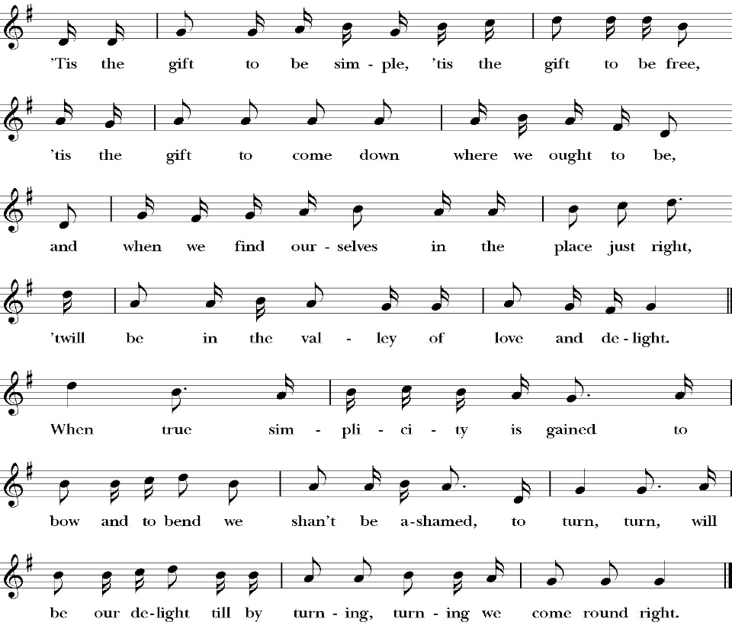
of Betty lee Blackmon

The Offertory

Celebrant All things come from you, O Lord,
People And of your own have we given you.

The Eucharistic Liturgy

Celebrant The Lord be with you.
People And with your spirit.
Celebrant Lift up your hearts.
People We lift them up to the Lord.
Celebrant Let us give thanks to the Lord our God.
People It is right to give him thanks and praise.

It is right, our duty and our joy, always and everywhere to give thanks to you, Father Almighty, Creator of heaven and earth.

Through Jesus Christ our Lord, who took on our mortal flesh to reveal his glory; that he might bring us out of darkness and into his own glorious light.

Therefore we praise you, joining our voices with angels and archangels and with all the company of heaven, who forever sing this hymn to proclaim the glory of your Name:

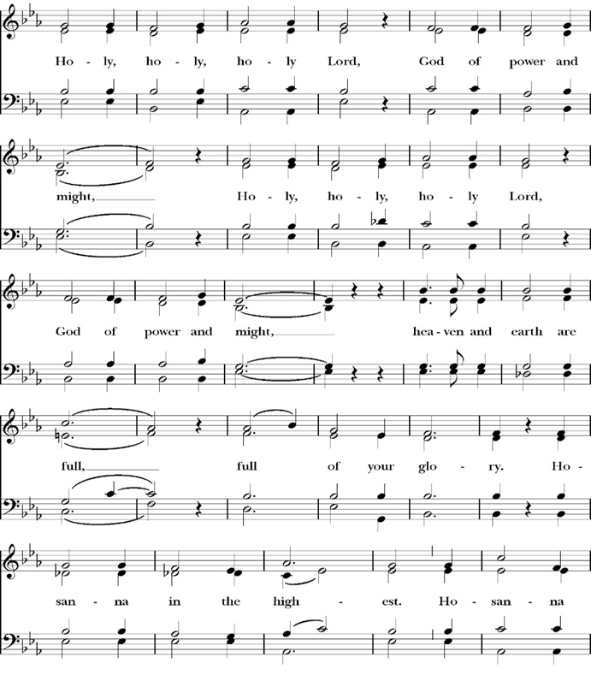
The Sanctus

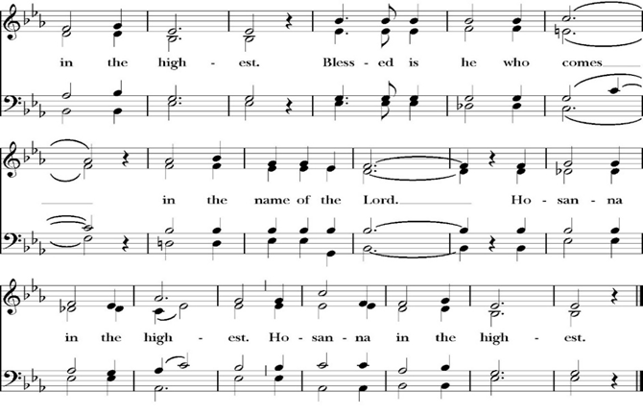
Holy and gracious Father: In your infinite love you made us for yourself; and when we had sinned against you and become subject to evil and death, you, in your mercy, sent your only Son Jesus Christ into the world for our salvation. By the Holy Spirit and the Virgin Mary he became flesh and dwelt among us. In obedience to your will, he stretched out his arms upon the Cross and offered himself once for all, that by his suffering and death we might be saved. By his resurrection he broke the bonds of death, trampling Hell and Satan under his feet. As our great high priest, he ascended to your right hand in glory, that we might come with confidence before the throne of grace.

On the night that he was betrayed, our Lord Jesus Christ took bread; and when he had given thanks, he broke it, * and gave it to his disciples, saying, “Take, eat; this is my Body, which is given for you: Do this in remembrance of me.”

Likewise, after supper, Jesus took the cup, and when he had given thanks, he gave it to them, saying, “Drink this, all of you; for this is my Blood of the New Covenant, which is shed for you, and for many, for the forgiveness of sins: Whenever you drink it, do this in remembrance of me.”

Therefore we proclaim the mystery of faith:

Christ has died.
Christ is risen.
Christ will come again.

We celebrate the memorial of our redemption, O Father, in this sacrifice of praise and thanksgiving, and we offer you these gifts.

Sanctify them by your Word and Holy Spirit to be for your people the Body and Blood of your Son Jesus Christ. Sanctify us also, that we may worthily receive this holy Sacrament, and be made one body with him, that he may dwell in us and we in him. In the fullness of time, put all things in subjection under your Christ, and bring us with all your saints into the joy of your heavenly kingdom, where we shall see our Lord face to face.

All this we ask through your Son Jesus Christ: By him, and with him, and in him, in the unity of the Holy Spirit, all honor and glory is yours, Almighty Father, now and for ever. Amen.

And now, as our Savior Christ has taught us, we are bold to pray,

Our Father, who art in heaven,
hallowed be thy Name,
thy kingdom come,
thy will be done,
on earth as it is in heaven.
Give us this day our daily bread.
And forgive us our trespasses,
as we forgive those
who trespass against us.
And lead us not into temptation,
but deliver us from evil.
For thine is the kingdom,
and the power, and the glory,
for ever and ever. Amen.

Celebrant Alleluia! Christ our Passover is sacrificed for us.
People Therefore let us keep the feast. Alleluia!

We do not presume to come to this your table, O merciful Lord,
trusting in our own righteousness,
but in your abundant and great mercies.
We are not worthy so much as to gather up
the crumbs under your table;
but you are the same Lord
whose character is always to have mercy.
Grant us, therefore, gracious Lord,
so to eat the flesh of your dear Son Jesus Christ,
and to drink his blood,
that our sinful bodies may be made clean by his body,
and our souls washed through his most precious blood,
and that we may evermore dwell in him, and he in us.
Amen.

Agnus Dei
The Ministration of Communion

The gifts of God for the People of God. Take them in remembrance that Christ died for you and feed on him in your hearts by faith, with thanksgiving.

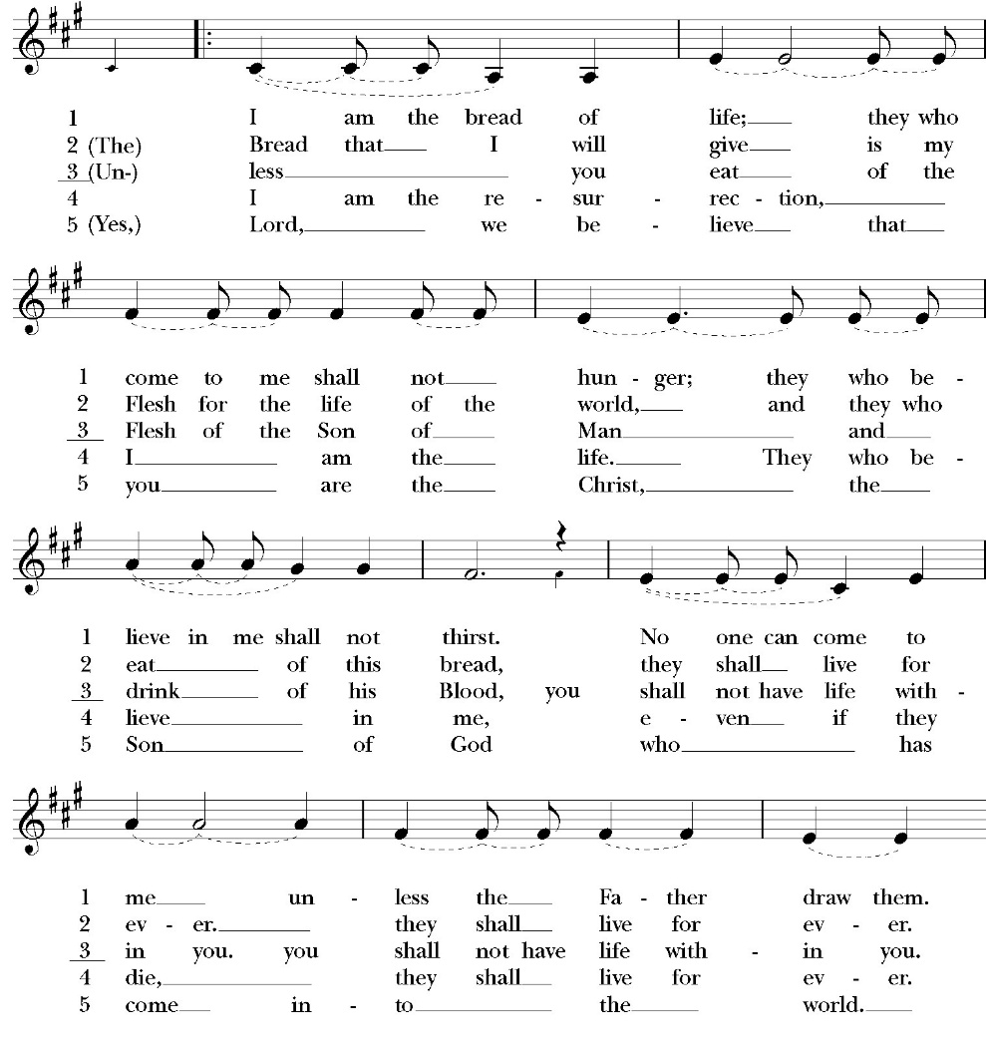
Communion Hymn: I am the Bread of Life

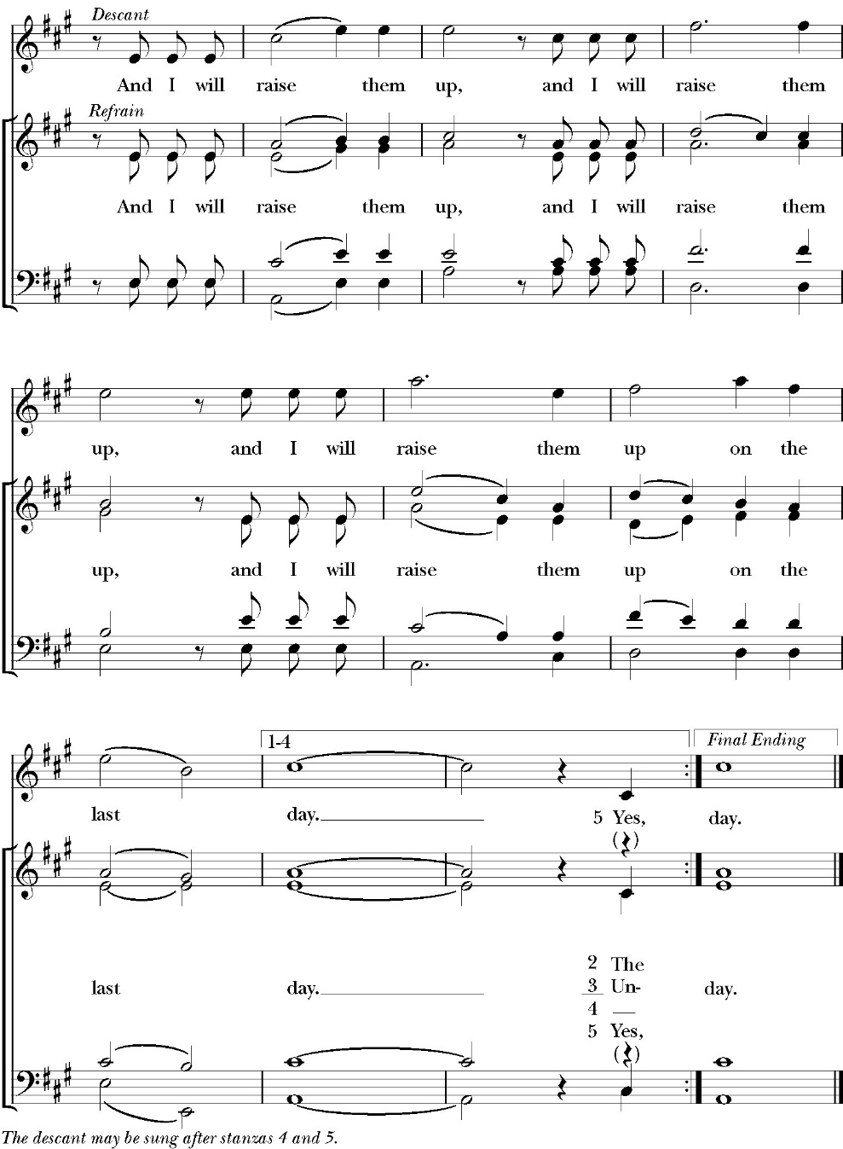

The Post Communion Prayer

Let us pray.

Heavenly Father,
We thank you for feeding us with the spiritual food
of the most precious Body and Blood
of your Son our Savior Jesus Christ;
and for assuring us in these holy mysteries
that we are living members of the body of your Son,
and heirs of your eternal Kingdom.
And now, Father, send us out to do the work you have
given us to do,
to love and serve you as faithful witnesses of Christ our
Lord.
To him, to you, and to the Holy Spirit,
be honor and glory, now and for ever. Amen.

The Blessing

The peace of God, which passes all understanding, keep your hearts
and minds in the knowledge and love of God, and of his Son Jesus
Christ our Lord; and the blessing of God Almighty, the Father, the
Son, and the Holy Spirit, be among you, and remain with you always.
Amen.

Closing Hymn: In the Cross of Christ, I Glory
(verses 1-3)

Celebrant Alleluia! Go in peace to love and serve the Lord
People Thanks be to God. Alleluia! Alleluia!
St. Paul’s Parish Calendar
Sunday February 1 – Sunday February 8

SUNDAY, February 1 – Fourth Sunday of Epiphany
9:15 AM Sunday Funday, Youth Room
9:15 AM Anglican Catechism Class, Conference room
9:30 AM Vocal Choir rehearsal, Chapel
10:30 AM Children’s Sunday School, Chapel
Pre-K –2nd Grade, Sunday School Room.
3rd -5th Grade, Youth Room
10:30 AM Holy Eucharist, Church
12:00 PM Annual Meeting

MONDAY, February 2

TUESDAY, February 3
6:00 PM Bell Choir Practice, Music Room

WEDNESDAY, February 4
9:30 AM Holy Eucharist with healing prayer, Chapel
10:15 AM Bible Study, Conference Room
6:00 PM Dinner, James Hall
6:30 PM This Is the Bible Program, Conference Room
7:00 PM Vocal Choir Rehearsal, Church

THURSDAY, February 5

FRIDAY, February 6
6:30 AM Men’s Bible Study, Valhalla Restaurant

SATURDAY, February 7

SUNDAY, February 8 – Fifth Sunday of Epiphany
9:15 AM Sunday Funday, Youth Room
9:15 AM Anglican Catechism Class, Conference room
9:30 AM Vocal Choir rehearsal, Chapel
10:30 AM Children’s Sunday School, Chapel
Pre-K –2nd Grade, Sunday School Room.
3rd -5th Grade, Youth Room
10:30 AM Holy Eucharist, Church

Church Office Hours
Monday-Thursday 8:00 AM-4:00 PM

Announcements

Annual Meeting of St. Paul’s Anglican Church
Today, Sunday, February 1, after the Worship Service
The annual meeting of St. Paul’s Anglican Church is an opportunity
to celebrate the ministries of the church, present the year-end budget
for 2025 and the budget approved by the Vestry of the church for
2026, and elect new vestry members and delegates to the 2026
convention of the Anglican Diocese of San Joaquin. A sandwich
lunch and childcare will be provided.

Nominations for Vestry and Delegates for 2026 Convention of
the Anglican Diocese of San Joaquin
The nominations committee (a subcommittee of the vestry) put
forward a slate of nominees to the Vestry at the January 13th meeting.
The following were approved by vestry to stand for election for
vestry and delegates to the 2026 Convention of the Anglican Diocese
of San Joaquin.

Vestry class of 2029 (Four vestry seats open)

Don Fowler
Joey Haas
Wendy Johns
Justin Qualls

Delegates to 2026 Convention of the Anglican Diocese of San
Joaquin (Three delegates and one alternate to be elected)

David Francis (Delegate)
Janet Robinson (Delegate)
Kim Robinson (Delegate)
Jim Doe (Alternate)

Additional nominations may be presented by confirmed voting members of the
congregation on the floor of the annual meeting on Sunday, February 1

Catechism Class, Becoming Like Christ: The Ten Commandments, Justification and Sanctification
Sundays, 9:15AM-10:00 January 11-February 15
The Anglican Catechism invites us to explore how we can connect
the authority of God’s word to our everyday Christian walk. This is
the final section of our Anglican catechism class, but does not require
previous attendance. We will explore how to live more fully
according to the law of God while also living according to the person
and teachings of Jesus.

February 1 Commandments 5 & 6
February 8 Commandments 7 & 8
February 15 Commandments 9 & 10 and Summary

The schedule may be modified based on weekly progress. No matter how far we get, the class will finish on Sunday, February 15.

“So…. This Is the Bible” Program
Wednesdays, February 4 and February 11

Dinner Menu, Wednesday, February 4, at 6PM:

Baked Potato Bar

Baked Potato
Bar Items: Butter
Sour Cream
Chives/Green Onions
Cheese
Bacon Bits
CHILI Beans
Salsa
Steamed Broccoli

Dessert: Lemon Cream Cheese Bars

"So...This is the Bible": A four week overview of the Bible
6:30-7:30PM
Have you ever read the Bible and found yourself to be very confused because you have no idea what is going on in the scripture you’re reading?

Have you ever been asked questions about the Bible by a non-Christian friend and found yourself grasping at straws and wishing you could give a better answer?

Is growing in your knowledge of the Bible and in your faith a consistent goal in your life that seems to fall to the bottom of your priority list year after year?

If the answer to this question is yes, then you are in good company. So many people, even devoted Christians, struggle to read the Bible and know less about the Bible than they might want to admit. If you would like to make 2026 the year that you learn more about the Bible for personal study, spiritual growth, and so you can more effectively share your faith - then this is the class for you!

In four sessions we will cover a number of topics including how the Bible was formed, how we can be sure the Bible is reliable, the overarching storyline of the Bible, how to study the Bible, and more! We hope that you will consider coming out and joining us! Children’s programming and nursery care will be available at the same time as this class. Our session dates are Wednesday evenings on 2/4, and 2/11. Stay tuned for exact timing and details.
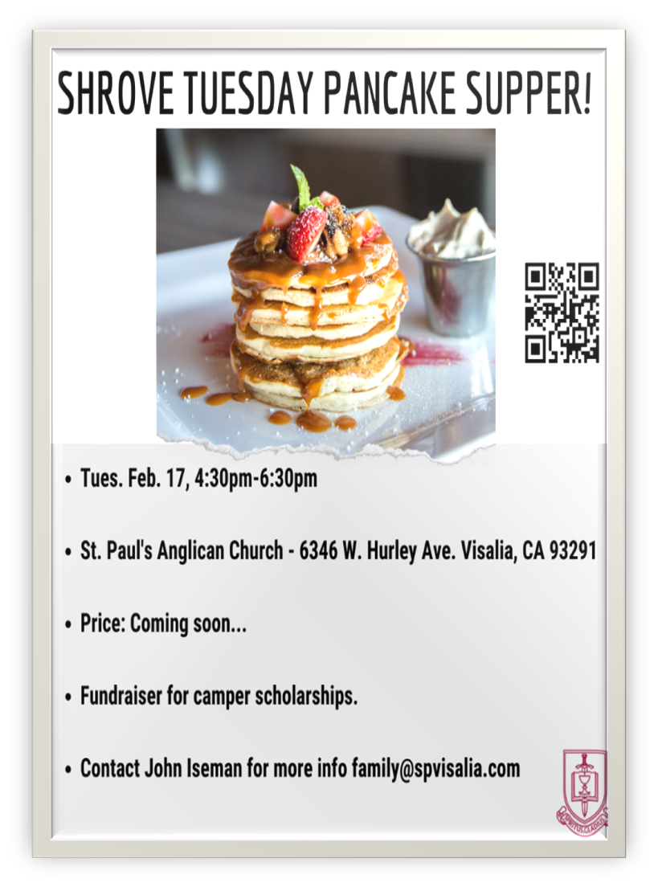
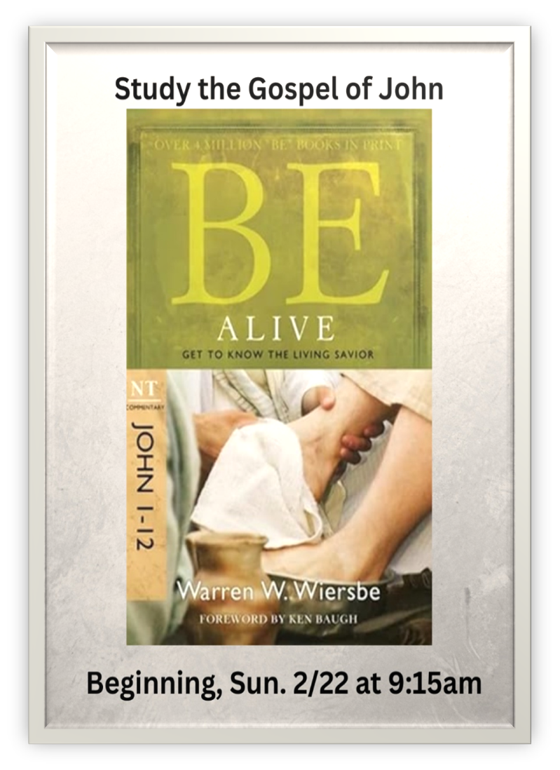
St. Paul’s Anglican Church
6436 W Hurley Ave
Visalia, CA
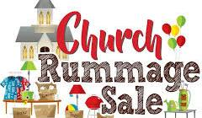

Friday March 6, 8:00 AM to 4:00 PM
Saturday March 7, 8:00 AM to 2:00 PM
Drop Off Donated Items in James Hall on:
Wednesday March 4 and Thursday March 5
Between 9:00 AM – 4:00 PM
Items need to be in Good Condition, Clean, gently worn clothing, household items, toys in working order gladly accepted!

Volunteers Needed for Set Up
Wednesday, March 4 and Thursday March 5
Between 9:00 AM – 4:00 PM
Proceeds will Go Toward the New Gate Project and
To Support our Medical Student in Honduras
If you have any questions,
Contact: Mary Murray at 799-6973

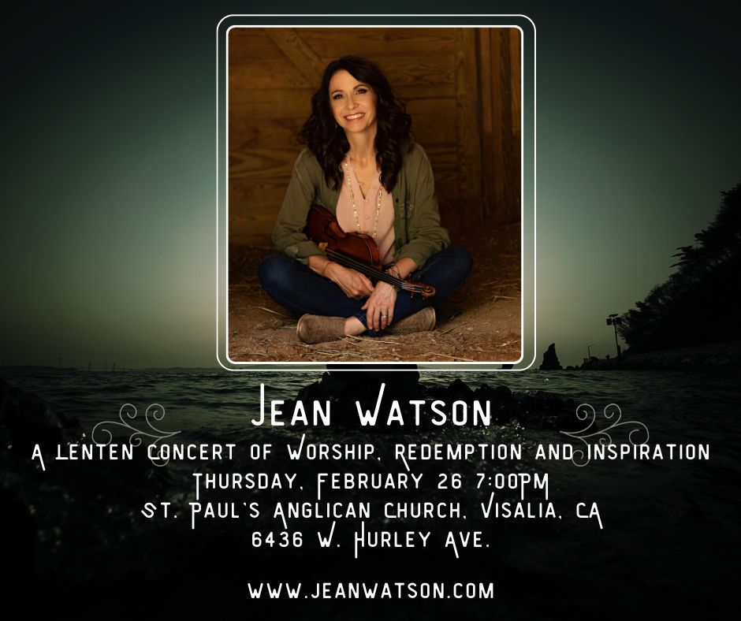
Jean Watson is a violinist/singer songwriter/speaker/writer who is passionate about bringing the sound of heaven to earth through words and music.

For the past 20 years, she has been traveling the globe sharing the love of Christ with whomever will listen.

Join us at St. Paul’s Anglican Church for a Lenten concert of
hope, redemption and the cross of Christ.

“It’s not always been easy, and I’ve walked through my share of struggles! Maybe you have too. One thing I’ve learned, however, is that God is faithful. Though we may fail Him, the Lord’s love will never fail us!” -Jean Watson
St. Paul’s Anglican Church
Parish Office
6436 W. Hurley Ave
Visalia, California 93291
559-732-4821
Office Hours: 8:00 – 4:00
Monday – Thursday

Worship: Sundays at 10:30AM
Livestream: Link at spvisalia.com
and on our Facebook page
Please be advised that this service is being recorded for broadcast
and/or archival purposes. By attending, you consent
to the inclusion of your likeness in these recordings.

St. Paul’s Clergy and Staff
The Rev. Robert Longbottom, Rector
rector@spvisalia.com
(559)802-2928
The Rev. John Iseman, Pastoral Associate for Family Ministries
family@spvisalia.com
The Rev. Kashy Rowland-Smith, Deacon
kashyrs@aol.com
Antoinette Horsting, Parish Administrator
bookkeeper@spvisalia.com
Marguerite Crownover, Organist and Accompanist
Cynthia Culp, Choral Director
Jackie Iseman, Nursery Coordinator
Shane Motl, Sexton

St. Paul’s is a member church of the
Anglican Diocese of San Joaquin
The Rt. Rev. Eric V. Menees, Bishop

Next Week’s Lessons
2 Kings 22:8-20
Psalm 27
1 Corinthians 2:1-16
Matthew 5:13-20

