St. Paul’s Anglican Church
Visalia, California
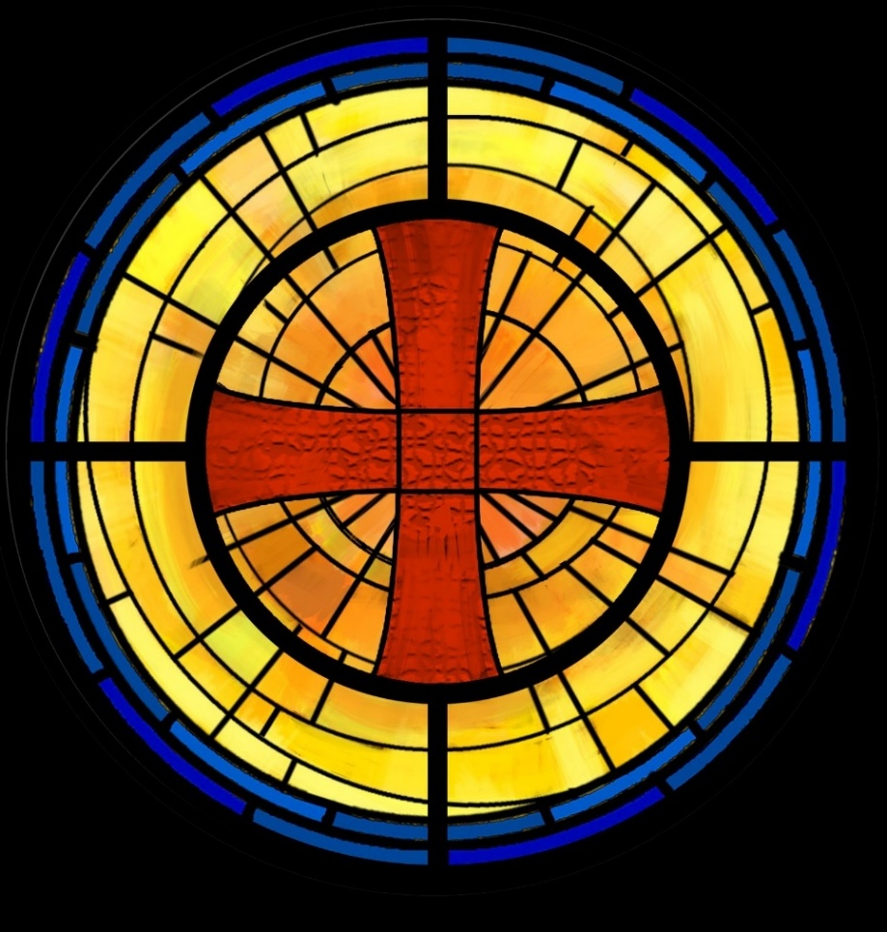

Fifth Sunday of Epiphany
February 8, 2026
10:30 AM

Welcome!

St. Paul’s Anglican Church extends a warm welcome to all visitors and newcomers, whether worshiping in person or at home via livestream.

Visitors’ Guide

St. Paul’s Church is a parish in the Diocese of San Joaquin of the Anglican Church in North America, which includes both Catholic and Protestant traditions. We accept Jesus Christ as Savior, and we promise to follow him as Lord. We believe in One God,

- the Father who created us and all things,
- the Son who redeems us from sin and death,
- the Holy Spirit who renews and sanctifies us.

We believe the Holy Scriptures to be the Word of God and to contain all things necessary for salvation, and we accept the Apostles’ and Nicene Creeds as essential beliefs of the Christian faith.

Holy Communion is open to all baptized Christians who have examined their lives, repented of their sins, and desire to live
in love and charity with all people.

Those not desiring to receive Holy Communion, and those who have not been baptized into the Christian faith, are invited to cross their arms across their chest, and a blessing will be given instead.

Visitors are invited to sign the guest book at the entrance table and introduce themselves to the clergy following the service.

The Holy Eucharist

Postlude: “Fantasy in A Minor” Bach
Opening Hymn: #7 - “Christ, Whose Glory Fills the Skies” p. 4
Acclamation p. 5
The Collect for Purity p. 5
Summary of the Law p. 5
Kyrie p. 5
Gloria p. 6
Collect of the Day p. 7
Lesson: 2 Kings 22:8-20 p. 7
Gradual: Psalm 27 p. 8
Epistle: 1 Corinthians 2:1-16 p. 10
Sequence Hymn: #488 - “Be Thou My Vision” p. 11
Gospel: Matthew 5:13-20 p. 11
Sermon: Rev. John Iseman
Nicene Creed p. 12
Prayers of the People p. 13
Confession and Absolution p. 15
The Peace p. 15
Offertory Choir: “I Want to Walk as a Child of the Light” Dan Forrest
The Offertory p. 16
Sanctus p. 17
The Lord’s Prayer p. 19
Prayer for Humble Access p. 19
Agnus Dei p. 20
Communion Hymn: “Shine Jesus Shine” p. 21
Post Communion Prayer p. 23
Blessing p. 23
Closing Hymn: #388 - “O Worship the King” p. 24
Dismissal p. 24
Prelude: “Recessional in G Major” Stanley

Opening Hymn: Christ, Whose Glory Fills the Skies

Words: Charles Wesley
Music: Ratisbon, melody from Geystliche gesangk Buchleyn

The Acclamation

Celebrant I will make you as a light for the nations,
People That my salvation may reach to the end of the earth.

The Collect for Purity

Almighty God, to you all hearts are open, all desires known, and from you no secrets are hid: Cleanse the thoughts of our hearts by the inspiration of your Holy Spirit, that we may perfectly love you, and worthily magnify your holy Name through Christ our Lord. Amen.

The Summary of the law

Hear what our Lord Jesus Christ says: You shall love the Lord your God with all your heart and with all your soul and with all your mind. This is the first and great commandment. And the second is like it: You shall love your neighbor as yourself. On these two commandments depend all the Law and the Prophets.

The Kyrie
The Gloria

Officiant The Lord be with You.
People And with your spirit.
Officiant Let us pray:

The Collect of the Day

O Lord, our heavenly Father, keep your household the Church continually in your true religion, that we who trust in the hope of your heavenly grace may always be defended by your mighty power; through Jesus Christ our Lord, who lives and reigns with you and the Holy Spirit, now and for ever. Amen.

Lesson: 2 Kings 22:8-20
⁸ And Hilkiah the high priest said to Shaphan the secretary, “I have found the Book of the Law in the house of the Lord.” And Hilkiah gave the book to Shaphan, and he read it. ⁹ And Shaphan the secretary came to the king, and reported to the king, “Your servants have emptied out the money that was found in the house and have delivered it into the hand of the workmen who have the oversight of the house of the Lord.” ¹⁰ Then Shaphan the secretary told the king, “Hilkiah the priest has given me a book.” And Shaphan read it before the king.
¹¹ When the king heard the words of the Book of the Law, he tore his clothes. ¹² And the king commanded Hilkiah the priest, and Ahikam the son of Shaphan, and Achbor the son of Micaiah, and Shaphan the secretary, and Asaiah the king's servant, saying, ¹³ “Go, inquire of the Lord for me, and for the people, and for all Judah, concerning the words of this book that has been found. For great is the wrath of the Lord that is kindled against us, because our fathers have not obeyed the words of this book, to do according to all that is written concerning us.”
¹⁴ So Hilkiah the priest, and Ahikam, and Achbor, and Shaphan, and Asaiah went to Huldah the prophetess, the wife of Shallum the son of Tikvah, son of Harhas, keeper of the wardrobe (now she lived in Jerusalem in the Second Quarter), and they talked with her. ¹⁵ And she said to them, “Thus says the Lord, the God of Israel: ‘Tell the man who sent you to me, ¹⁶ Thus says the Lord, Behold, I will bring disaster upon this place and upon its inhabitants, all the words of the book that the king of Judah has read. ¹⁷ Because they have forsaken me and have made offerings to other gods, that they might provoke me to anger with all the work of their hands, therefore my wrath will be kindled against this place, and it will not be quenched. ¹⁸ But to the king of Judah, who sent you to inquire of the Lord, thus shall you say to him, Thus says the Lord, the God of Israel: Regarding the words that you have heard, ¹⁹ because your heart was penitent, and you humbled yourself before the Lord, when you heard how I spoke against this place and against its inhabitants, that they should become a desolation and a curse, and you have torn your clothes and wept before me, I also have heard you, declares the Lord. ²⁰ Therefore, behold, I will gather you to your fathers, and you shall be gathered to your grave in peace, and your eyes shall not see all the disaster that I will bring upon this place.’” And they brought back word to the king.
Reader The Word of the Lord
People Thanks be to God

Gradual: Psalm 27
1 The Lord is my light and my salvation; whom then shall I fear? *
The Lord is the strength of my life; of whom then shall I be
afraid?
2 When the wicked, even my enemies and my foes, came upon me
to eat up my flesh, *
they stumbled and fell.
3 Though a host were encamped against me, yet my heart would not
be afraid, *
and though war rose up against me, yet would I put my trust in
him.
4 One thing have I desired of the Lord; one thing I seek: *
that I may dwell in the house of the Lord all the days of my
life,
5 To behold the fair beauty of the Lord, *
and to seek him in his temple.
6 For in the time of trouble he shall hide me in his tabernacle; *
indeed, in the secret place of his dwelling he shall hide me, and
set me high upon a rock of stone.
7 And now he shall lift up my head *
above my enemies round about me.
8 Therefore I will offer in his dwelling an oblation with great
gladness; *
I will sing and speak praises unto the Lord.
9 Hearken to my voice, O Lord, when I cry unto you; *
have mercy upon me and hear me.
10 You speak to my heart and say, “Seek my face.” *
Your face, O Lord, will I seek.
11 O hide not your face from me, *
nor cast your servant away in displeasure.
12 You have been my helper; *
leave me not, neither forsake me, O God of my salvation.
13 When my father and my mother forsake me, *
the Lord takes me in.
14 Teach me your way, O Lord, *
and lead me in the right way, because of my enemies.
15 Deliver me not over to the will of my adversaries, *
for there are false witnesses who have risen up against me, and
those who speak wrong.
16 I would utterly have fainted, *
had I not believed that I would see the goodness of the Lord
in the land of the living.
17 O wait for the Lord; be strong, and he shall comfort your heart. *
O put your trust in the Lord.

Glory be to the Father, and to the Son, and to the Holy Spirit;
as it was in the beginning, is now, and ever shall be, world without end. Amen

Epistle: 1 Corinthians 2:1-16
And I, when I came to you, brothers, did not come proclaiming to you the testimony of God with lofty speech or wisdom. ² For I decided to know nothing among you except Jesus Christ and him crucified. ³ And I was with you in weakness and in fear and much trembling, ⁴ and my speech and my message were not in plausible words of wisdom, but in demonstration of the Spirit and of power, ⁵ so that your faith might not rest in the wisdom of men^{[c]} but in the power of God.
⁶ Yet among the mature we do impart wisdom, although it is not a wisdom of this age or of the rulers of this age, who are doomed to pass away. ⁷ But we impart a secret and hidden wisdom of God, which God decreed before the ages for our glory. ⁸ None of the rulers of this age understood this, for if they had, they would not have crucified the Lord of glory. ⁹ But, as it is written,
“What no eye has seen, nor ear heard,
nor the heart of man imagined,
what God has prepared for those who love him”—
¹⁰ these things God has revealed to us through the Spirit. For the Spirit searches everything, even the depths of God. ¹¹ For who knows a person's thoughts except the spirit of that person, which is in him? So also no one comprehends the thoughts of God except the Spirit of God. ¹² Now we have received not the spirit of the world, but the Spirit who is from God, that we might understand the things freely given us by God. ¹³ And we impart this in words not taught by human wisdom but taught by the Spirit, interpreting spiritual truths to those who are spiritual.
¹⁴ The natural person does not accept the things of the Spirit of God, for they are folly to him, and he is not able to understand them because they are spiritually discerned. ¹⁵ The spiritual person judges all things, but is himself to be judged by no one. ¹⁶ “For who has understood the mind of the Lord so as to instruct him?” But we have the mind of Christ.

Reader The Word of the Lord
People Thanks be to God
Sequence Hymn: Be Thou My Vision
(vs. 1-2 before the Gospel, v. 3 after)

Clergy The Holy Gospel of Our Lord Jesus Christ, according to St.
Matthew.
People Glory to you, Lord Christ.

Gospel: Matthew 5:13-20
¹³ “You are the salt of the earth, but if salt has lost its taste, how shall its saltiness be restored? It is no longer good for anything except to be thrown out and trampled under people's feet.
¹⁴ “You are the light of the world. A city set on a hill cannot be hidden. ¹⁵ Nor do people light a lamp and put it under a basket, but on a stand, and it gives light to all in the house. ¹⁶ In the same way, let your light shine before others, so that they may see your good works and give glory to your Father who is in heaven.
¹⁷ “Do not think that I have come to abolish the Law or the Prophets; I have not come to abolish them but to fulfill them. ¹⁸ For truly, I say to you, until heaven and earth pass away, not an iota, not a dot, will pass from the Law until all is accomplished. ¹⁹ Therefore whoever relaxes one of the least of these commandments and teaches others to do the same will be called least in the kingdom of heaven, but whoever does them and teaches them will be called great in the kingdom of heaven. ²⁰ For I tell you, unless your righteousness exceeds that of the scribes and Pharisees, you will never enter the kingdom of heaven.

Clergy The Gospel of the Lord
People Praise to you, Lord Christ.

Sermon
Rev. John Iseman

The Nicene Creed

We believe in one God,
the Father, the Almighty,
maker of heaven and earth,
of all that is, visible and invisible.

We believe in one Lord, Jesus Christ,
the only-begotten Son of God,
eternally begotten of the Father,
God from God, Light from Light,
true God from true God,
begotten, not made,
of one Being with the Father.
through him all things were made.
For us and for our salvation he came down from heaven:
was incarnate from the Holy Spirit and the Virgin Mary,
and was made man.
For our sake he was crucified under Pontius Pilate;
he suffered death and was buried.
On the third day he rose again in accordance with the
Scriptures;
he ascended into heaven
and is seated at the right hand of the Father.
He will come again in glory to judge the living and the dead,
and his kingdom will have no end.

We believe in the Holy Spirit, the Lord, the giver of life,
who proceeds from the Father [and the Son],
who with the Father and the Son is worshiped and glorified.
who has spoken through the Prophets.
We believe in one holy catholic and apostolic Church.
We acknowledge one Baptism for the forgiveness of sins.
We look for the resurrection of the dead,
and the life of the world to come. Amen.

The Prayers of the People

Leader Let us pray for the Church and for the world, saying, “hear our prayer.”
For the peace of the whole world, and for the well-being and unity of the people of God.
Lord, in your mercy:
People Hear our prayer.

Leader For Stephen our archbishop and Eric, our bishop. For Fr. Rob, Deacon John, Deacon Kashy, and for all the clergy and people of our diocese and congregation and for the worldwide Anglican Communion.
Lord, in your mercy:
People Hear our prayer.

Leader For all those who proclaim the Gospel at home and abroad; and for all who teach and disciple others.
Lord, in your mercy:
People Hear our prayer.

Leader For our brothers and sisters in Christ who are persecuted for their faith.
Lord, in your mercy:
People Hear our prayer.

Leader For our nation, for those in authority, and for all in public service especially Donald our president and Gavin our Governor.
Lord, in your mercy:
People Hear our prayer.

Leader: In the St. Paul’s cycle of prayer, we pray for all ministries to children, youth and families both in our church and through our church into the community around us. We pray for Sunday Funday, Sunday School, Youth Group, Acolytes and all Sunday morning children’s ministries. We pray for all our family ministry volunteers. We pray for the children and youth you have given to our care and for their formation in the Christian faith. We pray for all children and youth to whom we are reaching out with the Good News of Jesus Christ.
Lord, in your mercy:
People Hear our prayer.

Leader In the ACNA Cycle of Prayer, today we pray for the Diocese of Quincy and Bishop Alberto Morales.
Lord, in your mercy:
People Hear our prayer.

Leader For all those who are in trouble, sorrow, need, sickness, or any other adversity [especially _____________]. We also pray for all who are currently serving in our armed forces and serving as first responders.
Lord, in your mercy:
People Hear our prayer.

Leader For all those who have departed this life in the certain hope of the resurrection, (we pray especially for ____________), in thanksgiving let us pray.
Lord, in your mercy:
People Hear our prayer.

Celebrant will add a concluding prayer

The Confession and Absolution

Celebrant Let us humbly confess our sins to Almighty God.

Most merciful God,
we confess that we have sinned against you
in thought, word and deed,
by what we have done, and by what we have left undone.
We have not loved you with our whole heart;
we have not loved our neighbors as ourselves.
We are truly sorry and we humbly repent.
For the sake of your Son Jesus Christ,
have mercy on us and forgive us;
that we may delight in your will, and walk in your ways,
to the glory of your Name. Amen.

Almighty God, our heavenly Father, who in his great mercy has
promised forgiveness of sins to all those who sincerely repent and
with true faith turn to him, have mercy upon you, pardon and deliver
you from all your sins, confirm and strengthen you in all goodness,
and bring you to everlasting life; through Jesus Christ our Lord.
Amen.

God so loved the world, that he gave his only-begotten Son,
that whoever believes in him should not perish but have eternal
life. -John 3:16

Celebrant The Peace of the Lord be always with you.
People And with your spirit.

Offertory anthem
Choir
I Want to Walk as a Child of the Light
By Dan Forrest

The Offertory

Celebrant All things come from you, O Lord,
People And of your own have we given you.

The Eucharistic Liturgy

Celebrant The Lord be with you.
People And with your spirit.
Celebrant Lift up your hearts.
People We lift them up to the Lord.
Celebrant Let us give thanks to the Lord our God.
People It is right to give him thanks and praise.

It is right, our duty and our joy, always and everywhere to give thanks to you, Father Almighty, Creator of heaven and earth.

Through Jesus Christ our Lord, who took on our mortal flesh to reveal his glory; that he might bring us out of darkness and into his own glorious light.

Therefore we praise you, joining our voices with angels and archangels and with all the company of heaven, who forever sing this hymn to proclaim the glory of your Name:

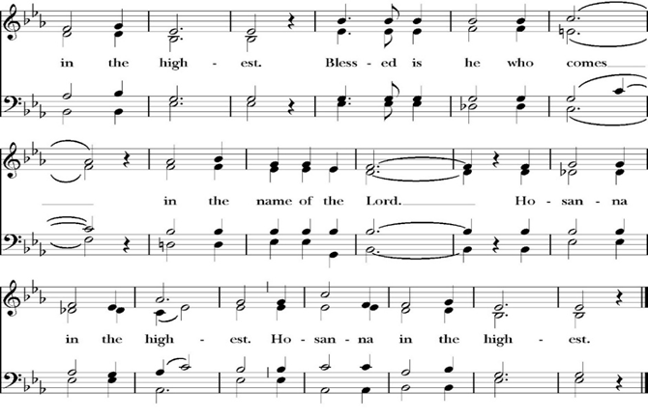
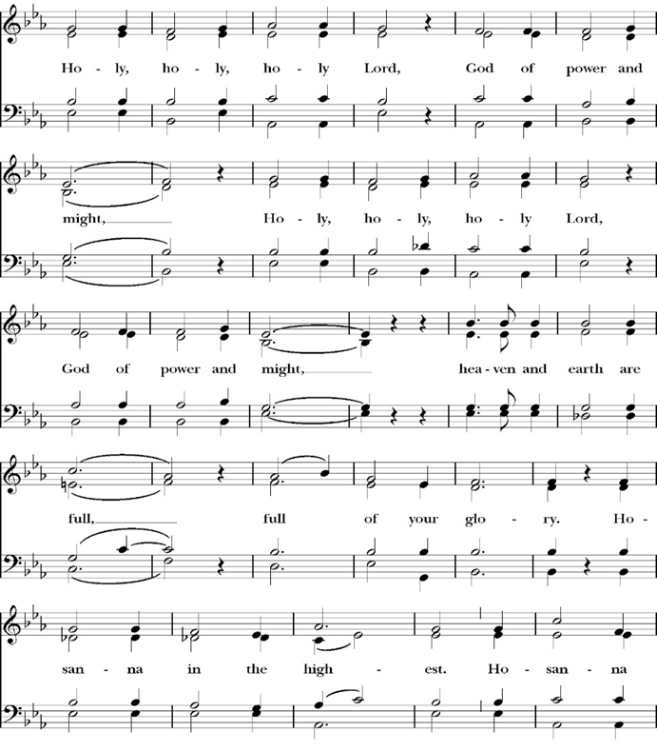
The Sanctus
Holy and gracious Father: In your infinite love you made us for yourself; and when we had sinned against you and become subject to evil and death, you, in your mercy, sent your only Son Jesus Christ into the world for our salvation. By the Holy Spirit and the Virgin Mary he became flesh and dwelt among us. In obedience to your will, he stretched out his arms upon the Cross and offered himself once for all, that by his suffering and death we might be saved. By his resurrection he broke the bonds of death, trampling Hell and Satan under his feet. As our great high priest, he ascended to your right hand in glory, that we might come with confidence before the throne of grace.

On the night that he was betrayed, our Lord Jesus Christ took bread; and when he had given thanks, he broke it, * and gave it to his disciples, saying, “Take, eat; this is my Body, which is given for you: Do this in remembrance of me.”

Likewise, after supper, Jesus took the cup, and when he had given thanks, he gave it to them, saying, “Drink this, all of you; for this is my Blood of the New Covenant, which is shed for you, and for many, for the forgiveness of sins: Whenever you drink it, do this in remembrance of me.”

Therefore we proclaim the mystery of faith:

Christ has died.
Christ is risen.
Christ will come again.

We celebrate the memorial of our redemption, O Father, in this sacrifice of praise and thanksgiving, and we offer you these gifts.

Sanctify them by your Word and Holy Spirit to be for your people the Body and Blood of your Son Jesus Christ. Sanctify us also, that we may worthily receive this holy Sacrament, and be made one body with him, that he may dwell in us and we in him. In the fullness of time, put all things in subjection under your Christ, and bring us with all your saints into the joy of your heavenly kingdom, where we shall see our Lord face to face.

All this we ask through your Son Jesus Christ: By him, and with him, and in him, in the unity of the Holy Spirit, all honor and glory is yours, Almighty Father, now and for ever. Amen.

And now, as our Savior Christ has taught us, we are bold to pray,

Our Father, who art in heaven,
hallowed be thy Name,
thy kingdom come,
thy will be done,
on earth as it is in heaven.
Give us this day our daily bread.
And forgive us our trespasses,
as we forgive those
who trespass against us.
And lead us not into temptation,
but deliver us from evil.
For thine is the kingdom,
and the power, and the glory,
for ever and ever. Amen.

Celebrant Alleluia! Christ our Passover is sacrificed for us.
People Therefore let us keep the feast. Alleluia!

The Prayer of Humble Access

We do not presume to come to this your table, O merciful Lord,
trusting in our own righteousness,
but in your abundant and great mercies.
We are not worthy so much as to gather up
the crumbs under your table;
but you are the same Lord
whose character is always to have mercy.
Grant us, therefore, gracious Lord,
so to eat the flesh of your dear Son Jesus Christ,
and to drink his blood,
that our sinful bodies may be made clean by his body,
and our souls washed through his most precious blood,
and that we may evermore dwell in him, and he in us.
Amen.
Agnus Dei

The Ministration of Communion

The gifts of God for the People of God. Take them in remembrance that Christ died for you and feed on him in your hearts by faith, with thanksgiving.

Communion Hymn: Shine Jesus Shine
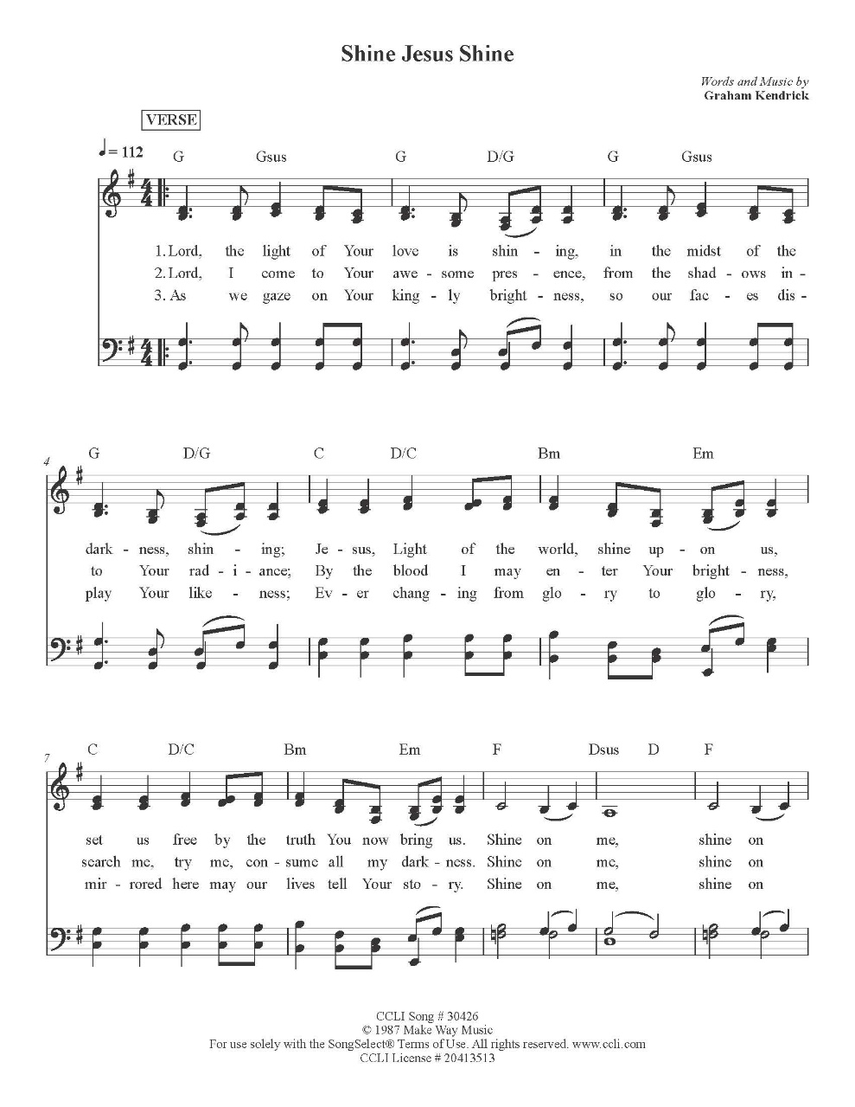

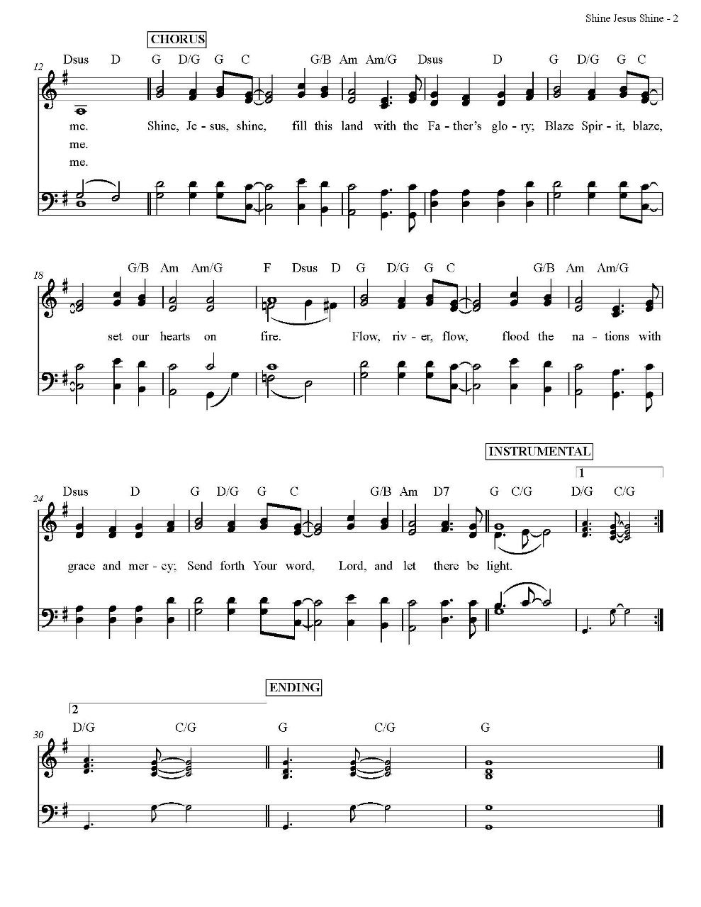

The Post Communion Prayer

Let us pray.

Heavenly Father,
We thank you for feeding us with the spiritual food
of the most precious Body and Blood
of your Son our Savior Jesus Christ;
and for assuring us in these holy mysteries
that we are living members of the body of your Son,
and heirs of your eternal Kingdom.
And now, Father, send us out to do the work you have
given us to do,
to love and serve you as faithful witnesses of Christ our
Lord.
To him, to you, and to the Holy Spirit,
be honor and glory, now and for ever. Amen.

The Blessing

The peace of God, which passes all understanding, keep your hearts
and minds in the knowledge and love of God, and of his Son Jesus
Christ our Lord; and the blessing of God Almighty, the Father, the
Son, and the Holy Spirit, be among you, and remain with you always.
Amen.

Closing Hymn: O Worship the King
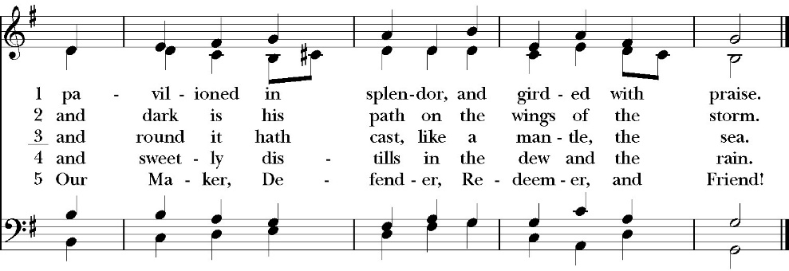
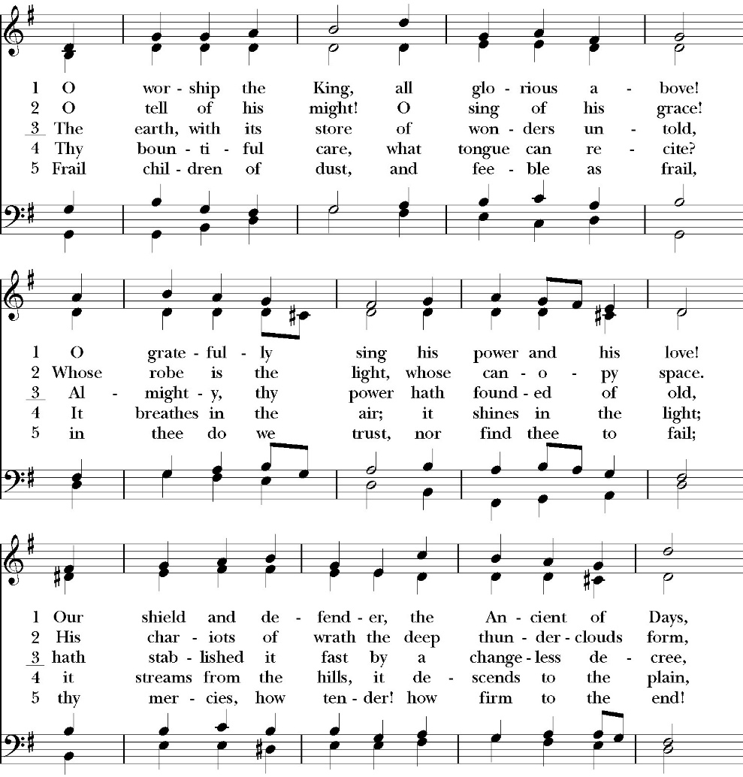
(verses 1-3 only)

Celebrant Alleluia! Go in peace to love and serve the Lord.
People Thanks be to God. Alleluia! Alleluia!

St. Paul’s Parish Calendar
Sunday February 8 – Sunday February 15

SUNDAY, February 8 – Fifth Sunday of Epiphany
9:15 AM Sunday Funday, Youth Room
9:15 AM Anglican Catechism Class, Conference room
9:30 AM Vocal Choir rehearsal, Chapel
10:30 AM Children’s Sunday School, Chapel
Pre-K –2nd Grade, Sunday School Room.
3rd -5th Grade, Youth Room
10:30 AM Holy Eucharist, Church

MONDAY, February 9

TUESDAY, February 10
6:00 PM Bell Choir Practice, Music Room
6:00 PM Vestry Meeting, Conference Room

WEDNESDAY, February 11
9:30 AM Holy Eucharist with healing prayer, Chapel
10:15 AM Bible Study, Conference Room
6:00 PM Potluck, James Hall
6:30 PM This Is the Bible Program, Conference Room
7:00 PM Vocal Choir Rehearsal, Church

THURSDAY, February 12

FRIDAY, February 13
6:30 AM Men’s Bible Study, Valhalla Restaurant

SATURDAY, February 14

SUNDAY, February 15 – Last Sunday of Epiphany
9:15 AM Sunday Funday, Youth Room
9:15 AM Anglican Catechism Class, Conference room
9:30 AM Vocal Choir rehearsal, Chapel
10:30 AM Children’s Sunday School, Chapel
Pre-K –2nd Grade, Sunday School Room.
3rd -5th Grade, Youth Room
10:30 AM Holy Eucharist, Church

Church Office Hours
Monday-Thursday 8:00 AM-4:00 PM

Announcements

Ash Wednesday, February 18
Imposition of Ashes and Holy Eucharist
7:00 AM Imposition of Ashes
(A brief prayer service with imposition of ashes)
12:00 NOON Holy Eucharist with imposition of ashes
7:00 PM Holy Eucharist with imposition of ashes,
Choir and Music

Catechism Class, Becoming Like Christ: The Ten Commandments, Justification and Sanctification
Sundays, 9:15AM-10:00 January 11-February 15
The Anglican Catechism invites us to explore how we can connect
the authority of God’s word to our everyday Christian walk. This is
the final section of our Anglican catechism class, but does not require
previous attendance. We will explore how to live more fully
according to the law of God while also living according to the person
and teachings of Jesus.

February 8 Commandments 7 & 8
February 15 Commandments 9 & 10 and Summary

The schedule may be modified based on weekly progress. No matter how far we get, the class will finish on Sunday, February 15.

“So…. This Is the Bible” Program
Wednesdays, February 4 and February 11
"So...This is the Bible": A four-week overview of the Bible
6:30-7:30PM
Have you ever read the Bible and found yourself to be very confused because you have no idea what is going on in the scripture you’re reading?

Have you ever been asked questions about the Bible by a non-Christian friend and found yourself grasping at straws and wishing you could give a better answer?

Is growing in your knowledge of the Bible and in your faith a consistent goal in your life that seems to fall to the bottom of your priority list year after year?

If the answer to this question is yes, then you are in good company. So many people, even devoted Christians, struggle to read the Bible and know less about the Bible than they might want to admit. If you would like to make 2026 the year that you learn more about the Bible for personal study, spiritual growth, and so you can more effectively share your faith - then this is the class for you!

In four sessions we will cover a number of topics including how the Bible was formed, how we can be sure the Bible is reliable, the overarching storyline of the Bible, how to study the Bible, and more! We hope that you will consider coming out and joining us! Children’s programming and nursery care will be available at the same time as this class. Our session date is Wednesday evening on 2/11. Stay tuned for exact timing and details.

Lenten Stations of the Cross Beginning Friday, February 20, and Ending March 27
Jesus Christ died on a cross for the sins of the world. Stations of the Cross is a meditative journey that, in a span of thirty minutes, allows the pilgrim to walk the way of the cross into the way of life and peace. All members are invited to join us for this beautiful and impactful devotional practice on Fridays at 6PM throughout Lent.

Practicing The Way: The Prayer Practice:
Pursue a deeper life of union with God.
This is a Lenten opportunity for discipleship and spiritual growth in Jesus Christ. To pray is to open your heart to God. Prayer is simply the medium through which we communicate and commune with God. The practice of prayer is learning to set aside dedicated time to intentionally be with God in order to become like him and partner with him in the world. The prayer practice small group is a video-based class on prayer developed by John Mark Comer, author and facilitator of Practicing the Way and its resources. There will be two opportunities to participate on Wednesday evenings. The 5PM small group will be led by Fr. Rob Longbottom. The 6:45PM small group will be led by Deacon John Iseman.

February 25 Session 1: Talking to God
March 4 Session 2: Talking with God
March 11 Session 3: Listening to God
March 18 Session 4: Being with God
March 25 Prayer and Praise in the church. An hour of prayer and praise music as we lift our prayers and hearts to God in worship.

Lenten Soup Supper will begin, February 25, at 5:45 p.m.
A sign-up sheet will be available beginning February 8 for those who wish to bring their favorite soup to share with others. This is a wonderful opportunity for the entire family to come together and share in the Lenten experience.

Lenten Wednesday Evening Schedule
5:00 PM Prayer small group led by Father Rob

6:00 PM Soup Suppers

6:45 PM Prayer small group class led by Deacon John

6:4 5PM Children’s class on prayer led by Deacon Kashy and
Fr. Rob
7:00 PM Vocal Choir Rehearsal
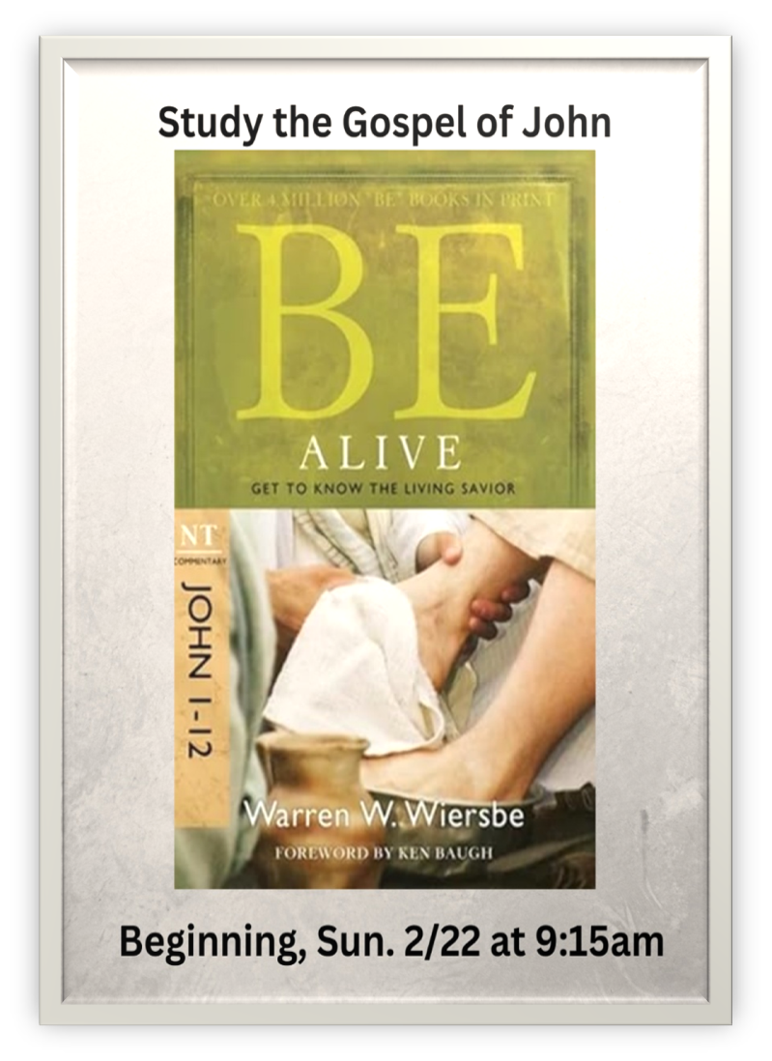
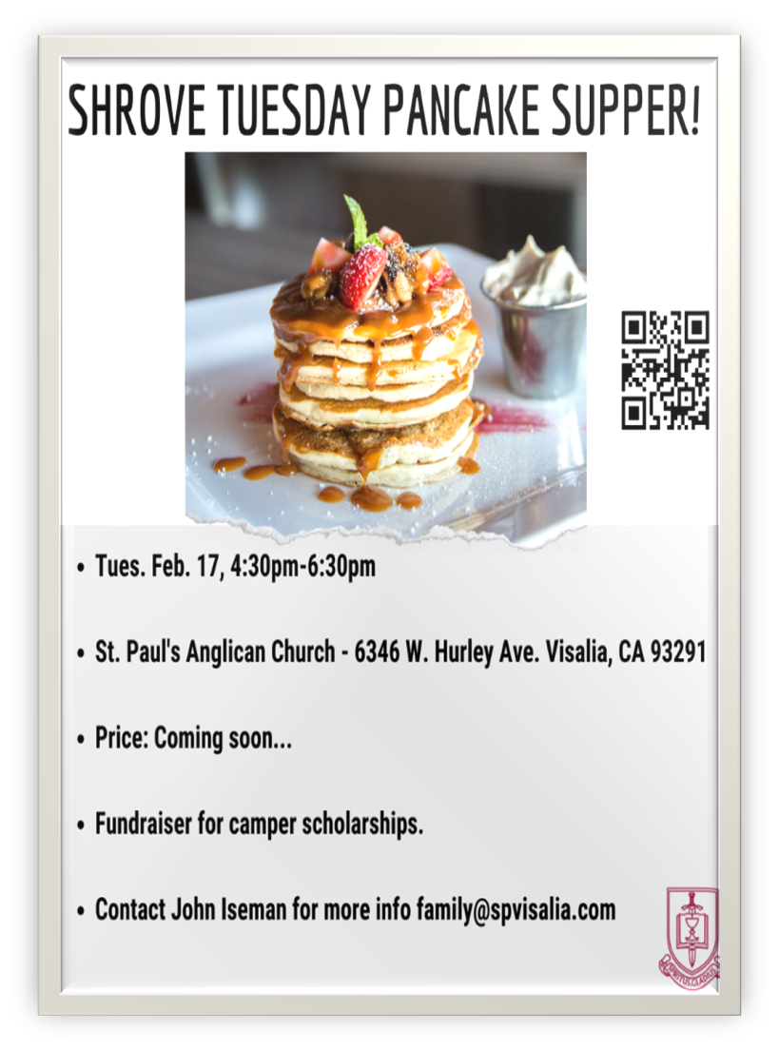

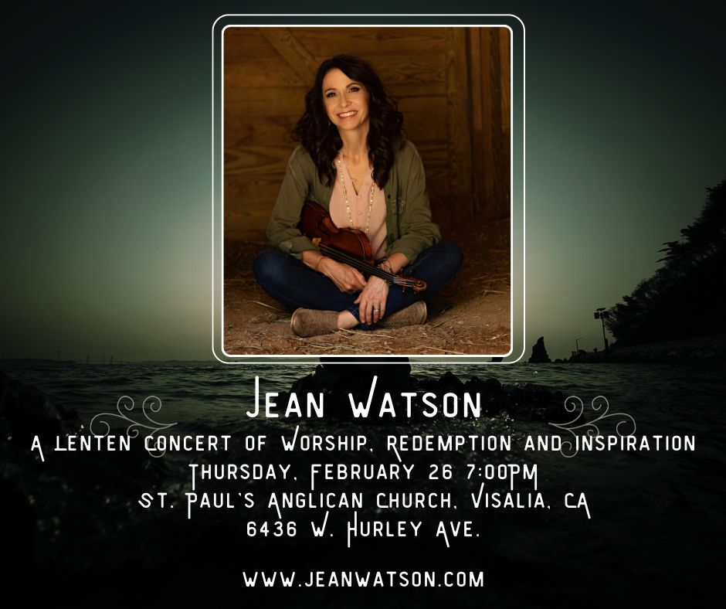
Jean Watson is a violinist/singer songwriter/speaker/writer who is passionate about bringing the sound of heaven to earth through words and music.

For the past 20 years, she has been traveling the globe sharing the love of Christ with whomever will listen.

Join us at St. Paul’s Anglican Church for a Lenten concert of
hope, redemption and the cross of Christ.

“It’s not always been easy, and I’ve walked through my share of struggles! Maybe you have too. One thing I’ve learned, however, is that God is faithful. Though we may fail Him, the Lord’s love will never fail us!” -Jean Watson

St. Paul’s Anglican Church
6436 W Hurley Ave
Visalia, CA


Friday March 6, 8:00 AM to 4:00 PM
Saturday March 7, 8:00 AM to 2:00 PM
Drop Off Donated Items in James Hall on:
Wednesday March 4 and Thursday March 5
Between 9:00 AM – 4:00 PM
Items need to be in Good Condition, Clean, gently worn clothing, household items, toys in working order gladly accepted!

Volunteers Needed for Set Up
Wednesday, March 4 and Thursday March 5
Between 9:00 AM – 4:00 PM
Proceeds will Go Toward the New Gate Project and
To Support our Medical Student in Honduras
If you have any questions,
Contact: Mary Murray at 799-6973

St. Paul’s Anglican Church
Parish Office
6436 W. Hurley Ave
Visalia, California 93291
559-732-4821
Office Hours: 8:00 – 4:00
Monday – Thursday

Worship: Sundays at 10:30AM
Livestream: Link at spvisalia.com
and on our Facebook page
Please be advised that this service is being recorded for broadcast
and/or archival purposes. By attending, you consent
to the inclusion of your likeness in these recordings.

St. Paul’s Clergy and Staff
The Rev. Robert Longbottom, Rector
rector@spvisalia.com
(559)802-2928
The Rev. John Iseman, Pastoral Associate for Family Ministries
family@spvisalia.com
The Rev. Kashy Rowland-Smith, Deacon
kashyrs@aol.com
Antoinette Horsting, Parish Administrator
bookkeeper@spvisalia.com
Marguerite Crownover, Organist and Accompanist
Cynthia Culp, Choral Director
Jackie Iseman, Nursery Coordinator
Shane Motl, Sexton

St. Paul’s is a member church of the
Anglican Diocese of San Joaquin
The Rt. Rev. Eric V. Menees, Bishop

Next Week’s Lessons
Exodus 24:12-18
Psalm 99
Philippians 3:7-14
Matthew 17:1-9

