Sermon Text: Luke 16:1–13 Date: February 22, 2026
Sermon Title: The Use of Money
Sermon Notes:
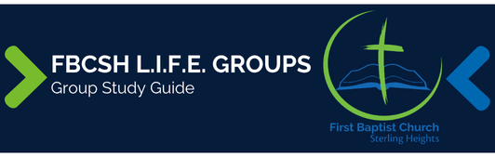

Sermon Text: Luke 16:1–13 Date: February 22, 2026
Sermon Title: The Use of Money
Main Idea: We should use our money in preparation for eternity.
Breaking the Ice
- Describe an example of someone who used money in a manner that clearly emphasized eternity.

Excavating the Truth
- Reread Luke 16:1–13
- The words “welcome” in verse 4 and “receive” in verse 9 (NASB) are the same Greek word. How does this wordplay aid the understanding of verse 9?

- The phrase, “No servant can serve two masters,” in verse 13 is literally, “No household slave can serve (as a slave) two masters.” How does such a literal translation help explain Jesus’ point?

Applying the Truth Personally
- What is an example of a time when I regret not using my money for eternity? What can I learn from this experience?

- What specific things about my use of money demonstrate to others that Jesus is my ultimate Master? What things convey the opposite message to people?

Applying the Truth Congregationally
- How does our church display a shared commitment to using our money for eternity? What might give a contrary impression?

- What can we do to help each other become better stewards of the money that God has entrusted to each of us?

Digging Deeper
- The word “master” in verse 8a is the Greek word for “lord/master” that is often used to refer to Jesus as Lord. How would the interpretation of the parable change if verse 8a were translated, “And the Lord praised …”?

- Use a concordance and develop a list of verses that address the topic of money. Write out principles that will help you live in a way that will not allow money to become your master.

Looking Ahead
- Read Luke 16:14–17 daily.

