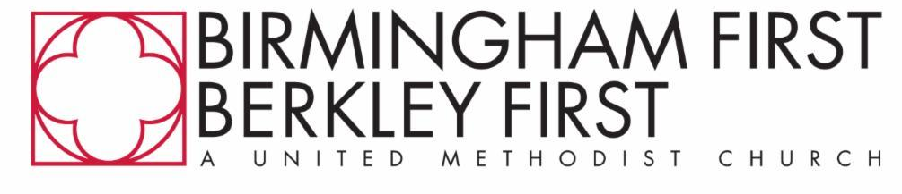

Seminary Relations
Ministerial Intern Application

Organization/Individual’s Full Name:
Mailing Address:
Email Address:
Phone:
School/Seminary:
Degree Area:
Years of study completed by Summer 2026:
Desired vocational area (if known; Deacon, Elder, etc.):
Are you pursuing ordination? _____ If so, which steps in the candidacy process have you already completed?
- Early Stage (Pre-Candidacy/Exploratory)
- Candidacy Summit
- Certified Candidate
Field Education: Are you hoping to fill a required internship or field education requirement for your degree program? If so, please attach an overview of the requirements. ___ Yes ____ No
Resume: Please attach a resume that includes previous ministry experience.

In this internship, you can expect to have a broad range of ministerial experiences. What are 1-2 areas of church ministry where you’d like to focus your energy?
- Liturgy & worship arts
- Preaching
- Ministerial leadership (leading committees, supervision of staff)
- Children & family ministry
- Youth ministry
- Congregational care/pastoral care
- Evangelism
- Teaching & disciple making
- Small group ministry
- Social witness/advocacy
- Administration & organizational skills
- Cultural humility/cross-cultural ministry
In 200 words or fewer, describe your relationship with Christ and how you came to sense a call to ministry.

This internship will place you as part of a clergy team serving together in the life of the church. What gifts or strengths do you bring to a pastoral ministry team, and how do you understand your role within a team that holds deep trust, shared leadership, and sensitive pastoral responsibilities?

Describe any ministry, leadership, or service experience (church, campus, community, or mission) that has shaped you.

