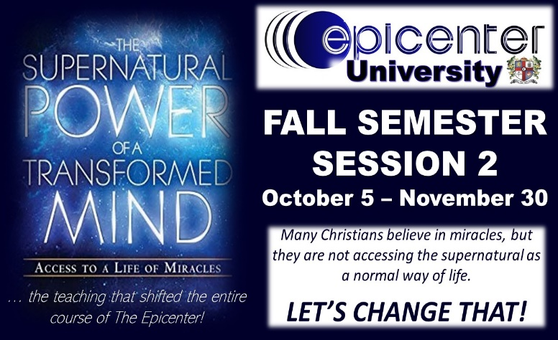
Wednesday Nights
6:30pm – 8:00pm
ER @ The Epicenter
An 8-week equipping course aimed at teaching & equipping you to experience the supernatural life that Jesus made available to you on The Cross!

FALL SESSION 1: COURSE REGISTRATION

First Name* Last Name*

Email Address* Cell Phone*

Do you text? YES NO (please circle one)

Are you on Facebook? YES NO (please circle one)

Do you use Facebook Messenger? YES NO (please circle one)
Course Requirements:

* a commitment to attend all five (8) of the eight (8) weeks of equipping, unless an emergency arises
* a commitment to be personally responsible for watching video sessions, should you have to miss a week
* a commitment to be ON TIME for each week’s session … walking in at 6:30pm IS LATE!
* a commitment to be present for the entire session each week … 6:30pm – 8:00pm

Course Needs:
* a 3-ring binder/notebook
* a personal Bible, both Old Testament & New

