
Thank you for reaching out as you start the process of calling a new pastor! To get started, we'd love to learn more about your church and your vision. Treat this questionnaire as a getting-to-know-you session and the beginning of your pastoral call journey. The goal is to help you think through and clarify your needs and equip us to provide you with names of candidates to consider. Please return the completed questionnaire to:
CLB Director of Operations: Paul Tjelta | Email: ptjelta@clba.org | Mail: PO Box 655, Fergus Falls, MN 56538
CHURCH NAME: ___________________________________LOCATION:________________________________
CONTACT: _________________________PHONE:____________________EMAIL:_______________________
May we list your church’s pastoral opening and contact information on the CLB Forge website’s Pastoral Calling Process page? _______ YES _______ NO
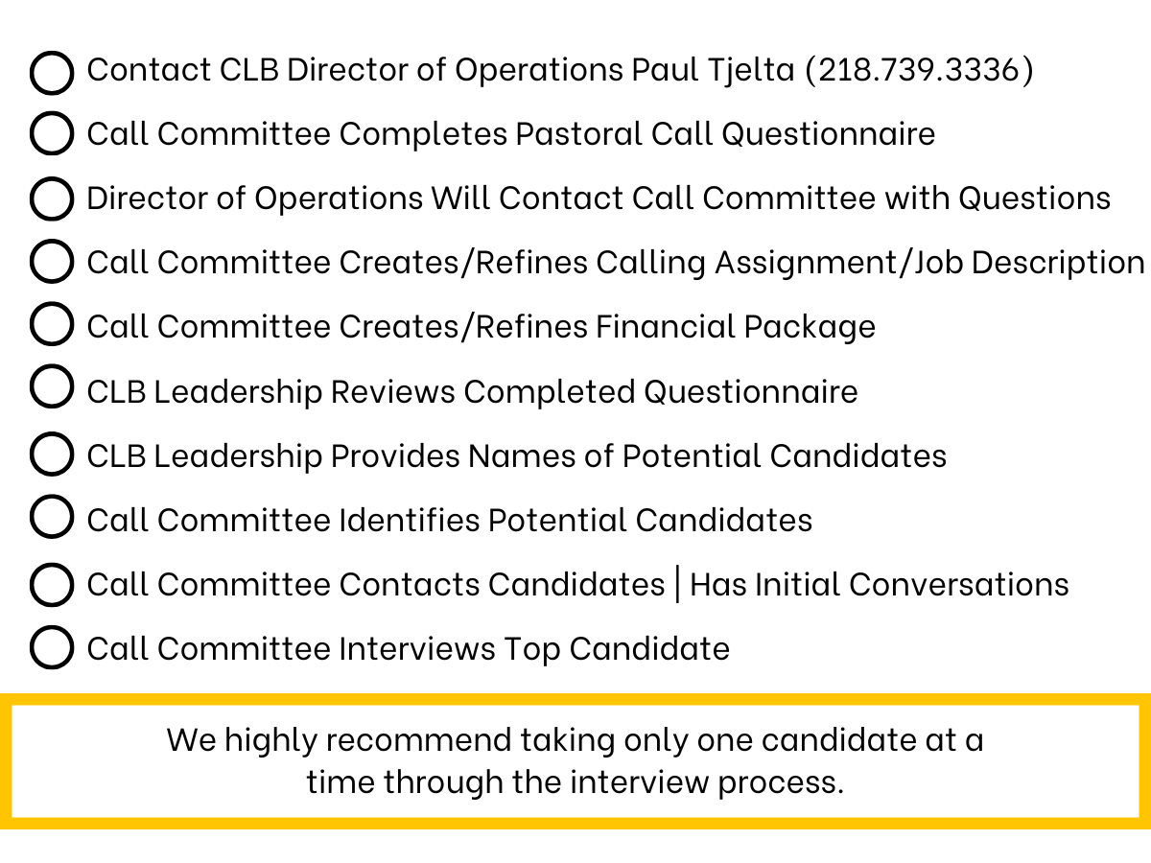

YOUR STORY & VISION
- Please outline the key historical events in the life of your church. (Defining moments!)
- Please tell us what your church looks like today. (i.e. attendance, ministry, community involvement, etc.)
- Please tell us what your church excels at.
- Where could your church use help?

THE CANDIDATE
- What is your congregation looking for in their next pastor? (Strengths, expectations, etc.)
- How will you measure the effectiveness/“success” of a new pastor?
- What will be the most difficult thing a new pastor will have to address in this church? (Any concerns candidates should be aware of.)

THE CALL
- Please describe your call process and who is involved in it. (Include contact info for point person.)
- Do you have an updated job description/calling assignment? (Please provide a copy. If you need help creating one, we are happy to help!)
- What is the church’s current financial situation? (If willing, please provide your annual budget. For Internal Use Only.)
- Do you have a financial package put together for this position? (If so, please provide a copy. For Internal Use Only.)

