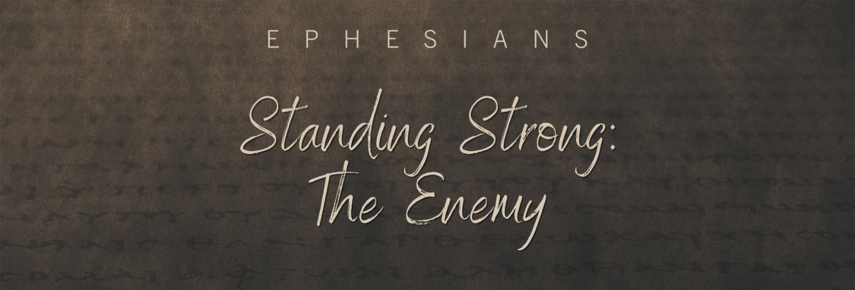

Sunday, August 21, 2022
Pastor Keith Thompson
Ephesians 6:10-13

- God equips us to resist Satan’s _______________ (10-12).

- God equips us to resist Satan’s _______________ (13).

