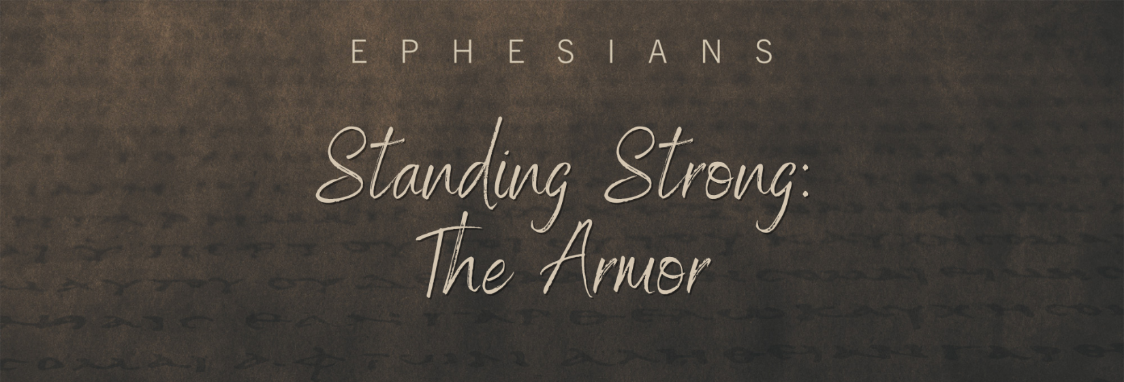

Sunday, August 28, 2022
Pastor Keith Thompson
Ephesians 6:14-20
1. We prepare for Satan’s attacks through ______________________ ________________________ that produce ______________________ in Christ (14-16).
- The Belt of ____________
- The Breastplate of __________________________
- The Shoes of ____________________
- The Shield of ____________
2. We repel Satan’s attacks through ________________ ________________ that accesses the ______________ of the Holy Spirit (17-20).
- The Helmet of ____________________
- The Sword of the ______________

