
Congregations: Please reproduce and distribute this information to your Synod Assembly voting members.

January 5, 2026

Dear 2026 Synod Assembly Participant:

This year, synod assembly will be held on Saturday, April 25th. Join us at Bethany Lutheran in Rice Lake. Our theme is Cross Connections: Building Bridges.

All voting members AND advisors must be registered by April 3rd so necessary onsite preparations may be made. Each voting member should have a different e-mail address. E-mail addresses are helpful as we provide lots of information prior to assembly electronically.

There is no paper form to mail in registration. Please register all participants online.

Pre-Assembly forums will be held for voting members on April 12, April 14 and April 16 at 6 p.m. on Zoom. All voting members should plan to attend one forum. We will discuss resolutions.

Determining Voting Members
The voting members of the assembly are determined as follows:
- Congregations are allowed 2 lay voting members, 1 male and 1 female. If a congregation cannot find both a male and female, contact Liz Bartsch at the Synod Office lbartsch@nwswi.org

B. Most congregations in our synod have baptized membership of 1-1000 allowing them 2 lay voting members. If your congregations’ baptized membership is greater than 1000 see the chart below for number of voting members.

Congregation Size | Number of Voting Members | Gender
1-1000 | 2 voting members | one male, one female
1001-1500 | 3 voting members | one male, one female, one either
1501-2000 | 4 voting members | two females, two males

In the selection of voting members, congregations are urged to be aware of the matter of inclusiveness of persons of color and/or persons whose primary language is other than English.

C. All Ministers of Word and Sacrament (pastors) and Ministers of Word and Service (deacons) under call or on leave from call on the roster of the Northwest Synod of Wisconsin are voting members.

- All retired ordained ministers on the roster of this synod who are currently serving as interim pastors and all ordained ministers on leave from call on the roster of this synod who are currently serving as interim pastors and who are in attendance at the assembly are voting members.

- All retired ordained ministers and ordained ministers on leave from call on the roster of this synod may participate as voting members at the Synod Assembly, if they are affirmed by their congregation and consistent with the constitution of the Northwest Synod of Wisconsin. The retired ordained ministers and the ordained ministers on leave from call shall not be counted towards the lay male or lay female voting members allotted to each congregation. If the 60% lay person voting requirement of the constitution is not met due to the vote participation of retired pastors and ordained ministers on leave from call, the officers of the Synod Council shall reduce the number retired voting participants and ordained ministers on leave from call by lot until the 60% requirement is met.
- Youth/Young Adult Voting Members
It is the goal of this synod that at least 10% of the voting members of the Synod Assembly, Synod Council, committees, and organizational units of this synod be youth and young adults. For purposes of the constitution, bylaws, and continuing resolutions of this synod, the term “youth” means a voting member of a congregation who has not reached the age of 18 at the time of election or appointment for service. The term “young adult” means a voting member of a congregation between the ages of 18 and 30 at the time of election or appointment for service.

Information to assist you and your congregation in inviting, selecting and supporting your youth and young adult voting members for the upcoming Assembly:
- It is our hope that each conference will elect youth person(s) (male and female) to attend synod assembly. There is no cost for these conference youth but the conference dean or their home congregation MUST register them.

Resolutions
March 15th is the deadline for resolutions to be submitted for consideration at this assembly. Instructions and forms are on the website at www.nwswi.org

Remember to visit our website for assembly updates: www.nwswi.org.

God’s Blessings to you,

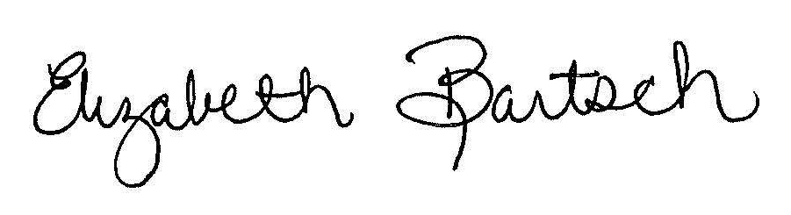
Assistant to the Bishop-Administration
Assembly Manager
Northwest Synod of Wisconsin

