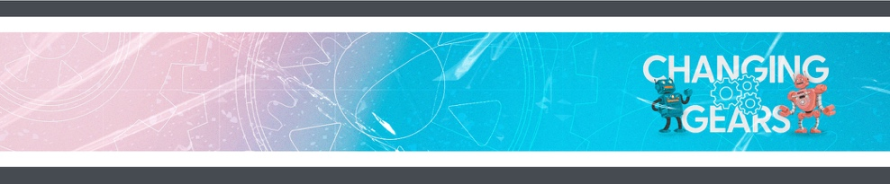
WEEK 1
GROW AT HOME

Hey, families! Here's a look at what we're covering with your kids so you can help them continue to grow at home during the week.

GROW AT HOME THIS WEEK

THIS WEEK  This week, kids hear about the transfiguration of Jesus and what the disciples learned from this.  - THE BIG IDEA: We change when we know who God is.  - THE BIBLE: Matthew 17:1-9  ASK THIS  Because sometimes you and your kid need a conversation-starter that isn't,  "So . . . how was church?"  - How do you feel about change? What are some examples of change that are good? What are some that might feel scary or difficult?  - Who can you tell about the good changes God is making in your life? | REMEMBER THIS  This month, your kids are memorizing the Bible verse  2 Corinthians 5:17 (NIV), in case you want to work on them together.  NEXT WEEK  Next week, kids will hear about the conversation between Jesus and the Samaritan woman.

GROW AT HOME

WEEK 1
GROW AT HOME

Hey, families! Here's a look at what we're covering with your kids so you can help them continue to grow at home during the week.

GROW AT HOME THIS WEEK

THIS WEEK  This week, kids hear about the transfiguration of Jesus and what the disciples learned from this.  - THE BIG IDEA: We change when we know who God is.  - THE BIBLE: Matthew 17:1-9  ASK THIS  Because sometimes you and your kid need a conversation-starter that isn't,  "So . . . how was church?"  - How do you feel about change? What are some examples of change that are good? What are some that might feel scary or difficult?  - Who can you tell about the good changes God is making in your life? | REMEMBER THIS  This month, your kids are memorizing the Bible verse  2 Corinthians 5:17 (NIV), in case you want to work on them together.  NEXT WEEK  Next week, kids will hear about the conversation between Jesus and the Samaritan woman.

