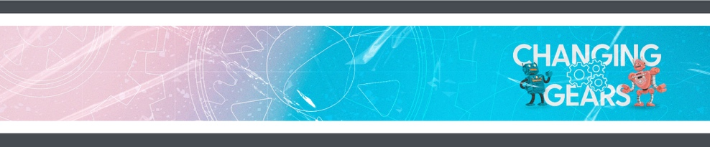
WEEK 3
GROW AT HOME

Hey, families! Here's a look at what we're covering with your kids so you can help them continue to grow at home during the week.

GROW AT HOME THIS WEEK

THIS WEEK  This week, kids hear about how Jesus healed a blind man.  - THE BIG IDEA: Jesus changes how we see things.  - THE BIBLE: John 9  ASK THIS  Because sometimes you and your kid need a conversation-starter that isn't,  "So . . . how was church?"  - How do you know God is with you even though you can’t see God?  - What does it mean to live in the light and not darkness? | REMEMBER THIS  This month, your kids are memorizing the Bible verse  2 Corinthians 5:17 (NIV), in case you want to work on them together.  NEXT WEEK  Next week, kids will hear about the time Jesus raised Lazarus from the dead.

GROW AT HOME

WEEK 3
GROW AT HOME

Hey, families! Here's a look at what we're covering with your kids so you can help them continue to grow at home during the week.

GROW AT HOME THIS WEEK

THIS WEEK  This week, kids hear about how Jesus healed a blind man.  - THE BIG IDEA: Jesus changes how we see things.  - THE BIBLE: John 9  ASK THIS  Because sometimes you and your kid need a conversation-starter that isn't,  "So . . . how was church?"  - How do you know God is with you even though you can’t see God?  - What does it mean to live in the light and not darkness? | REMEMBER THIS  This month, your kids are memorizing the Bible verse  2 Corinthians 5:17 (NIV), in case you want to work on them together.  NEXT WEEK  Next week, kids will hear about the time Jesus raised Lazarus from the dead.

