#1
The Love Connection

Intro – Throughout history there have been different ways to find a marriage partner.

Love or Infatuation?
Ann Landers

Infatuation is instant desire. It is one set of glands calling to another. Love is friendship that has caught fire. It takes root and grows – one day at a time.

Infatuation is marked by a feeling of insecurity. You are excited and eager, but not genuinely happy.

There are nagging doubts, unanswered questions, little bits and pieces about your beloved that you would as soon not examine too closely. It might spoil the dream.

Love is quiet understanding and the mature acceptance of imperfection. It is real. It gives you strength and grows beyond you, to bolster your beloved.

You are warmed by his presence, even when he is away. Miles do not separate you. You want him nearer. But near or far, you know he’s yours and you can wait.

Infatuation says, “We must get married right away. I can’t risk losing him”.

Love says, “Be patient. Don’t panic. Plan your future with confidence.”

Infatuation has an element of sexual excitement. If you are honest, you will admit it is difficult to be in one another’s company unless you are sure it will end in intimacy. Love is the maturation of friendship. You must be friend before you can be lovers.

Infatuation lacks confidence. When he’s away, you wonder if he’s cheating. Sometimes you check.

Love means trust. You are calm, secure and unthreatened. He feels that trust, and it makes him even more trustworthy.

Infatuation might lead you to do things you’ll regret later, but love never does.

Love is an upper. It makes you look up. It makes you think up. It makes you a better person than before.

I. The Romantic Myth
There is a traceable history of the notion of “Romance” in the Western world.

II. Romance vs. Love
Romance
- Romance Produces
- Romance Emphasizes
- Romance doesn’t
- Romance demands
Love
Notice the 2 components of Love:
- Commitment
- Self-Discipline

III. Building on Love
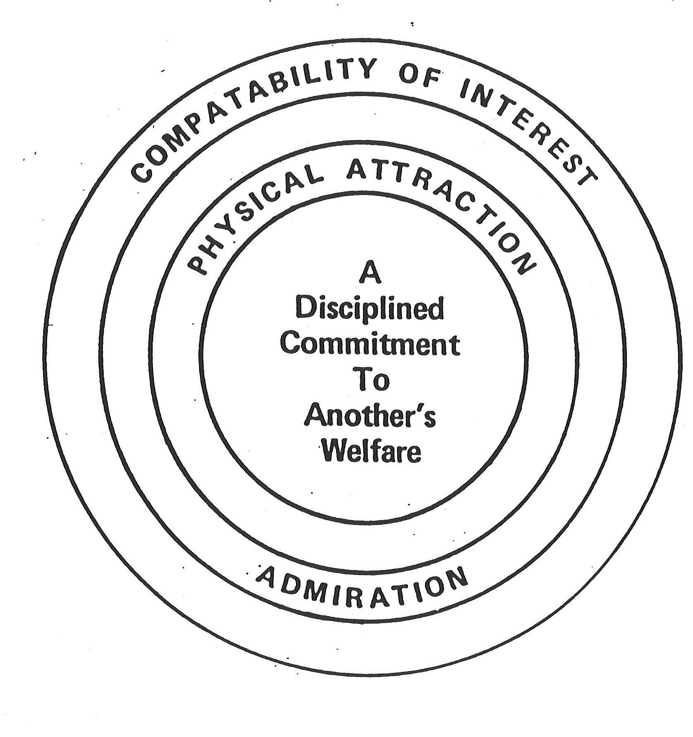
IV. Summary
Equal value =
Above value =

