Where Do We Go From Here? Studies in Deuteronomy
© 2026 Sandra Richter, Westmont College
- The Foundation: The “Ten Words” of the Covenant (Deuteronomy 5)
- Shema: “Hear of Israel!” (Deuteronomy 6:4-10)
  - The morning and evening prayer of the Jew
  - One cult site for one God! “One lord, one faith, one baptism”
  - “The pivot around which everything else in Deuteronomy revolves … the plumb line by which their relationship to Yahweh of history was constantly being measured” (Patrick Miller)
  - “The book is essentially an exposition of the great comandment” (Duane Christensen)

- Deuteronomy 6
When God makes you successful, don’t forget where you came from!

- Deuteronomy 7
When God makes you successful, don’t join the club!
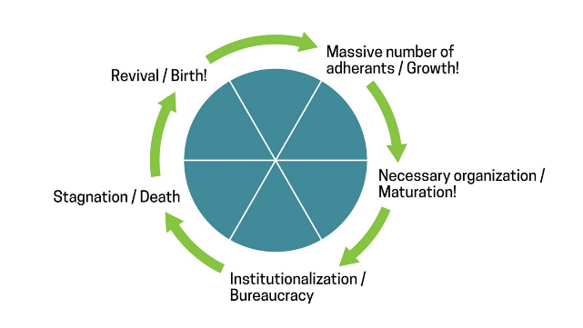
- Deuteronomy 8
When God makes you successful,
don’t think it’s because of how talented you are!

- Deuteronomy 9
When God makes you successful,
don’t think it’s because of how moral you are!

- Climax: Deuteronomy 7:7-10
Yahweh did not set his affection on you and choose you because you were more numerous than other peoples, for you were the fewest of all peoples. But it was because Yahweh loved you and kept the oath he swore to your ancestors that he brought you out with a mighty hand and redeemed you from the land of slavery, from the power of Pharaoh king of Egypt. Know therefore that Yahweh your God is God; he is the faithful God, keeping his covenant of love to a thousand generations of those who love him and keep his commandments … Therefore, take care to follow the commands, decrees and laws I give you today.
