Print & Cut Vinyl Sticker
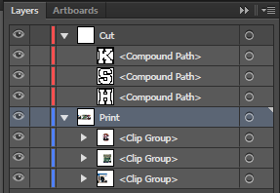
The print and cut vinyl sticker is where you print an image on to a sheet of white vinyl. Some of the tools that you will use in Illustrator are; Clipping Mask, Outline Stroke, Offset Path. Using these tools we will create our print and cut vinyl sticker.
Design Criteria
- Two Layers
  - Print (Blue)
  - Cut (Red)
    - Make sure you CAPLITALIZE C&P.
- Cut layer should have no stroke.
- Image must have a bleed.
  - Desired image is printed past the cut path.
- Designed in Illustrator
- Design must be appropriate
- No paths can overlap, the cutter cuts on the path lines.
- Must be a new design that has not been used for any other project.
Once you have finished your Print & Cut Vinyl Sticker you will package your file into the print & Cut folder at the following link. Copy and paste the link into the address bar in the Windows Explorer window.
G:\KHS\Teachers and Students\Bowers, Marshall\Print Jobs\Production Graphics Class Work\Print & Cut
