2024-2026 Biennium Induction
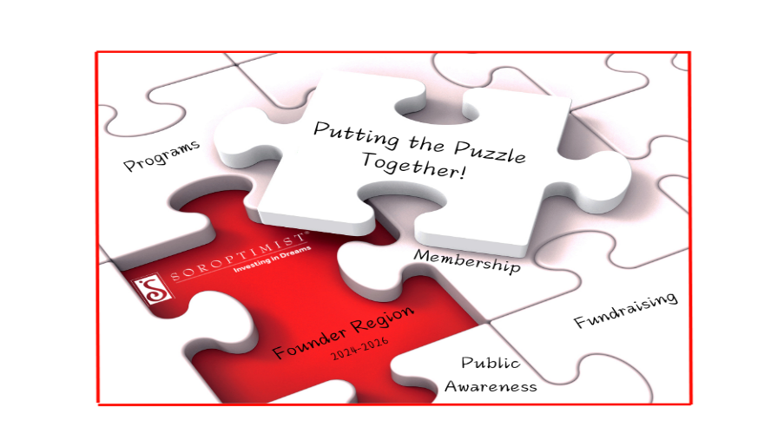

Today we are celebrating the induction of our new member(s) _________________________________________________________________ into Soroptimist International of _______________________________________.
Our Soroptimist Vision is that women and girls will have the resources and opportunities to reach their full potential and live their dreams. Our Soroptimist Mission is to provide women and girls with access to the education and training they need to achieve economic empowerment. By becoming a member of this international organization, you are having an impact on the lives of women and girls who can benefit most from our life-changing programs.

Our organization was founded in October 1921 in Oakland, California. Violet Richardson served as the first president of the first club in Alameda County. What began earlier that same year, with the power of eight women sharing their vision, has developed into today’s worldwide organization with over 75,000 club members in 122 countries. Our name, Soroptimist, is a coined Latin word meaning “best for women”, and that is what our clubs aim to achieve. Soroptimists are women at their best working to help other women to be their best. We believe in dreams and the collective power of working together to achieve them.

Soroptimist International works at a local, national and international level to Educate, Empower and Enable opportunities for women and girls. You are also a member of a Federation, Soroptimist International of the Americas, sometimes referred to as SIA. Our Federation’s identifying project is our “Live Your Dream: Education and Training Awards for Women” program. This program aids women seeking to improve their economic status by gaining additional training and education.

You are also a member of Founder Region, one of 28 regions in SIA and named appropriately so, because here is where it all began, over 100 years ago. Our region includes clubs located in Northern California, Hawaii, the Northern Mariana Islands and the Republic of Palau. Our region’s identifying project is Founder Region Fellowship, in which grants are awarded to women in the last year of their doctoral studies.

Our region theme this biennium is “Soroptimist-Putting The Puzzle Together”. As we continue upon our second century of improving the lives of women and girls, we must put all the people and programs of our organization together so we create a beautiful picture and have a sustainable impact on those who have yet to need our help and support. They count on us to be here for the next one hundred years as we continue to work toward our increased collective impact of empowerment through education.
You are also a member of Soroptimist International of ________________________________. You are joining a club that is a vibrant part of your community. Soroptimist membership celebrates the power of individuals working together to create an increased collective impact as stated in our pledge. This is our Joy of Achievement.

Soroptimist membership celebrates the unique power of women. It’s a gift that one gives themselves: the chance to help others in an atmosphere of support, friendship and fun. Club members have the responsibility to share with you the Sincerity of Friendship, by making you feel welcome and inclusive. The club demonstrates to you the Dignity of Service, by helping women and girls in this community and throughout the world. Club members recognize that we all experience Soroptimist in different ways, and we appreciate and respect the various levels of participation. We will never make you feel guilty - we are all volunteers.

As a token of your membership, the members of your club present to you a Soroptimist pin to wear on your left side, above your heart. The pin represents your commitment to our mission and vision, and to empowering women and girls to live their dreams by giving them the resources to create a positive change for themselves, their families, their communities and their world.

On behalf of Founder Region, I present you with a “New Member Bookmark” to help you keep our mission front and center at all times. I would also like to present your sponsor with a bookmark and thank her for increasing our collective impact. The best way for our organization to thrive is Put the Puzzle Together!”, and invite everyone we know to join Soroptimist and become a member of this amazing organization.

CONGRATULATIONS AND WELCOME!

